Jio Financial Services Elliott Wave Update: Wave (5) in Progress

JIOFIN resumes its bullish trend after completing a correction near 198.47 INR. The stock is now advancing in wave (5) of a larger Elliott Wave sequence.
After a prolonged correction, Jio Financial Services Ltd (NSE: JIOFIN) completed its larger wave II near the 198.47 INR level. This area also aligned with the ideal blue box buying zone. Price turned up from there, signalling the start of a bullish wave III sequence.
Since that low, the stock has shown strong upward momentum. A clear five-wave impulsive move has developed within wave ((1)) of III. Wave (1) kicked off the rally from the April low. It was followed by a corrective wave (2). The bullish trend resumed with a strong wave (3), then a shallow wave (4) pullback. This pullback respected prior support and stayed within the bullish right side tag. The recent breakout suggests wave (5) of wave ((1)) is now underway. Further upside is likely before the market enters a larger wave ((2)) correction.
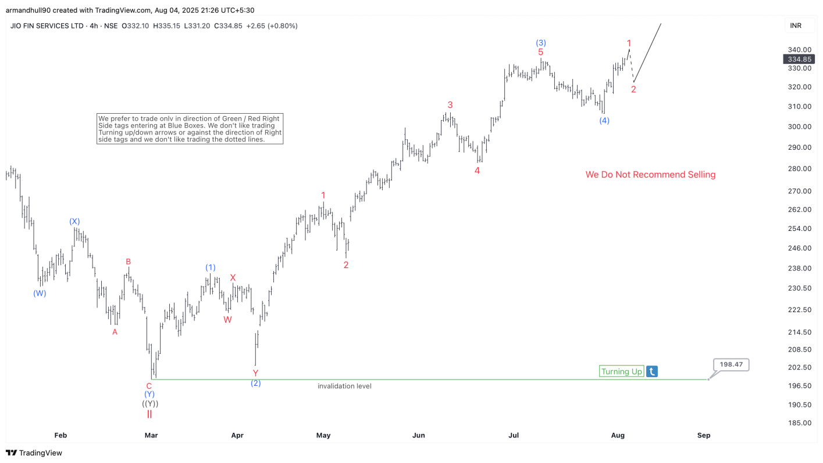
The invalidation level at 198.47 INR remains key to the bullish view. As long as price remains above this level, dips are expected to be corrective and should offer buying opportunities. This rally is not just a short-term recovery but part of a broader bullish cycle that began after the March low. Traders should continue to monitor the development of wave (5) and look for momentum confirmation as price moves higher. Any shallow pullbacks in the short term can offer favorable risk-reward long setups within the ongoing wave III rally.
Explore a variety of Stocks & ETFs investing ideas by trying out our services 14 days and learning how to trade our blue boxes using the 3, 7 or 11 swings sequence. You will get access to our 78 instruments updated in 4 different time frames, Live Trading & Analysis Session done by our Expert Analysts every day, 24-hour chat room support and much more.

