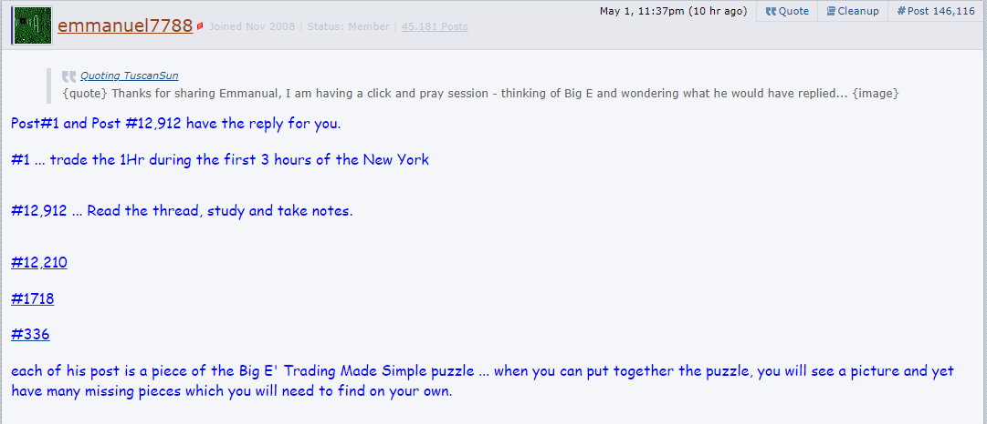

#1 Post
-  eelfranz
- Joined May 2008 | Status: Grand Poopaw | 1,488 Posts
Is that possible? Yes.
Years ago when I retired I was looking for something to do. I attended a free local presentation about trading FX. My mind said "We can do that and make money too... from the recliner"... so the torture began as happens to all newbies...
I bought one sure fire program for $2,300... saving $1,700 off the normal $4,000 price. Man... I'm on my way I thought. It was so difficult to understand and trade that I never made a dime... in fact I lost most of the time. When I called the companyit was all Greek to me... I thought a lot of good that 19 years of education is doing.
I said this is BS and went on to other systems. I switched to Demo trading for several years while studying old charts. What made them tick? Every method had quite a few rules, indicators...on & on.
I finally got fed up with them all... remembering the thoughts years before of "I can do this". Then why was I getting my butt kicked on a regular basis... so frustrating.
I wanted a method that was simple, worked on all timeframes, simple rules, few indicators.... that when looking at my simple chart it just shouted out what I needed to do and developed a method that is 70-80%+ wins for me on a regular basis. It took over 2 years to develop this method. I worked hard... late nights and weekends to. I was so hungry for success.
I hate trading 5min-15min-30min charts. Why? You have to monitor each trade from beginning to end and hope and pray you made a correct entry. I only trade 1hr charts during the the 1st 3 hours of the USA OPEN and 4hr trades at night. I check for set ups at 10pm Pacific,2am and close all 4 hour trades by 6am Pacific.... You ever woke in the morning popping on your puter and find you made 150 pips while you slept... guaranteed to put a smile on your face and a skip in your step.
I post a lot of training charts to drive it into your brains what to look for and how easy it can be... Just open your eyes, brain and pay attention and you'll be making pips soon...
You'll learn down the road that most of the stuff you have learned in the past is crap. I did. The list of rules in most methods will keep most dizzy... never building confidence... without confidence in your entries and exits you have nothing worth while.
We have a group of great traders who have been trading this method for 6-8 months already who will help you jumping in to answer your questions too.
I am very protectful of all our members. We don't have a stressful thread... no name calling allowed. I'll delete anyone who starts any problems. If you have a problem PM me and don't post it. If your not happy... please move on quietly. I'd do the same for you. You want Stress Free learning... come join us...
Really can't understand something... PM me your phone number and best time to call and I'll clear it up for you looking at an FXDD Demo chart so we are looking at the same chart.
You will need a MT4 platform to use our progam.
The key to this method is the Traders Dynamic Index indicator for entries and exits. I also use a Stochastics (8,3,3) indicator. It is ONLY used to confirm direction. Nothing else.
We only use Heiken Ashi candles... that's important.
We want you to be an active member asking questions, posting charts and making observations when possible.
Start trading a Demo account until you build your confidence and only then consider switching to a live account...
Disregard template posted below and see updates... Read the complete thread BEFORE ASKING QUESTIONS... YOU WON'T BE SORRY
See post #25 on page 2 for indicators...
Latest update: PAGE 11, Post # 156... thanks Cliff
Another update by Numb3rs - 4/29 - Pg 48, post 713
UPDATE: See post #25
See post 14 & 15 for TDI & HA (APB) candles.

#6 Post
- eelfranz
- Joined May 2008 | Status: Grand Poopaw | 1,488 Posts
Entries and exits...
We Enter a trade when green crosses red on the TDI at the beginning of that candle... If it's candle 3 or more don't enter... find another trade set up. The only exception is if green bounces off red and continues... it's ok to re-enter on the bounce...
Exit your trade when the green TDI line goes flat, starts to hook over or makes a check mark reversal.
If you add other things it will influence your decisions... usually to your detrament. Don't try to complicate it thinking it can't be this easy.
Important to study TDI entries on old charts, any time frame... Give yourself a chance and trade it like it's layed out...

7
#12,912 Post
- eelfranz
- Joined May 2008 | Status: Grand Poopaw | 1,488 Posts
So many new traders... Do not think you can trade with us without reading the thread and taking notes. READ & STUDY.
Snarlyjack - Good to hear from you old friend. We have stood back to back in battle more than a few times. May your trades be blessed buddy.
Come visit more often.
Big E

4

#12,210 Post
-  smatthew
- | Joined Sep 2011 | Status: Would like to profit consistently | 233 Posts
- Strong looking. H4 and H1 both down.
- Real close to previous low...
- Just 10 pips away from 1.3500...
- Five candles on last down reversal.
- No consolidation.
- Large candles.
- Medium EUR news just passed 15 minutes ago. Next news at 10am.
- TDI angle 4-6, bounce trade: green bounced off red. Stochs flat and near oversold. Decided to stay out, mainly because PA was close to 1.3500.
Quoting eelfranz
Remember when your looking at PA... it loves to return to previous hi or lo levels... check out a few charts.
Remember to always consider your forex basics when thinking about entering a trade...
Does it look week or strong...
How close are we to previous hi's or lo's...
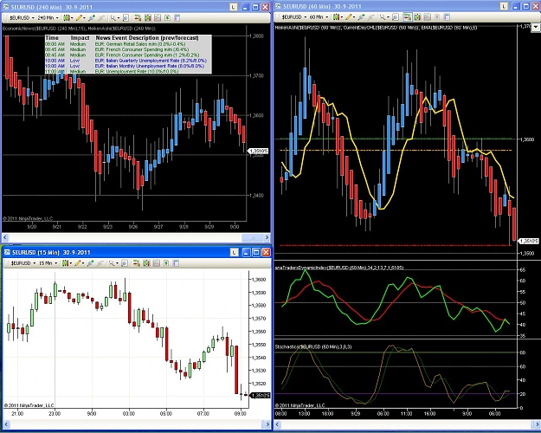
Financial independence is what I live for

#1,718 Post
- eelfranz
- Joined May 2008 | Status: Grand Poopaw | 1,488 Posts
Dyekid217... Good analysis buddy...
I get a little frustrated when people keep adding stuff and then posting it on the forum. I repeatedly ask others to PM others on the thread with the new ideas and not posting them. At least PM me with their ideas...
The main entry rule is: green crossing red on the TDI within the first 2 candles for an entry...
I don't care what the red TDI line is doing.
Did Stoch's confirm the TDI signal between the 20-80 lines...?
The 12-2 and 4-6 is for the TDI and not the 5ema... that would just be a bonus...
If you meet the TDI entry rule it doesn't much matter where the 5 ema is in relation to the 1st two candles...
All this extra crap does nothing but confuse other traders and their success rate drops and they can't figure out why...
Everyone - Please stop adding anything... stick to the SIMPLE BASIC RULES.
That's what makes it work !

#336 Post
- eelfranz
- Joined May 2008 | Status: Grand Poopaw | 1,488 Posts
Those wanting more examples go to Forum: Commercial, then Craig Harris Stochastics Method... then start reading on page 246, post 3676 to the end... you will learn more fast... We switched from there to only discuss this method in the new forum...

