UTILISATION OF THE FRACTAL OF PRICE

The main idea is that the "Fractal" of Price goes from the SRL (Support & Resistance Level) 0/8 to 8/8 - this Fractal is ruled by its Price Octave of value =1/8 th of the Price Range. (12.5 % of the Fractal of Price)
As long as Price Action does not fluctuate above the Upper (SRL 8/8 Ultimate Resistance) and under the Lower (SRL 0/8 Baseline) Limits of the Fractal of Price of plus or minus 25 %, Price Action will be "ruled" by the same "Octave" (your Octave Gap).
Above or under these limits Price Action are ruled by another "Octave (Octave Gap), multiplied or divided by 2 because they have penetrated in a different price territory.
Let's take an example with SES GLOBAL - a french corporation.
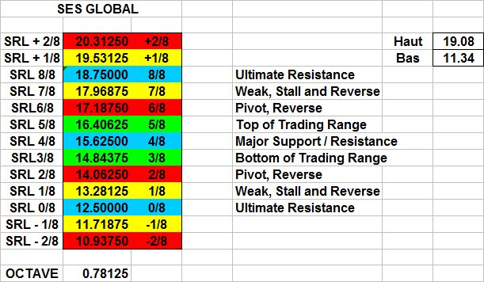

The table shows us the Fractal of Price ruling the Price Action of SES GLOBAL for a Top of 19.08 (at the time) and a Bottom of 11.34
Then the Price Range is 9.375 points = 20.3125 - 10.9375 . Price Octave = 0.78125
Let's assume that SES GLOBAL Price Action breaks the Upper Limit of the Price Range, then we get a new Fractal.
The new Price Range is now 18.5 points = 28.125 - 9.375 with a Price Octave (Octave Gap) of 1.5625
Price Range and Price Octave (Octave Gap) have simultaneously doubled.

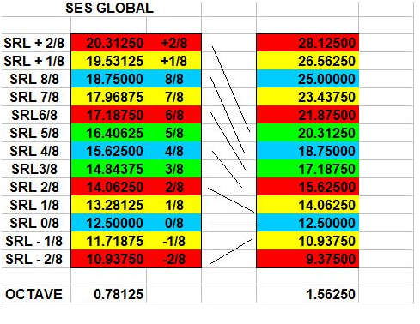
If you compare the Fractal of Price BEFORE Price Action broke its upper limit of 20,3125 with the new Fractal AFTER Price Action has broken 20,3125 generated for example if Price Action of SES GLOBAL has reached 20.50, you observe that :
- Support and Resistance Line SRL (0/8) stayed the same in both fractals.
Reason is that the last significant bottom has not changed. Price Action has only broken the upper limit of the previous fractal.
- One key point is that the former Support & Resistance Line SRL (8/8) whose property was Ultimate Support & Resistance become in the new Fractal the Support & Resistance Line SRL (4/8) - whose property is Major Support & Resistance / Center of Gravity.
- The former Support & Resistance Line (4/8) whose properties were Major Support & Resistance / Center of Gravity become in the new Fractal Support and Resistance Line SRL (2/8) whose properties are Pivot, Reverse.
- The Support & Resistance Line SRL (2/8) in the former Fractal become in the new Fractal the Support and Resistance Line SRL (1/8) - whose properties are Weak, Stall & Reverse.
From a Strong Line in the former Fractal SRL (2/8) is now a Weak Line in the new Fractal. Everything is relative.
- The Support & Resistance Line SRL (6/8) in the former Fractal whose properties were Pivot, Reverse become in the new Fractal the Lower Limit of the Trading Zone (3/8).
- The Support & Resistance Line SRL (+ 2/8) in the former Fractal become the Upper Limit of the Trading Zone (5/8) in the new Fractal.

Following the extension or contraction of the Fractals of Price the Support & Resistance Lines (SRL) see their status change, have different properties and sometimes simply vanished.

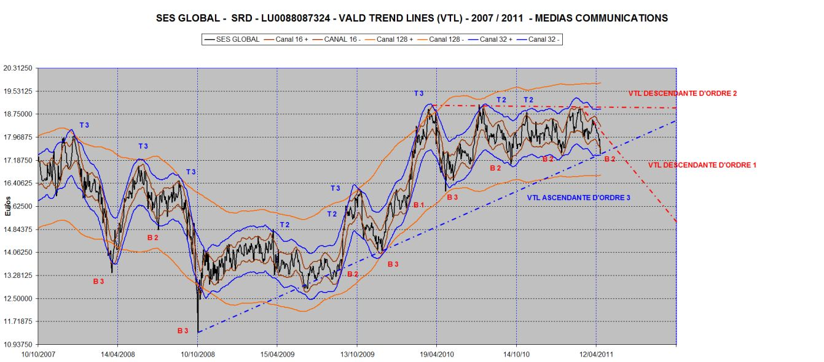
A Chart of SES GLOBAL showing all Price Range de (-2/8) à (+ 2/8) with the Enveloppes and the VTL as well as a very remarkable contracting Triangle.
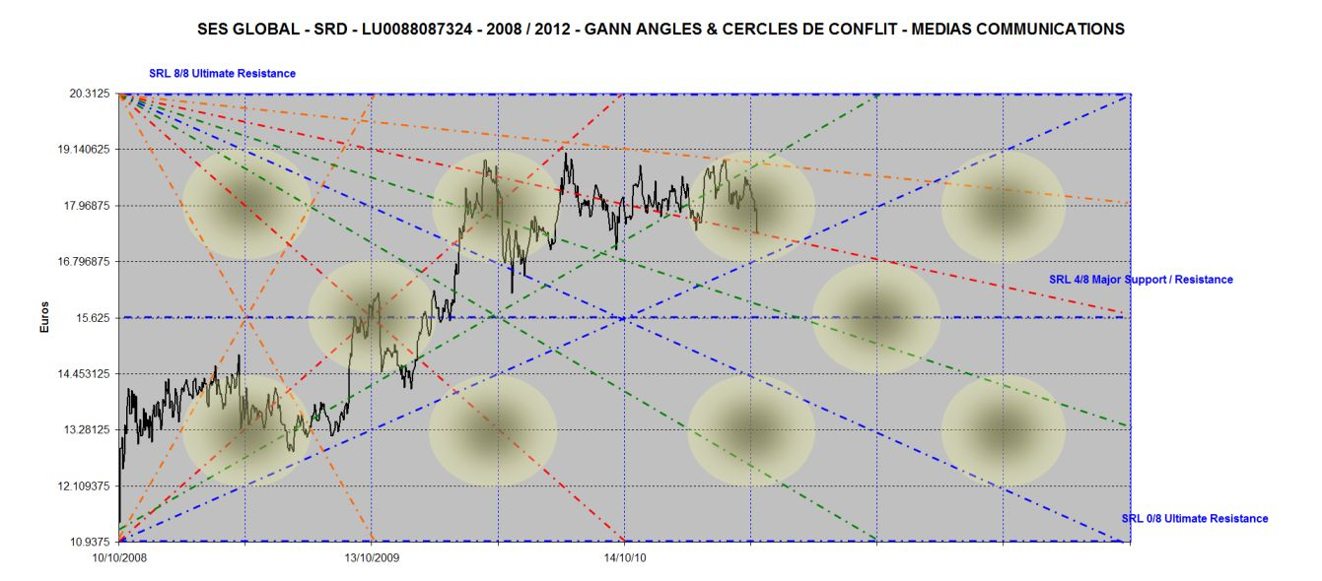

Gann Angles and Circles of Conflict in the same Price Timeframe

on a toujours 8 Levels + 2 + 2 = 12 Levels
Sometimes 10 Levels - when Support and Resistance Line SRL (0/8) = 0. Because Prpce can not be negative.
Consequence of the extension or contraction of the Fractals of Price the Support and Resistance Lines SRL’s see their operative status, modified and sometimes disappear .

