Murrey Math Trading System "Setting the Square in Time"

Setting the "Square in Time" (Murrey Math Lines and U.S. Quarterly 4 Day Trading Cycle) 30 Year

Go back to Quick Reference Sheet G. and review all of the major and minor Murrey Math Lines, for any stock, or anything, trading between zero and 100.0. (spend a few minutes studying this chart).

Now, let's remember, that to set up our "Square in Time," we must look at the current high and low extremes of our stock, over any significant period of time.

We should always set our squares from 3 different perspectives: long term, intermediate, and a short term trading view.

(but we are never able to trade any wider a range, than the difference between the last high or low, for if it were worth any more, currently, it would already be up there).

But, we shall set our square from one perspective, the short term, at this time, and then, after you are comfortable with the following 3 examples, you shall look at a longer term perspective, which, by just using the same rule, (look at the obvious high - low price extremes) and count by 2 major math lines or 4, or 8, minor Murrey Math Lines, as long as you encompass all of its high - low trading activity, no matter how far back you go.

Go back to the Charts by Group section, pages 7., and 8., and review each chart, for a few minutes, and you will see, what you are about to now read.

We shall set our "Square in Time" under the strictest Mathematical calculations.

(now before you get out a ruler, just to prove me wrong, rather than to just take my word for it, and go on and learn how to predict the "Harmonic Rhythm" of your market, just take my word for it, right here and now, that if it looks like a square, then it acts like a square, besides, if you get back far enough from it, it will look like a square.

And since we expand, and condense our squares, so that we may have, either a close up, or longer time scale, view, we will inadvertently skew our square, for the convenience of my failing eyes, but if you don't trust me, then go back and read what Sir Isaac Newton had to say, on the subject, and get his perspective, on the subject.

It must be clarified here, that we must always use enough horizontal and vertical lines, starting from our zero Line, (tee off date - for those who think in terms of when they will play golf next), to start our vertical lines, to the height of a house, to set our horizontal price lines, in which we shall close our prices in a square.

Let's clarify the meaning of our "tee off time," and the height of our house.

Most adults enjoy the game of golf, (if they want to ride in a golf cart, and act as if they are exercising their bodies, and play a game where you get a handicap for performing poorly).

So, since most golfers quit playing golf, as soon as the football season starts, each fall, we set up, our rhythm of all stocks, or markets, based on the most favorable "tee off tunes," when the least number of people will want to play, and especially, when the temperature is the most pleasant, and the bent grass greens are growing, and are in the best putting shape, which is the 1st week in October each year, so we set our 1st "tee off time," at October 7, 1994, which also, just happens to be my birthday.

There is a simpler reason, why you should set up your 1st vertical line, in your square, off this date.

And I have already told you once, so let's just assume that the fall football season, is reason enough, to set up everything, since most men, just out of college, live or die, with whether or not, the University of Alabama beats the University of Tennessee, 5 times in a row, in Alabama, rather than 4, (try and be an Auburn University graduate, and a salesman, and walk into a selling situation, with a graduate, from the University of Alabama, just 48 hours after Auburn bas just beat Alabama, in the last two minutes, in Birmingham, and you start the "small talk" around, "where did you go to college, and what did you think of the game last Saturday ?"

The 1st question: "where did you attend college?" may have already been answered as soon as you walk into the office, for every "faithful" graduate shall display at least 12.5 items, that will solidify his matriculated alma mater.

And the fact that his loyalty runs into his blood, and the Êict that he bas 1/2 of an item, is indicative of the fact that a last minute touchdown, sparked a response, mat found a coffee cup, broken, and crumpled in the corner, but its largest recoverable portion, is back in its dust -free space: a reminder that maturity is measured in wins, not ones reaction to last minute luck or bad calls.

How much business do you think you will get from this customer, if you don't lie, and say that it was just luck ?

Well, since we have set a universal truth in front of us, we may build off it, to predict how the whole world of business revolves off the success or failure of one's football team, as the season kicks off each fall, and on my birthday.

But, back to golf, and our October 7, 1994, 'tee off time," and the setting of our 1st vertical line. We are ready to go forward in time.

Our next "tee off time" shall be every four trading days, since we love the game so much. We don't play on the weekends, for that is when the "hackers" play, and men who don't "love" their families, or they would be at home working in the yard.

Or better yet, they should be making that loyal 3 hour drive, over to the University of Tennessee, watching them increase their personal "inner self image" each time, their team beats another school by enough points to beat the spread, or have them move up in me national rankings, that come ont each Tuesday.

So, now we have the Vertical Lines of our square set into the future: we set our first "tee off time" and mn it forward every 4 working days, when we know that we might expect to see either a change in our games, or a reverse, in the stock, or market, we are following, as we look forward every 4, 8, 16, 32, or 64 games, which equals the number of trading days in each quarter of the U.S. 30 Year Bond market

(Look at "Classic 9 Trades in a Row" example: Dollar General Stores). See why playing golf, bas as much to do with this stock's reversals, as you would know, or team, by watching the change in the U.S. Bond Market.

We always "tee off" during the week, so we can take the time off from work, and not interfere with our weekends, and especially, since every time, we sneak off, and go out and play golf with a new client, the market wants to reverse, or go "crazy."

So, whenever we mark our calendars, to go and play golf, we should expect one of two things to happen, and that is, we either enjoy our golf game, or we may rest assured mat, when we take that golf bag out of the trunk, mat the overall market senses it, and proceeds to get very volatile, and reverse, ail our current positions, as soon as we drive down the first fairway.

Finally, we must figure that since all good things are seasonal, and that the last post season game shall end in the 1st week of January each year, and that we need, at least 1 week, of rest to get over all those Bowl games, we must end our fall "tee off times" on January 10, 1995, and start up again, ail over every 4 days, excluding weekends, and holidays, just as we did before.

Pure and simple, that's how we set our vertical time lines, to predict, when to expect our stock, market, Index, Mutual Fund, commodity, currency, metals, I said everything.

If every expert, in these markets went to college, he is duty bound to grieve, or get smarter, every time, their team wins a football game, so l am not going to waste your time, to try and set up any special rhythm for every market, when fall means four things, which are: 1) football season starts, 2) fall "tee off times" begin, 3) my birthday is October 7, and finally, and less importantly, 4) this is the starting week, of the fourth quarter of the U.S. Treasury Bond Market.

Plus, there must be some correlation, between the start of football season, and the trading action of ail markets on Mondays, for ail Smart investors know that you make 80 % of all profits, year in and year out, from October to April, each year.

And that all markets are usually down, on Mondays, more times than they are up, for the simple reason, that the American football season is set on 13 games, which is the same number of weeks in the Bond market, for one quarter, so you would expect, that if 45 % of all schools must always lose on Saturdays.

Then we would know that the alcohol, hot dogs, pop com, and 6 hour drive combination, coupled with the fact, that their I.Q. is based upon the "athletic prowess" of 25 prop 48 players, from who cares where, except on Saturday afternoon, while the college presidents, show those 5 minute tapes, proving that their respective college is more intelligent than illiterate, muscle bound athletes, who want to say hello to only their mothers, only after they have slaughtered their opponents.

We would do well to ask our broker, each Friday at lunch, for he will be headed toward the Hamptons, on the 2:45 pm, Express, what the spread is against his college team, and then get a "hedge spread" against the direction of the general market and your current positions, as the odds nm up or down during the 3rd quarter of his alma mater's football game.

Another Universal Truth may be verbalized right here and now, so that you will see that every stock, or market in the world, shall be affected by our U.S. Bond Market, and the time span between December 7, 1941, and Sept. 2nd, 1945, on another old war ship, Missouri, when 2 statisticians, from M.I.T. asked Emperor Hirohito, if he would surrender if we invited our troops to enter his shores.

And he may have politely said, " with all respect to your question, would I have asked our pilots to fly 300 miles to Hawaii, when they needed enough for 600 miles to get back to our ships, or did you expect them to go the beaches, as they will 2 generations, after this war, for you Americans, are too young to have the only two things that make any nation great, and that is generations of respect and tradition, and dedication and guts to stand up for any decision that is good for the majority, not the minority, no, we can't be talked out of our destiny, for we must be shown, through force, that you are strong enough to back up your threats, so we shall kill every American, who crosses our border, just as we did in the South Pacific, when we killed "1,000,000,000,000,000 American soldiers on Bataan and Corregidor, and the 13,000 American soldiers, who lost their lives trying to overtake Okinawa, in the Pacific, equal to what the "Death March" did in Europe."

"And that was to not allow captured enemy soldiers to sit and think, and plot out how to escape, from their captors."

"Besides prisons cost money, but the "guilt ridden rich" politically correct, "tree savers," whose own Daniel Boone, Davey Crockett, John Donelson, John Sevier, from Tennessee, carved out tobacco farms by killing 1,000,000,000,000 trees, so they could send us "Marlboro's," 2 bombs and a new constitution, and one thousand years of "guilt."

"Then we will gladly lay down our swords, and beat them into "Hondas" and attack you again across the negotiation table, for without a bomb, you don't know how to think."

"So a common sense "democrat" asked the Enola Gay" to deliver its U-238 payload, to kill 250,000 Japanese, and save 3,000,000 lives, on both sides."

Just as you bombed cities in Germany, that didn't have anything to do, strategically, or militarily, with the war, just to get back at "Hitler" for his ambition, to partition Czechoslovakia, and restore k to his German Empire, in 1938, from a Northern European group of "wimp land traders," who let a short "bully" talk them out of a fight.""So they could finally, drop a bomb, on August 6, and 8, 1945, to prove the simple point of the universal truth: it is a universal law of this Earth, that the country with the biggest, and baddest "bombs" bas the "bonds" that everyone trades against."

So, everything that is traded, in this world, on this Earth, is affected, indirectly, by a rise or fall in the interest rates of our U.S. 30 Year Bond Market.

Common sense would dictate to us, that if you must grow something to produce something, to eat or wear, then we must know, the first week of the first frost, in the fall, what the goods produced are, to be able to estimate, whether or not, what has happened, since the spring planting season, is inflationary.

(the Mayan Indians said ail this 3113 b.c., back when they played an earlier version of baseball, and rather than arbitrate the services, of inferior play, against the T.V. rights, they simply killed the losing team, and everyone went and played golf, in the winter months, at Cancun, and forgot about the losers.

And if they feel any guilt, about killing the losing team, they would just sacrifice a virgin, and that would exonerate everyone from ail their sins, for at least, until the next baseball season).

Now on to how to build our house.

We must see the low reversal action of our stock, or market, and equate it to the zero line, or basement floor, of our house, since that's where most people spend most of their time.

Most traders think that the low price is in the basement, but that isn't always the case, for it may fall even lower into the crawl space, (but it wanted to stop in the basement, instead of crawl space).

This shall be explained through example: (look at Setting Up "Square in Time"

(charts # 303 thru 308) Volunteer Capital,

(charts # 107 thru 112) Columbia - H.C.A.,

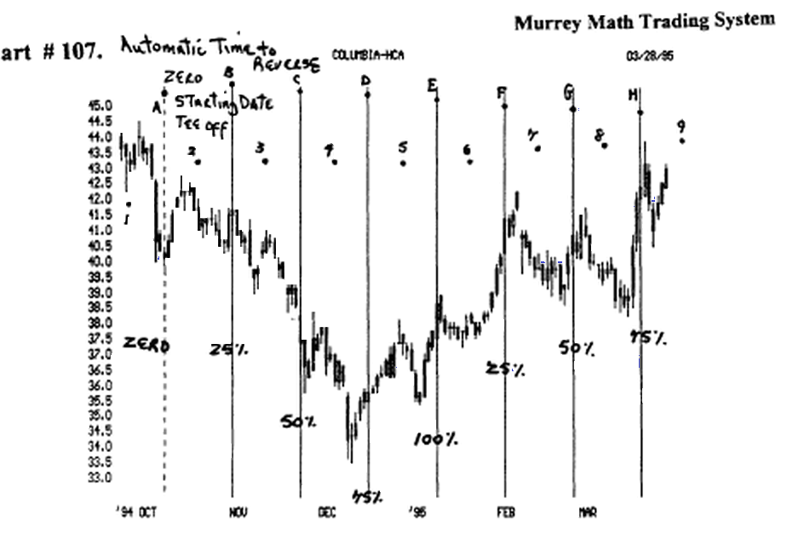

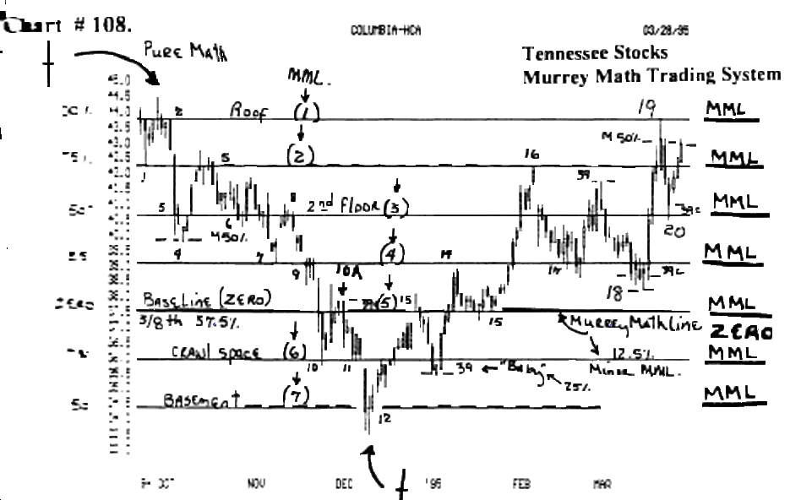

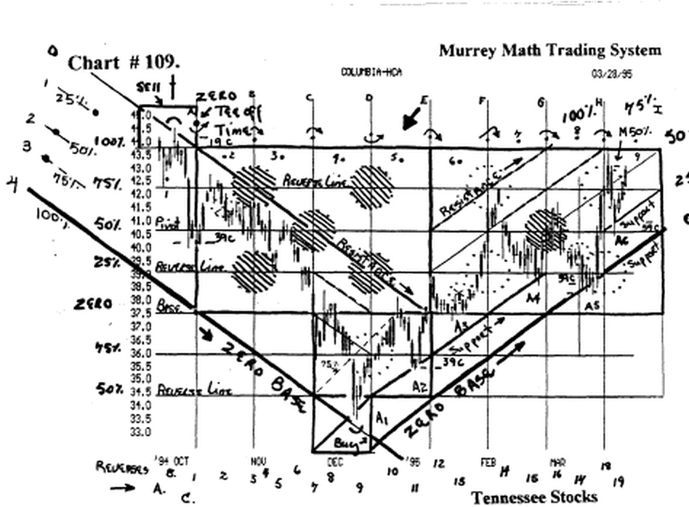

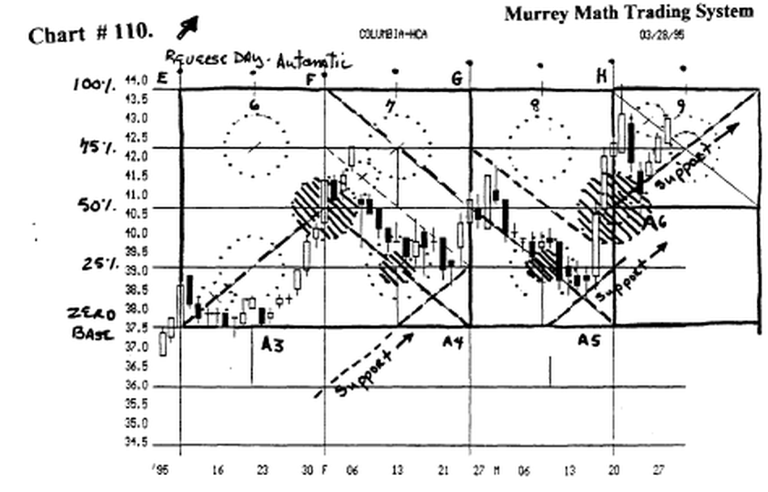
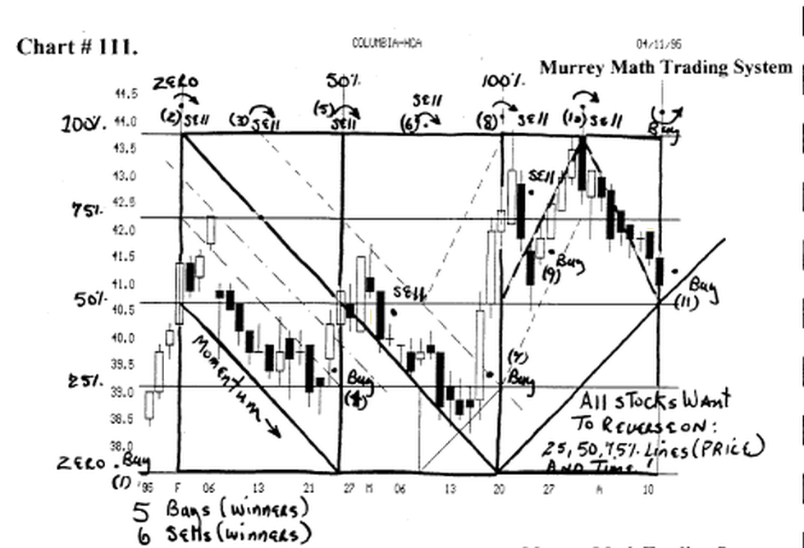

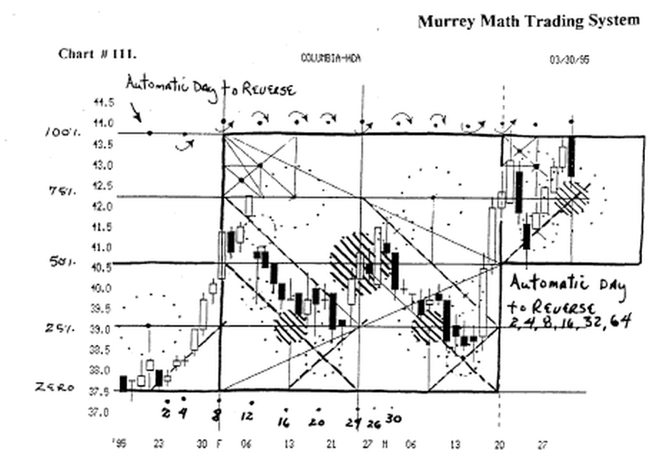
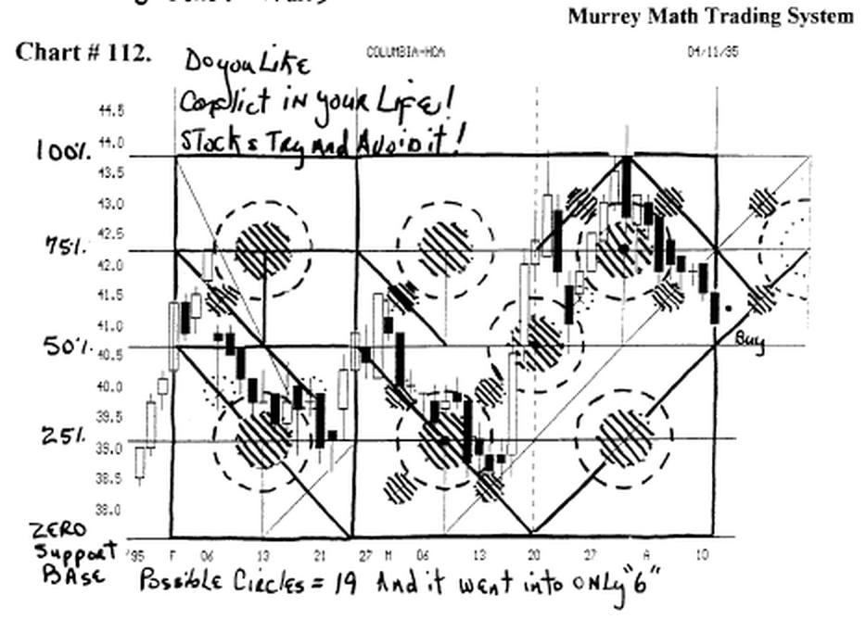

and (charts # 280 thru 291) Dollar General Stores.

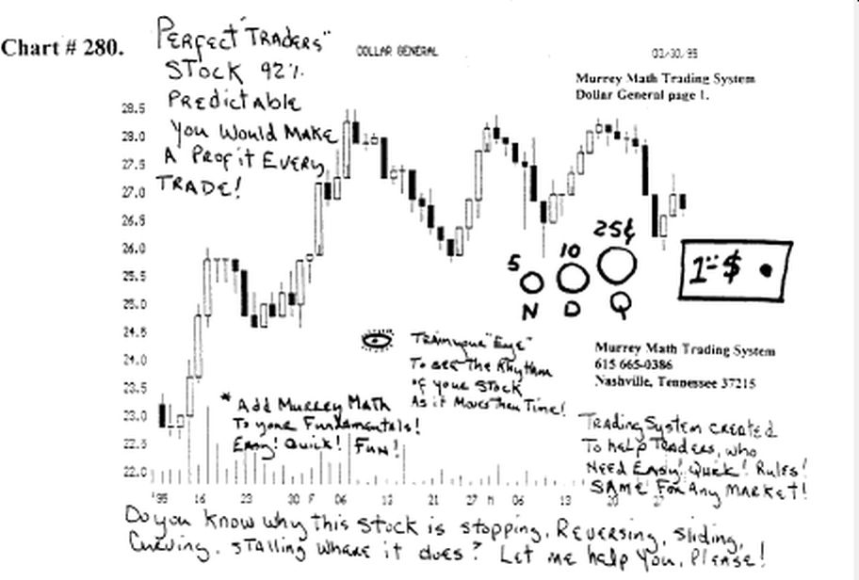

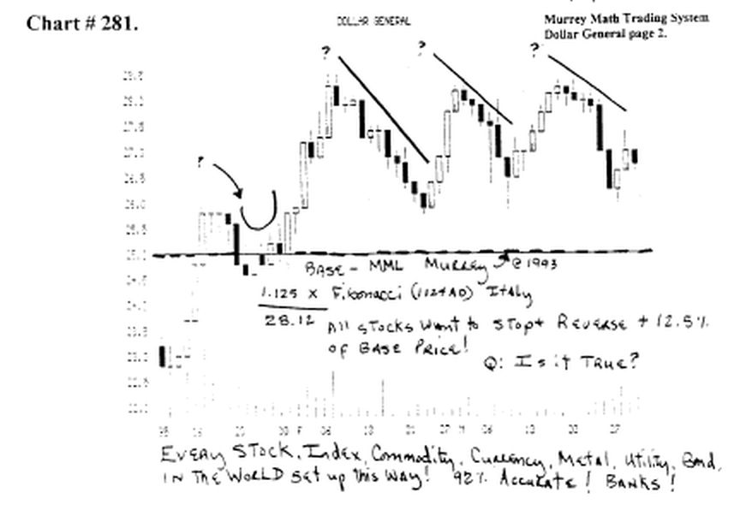
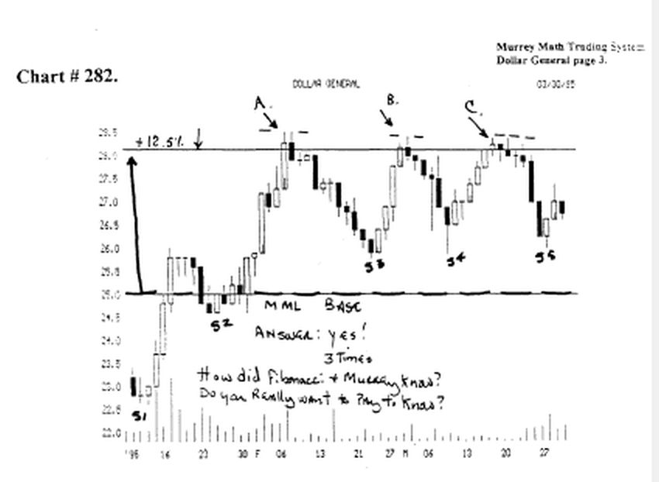
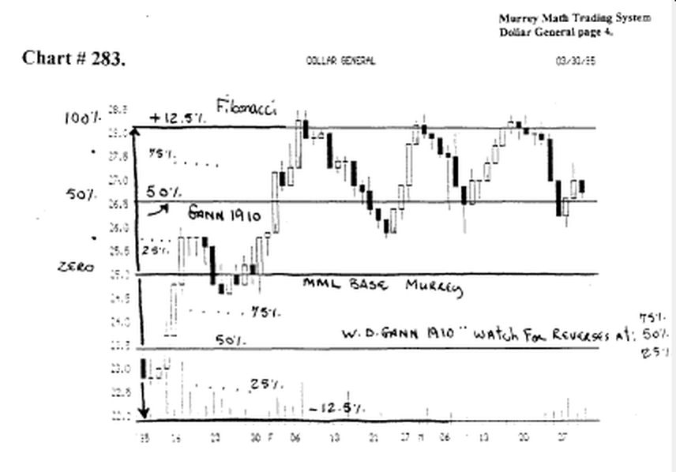

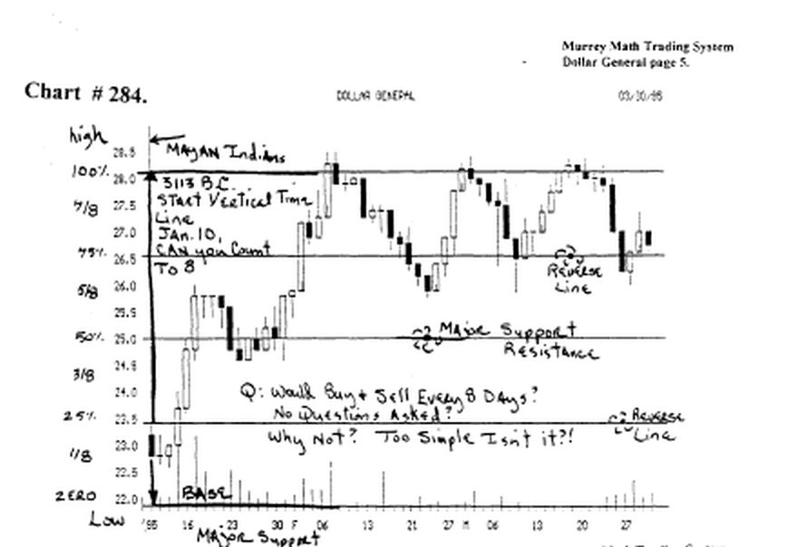
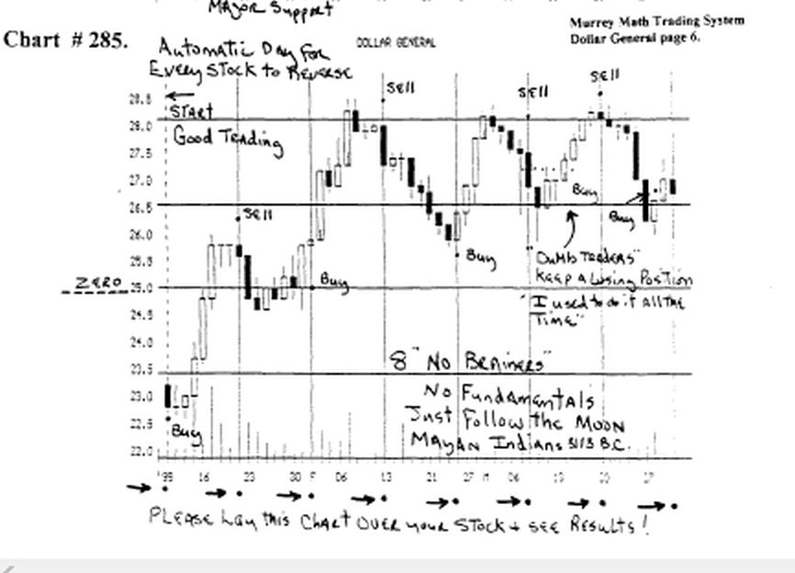

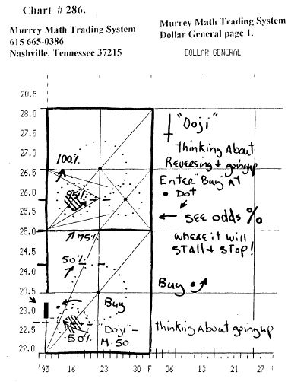
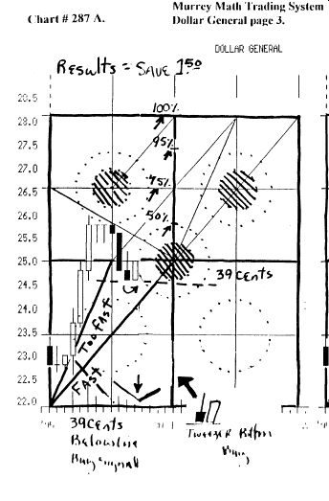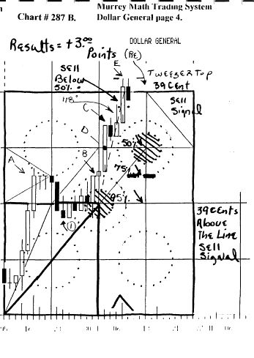
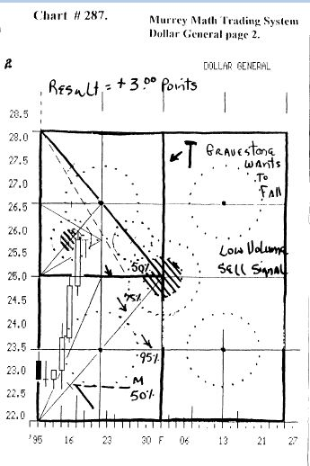
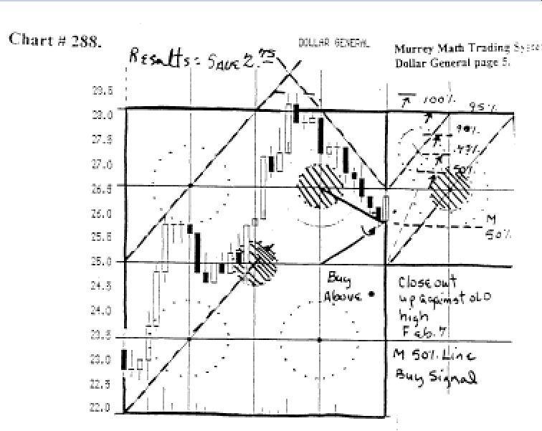

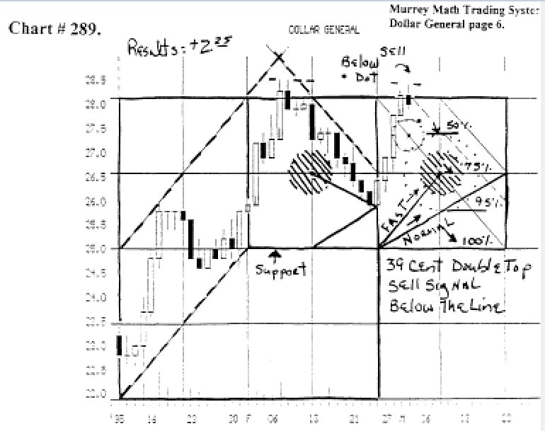

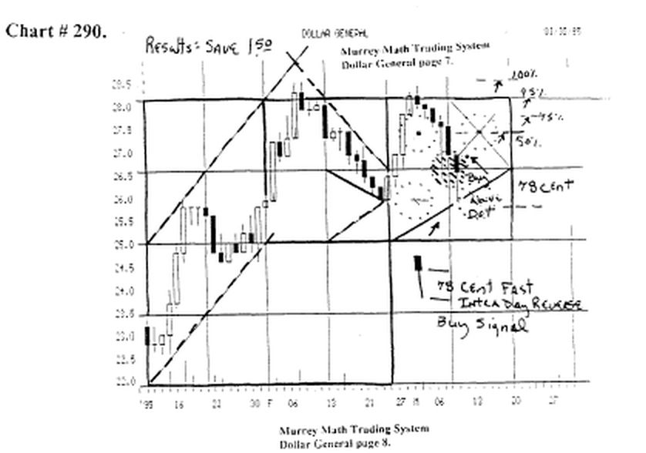

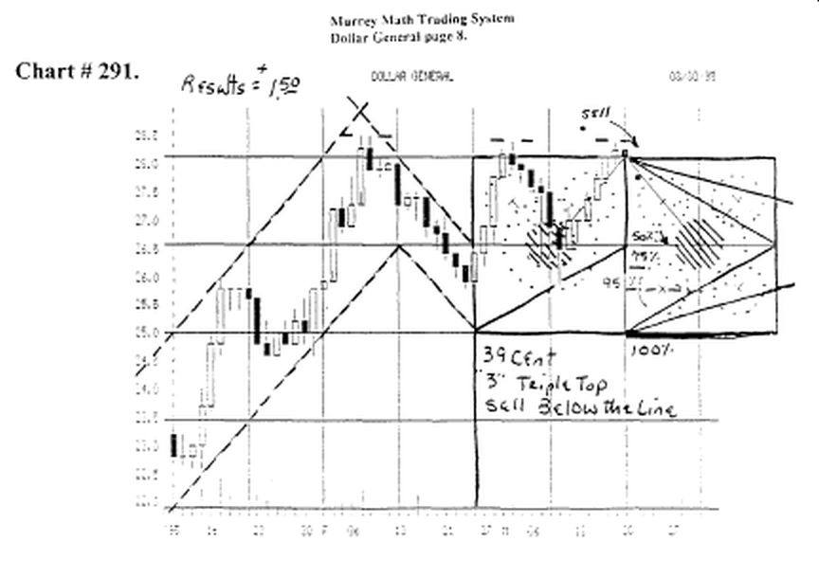
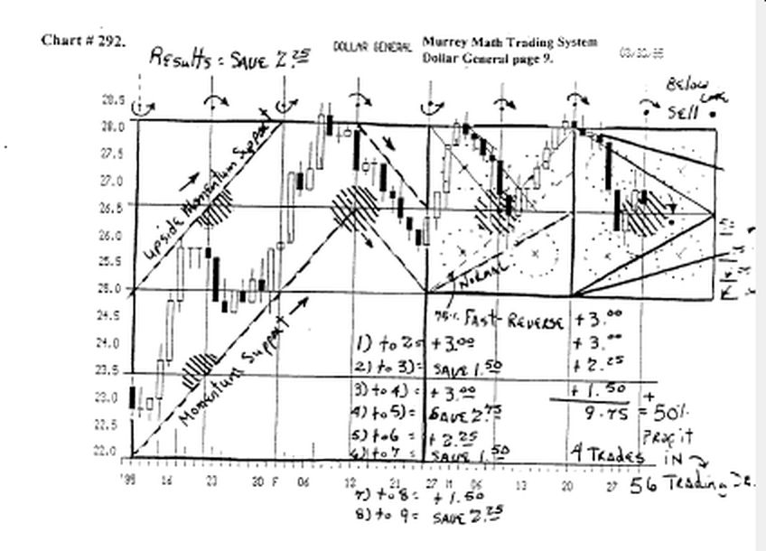

Look at (charts # 303 thru 308) Volunteer Capital.

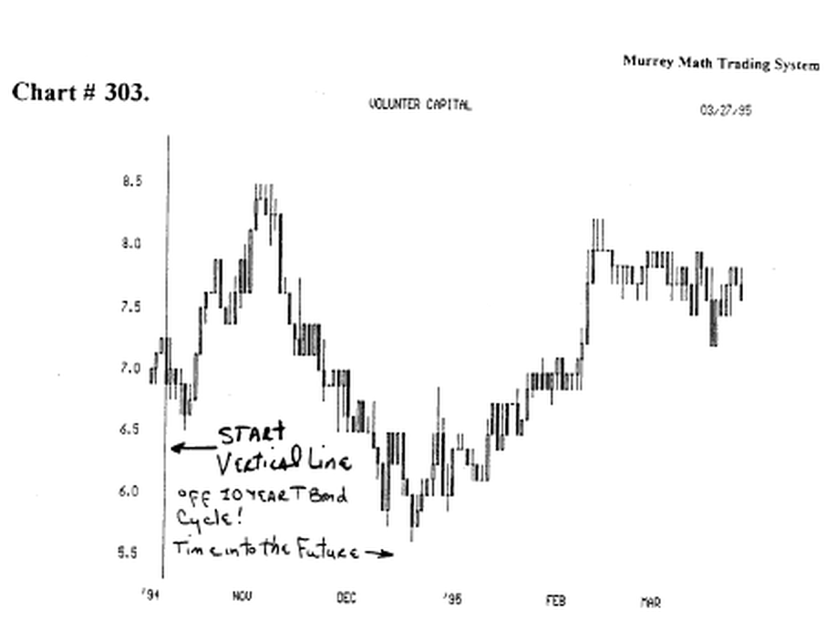

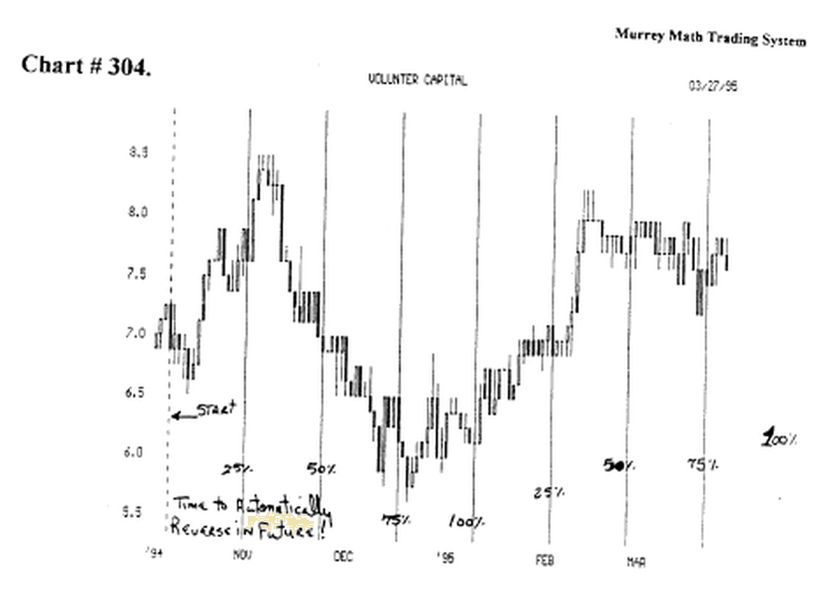
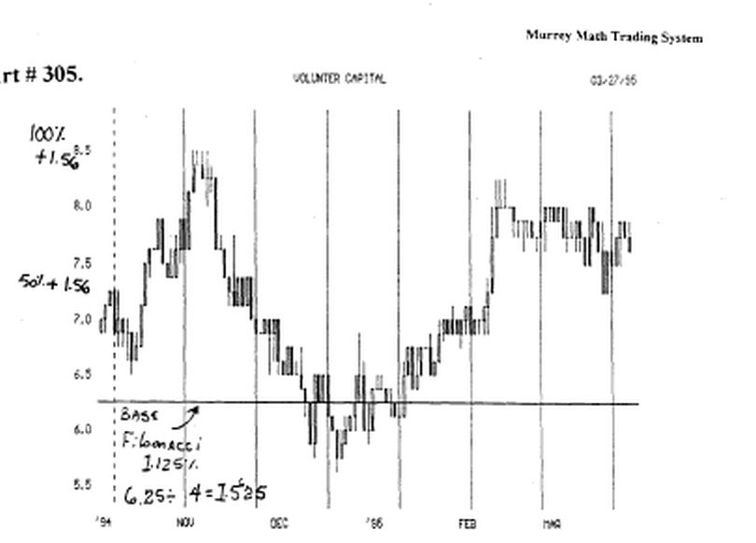
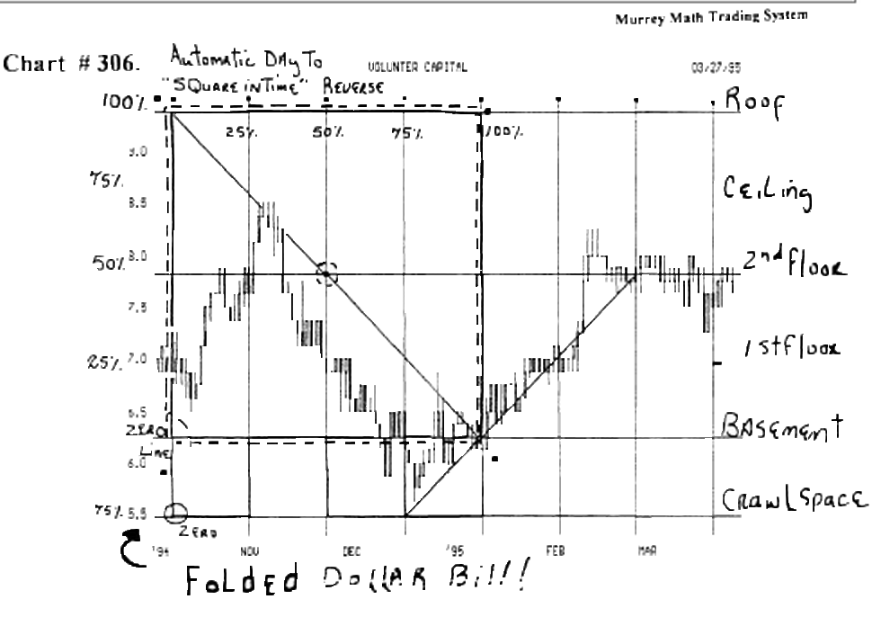
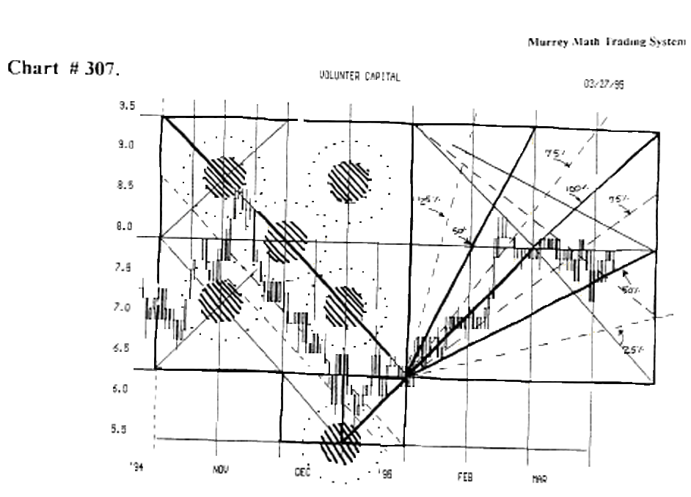

It's high range, and low range, are 8.5 and 5.5. (you are about to get side tracked but I shall return).

You are about to learn another "Revelation."

This stock is trying to reach an exact price, as a 12.5 % portion of a 12.5 % portion, of a perfect fractal square.

Since the goal of every "average golfer" is to stay under 100., the converse is true, that ail stocks want to run up to 100.0.

So, we must divide a perfect fractal square of 100.0, by 1/8 th, and we get 12.5, and we mark ail of the 8 divisions, from zero to 100.0.

Now, we must realize (it's already been explained in another section) that since a golf ball will travel at varying distances, at sea level, and up at the high altitude of Denver, Colorado, so we must set our Fibonacci reverses off his Ratios of: 12.5, 25.0, 37.5, 50.0, 62.5, 75.0, 87.5, and 100 %= 100.0.

If we look back to Figure T. (Spiraling Galaxy) of stars in outer space. We recognize that each arm wanted to break away from its central core, on a percentage of 61.8 % and 38.2 %. And has been known and recognized, as the "golden section" for over 10,000 years.

(Please stop, and go forward, to Chapter 8. "Harmonic Rhythm." Read the first 8 pages, and you shall see why we would use 62.5 and 37.5, rather than the "golden section" 61.8 and 38.2.

Golf solved this problem, when an American Astronaut, took that "historic swing" on the Moon, by hitting a 7 iron 450 yards, without a trailing wind.

Well, the pro tour, decided, right then and there, that it would be worthless, to bring grass up to the Moon, when all of the fairways would consist of sand, and that any average astronaut, even with all that gear, could hit a 7 iron 450 yards, (that's out of a sand trap).

And if you can't play golf, anywhere in the world, then Club Med won't build there.

So, since the "specific gravity" of the Moon is 1/7 th less, than the gravity on this Earth, and only tidal waves, are affected by its pull, on this Earth, (really a joke), and not the distance of how far a golf ball might fly, unless you go to Denver, Colorado.

But they don't count, because they are starting out too high, plus it is too cold out there, to play year 'round, so we must use 12.5 %, of 1/8, which is a Fibonacci Ratio, that has no gravitational pull against it; on the Moon, or on our "Blue" Earth.

A simpler way to explain "specific gravity" being constant to the nearest object that exerts its inertia, shall be seen easiest, when two friends are driving along the golf course, on the cart path, on the 17 th hole, on a course with 14 holes with water along its fairways, and the worst player looks over to his friend, who is presently, just one stroke better, if he has any balls left, and his partner tosses him his next to his last ball, without a eut in it, and the bail doesn't go flying off, behind them, but moves forward, with them, as they travel toward the next to the last pond, from which they hope retrieve, their bail, or the best bail, that they might pull out of the water, to hit, and hopefully, shoot a bogey, and then take off a stroke, because lousy players, don't have to be any good, to shoot par golf, especially with a high handicap.

As simple as that, if a golf bail takes on the "specific gravity" of 2 average over-weight golfers, moving along in a golf cart, at 20 m.p.h., then, why on Earth, would we ever think that the Moon, or even the Sun, that is always Farthest away from the Earth, in the winter, in the Northern Hemisphere, (try and explain that one), that we would ever expect these objects, as far away as 93,000,000 miles, could sway our trading strategy.

I agree with the golfers, and Fibonacci, and know that 62.5 and 37.5, predict stock or market reversals, more accurately, plus, too many golfers have trouble counting, (I guess that's true, for some golf courses offer pencils with an eraser on them), or their members, have short term memory problems, if they can't remember what they shot on a hole, between the last green, and the next tee box, so we use the same "pencil aided logic" and keep it simple, and use 62.5 % and 37.5 %, on this "Blue" Earth.

Now on to how to build our house. (2nd attempt).

This shall be explained through Example: (look at typical chart (charts # 303 thru 308) Volunteer Capital.

It's high range, and low range, are 8.5 and 5.5.

The distance between the top, and the bottom, of anything, shall be the 50 % line.

It may be seen simplest, when we call the 100 % line as the roof, and the ceiling is 75 %, and the floor, on the 2nd floor is the 50 % line, and the 1st floor is the 25 % line, and the basement is the zero line.

The 100 % fractal Square of a stock mat trades between 8.5 and 5.5 = 100.0.(find the smallest 50%)

50 %of 100.0 = 50.0.
50 %of 50.0 = 25.0.
50 % of 25.0=12.50.
50 % of 12.50 = 6.25.

Since W.D.Gann said that the minor 50 % line, of any high / low price range, shall be a pivot (reversal line) for your stock, we would expect this minor 50 % line to be the basement, for our stock, if we agree, that all stocks, will react on 62.5 or 37.5 %, of a perfect fractal square, which since this stock is trading around $ 7.00, its base is 6.25.

But you are telling yourself, that it fell down to a low of 5.5, so why isn't the basement down there ?

We just proved it isn't, by dividing 100 by 8, and we found that the lowest 1/8 th to be zero to 12.50. But we can't trade a stock, any wider than its current trading range, as to where its (high / low) major, or minor, Murrey Math Lines, around where it trying to reach, not where it stops, just above or below a Murrey Math Line.

It wants to base out down at 6.25 and its roof is 9. 3/8. There I finally said it.

Well, what is the lowest low, down at 5.5 ? It's the crawl space; or whatever you want to call it ?

Stop right here, and go over to Charts by Group (pages 5., 7., and 8), and go through and find any group of stocks, that trade, within the same price range, and you will set the very same top, (100 %) roof, and basement, (zero) bottom, although their stock values are based on different products, and earnings, and all those values, that reflect, the inherent value of a particular stock.

You should be clear an what we are trying to do, by looking at all of those examples.

Perceived (M.M.L. Line) (Harmonic Rhythm) High or Low (support / resistance price level)

Very few people ever live up to their parents,' wives,' or own expectations, and many who over achieve, don't stay up on that pinnacle of success, very far from the top (19 or 39 cents), but there are many more, who try very hard, but never quite make it up to the mark, (19 or 39 cents) so they fall sharply back down to a level nearer to 50 % of what they are capable of, when we look at ourselves, in reference to physical appearance, work attitude, or scholarly achievement.

The same thing is true of stocks, or anything you trade throughout the year.

But, just as we brag on a child, who almost makes it up to their highest level, at whatever they try, but who falls short, of the purest measure of excellence, especially in Math, we must, if we are "politically correct," we will just let them get close to their goal, and count it as being correct, and acceptable.

Remember that 45 % of all the public school adults (18 years old) in New York City, Chicago, Los Angles, and Detroit, don't even graduate, then they wait till the mobile book library comes by their neighborhood, and they "steel" the tires, and rip out ail of the "cuss words" in all of the 6th grade books, and if we can let kids off, by just letting them get close to correct, then we should expect the same of any stock or market, as it trades through time.

(So, if a stock, or market, makes a run up or down, within 19, 39, or 78 cents, above or below any (8/8 ths), or 4/8 ths, or 2/8 ths (Murrey Math Line) then, we should go ahead and count it as having made it up there or down there.

(This is one of the 5 "Revelations" that you would discover in this trading System, that aren't recognized by any other trading System.

But since I have used nothing but pure math, we are able to predict reverses, for stocks trading below 250, on short falls of 19, 39, or 78 cents, and over shoots, of 19 or 39 cents. (Indexes that trade over 250 should have a minimum signal of: 1.953125, .244, .488, or .976, when we are looking at the O.E.X., S & P 500 Cash Market, or the Futures market).

I can't spend the time reeducating you on the numbers each time I make a reference to a set of numbers that I already have memorized, so common sense deducts, that if we just bad some sheets, with all of these numbers already pre set and typed out for us, we, if we were ever confused, about our "baby" Ganns, inside our divisions of our Murrey Math Lines, we would just refer back to them, to refresh our memories, until we had them memorized.

Well this isn't the Gotham City Press, where Louis Lane, makes sure that ail is right, honest, and true, but you ought refer back to the Quick Reference Sheets (10) and familiarize your recall, with the appropriate number, for the stock you are trading.

This book has 64 different cases of a stock or "whatever" that falls short, or overshoots by either 19 or 39 cents from either a: 2/8, 4/8, 6/8, or 8/8 line, when it approaches a Murrey Math Line.

W.D. Gann took the actual high and low range of fluctuation, and divided the difference by 8, then set his trading rules, inside these actual parameters.

Look at example charts in: Setting Up The "Square in Time"

1A) Volunteer Capital,
2A) Columbia -H.C.A.,
and 3A) Dollar General Stores,

and let's decide if we are able to deduce the difference, between the "actual low" and the perceived low, for each of these stocks, against the current time span, that they have been trading, these past 3 months through time:

1A) Volunteer Capital, actual low = 5.5, and the Murrey Math Line (basement) - perceived low is 6. 1/4, (for we divided 100.0 by two, till we reached it) which is a 50 % line between 12.50 and zero (go back and review Quick Reference Sheet G.).

You will see that the basement is set at the 50 % line, and the roof is set at the 75 % line.

The perceived high is different from the actual high.

We know that zero is the low, and 12.50 is the 1st 100 % (8/8th) line, and that the greatest support / resistance line is 6.25, so if we set our basement at 6.25, and the rule is that we must move our horizontal Lines up +2, +4, or +8, then we would be setting our roof, on our house at 9. 3/8. (simple).

Looking at this stock's high range, over the past 80 trading days, finds it stalling out, up at 8.5 on a 5 day "tweezer top," with (1) rickshaw "doji" and a small 'doji" and a small "evening star" which have told you, 3 out of 4 days, that it intended to go down, but ail of the "buy and hold" experts, were holding out for 9.00, so it fell all the way back down, to their support at 6.50, and decided to fall all the way down past the basement, into the crawl space, just to go against all the long term investors, who bought more shares, back down at 6.50.

(the key to selling this stock was twofold:

- it had run up vertically too high in price, and,

- it had moved up in too short a period of time).

2A) Columbia - H.C.A., actual low = 33. 5/8, (intraday) and the perceived Murrey Math Line (basement) - perceived low is 34. 3/8, which happens to be a 75 % line, between 25.0 and 37.5. (go back and review Quick Reference Sheet G.)

You will see that the basement is set at the 50 % line, and the roof is set at the 75 % line.

The perceived high, is different from the actual high.

The last 80 days its actual high was 42.375, and it was trying to get to 43.75.

Deductive reasoning must be used to parallel the same price range, that we set, for Volunteer Capital, in the last example.

The major 50 % line between 100 and zero, is 50. So the 12.5 % basement below 50 is 37.5. But, since it is too far away from 50 we set our roof 4 Lines above our basement line.

3A) Dollar General Stores, actual low = 22. 625, and the perceived Murrey Math Line (basement) is 21. 875. This just happens to be the 75 % line, between 12.50 and 25. (go back and review Quick Reference Sheet G).

And in this case, the 50 % line, also happens to be the major 25 % line, for a stock trading between zero and 100, so we set the 100 % line, or 8/8 ths, or roof, up at28. 1/8.

The perceived high is different from the actual high. Deductive reasoning must be used here, for this stock, as soon as it closes 4 days in a row, above 25, and that is to run up 2 more Lines, to set our "Square in Time" in a square that is equal to its last basement, which is in this case 21. 87.

We can't expect any stock to run any higher than its next higher major Murrey Math Line, even if it has traded higher than that in the past: if it were worth more, it would currently be trading at a higher price.

Go and Review the section called "Classic 9 Trades in a Row" Traded off:

1) Murrey Math Lines,
2) Fibonacci 37.5, 62.5,
3) Murrey Math "Square in Time"
4) Gann Rules of common sense trading observation,
and 5) Murrey Math "5 Areas of Conflict"
6) Munesha Homma's Japanese Candlesticks.

And follow the 9 trades, and what the key daily activity was, where we would enter, and where we would expect to close our position, based how far it has run up, or down, through our "Square in Time" against our Murrey Math Lines.

