CHAPTER 1.

(Setting up mathematical rhythm for your stock)
Range of fluctuations
(l/8th lines) rule set by W.D. Gann 1910

This is the starting point, toward establishing your trading system using math as the basis of your trading.

How do we set the range of fluctuations ?

Look at chart (# 74. Bell South) (weekly).

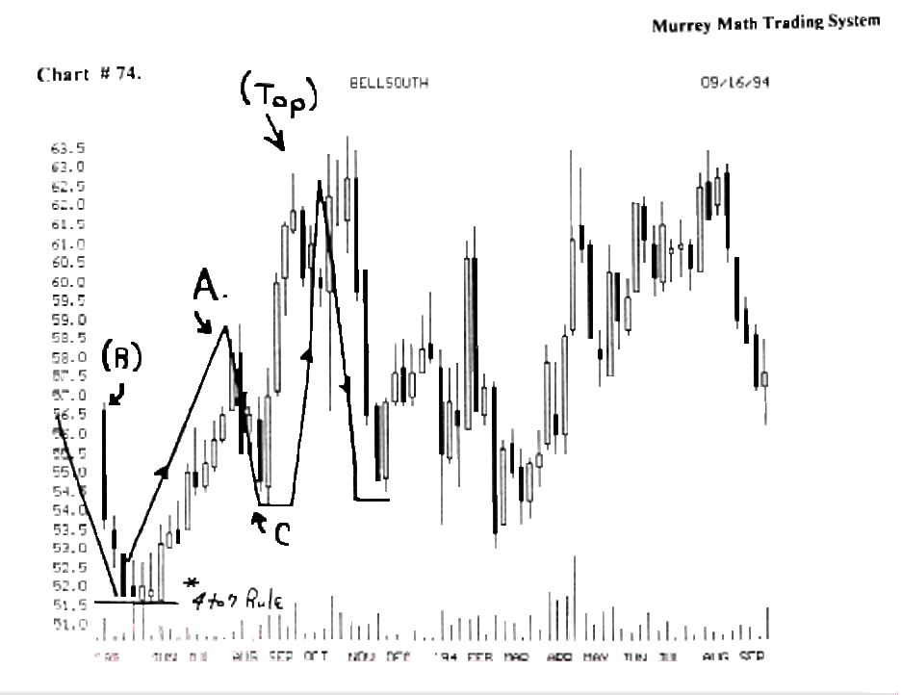

We need a stock to evaluate, so we shall choose it.
Why do we begin with a look at our stock, from a weekly perspective, rather than just a short term, daily basis, that most traders use to judge a stock?

W.D. Gann always wanted to see, each Friday, if it
finished higher than the opening price of Last Monday.
It based out last June,'93, for 4 straight weeks, at 51.4/8. Since it wouldn't fall, or go up until the 4 th week, (4 to 7 rule), we should get ready to go long on this stock at 52.1/2 with a stop at 51.00.

It moves up above the old resistance, of May,'93, at 57.00, (R), then it stalled out the first time around 58. 3/4, (A), and retraced back down to 54.1/4, (C), then it moved straight up until October,'93, where it topped out around 62.5/8 (top).

Now we must expect that this stock can't just keep moving straight up, since it had already climbed almost 25 %, in the past 17 weeks. It must reverse. It did.(top)

Look at chart # 75. Bell South, (weekly).

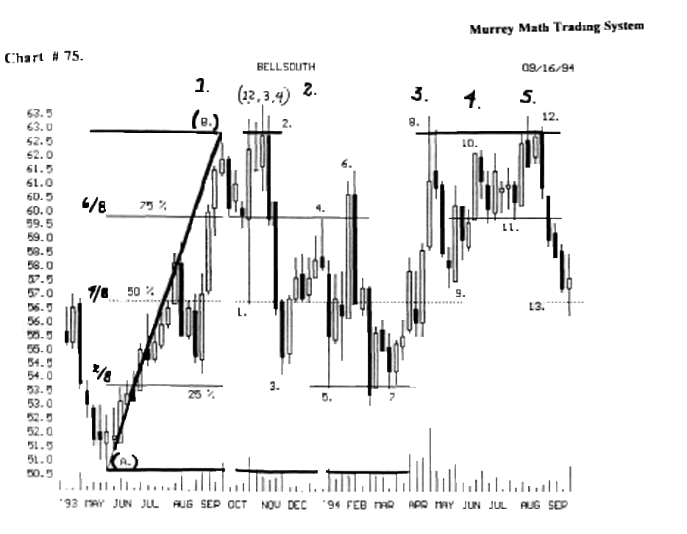

Find the (a) low, and (b) high, to set our extreme range of fluctuations. Why do it this way_? Simple ! W.D.Gann said to do it this way in 1910.

²
We started our range of fluctuations (a) low, and (b) high, for B) over only 17 weeks, which is 1/3 rd of a year. (see chart # 74. Bell South).

So, since it has moved up almost 25 % in the past 17 weeks, we feel that we should get the "feel" for its trading action in the future, from this price range and span of time.

WD. Gann said on page 35. "strength of resistance levels: when a commodity is advancing and crosses the 1/4 or 25 % point, the next most important point to watch is the half-way point or gravity center, or 50 % of the average of the range of fluctuations....

Second, the next point above the half-way point is the
5/8 point, or 62.5 %

Third, the next and strongest point after the half–way point is crossed is the 3/4 point, or 75 %

Fourth, if the range is very wide, it is important to watch the 7/8 point, or 87.1/2 % of the move. This will often mark the top of an advance."

W.D. Gann said on page 35. "but in watching these resistance points, always watch the time period and old tops and bottoms on the weekly chart and follow rules given on formations."

Look at chart # 75. Bell south. (weekly).

We have established our range of fluctuations from (a) low, and (b) high, and now we shall see if W.D. Gann's rules regarding the range of fluctuations, shall be consistent with what is really making this stock move through time.

1) chart # 75. Bell South,) fell from its high, (b), back to (1) the 50 % retracement off its high. W. D. Gann said that the 50 % line, was the greatest place to buy long again, if your stock is a good stock and falling.

This all happened in just in one week. Then, it ran back up to (2) to test the old high of (b), so it tried to break through for 4 weeks.

Then it fell on the 4 th week, (4 to 7 rule), back down to the (50 %) Line, but it couldn't hold, so it fell all the way back down to (3) 25 % Line, which W.D. Gann said was a major pivot point to buy again.

It pivoted, and reversed back up to (4) the 75 % Line, but it could only touch it for 1 day, then it fell, and closed the week, down below the 5/8 th Line.

h fell from (4) 75 %, back down to (5) 25 % line, and it formed a double bottom, and it reversed back up to ( 6 ) the 87.1/2 % Line, which W.D. Gann said that if it couldn't break through 7/8, it would fall fast, if it had made a long run up to 7/8 line. h fell back to (7) 25 % line, forming a triple (3) bottom, which W.D. Gann said was a great place to go long, and it did.

It based out for 4 weeks (4 to 7 rule) and reversed back up to (8) which is the 3 rd try to break through to new highs. The (3 times) rule says to short a stock that can't break through the 3rd time to new highs.

When it reached (8) it couldn't close the week near the old high, or above the 7/8 Line, which is a weak Line....

Look at (chart # 76. Bell South.) (weekly).

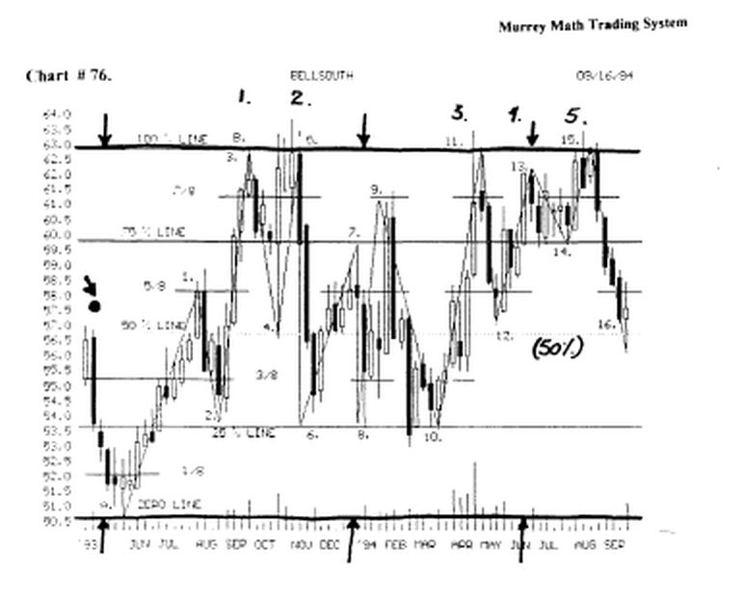

Look at (11) and you will see that it couldn't close the week above the 87.5 % Line.

We learned that 7/8 this is weak, so it fell back down to ( 12) the 5/8 th line for support.

It got support back at (12), so we would assume that it would settle there, and reverse and move up to test the old highs.
It did just that, when it reversed and went up to (13) above the 7/8 th line.

It wasn't able to go back up and test the old highs from (5) then it fell back for support on the 75 % line, which W.D. Gann said was one of the 3 major pivot price points.

It hold at (14) and went back up to test the old highs at (15) and again it couldn't close above the line for a 5th or 3rd time, (which ever you choose). It had to fall.

But it had to fall, because it had had too many times to break above its old highs, and it didn't make it.

The sentiment to break out to higher highs failed.
It fell like a rock from (15) back down to the 50 % line for support.

If it holds here, it would be a great place to re-enter a long position (at 16).

This stock made 15 different reversals over the past 15 months. (running 3 to 6 points each time).

We had the opportunity to make money 7 different times, (we would have made 21 points or 40% profit).

And, each run up was at least $ 2.50 profit per run.
(It would be impossible to enter every position to make the maximum profits, from every trade).

The unbelievers will say that we picked a high / low retracement that worked out that way, so you made all this up, just to satisfy your trading philosophy. (remember this is exactly how W.D. Gann said to set up your trading strategy).

Look at (chart # 2. Disney). We have set the (a) low and (b) high, range of fluctuations between 38. 1/2, and 48. 1/2. Notice that it fell all the way back down to the l/8th line in Apill,'94.

Now, it based out at 40.0, which was 5 months between the base of these 2 lows.

The buy signal was:

1) time: 4 month's width of the 2nd higher low, stalled out on the l/8th Line,

- closing price support line, (l/8th) weak, should bounce, and reverse up fast off this Line,

- the run down from the high was so steep, (48.1/2, back down to 40.00) which is a 7/8 ths retracement off its 100 % run up. This was too steep for a good stock to fall.

- notice the high volume on the very bottom, in the
middle of Apnl,'94. (that was a buy signal to reverse).

W.D. Gann said on page 36. "always remember that the 50 % reaction or half-way point of the range of fluctuation of the extreme highest point is a point for support on the down side or for meeting selling and resistance on the way up. This is the balancing point because it divides the range of fluctuation into 2 equal parts."

Look at (4) the lower high base off the 1l/8th Line.

It reversed and moved up +37.5% to the (50% pivot point), which happens to be 50 % of the difference between (A low) and (B high) (major resistance).

W.D. Gann said on page 36. "a minor half-way point would be the 1/2 way point between a minor top and a minor bottom. Reactions usually run half of the last move or the way - way point."

Look at chart # 3. Disney.

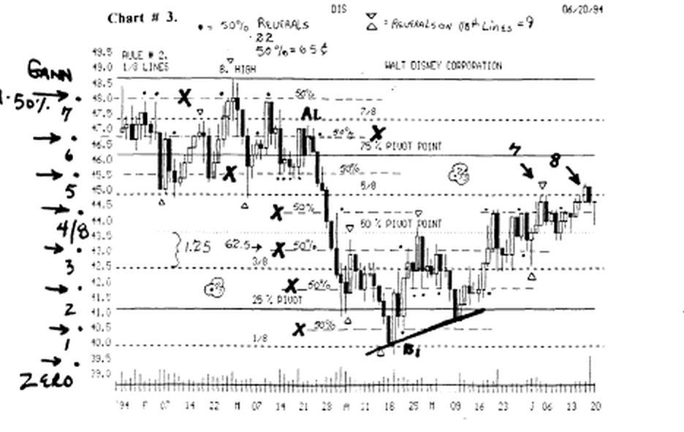

There are black dots next to every minor 50 % reversal. You shall see 22. I placed an X on each of these minor 50 % lines.

I placed a triangle above, or below, each major 1/8th line. And you see that it reversed only 9 times on these.

W.D. Gann said on page 36. "the 5/8 point is a very important point to watch for top or reaction. Wheat will often react from the 5/8 th point back to the half-way point and be a buy again."

It tried at (7) and (8) to break above the 5/8th line, but it couldn't. Maybe it will close above it 4 days in a row the next times back up to the line.

W.D. Gann said on page 37. "weakest points: a sign of weakness is when a commodity advances and fails to reach the half-way point by one or more points, or by 1 or 2 cents per bushel, then declines and breaks the last bottom or other resistance points."
(We shall address this 2 cent signal later).

Look at (chart # 3. Disney).

Notice the x's (7 of them), which are 50 % of a "Gann" minor 1/8 th Line.

The back dots ( 22 ) of them, shows us that this stock reverses on smaller price signals than anything W.D. Gann said in his trading years of observations.

(It is critical to understand this M-50 concept: that stocks will want to reverse at the 50 % line of a l/8th Gann line, when it is running up or down. through time.

It made 9 reversals on a "Gann" l/8th Line. And each "Gann" Line is S 1.25.

But we see that it reversed 22 times on 62 cent signals.

Look at (chart #11. DJIA. 30 stocks).

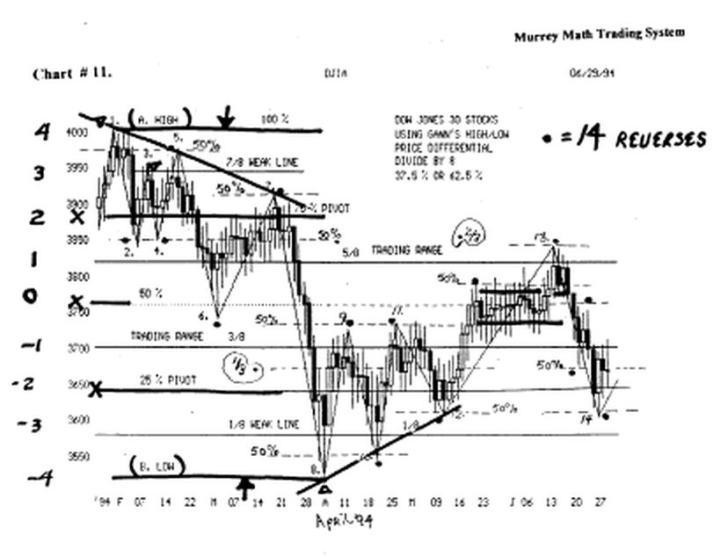

Look at the (v) and the black dots, where it reversed off its (a) high and (b) low.

Look at 2, 4, 5, 6, 7, 9, 10, 11, 12, 13 and 14, (minor 50 % reactions ) of a "Gann" line.

Now, let's use our "past history" brains. This is difficult for 90 % of all traders, who use only fundamentals.

We must learn to deduct a trading strategy, from a known list of market reversals over the past several years of trading.

Since most people are so short sighted, they won't think about the fact that the past 3,4, or 5 years is still a part of the poker game called investing.

We continue to want to gamble, our after tax profits. against another company's ability to make a profit faster than our own company has the ability to grow

Look at chart #11. DJ.I.A.

We set the Gann lines at (a) and (b). Then we must buy the bounce in April,'94, (8), then look for the first reaction at 25 %, (9) because, it is the lower pivot price point below 50%.

It stalled out at the 3/8 th line, (9), or 37.5 % of the total run, between (a) and (b).

This 37.5 % run is one of the 2 Fibonacci ratio numbers that govern normal market moves, before they want to stall out, or reverse.

You learned in the foreword, that there are 2 natural percentages, that stocks, and markets, want to run to, and they are 37.5 % and 62.5 %.

Remember that we don't use 61.8 % or 38.2 %. (because they measure percentage runs and retracements in space), so we use 37.5 % and 62.5 % ratios. You will find that you will get a better trading edge using these Fibonacci Ratio Numbers

Now, back to using our "past history" brains.

If a market wants to get major resistance at the 25 % Line, and it doesn't stop there, and 50 % is the major Line of resistance for an (a) and (b) move, we would expect it to get the greatest resistance at 50 % of these 2 Lines, which is 3/8 ths, or 37.5 %, (9) or (11).

Notice at (9) it failed to close on the 3/8 th Lines for 4 (4 to 7 rule) days, then it fell back toward the old lows at (8).

Go back just one page and re-read W.D. Gann's statement about weakest points."

W.D. Gann used 1 or 2 cents as a signal for wheat's weakness to make it up to the Line. But wheat was selling for 55 cents per bushel in 1861.

Ironically, W.D.Gann wouldn't tell you why, in all the books he wrote, why an exact price point is a signal that a market is weak, or has overshot the Line, on too much enthusiasm.

So, I shall tell you, in a later chapter, that you must react to the Dow 30 stocks, if it stops short of the line by 19.5 or 39.5 points.

Now let's use our "past history" brains more deductively.

Since most traders and experts are so short sighted, we must find a precise measuring devise to signal a reversal, so let's say that all the experts were using (a) 7, 75 % Line, and (b) 8, zero line, we see that the run up off this 100 % run should meet its greatest resistance at 50 % of this range.

And it failed at (9) and (11) this major 50 % line, between these 2 extremes between (7) high, and (8) low on a short term trading basis.

So, we have deducted, using our "past history" brains, that the longer term (a) and (b), and the shorter (7) and (8), that it should get tremendous pressure to not want to move up higher, where it reversed at (9).

It failed there (9), 3/8ths long term and the 50% Line short term. And so it fell back for support at (10).

It reversed at (10) and ran back up to the old high, and failed, at (11), then it went back down for support at (12), which was a (M-50) minor 50 % line, then it made a "3rd higher low" so it broke through to a new high toward its old 5/8 th line up at (13): and it did.

The tries (3 rule) applies to thrust a market up or down. with more force, in the opposite direction.

Our "past history" brains are working more all the time, because we see that back down at (12), it wouldn't close down on the(M 50) 50 % Line, which is 78.5 points off a "Gann" line, so we would deduct that it closed above the 50 % Line 39 points off the Line, and it moved laterally for 4 days (4 to 7 day rule), then it moved up toward the 5/8 th. Line.

Now, let's develop our "past history" brain's trading strategy further, by counting the length of this run: we see that from ( 12 ) to ( 13) is 37.5 %: Fibonacci Ratio.

And it ran up against the 5/8 th. Line (13). h reversed and fell back down to (14) minor 50 % between 2/8th and 3/8ths lines Long term (a) and (b).

The 5/8th. and 3/8th. Lines: normal the trading ranges. What do we mean by trading range ⁹

This is the upper and lower parallel trading range that a market wants to trade within, and when it goes above this range too far, it will want to come back to the line. This 5/8th line now becomes a support Line.

And if it trades below the 3/8 th. Line, it is hard to break back up through, when it is trading below it.

When it is trading below the 3/8th. line, and the farther it runs up to the 3/8 th. Line, the harder it will be to break through the first time, it hits up on the trading range line (3/8th).

Stocks have a hard time getting into the trading range, but once they are in there, the harder it is to get them out of it.

And after it has broken out above the top of the trading range (5/8th Line), the harder it is to break back down into the trading range.

But, common sense would dictate, that the more times it has to race to either the 3/8th or 5/8th line and can't make it through, then the more likely it will reverse after 4 to 7 days or 10 to 12 days. It is unusual to see a major index run sideways for more than 12 days without reversing fest in the opposite direction.

If an Index holds for more than 12 days in a row and won't go up or down: it may be assumed that its last directional move is not quite over yet. So look for more of the last directional move to continue: (12) to (13).

So now that it has a high probability, that it will not reverse, but keep going in the direction, of its present trend, you should go back down to (12) and count die length of this up move: it shall be (+37.5%) to (13).

Let's see what this rule means on a chart. Look at (8) and this low at zero, where it reversed at the very bottom, then moved up 37.5 %, and hit the (3/8th) line,(9), then stalled out the first time, for it couldn't get into the trading range, then it fell back to (10), for support at the (M 50%) Line, then made a second run up to try and break into the 3/8m line (trading range) (11).

But it couldn't do it, so it fell back to (12), at the (M 50%) line, and then it ran up to the 3/8ths line, and it broke through, this time, and ran up past the 5/8ths line, and stalled on the (M 50 %) line, then went sideways for 15 days, trying to decide which way it wanted to go: it went up for 3 days, (13), then it went sideways for 4 days (4 to 7 rule) and then tanked. (h closed 4 days in a row just below the line, which meant that it wanted to reverse and fell back for support (14).

Let's use our "short term" brains again. And we see that it has retraced from (7) to^(8) and we see that it reversed after a 62.5 % fell back down to (10):

How do we get 62.5%'⁷
Simple ! Just "eye ball" the difference between (8) and (9) and it looks to be a fall of 62.5 %.

Let's use our "short term" brains a 3rd time. We shall measure the difference between (10) and (11) was reversed at 62.5 % of the previous move, just as it had a 62.5 % of the (8) and (9) move, forming a "3rd higher low."

W.D. Gann said that we should look for combinations of "3" and to follow the trend, which in this case, it reverse, and move back up.

We shall call this 3rd higher low a "short-legged "W." These are great buying opportunities.

Look at the reverse of the short-legged "W" on the high. You see (1), (3) and (5), which are descending lower highs, which predict a hard fell for a stock. And it really fell hard at (7).

The opposite is true on the up side, when we talk about stocks that fell back down to the 5/8th line, when a market is on a high, it will want to stall out the first time it moves back down to the 5/8 ths line.

When we look at (1) we see that it fell, and broke through the 75 % Line and reversed (2), (up), and closed the day, 19 cents above the Line, so we know that it wants to reverse and go back up toward the old high.

It failed at (3) the 7/8 th. Line, which is very weak, plus the fact that it only reversed back up for 1/8 th., And since it landed on the 7/8 th. Line, it fell back down to (4) for a double bottom.

It reversed at (4) and tried to break above the old high (3) but it couldn't close the day above it.

Plus, it stopped 19 cents below the line 2 days in a row. Then it fell down from (5) to the (6) and it ran down to the (M50%) Line between the 4/8th and 3/8th Line.

Then it closed on the day just 19 cents below the line for only 2 days.

(Remember that Gann said to watch for signals of 2 to 4 days, but we say that it must move laterally for 4 to 7 days in a row, to stall out and up or down move in its current direction).

Then it reversed back up from (6) to (7) which is the
75.0% Line.

W.D. Gann said that the 75. % Line is the line of greatest resistance for any market above the 50.% Line.

It formed 3 lower highs, (1), (2), then (3), so it really tanked after the magic "3" times rule. (the slanted downtrend line was a stronger reason to fall fast).

Trading range (trades 40 % of the rime within 3/8 and 5/8 lines)

(Markets want to trade within the 3/8 ths and 5/8 ths almost 40 % of the time. If we count the number of days it trades inside these 2 lines, we see that it has traded in here for 40 days out of the last 108 trading days). (what percentage is that?)

This won't make you any money, but it does tell us that all markets want to come back to its moving average, especially if it runs up or down below its average by too far, too soon.

Let's look at the natural rhythm for this Index, the Dow 30 stocks, its center point is just about 3, 750.0, and it moved the same amount above and below this "natural rhythm" Line. (+4) and (-4) using W.D. Gann's rules.

We know that it does, because, we chose the high and the low, and almost the 3,750.0 line was just about in the middle of these 2 extremes, but that is not the truth.

This Index is running to this exact number (as a proportion of the Law of Exact Proportion).

We shall explain this mathematical phenomena, in a later chapter.

Look at (chart # 19. Merck). ( weekly ).

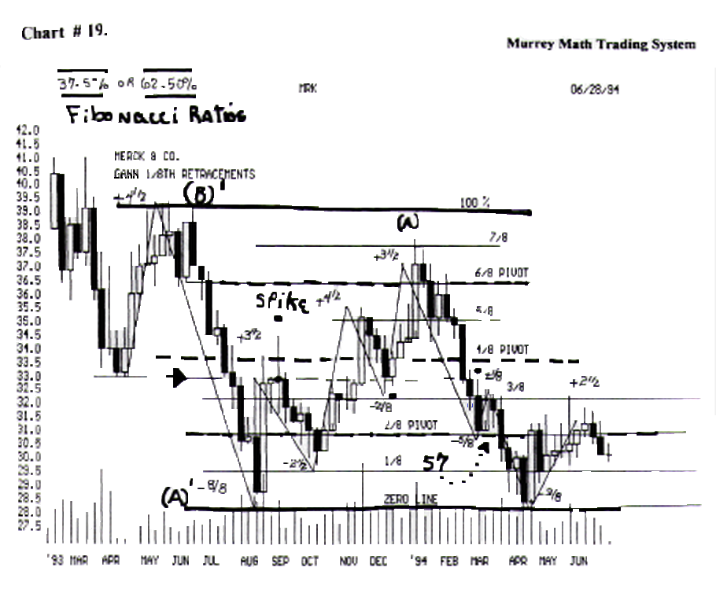

We set the high at 39.1/8, (B1) and the low at 28.1/8(A1).
We see that it reversed off its low and stalled out at the 50 % line, between the 3/8 and 4/8 lines, (M 50 %), just below the 50 % line of the overall move. (see the spike (black dot).

It fell down from the black dot, 62.5 % of the last up move, (2.1/2) back to the 1/8 th line, which is a weak line, and it held, so it reversed fast back up past the 50 °'o line, and stayed there for 4 weeks, then it moved up to the 5/8th line and stalled, after a (+4. 1/2) move, in November,'93.

Important rule: The 1/8 th. Line is weak. If it can't hold here, it will continue to fall back, but if it reverses and moves up off the 1/8 th. Line, it will reverse up fast toward its old highs.

Notice how it reversed at (-2 1/2) on the l/8th line. and it went up to (+ 4 1/2) to the 5/8 Line, then it reversed back down (- 2/8) to the 3/8 th Line, (bottom of the trading range), then it moved back up (+ 3/8.5) to the 7/8 th. Line, then it tanked.

Important rule: The 7/8th line is weak. If it holds
here, it will move on up to the 8/8 th Line or above.

But if it can't hold here, it will reverse fast and fall back down trying to look for support at either the 5/8th or 4/8th lines.

If it reverses at the 6/8th Line after falling only l/8th back down from the 7/8th line, then it will reverse fast back up and test the 8/8th line.

(see A) Merck, tanked at the 7/8 line (+ 3/8.5) all the way back down to form a double bottom of over 8 months wide.
h did stall after a (-5/8) fall in March,'94, on the 25 % line, but it could only go up l/8th back up to the 3/8th line.

It didn't want to let it in, so it fell back down from there and formed a double bottom of almost 9 months on the zero line after a 37.5% (-3/8ths) fall.

We would buy here, expecting the first rebound to be short, or no higher than the pivot point of 25 % line, then it would fall back.

Then we would buy it again, if the 2nd low was no lower, or forms a higher low, within the next 2 trading reversals in time.

Look at (chart # 77. Cotton) (December' 94).

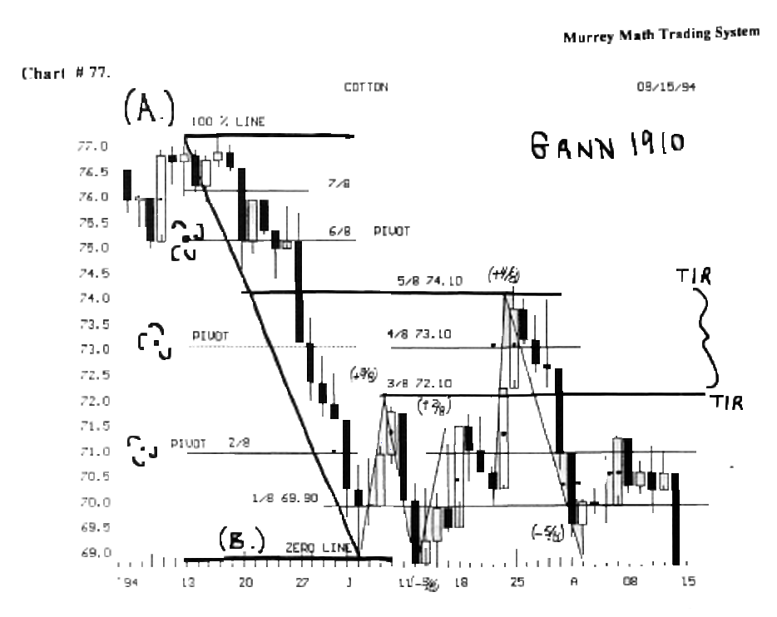

We use W.D. Gann's # 1. Rule: divide the (a) high and (b) low by 8, and look for pivots at the 25 %, 50 %, and 75 % lines. Let's see if it did just that.

Let's look at the responses of cotton off its low (zero line). The Fibonacci ratios are 37 5 % and 62.5 % (normal reactions).

It moved up (+ 3/8), from (B) to (72.10). Then it fell (-3/8) to form a double bottom July 13,'94.

Then it went up (+2/8.5), then it got weak, right on the minor 50 % line between the 3/8 and 2/8 line (this time below 72.10), and it fall back down to the l/8th Line July 20/94, to form a perfect short legged "W."

W.D. Gann said that the minor pivot point is 50 % of a "Gann" Line, so we would expect it to fall if it can't make it up through the 50 % line.

It went back down (1/8.5), which is (-37.5 %) off the (-3/8) and the (+ 3/8) reaction, and stalled right on the l/8th Line at 69.90 (July 20th,'94).

And it moved up (+ 4/8) to the overall 5/8 line, which is the top of the trading range and it stalled out and reversed back down to the same low to form a wider triple bottom, which is another buying opportunity.

Notice that cotton failed to make (touch or reach) the 5/8 line by a few cents, so we know that it wants to reverse, because it closed below the 4/8 th. (pivot line) on the "3rd" day, we knew that it wanted to fall back for support.

It went all the way back down to form a triple bottom, after a (- 5/8) or 62.5 % retracement that Fibonacci said would finally support a market, especially, if it touched a previous low.

Then in August,'94, it reversed back up, to try and run back up above the 25 % Line, but it could close only a few cents above the line on the 7th and 8th, and on the 8th it closed below 50 % of the trading on the 7th, which was a sell signal to us.

It must always close at least 4 days in a row above the Line. or more than 78 cents above the line for us to want to stay long in a position.

50 % of a candle's body is support / resistance (short term), (we shall discuss in detail later).

Look at the black dots at 50 % of a candle. We must watch these pivot points, within the body of a significant candle. The longer the candle, the more significant the 50 % Line for support and resistance.

This 50 % line may be significant for as many as 10 to 12 days, then it fails to have any effect, unless it is extremely long. We must always keep these long days' 50% lines in our heads so we can trade against them in the short term

We won't set any parameters of length, because they are just common sense observations.

These 50 % Lines are more significant to day traders, not the long term "buy and hold traders'.

The long term trader should gauge their 50 % lines against a weekly chart.

Look at chart # 78. Cotton ( December,'94).

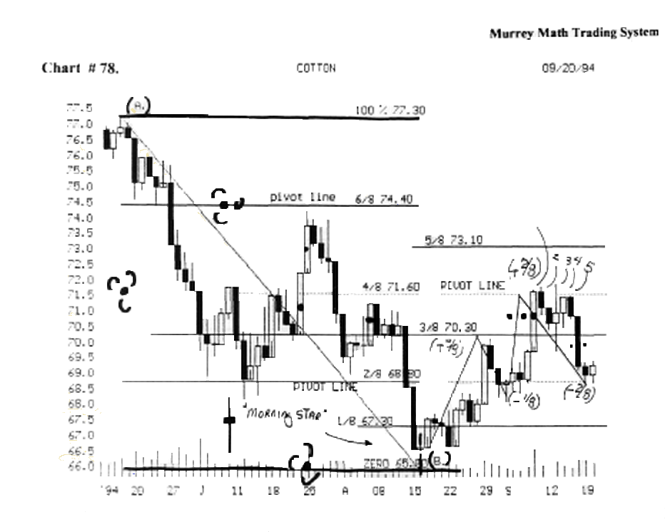

We have reset our (a) high and (b) low, because it fell below our old lows.

We got a "morning star" reversal signal, the 15th of August,'94, so we set this as the low for the "Gann" 8/8 retracement off the high of (a) at 77. 3/8.

A "morning star" was formed on the Aug.15,'94. which was a "buy signal" for cotton.

A "morning star" is part of the Japanese Candlestick Charting Technique, written by Steve Nison, and published in 1988. (it would be worth your time and money, to get it and learn the glossary terms in the back of the book).

Let's see if it is predictable since we took a new low: it reversed at the 3/8 th. Line (Aug.29,'94) after a +37 5 % Fibonacci ratio the first time back up.

Then it retraced (-1/8 th.) down to the 2/8 th. line, which is a pivot line (25 % major pivot line W.D. Gann).

It formed a "morning star" on (Sept.2'94) and moved laterally along the 2/8th line for 4 straight days, then it broke out fast to the 4/8th line, and stopped right there.

Then it ran back up to the major pivot Line, which was the 50 % Line, (71.60) (4/8), and it reversed back down to the 2/8 ths line, which is another major reverse Line.

Now, we must wait for direction. We must use the rule (4 to7 days) to see what the direction shall be to-morrow.

No one knows the answer today. We should not know !
This is what makes trading exciting ! We don't always know the answer from just one day's trading activity.

The uncertainty of pivots: that's why W.D. Gann said to "trade with the trend." (you won't always make all the profits from a run up or down, but you will always be in your trade in the right direction.

If I had the answer today, everyone would jump on board at 2:00 p.m., and distort the market's true direction.

We must leave in the uncertainty, to keep this world of trading exciting ! That is why we place a stop.

But, we do know, that a close below 69.80, will trigger a reversal in attitude, that would make us think that this cotton contract will fall back toward its old lows of: (1) 67.30, or (2) 65.80, which is the old low, to form a new lower double bottom.

We know the rule (4 to 7 day) lateral moves: that if it can't get support on this 2/8 (pivot price point) for at least 4 days, it will have to fall back down at least 1/8 m, or 2/8 ths, to its old low to gain support to move back up.
This is old news: anyone can set the rules after the market has done what it has done !

That is why we must sell with a small profit, every time our market moves up against either 37.5 %, 50 % or 62.5 % of any set of retracements. (before it has rime to reverse and take back our profits).

Prediction for tomorrow: using the rule (4 to 7 days) lateral move, we know that, if it can't hold on the 3rd day, it shall want to go lower to make a (- 3/8) retracement and base out down at 67.30, but we should always look for support at 50 % between the 2/8 and 3/8 Lines and resistance at minor 50% of 5/8 and 4/8ths.

W.D. Gann said to watch "minor 50 % Lines of any significant Line."

We also remember that the 1/8 th Line is a weak Line that doesn't have the power to reverse a market, but if it does, it will be a fast, sharp reversal back up toward its previous resistance at 4/8 (71.60).

Notice the rule (4 to 7 days lateral move), where it tried 4 days in a row (Aug.8th,'94), to break above its 4/8 (71.6), and it couldn't. So it must fall back for support. That is exactly what it did ! (to form a lower bottom) at (B).

Notice the black 50 % dots, h could not even approach the 50 % line of its last big down day, 2 days prior.

This meant that there was no buying to turn this market back up.

If it moves sideways for 4 to 7 days it is looking for direction: and if it moves lower on the 3rd day, it is saying that it is weak and it can't do anything else but fall back down for support.

Ironically, we have never considered the buying, selling, consumption, or weather reports, that should move this market. (just math reversals off lows and high price extremes, over a given number of months)

As we factor in these factors, they aren't a facto r !
Fundamentals, news, politics, weather, or consumption, will always push the cotton market in one direction or another for one day, then the Fibonacci ratios always take over, and we hope that we know how to interpret the indicators, when they occur. That is our goal !

AU traders, investors, growers, brokers should learn to trade based on what they here and what they see (charts). If you don't have both parts of the puzzle you are just 50 % where you need to be, when it comes to making maximum profits off your expertise.

Look at chart # 79. Bell South.

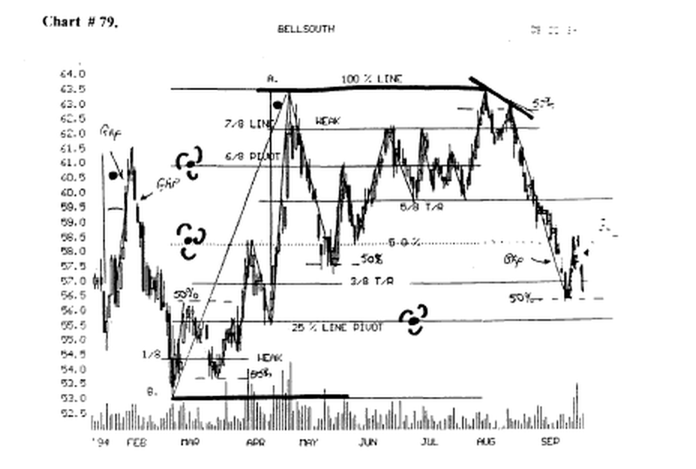

We have set the low at (b.) and the high. at (b.) and watch for retracements

off these 8/8 th. Limes. We use the "Gann" minor 50 % Line support / resistance, off each line.

You look at each reverse, and how far it has run off each run, and use your "past history" brain to record how the market pivoted off a "Gann" line, and if it runs up or down 37.5% or 62.5 %, of a high or low.

Please keep looking at chart # 79. Bell South, and you decide what it has done, and why.

Just look back and read the rules about where and when a market should pivot. Then these preset Lines should tell you what should happen off each pivot.

If we read the entire book, we *hall use all die rules we have learned to predict, when and where the market shall pivot, or stall out !

If the "buy and hold traders" had entered a buy position in January,'94, at (57.00); they would watched it reverse 26 times, just to have lost $ 1.00 per share, when they finally sold it down at (56.00): 9 months later

Please find the black dot, which denotes a 78 ° angle, which should be sold immediately, waiting for a retracement in the near future.

The dot black at (a) is when this stock was reported to be a part of the great "information super highway" of tomorrow. (April,'94).

After the news came out about Bell South's link up with another company to present the "information super highway" to the public, someone also leaked it out to the public, that New York city, Chicago, or Los Angles, its high school students, and 20 % of the rest of the adults in this country, can't read well enough, to have the opportunity to use all this valuable information, even if they can afford it.

Maybe this news, or common sense, set in, and the stock reversed and fell back down to its moving average. because it would take 5 years to complete.

It made another 78 ° angle, earlier, and moved up above its previous high back in Feb.,'94.(fell like a rock this time also because it got ahead of itself in price and too fast in time, (nobody wants to measure time).

It moved up 3.00 points above its old high, of (Feb. '94) and didn't even stop, for 1 day at the resistance of its old high back in(Feb.'94).

It moved up past die old high on a "drive through" above the 6/8th line{Chapter 6. Special Situations) for a detailed explanation of what is meant by this indicator.

We must come to the logical conclusion that all stocks want to zig zag through time, not go straight up or down! (if they do, we must sell fast with a profit).

When it gets ahead of its moving average, moving up or down too fast, we must expect it to reverse and try and gain its equilibrium, and come back to its moving average, or at least its upper or lower trading range.

It is easy to sit here and look at the past and say why it did what it did.

But, we must "buy the bounce" and sell the bump" of any stock. The more extreme the last run, up or down, the more pronounced should be the bounce.

Just "eye ball" each high / low retracement and look and see if it reversed after a retracement of 12.5 %, 25.0 %, 37.5 %, 50.0 %, or62.5 %, or 75.0 %.

We may observe that most moves are 25.0 % or 37.5 %: which is about 3.00 points.

How many times would you have been correct and not left much profit on the table, if we had sold out every time it went up 2.50 points ?

We would have won 7 times, using this simple rule. We would have pocketed 21 points, or S 21,000.00 profit, per 1,000 shares traded.

And this stock has ended up losing 1.00 point the past 9 months.

Everyone always says, "But, you didn't know the future." (where it has ended up, before it gets there), so we must sell every time we meet our profit objective, then let the future take care of itself.

(Go to Quick Reference Sheet % Runs for profit)

Had we bought in at 56.0, and we would have sold it each time it ran up 2.50 points, we would have made 21.0 points, or 37.5% profit in 9 months

Only 3 moves lasted longer than 3.00 points. So why do we stay long, and let it retrace, and lose free profit ?

Please find the word (weak) and look at the descending stairs of volume as the stock price fell.

It had no volume to the downside, then it reversed on extremely high volume and went up for 8 straight trading days.

The Japanese said that no market should nm up more than 10 days in a row, and we should sell all 78 ° angles that run up more than 37.5 %. (fast).

Because the odds are that this upsurge is due to news !

Notice all the high volume at the 8th trading day. (Apr.'94). ft started the day at 59.5 and finished the day up at 62.0. This was a 2.50 move up in just one day.

Nonce that it didn't even stop at the old high back in
Feb.,'94.

The final topping out day, it opened the day at 62.00, then it moved up to 63.50, then finished the day back down at 62.3/8. This is called a failing star.

We should look for a fall within 3 or 4 days ( 4 to 7 day rule).

It fell on day 2, then all the late "traders" bought it back up to 62.00.

On the 3rd day, then it had a small trading range on day 4, then the volume, fell back to less than 50 % of the final exhaustion topping out, so it fell just as fast as it rose, and fell (- 4/8.5), and stopped on a minor 50 % line between two Gann lines, (57.1/2) (May 10/94).

Then it went back up 50 % of the last high and low, (6/8th line) which WJ). Gann said was the greatest resistance area, so it fell back for support, and stalled an the 50 % line. which W.D. Gann said was the greatest place to buy a stock moving up. (buy here).

And then in Jline,'94, it reversed off the 50 % Line, back up to the 7/8 line, which is weak, then it fell back down to the 5/8 Line, (top of the trading range), and it held above this line.

It finally pushed back up to its old high 3 months later,(Aug.), then it fell back just below the 7/8th line, which is weak, and it reversed back up toward the old high, but it could only go back up just 50 % (of a minor Gann Line), between the 100 % line and the 7/8 line.

it formed a lower high in August,'94, then it tanked when it couldn't go up to the old highs for the 3rd time.

Notice that it stopped on the 5/8 line for 2 days, and it couldn't hold for support (4 to 7 day rule), and on the 3rd day it closed below the 5/8 line, then it fell again back down to the 50 % line, which is major support, winch should stall this stock, and it did, but for just 1 day, then it fell further back down toward the 3/8 line.

Now, we must use our "past history" brains again.
Fibonacci said that all stocks want to stall after a 3/8 (37.5%) fail, and it did, after (-2/8.5) on the 5/8 line, then a. stalled below the line, after a ( -3/8 ) fall.

Then it finally stalled out down after a Fibonacci ratio (- 5/8) retracement to the (minor 50 % line) between 2/8ths and 3/8ths Lines.

it stalled on a "Gann" minor 50 % line, and retraced back up to the major 50 % line, which had previously been support on the way down, now becomes resistance on the way back up.

h fell back down to want to form a double bottom.
We would gain invariable insight to the reactions of this stock, if we paid close attention to the direction of the U.S. 30 Year Treasury Bond Interest Rates.

Look how many times this stock reversed after we set our (a) and (b), and after it had run 2/8, 3/8, or 5/8, or that it wants to pivot on a "Gann" minor 50 % line, between Gann lines.

The "buy and hold traders" want the (+• 5/8) move of 7.5 points, but we got only 1 in 10 months, and it went against them, and since they won't trade after a (-*• 2/8) move, they stayed in and prayed every night, and said "I am in it for the long term, besides, it is a great stock."

We would have entered 11 trades over the past 10 months.

We would have won 9 of 11, and would have sold every time we had made 3.00 points, so we would have made done it 7 times.

So we would have made 21.0 points, or 40 % in ten months, by just getting in every time it (use our "past history" brains again), rails 2/8, 3/8, or 5/8 retracements off a gann Line.

We should pray for it to fall, so we could make a trade, on the way back up.

We never want to buy a stock, if it has already run up more than 3.00 points off its last bounce.

Why ? It would stand to reason that if any expert asked you to buy a winner, our first question should be: how high is it from its last low reversal price point ?

Then you will save yourself the "whip lash" of buying at the high, if h has already moved up past 3.00 points, and the odds are greater of rallying, than keep going up.

Remember, the faster a stock moves up, above its moving average, the faster it will retrace, so, the faster we should sell, if it moves up past (+3/8) (+4/8), or (+5/8).

All stocks want to fall faster (vertically), than they go up, so we must not wait more than 1 day past our profit price. or we will always wait another day, then another day, then another day, and we are still in our original position, having to lose time, and make up for its lose, and only 3.00 points instead of 6.00.

But someone in the back of the room always says, "I don't like paying a broker a fee!"

Then, please go to a discount broker and trade using your own brain. and the "natural rhythm" that each stock sets for itself, as it trades thru time.

These rules never guarantee anyone that he or she will ever make any money on any trade, because even W.D. Gann lost 24 trades out of 288 in a 25 day trading period.

So we must accept small loses, as a part of small gains, when we put our money at risk, in the market.
************»****••*****»**•*»*«*«******««****«s
No System is perfect, just as these rules, are only guide Lines to set up the best odds that we are buying
or selling with the "general trend,"
********************************************
A Simple trading System to test on paper only:

Just find a good stock (fundamentals), wait for the stock market to fall 100 points, then let it hold for 2 days, find a stock in the top 20 stocks, (anyone's list) that has fallen with the general market, and has reversed ! on a Gann Line or a "Gann" minor 50 % Line, after a fall of at least ( -2/8 ) or ( -3/8 ), or 5/8th Line, and "buy it."

Then, look in the newspaper, Investors Business Daily. then turn to the Sectors section telling us the leading sectors in the market today, find a stock in top Sectors section, then find the stock alphabetically in its particular exchange.

Then we look at the 2 sets of numbers (to the left of the price) assigned to this stock, to tell us: 1) its position in its own sector, and 2) its profitability percentage over the past 5 years.

So we want a stock that is an (A) and above 85 Then we buy 1,000 shares. And watch it rise.

(We should place a stop 50 cents below our entry price, to protect against a fast reversal).

And plan to sell it when it goes back up 3.00 points above the pivot point.

Never stay in your position, if your stock rails 50 cents below your stop.

It is impossible to always make much profit, but it is very simple to place a stop, as soon as you buy your stock and protect yourself against large losses.
A stop is just as important as the entry point.
»»«»«»»»»«»»«*»»»»*»»»*»»«»«»»»»****««»»*»»***»»
The entry price point is critical !

- The closer we buy near the bounce, the greater the
odds are that we will make our 3.00 points.
- And, the longer we wait for the price to rise, (for
confirmation ), the less profit, we shall make.

- So we shall take our entry price, then go back down
to the low (bounce) price, and deduct this difference
from 3.00 points, and be happy to make this
"difference" amount of profit for that particular trade.
»»»»»*»»»»**»»«*»»»««»»«*•»»•*»»»»»»»»*»»»*»**»»

Look at chart # 79. Bell South.

Remember, that it took 10 up moves, that sold off, to finally get to the top, (63.5), and it took just 1 vertical fall, to send it back down in just one month, lower than what it took 5 months to finally top out at 63.5.

Always move up your stop, to protect profits, as your stock moves up, and especially, if it goes higher than our 3.00 point profit goals.

Then we should place a sell stop, 50 cents below our profit goal. (As our stock moves higher, above our 3.00 point profit) we keep moving to protect our profits.
If we get a (+ 2/8) or (+ 3/8) or (+ 5/8) profit, and it is up against an old high (for the 1st time), we should be ready to sell when it touches the old high.

Or if it hits up against a 4/8th, or 5/8th, or 6/8th line.
W.D. Gann said that the longer the time span between the 2 highs, the better the odds of safely selling against the first time it touches the last high.

There were 4 months between the high of April,'94, and the double top of Aug. '94. We sold the first time up.
And if it fails to reach the old high, or the Gann Line, or the "Gann" minor 50 % line, by 19 cents or 39 cents for 2 to 4 days in a row, we should close out our position, and pocket the profits, and wart for it to fell, so we may buy it back again at a lower price.

We should expert to trade several times on the way up to a new high, or previous high.

But the upside trades on the way down will not last as
long.

Or move up as high, as we would expect, when it 15 advancing. (look for up moves of + 1/8, +2/8, or +3/8ths.
We should expect only a (+2/8) or (+3/8) bounce, when a stock is going up in a rallying market.

We got only a (+ 2/8) swing in Sept., '94.
Traders love to take a profit on the way up, and anyone, will sell out, at any price, on the way back down.

So we should place a stop, (just below where we want to protect our profits from a fast, steep fall).

W.D. Gann said on page 37. "resistance points near the same levels: when 2 half-way points or any other 2 resistance points, either in the range of fluctuation or the division of the highest selling price, occur near the same level, you should add these 2 points together and divide by 2, as the half-way point between these 2 points will often be a support point on a decline or a selling point on a rally."

Look at Chart # 80. Chiron. (weekly). (3 year chart).

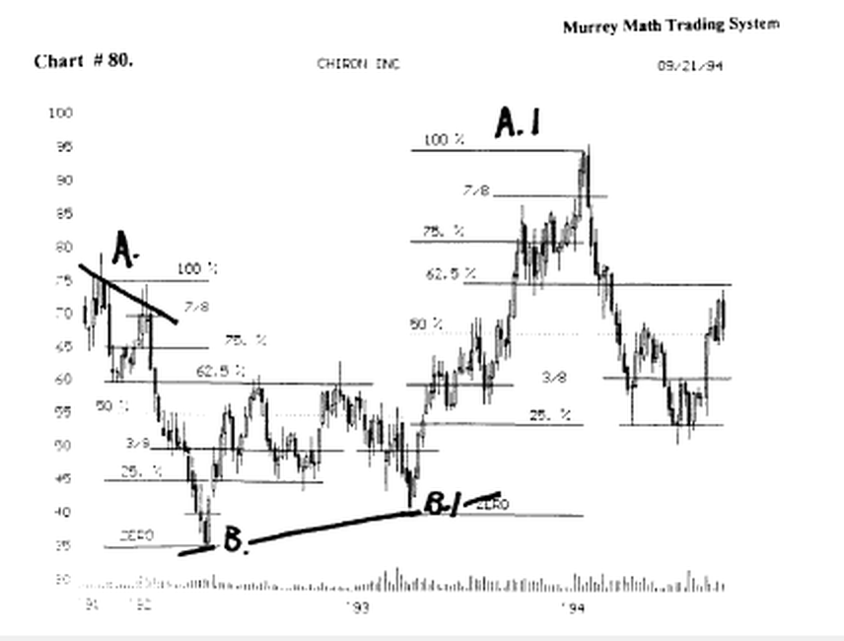

We set our first (a) and (b) Gann Lines, and we traded off these Lines, until it ran up past our 100 % Line.

Then, when it reversed sharply, at the top, we took a new (A1) and (B1) and watched to see if it reacted just to our last set of Gann lines, or was the first set still in effect.
Almost all of these Lines match up exactly.

We didn't have to average these previous 25 %, 50 %, or 75 % lines.

But, we must understand that the short term and long term Gann Lines must be considered as we make a trade.
These Gann Lines have affected this stock for the past 3 years.

W.D. Gann said that the entire history of a stock is needed, but we don't think anyone in this country is long sighted enough, to look backward, or forward, past what they read in the newspaper each day, or on T.V., by expert commentators on the financial talk shows.

Look at (chart # 27. KO. Coca Cola). ( weekly ).

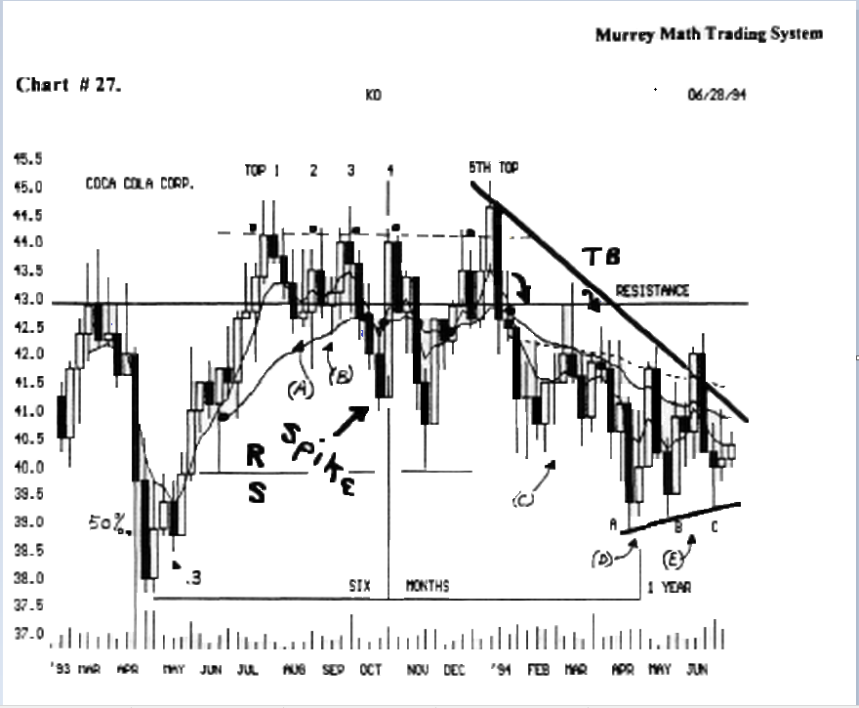

There are 5 different retraces between 37.4/8 and 44.00. We should divide these retraces by 8, and then find common lines and watch resistance along the greatest number of common Lines.

And you may divide the 5 differences by 2, to see where a market will pivot.

This is a great stock to drive you crazy, using all of Gann's rules, for it is a traders' stock, (it reverses on small price moves). (too many "whip lashes").

It is bought and sold on 3.00 and 4.50 point swings.

If we enter a position on this stock we must be prepared to get out with our 3.00 points, then get back in, after it has fallen back down minus 3.00 points.

The longest run up was 8.00 points, and if we had held it from Apr.'93, to Apr.,'94, one would have made 1.00 point, plus dividends. Not bad !

But, had we bought at 38.00, and sold at 41.00, we could have bought it back, when it fell back to 39.3/4, (June,'93).

We bought again at 40. 3/8, and then sold again at 43.00, which is an old high, but it ran up 3 more weeks, to 44.4/8.

Then it started trading against Gann's rules Low - 37.5) and (high - 44.00).

If we measure this high low distance, we find that it stalled at the 50 % Line between these 2 extremes in October,'93.
Then, it tried to break above its old high for a 4th time and failed, then fell back down to a 62.5 % fell, then tried a 5th time to break through to higher highs, but it failed, and tanked vertically.

It is rare to find a stock make this many attempts, unless it is very stable, large in its holdings, and has a very Large capitalization, and not break through to a new high, or reverse and fall fast.

Look at (Mc Donalds see chart # 85).

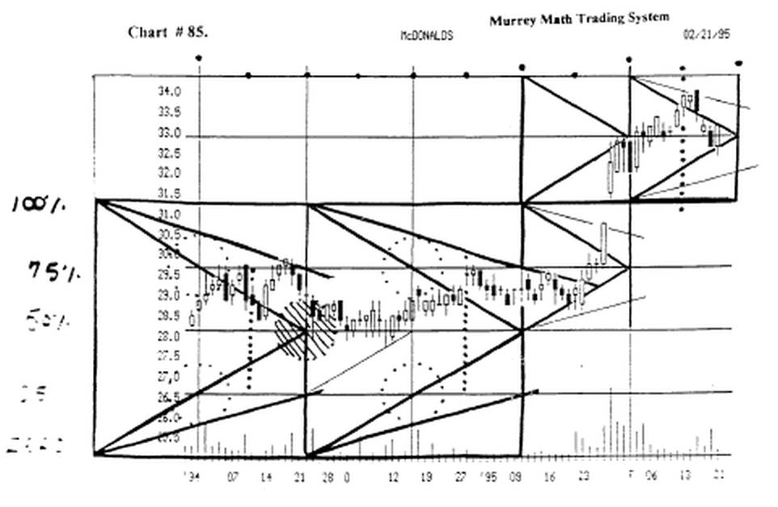

You will see the same narrow range between 28.0 and 29.5/8.

It was trading over the past few months, from Nov. '94, thru Jan.23,'95 without it felling under 28.1/8.

Then the earnings came out and it gapped up fast.

Look at the black dot in the middle of the small square. h reversed on a day that was predetermined back in Oct.'94.

It also reversed on a 45 ° angle Line, which was a major support Line. Is this luck ?

Please look over to the lea of this chart. I have set the "Square in Time" for this stock off its Fibonacci baseline, and then set its high (100 %) line off its Fibonacci multiplier ( x 1.125%) at 31.1/4.

We have spent much time talking about the significance of 4/8th, 6/8th Lines, and the top of the trading range.
So, let's look at what this stock did in reaction at the 4/8th and 5/8th liners: it stayed in here for 56 trading days. Then it broke out on the very day marked (dot).

Now you should be asking yourself, "how did he set up these gann Lines?" Easy ! Quick ! Fun ! 8th grade math.

I divided 100. x 8 = 12.5. Then I added 12.5 twice and set 25. as my zero Line (0/8th).

Then 1 multiplied 25. x 1.125% = 1.5625 and added it to25. four times and stopped at 31.3/8ths.

I never considered W.D. Gann's # 1 rule and mine has worked 100% for 56 trading days. Plus it turned right on the day I predicted as a reversal day 72 days out!

I shall explain my easier way in the next chapter.

If you want to see my way work "perfectly" look at chart # 90. Bankers Trust

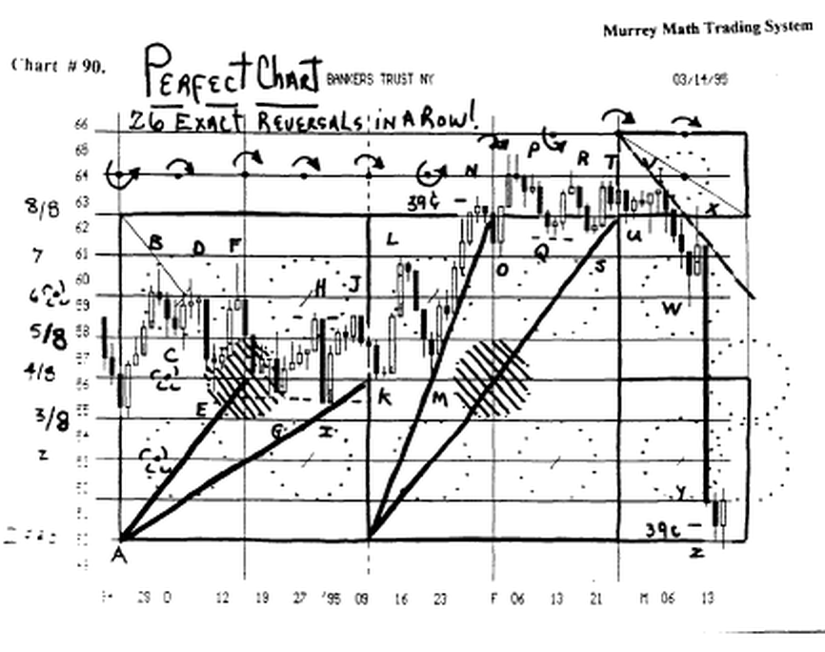

If you divide 100. by 8 = 12.5 x 4 = 50. + 12.5 = 62.5.
Zero Line (0/8ths) = 50. Then set each l/8th at 1.5625 all the way up to 62.5 (8/8ths).

You court them: 27 times it reversed off a Murrey Math Line by just dividing 100. by 8 twice.

How much more than an 8th grade education do you need to see that all stocks are wanting to run to the Law of Exact Proportion of its current price !⁹

Notice that it went up exactly + l/8th above its 100% Line, then it fell back to its 100% Line, then tanked because it couldn't break the downside 45 ° angle ?

How easy does it have to get ? Look how long it wanted to trade inside the 3/8ths and 6/8ths Lines !

Look how it reversed fast on the 7/8ths and l/8ths Lines!
The longest up move was +4/8ths. And the long down move was -9/8ths. And it stopped right on a minor 50 % Line off its zero baseline. Is this luck ? Who cares ?

It is just Murrey Math !

If you want to set some Gann lines look at (charts #21. O.E.A.

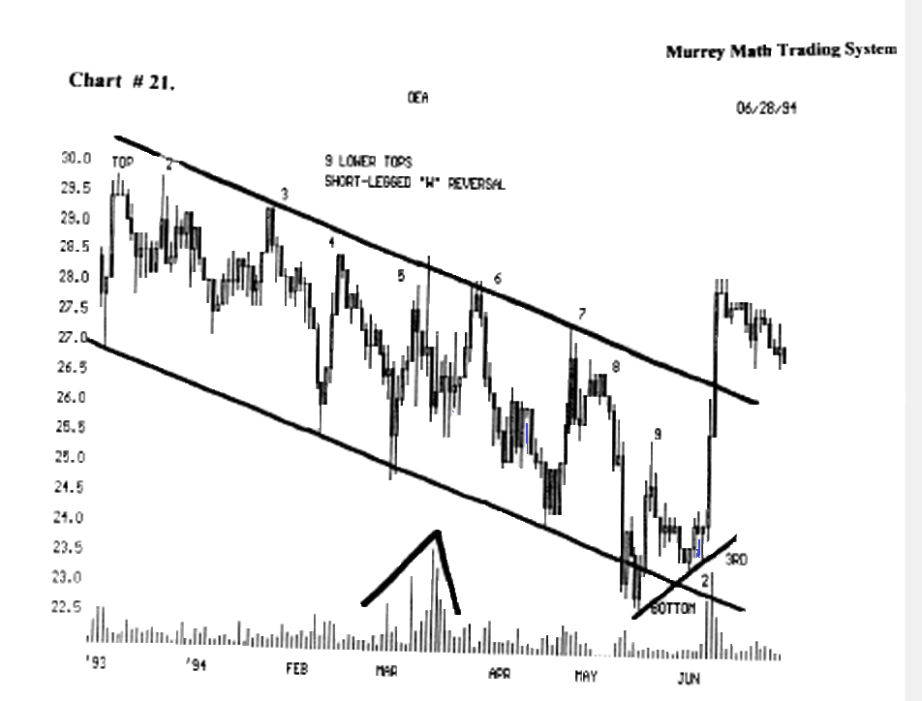

And # 20. J.P. Morgan).

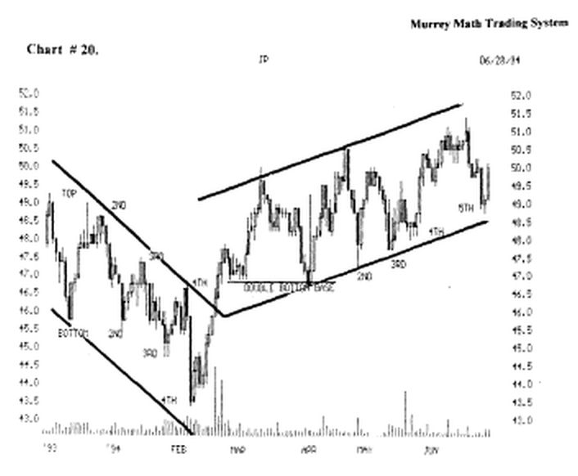

You would love to set, and reset, these lines every month. These stocks are traders' stocks.

These must be set, and reset, because there is no long term trend to evaluate, for it is trending down from its high. (trading these stocks would be fun). (headache).

Look at (chart # 43. M.O. Philip Morris).

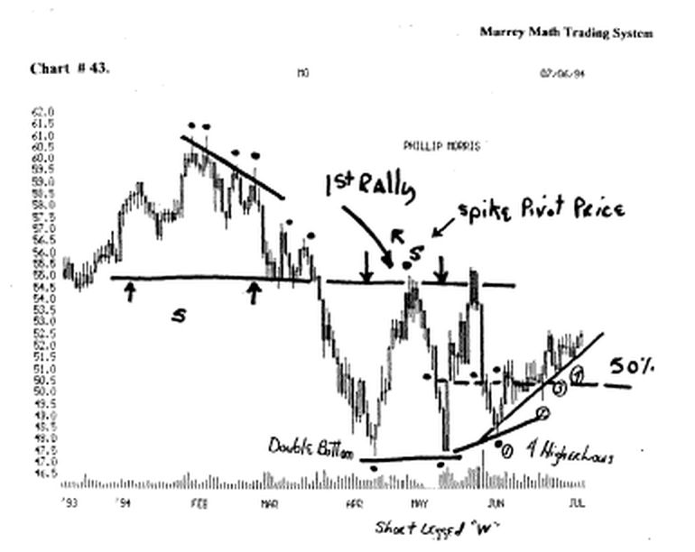

We see that it has major support / resistance at 55.00. It made a major spike price pivot (s) in May,'94.

It formed a double top in May,'94, just above the old
high. (19 or 39 cents).

(we must not think that the new highs will be made unless it holds 39 cents above the 2nd new high for at least 4 days in a row).

It formed a double bottom down at 47.00, then formed a "short legged "w"" and tried to move back up to try and break above its old highs.

Look at (chart # 44. M.O. Philip Morris).

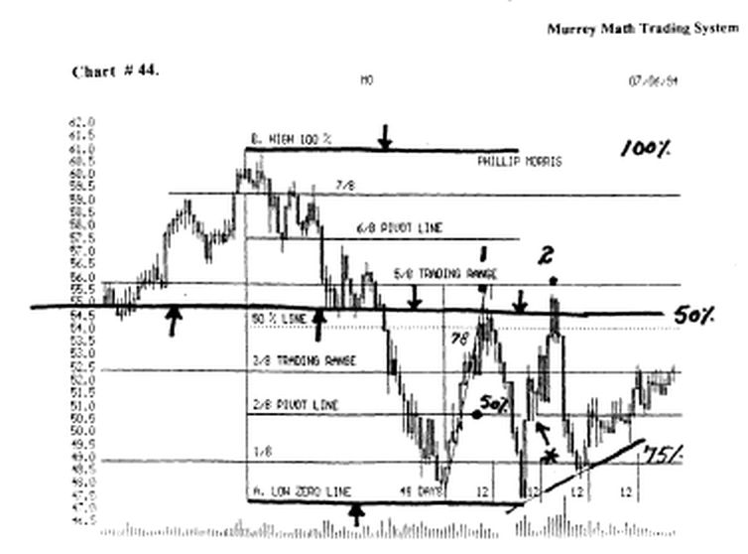

We have set the Gann (a) low and (b) High, and we shall expect to see it react along these 7 Lines within it.

A thick black Line is drawn on the same area of resistance.
And we see that it reacted within 39 cents of the 50 % Line, and the 5/8 Line.

And since it couldn't make it up there for at least (Gann said 2 days in a row ) and I say at least (4 days in a row), it fell back for support in May,'94.

We see that it reversed on the 1/8 th. Line, which is a "weak " Line, and if it holds on a weak Line, it reverses fast. (off a "short-legged "W"").

Let's test our "past history" brains by looking at the reversals back up at 7/8, 6/8, and just 39 cents above the 5/8 th. And 50 % Line.

And the obvious question is: how can this stock react to these Lines when it took from the high in Feb.,'94, till the low in Apr.,'94, for us to trade against these extremes ?

(remember with W.D. Gann you can't figure out what to do, until it has already done something for months or years).

We know the answer: that it is based on pure math as a part of the law of exact proportion, as a portion of the square in time, as we measure our stock against the Law of Distribution and Exact Proportion as stated through the exact Fibonacci ratios from 1124 a.d.

(But you will see with the Murrey Math Trading System, and the OREX example, we are able to start from day 1, with a stock that has never ever traded before, and set the vertical and horizontal lines, and start trading it on day 2: we must have at least 2 days of direction to make a common sense judgment for short term direction).

But it isn't the purpose of this chapter, to explain it all right here and now !

Please go back to page one of this chapter, and read this page over again and try and see that a stock will react as it moves from one resistance line to another through time. one must set these 1/8th lines to memory).

The major resistance level is the 50 % line, and the next most important are the 25 % and 50 % lines.

And the next important are the 3/8 and 5/8 Lines.

There is only one mention of the 7/8 or 1/8 Lines as being tired Lines that will mark a weak Line. We must set our Gann Lines and trade along these (a) low and (b) high, retracements within.

But these lines are more critical, to signal fast reversals. Especially, if it has had a long run, up or down.

The natural tendency is for the stock, or market, to run past the Line, in fast markets.

News, enthusiasm, good or bad fundamental reports, or political actions, or even new products, shall run a stock up or down, past the Line.

Then, the 7/8th or l/8th line stall out, or reversal, shall be a fast reversal signal, for our stock.

Conversely, if it doesn't stall out on this line, it will continue to fall further, or move higher, to the next resistance Line.

This chapter is an introduction to how W.D. Gann has taught his students to trade stocks, based on his No. 1 Rule - set 8 retracements of l/8th of the "whole difference," between the extreme high and low prices.

This is a classic way to trade, but it forces each trader to reset one's own sets of highs and lows, between too many variables, when it will always be a personal value judgment based on the individual's own perception of how to set these "Gann lines."

Murrey Math Trading System sets all retracement lines off exact "Squares in Time." (we shall explain in detail, in Chapter 1 Part U).

