CHAPTER 6. SPECIAL SITUATIONS C

USE ALL THE RULES (NOT JUST ONE OR TWO)

Look at chart # 44. (MO) Philip Morris.

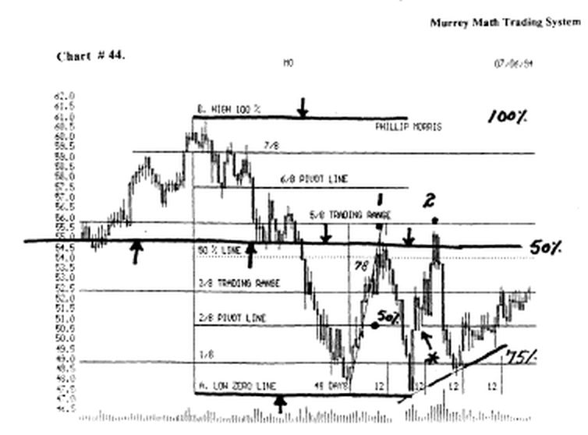

This stock fell sharply, all the way down to 47. 1/2, then it retraced back up to 50 %, of its high and low range of fluctuation, which W.D. Gann said was the greatest point of resistance, in this "poker hand," and it formed a spike pivot price, at:

(1), and politely, reversed, and fell back down to its old low, to form a double bottom, and once again, the "buy and hold" traders loved it, because they just knew, that it wouldn't do the very same thing, that it had done before, but they didn't take into consideration, the speed of the up move, and its angle, was too sharp, on the up move.

So it had run up too sharply, by eager investors to listen to their "experts" declare that they thought the worst was over, and enthusiasm, took the stock back up, that fast, not a change in its ability to earn more profits, or to correct the inherent reason why it went down that sharply, in the 1st place, so it formed a spike pivot price.

And failed to close above the 50 % Line, for 4 days in a row, so we know that it must fall back down, for more support, which it did, and formed a double bottom, which is a great time to buy, and h ran back up, and tried to close above the spike pivot price, and it did, on its very 1st try.

But the next day, the 10 % of the "buy and hold" traders, who had 1,000 shares sold it off fast, for it takes a 1st grader 14 repetitions, at a new task to master it, but it takes a common sense book, and guts, to learn, that this is just a poker game based on news, and 1/2 of it is made up by either the "wall street gurus" or the individual corporation, to satisfy their "buy and hold" investors.

Who after all, that is why the corporation was formed in the first place, and that was someday down the road, this stock shall be double, in price, what it currently is trading at.

(try and tell that to all those people who got into the market in 1929, and it took until 1948, for the S & P
500 Cash Index to be worth anything. Or better yet, it took 18 months, to overcome the Black Monday debacle.
If you had known come simple Japanese candlestick rule and that is the "10 day rule" states that no market should run up or down, for more than 10 days in a row, before it reverses, and consolidates.

Yet, everyone, on the floor of the stock exchange would clap and cheer, every day it kept going up, past 10 days, and only the smart "traders" kept their hands in their pockets, protecting a hand full of free profits, for every 10 days it moved up, was a reason for them to sell 10 % more of their portfolio, so by the time it finally tanked, in October,'87, right when the start of the bond market's 3rd quarter started, they were either shorting the market or waiting to buy back in, at a cheaper price.

Look back to Philip Morris. It didn't move back up very fast now. And the reason is that all the brokers who had cheered it up, the first time, had been burned so badly on the first reverse, and they didn't know the 50 % rule, and they failed to get their clients out, the 2nd time it tested the spike pivot price.

And it reversed, and fell back down for a double bottom, that they took the same attitude of their clients, and said, since they were a consumer product driven business, they would come back, and besides, we are in this together, for the long haul, especially since you have only 500 shares to trade, that we will just leave it alone now, and go and concentrate, on another "hot" long term tip, that we will have to agonize through, together, while the 1,000 lot traders, are making their broker commissions, because he trades, and makes a profit, which he puts in his account, only when he sells.

(go and try to explain to your wife or daughter, that you have a 50 % profit in a stock, and that you are worth so much more from buying a stock, yet they can't spend any of it, and 3 weeks later, you have to tell them, that your 50 % profit has fallen back down to even, and see what they say, when it comes time for them to buy a new dress, shoes, or even a car?).

Look at chart # 44. Philip Morris.(weekly)

This is a longer view, of the same stock, from a condensed view of trading activity, for those who say that they are just too busy to watch their stock's daily activity, so they just leave it to their broker, to tell them when to buy or sell, and they are more comfortable with that arrangement.

But, you see that it makes more easily seen (support) back in March/93, which instantly became resistance to the up side, as soon as it went back up, and bumped its head on it, in Feb.'94, when it reversed.

And fell 1 year later, and all of the "buy and hold" traders were just sure that it would break through, and all of the "poker" traders were happy to just get rid of a loser, or the "bottom pickers" were happy to sell against previous support, the 1st time up, and pocket 33 % profit in just 6 months, or $ 15,000. profit, on a 1,000 share lot of shares.

Look at the "evening star" formed 39 cents below the line. This was a double trouble signal. The next week it fell vertically. The next week it formed a "shooting star" on the bottom of a bad week, which said that it wanted to reverse, and go back up.

Then the 3rd week it formed a "gravestone" which meant that it was trying to reverse, and go back up.

But the opening price on Monday morning said no way, and you would have to exit any long positions, because it had tried to reverse for "3" straight weeks, and it just couldn't do it, so it had to fall back down for support, which it did, but it stopped higher, than its old low of (C) the 3rd bottom, which was a buy signal, and it reversed, and moved back up.

Remember: any rule stated on a daily basis, is applicable on a weekly chart.

And all stocks, or markets, should be viewed from a weekly chart first.

Look at chart # 16. I.B.M. (weekly).

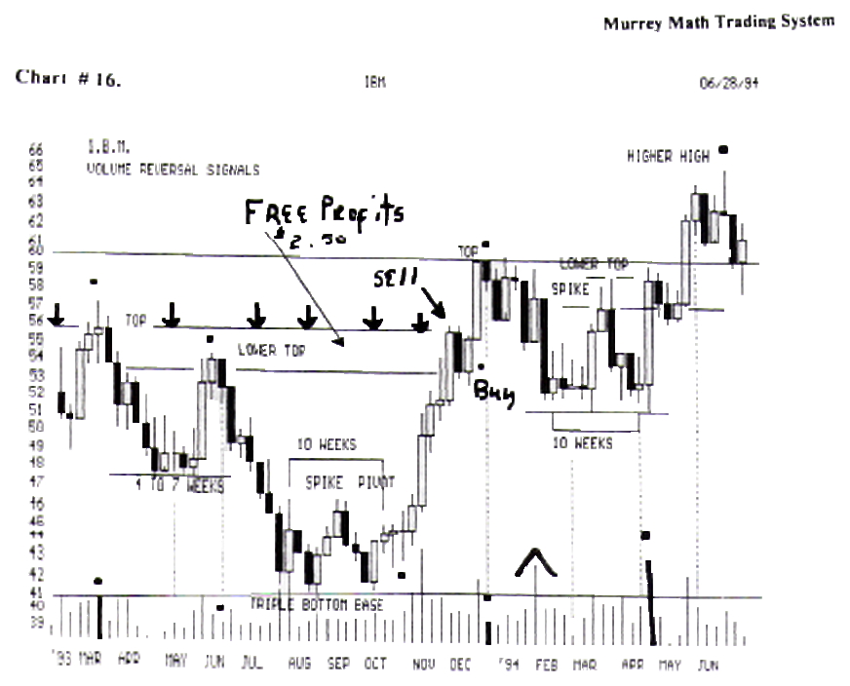

It fell from 56 1/4, back down to 41.00, to a 10 year low, then it reversed, and formed a spike pivot price, in Sept.'93, then it fell back down to form a triple base, and then it ran back up and tested its spike pivot price, and when it got back to it, (see black dot), it formed a "rickshaw" "doji" which meant that it was making up its mind, which way it wanted to go, and it finally decided to move up, for the next week, it broke above the spike pivot price, and has never been back down there since.

(notice how the 4 to 7 rule and 10 to 12 rule for consolidation worked on a weekly basis, just like it works on a daily basis ?).

Look at the "free profits" the and extra commissions both parties participated in, when they no knew to sell, the 1st time up, against a previous high, which was back in March,'93, then you would have bought it back.

The next week, when it didn't fall, like Philip Morris did, so we pocketed $ 2,500. for just "guessing," and not caring what happens

After we win our poker hand, knowing full well, that we shall bet again, but this time, we are able to buy 4 % more stock with no more effort, than just picking up the telephone, and making the very same call, to the very same broker, who has pocketed an extra commission for making you an extra 4 %, in just one week, after you had just made 30 % profit from 43.

Look at chart # 19. (MRK). Merck.(weekly).

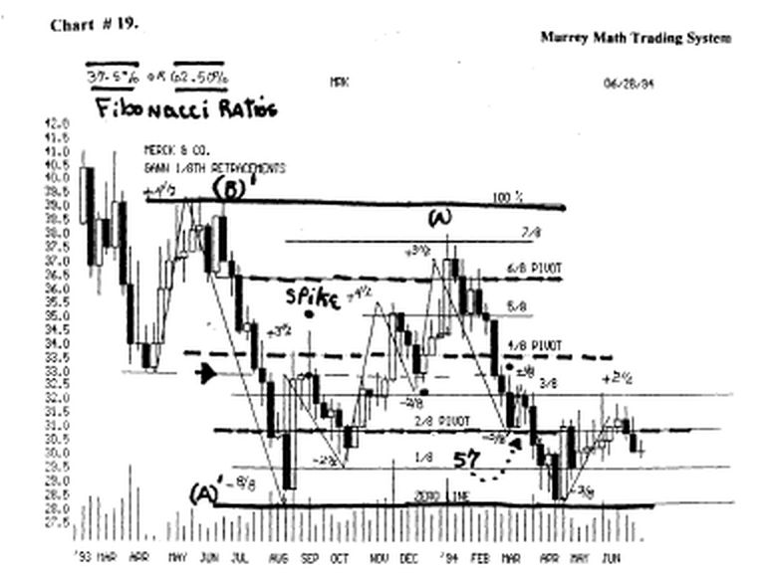

The (spike) spike pivot price was very significant. for it formed a long "rickshaw" "doji" where the high and low range for that week, was 2.00 points, but since it ended the week, on the very same price, it was asking you for direction, and it got its answer, the very next week, when it fell back down below the 2/8 th line for support.

Then it reversed, and moved up above, and closed up on the 5/8 th Line, well above the spike pivot price, but for the next 3 weeks, it fell back down, and found support right on this very same price, then it broke free of this price level, and screamed back up, to try and touch its old high at 39.00 but it could only make it to the 7/8 th line, which we know is very weak, especially, after a long run to try and get back up to its old highs.

And the "poker" players took a 12.5 loss, and got rid of it, since it had taken 6 months, for them to almost get even, and we know that markets want to reverse stronger as the time span widens from 4 to 7, 10 to 12 days: to 20, or 30 days: or 3 months, 4 months, 6 months, 9 months, 12 months: or 1, 2, 3, 5 or 10 years in longer time spans, which no one thinks in.

(isn't it funny, that it formed an 8 months double bottom, which was one month short, so it was deemed a
good buy against its previous bottom of the same price, since all of the buy and hold traders, were now, more confident, that with just one more year, they will get back up to where they entered, and that they too could declare a profit).

W.D. Gann said on page 8. "When a trader makes a profit, he gives himself credit and feels that his judgment is good and that he did it all himself. When he makes losses, he takes a different attitude and seldom ever blames himself or tries to find the cause within himself for the losses."

"He finds excuses; he reasons for himself that the unexpected happened, and that if he had not listened to someone's else advice, he would have made a profit."

"He finds a lots of ifs, and buts, which he imagines were no fault of him. This is why he makes mistakes and losses the second time."

"The investor and trader must work out his own salvation and should blame himself and no one else for his losses, for unless he does, he will never be able to correct this weakness."

"After all it is his own acts that cause his losses, because he did the buying and the selling."

"You must look for the trouble within, and correct it. Then you will make a success, and not before."

(remember that the male ego is structured to appear strong, aggressive, and always right, and a failure to do so, is called losing "face," and just as one segment of our society would rather shoot someone than to say l am sorry, or to admit, that they are wrong.)

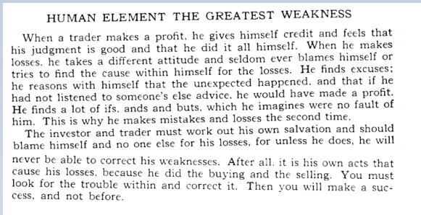

Middle class men, who have a steady job, will bide behind the "buy and hold" and "l am in it for a long time" mentality.

Rather than to admit to himself, that neither he nor his broker, that they really don't have the "feel" for the general direction, of the markets, or just one stock, for that matter, or they would go to charts # 280. thru 291. and go and read the mathematical logic behind Chapter 7.

Dollar Bill (and dollar's worth of change), to see that math, is better than listening to what you think you know, or what your broker tells you how much experience he has, in this business, for 70 % of all traders are long term, and the market goes up 70 % of the time, so if we don't have another 1929, or 1987, or Oct'93, to Nov.'94, where the bond market, utilities, and stock market, all lost 23 % of their assets, you will always make money.

But just like everything else in life, just about the time you are confident mat your 2 year old, is not getting into trouble, or if your teenage daughter is acting as an adult, for more than 14 days in a row, and not ashamed to go out to dinner with you, because you are old and "old fashioned" and not "bop", like her grand parents, you will learn fast, that if you learned 2 rules every day, (and mere are only 64), about what W D. Gann said about what he had observed, over a 30 year period, of trading, that in 2 months, you would be smart enough, if you watch what is happening, to make it on your own, to get a closer look at things, to keep an eye on your investments yourself, and accept the profits, and losses, as your choice, since it is your after tax profits, at stake every time !

W.D. Gann said on page 9.

"You must study and investigate for yourself."

Do you have the time, every day, to learn 1 rule, out of 64, and then integrate them into a common sense, trading strategy, that follows the trend.

W.D. Gann said on page 9.

"I can give you the best rules in the world and the best methods for determining the position of a commodity, and then you can lose money on account of the human element, which is your greatest weakness."

"You will fail to follow rules. You will work on hope or fear instead of facts. You will delay. You will become impatient. You will act too quickly or you will delay too long in acting, thus beating yourself on account of your human weakness, then blaming it on the market."

"Remember that is your mistake that causes losses and not the action of the market or the manipulators. Therefore, strive to follow rules, or keep out of speculation, for you are doomed to failure."

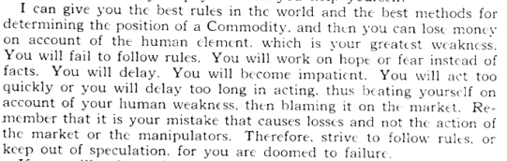

W.D. Gann said on page 9.

"If you will only study the weakness of human nature and see what fools these mortals be, you will find it easy to make profits by understanding the weakness of human nature and going against the public, and doing opposite of what other people do."

"In other words, you buy while other people who just guess do me opposite. Time spent in study of price, time and past market movements, will give you a rich reward."

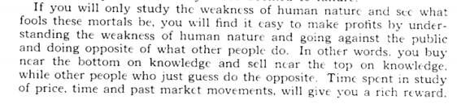

Look at chart # 32.(BS) Bethlehem Steel. (weekly).

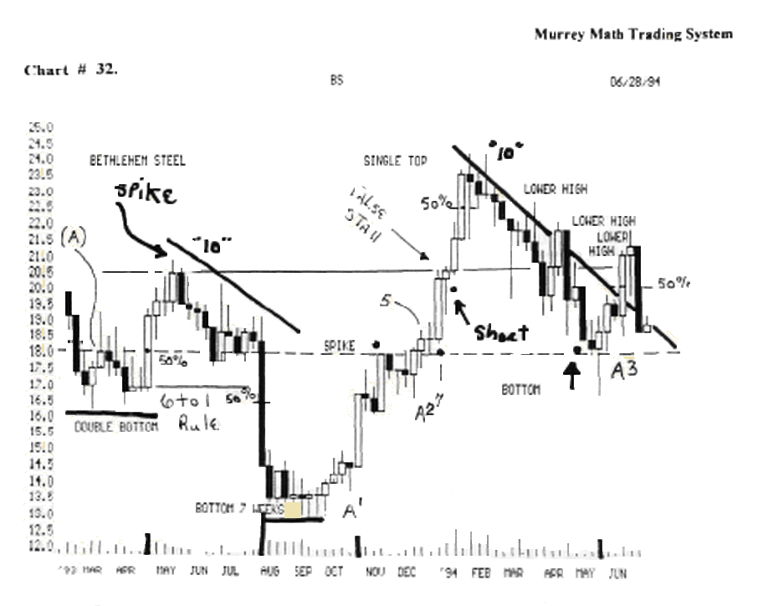

This is just about the worst, untypical stock, you would ever want to trade. It doesn't do anything right.

After 10 weeks down, it should have reversed, and moved up, off its (50 %) support Line, but it fell sharply, back all the way down to 12.5, for a base, then it moved back up, and formed a spike, and didn't reverse back down, but for just one week.

Then it ran back up, and bumped its head, on the (50 % line), then it fell back for support, for 4 weeks, (4 to 7 rule), then at (5) it finally closed above the Line, for 1 week, then it formed a "doji" asking you traders for direction.

Then at (7), it broke out, and moved up strong, and bumped its head against a higher spike, back at May,'93, then it did something that you won't see very often, and at (false stall), it made a classic "hangman," which is a reversal sell signal, which must be shorted below the opening price (see the black dot).

But, it opened the next week higher, taking out the May,'93, spike so it ran up higher, only to please the buy and pray traders, for it fell for 10 more weeks , and this time, it reversed, as it should, but it couldn't move up thru a simple black line, and it fell all the way back down, to the (spike 50% line) for support, which it got down at (A3), a third higher low. (buy).

Time off 1st bottom x 1.618

W.D Gann said on page 56. "Add 3 months to an important bottom, then add 4, making 7, to get minor bottoms and reaction points."

What was he really trying to say ? He was really using Fibonacci numbers, which were the "golden section" numbers that were derived from observing spinning galaxies in the heavens.

(you might turn over to Chapter 7. Dollar Bill and dollar's worth of change, and read it from page 27. forward, to see how a group of (64) 8th graders figured out what their father's should have already known, since it has already been sitting on book shelves, for 50 years, in your local library, under the title of How to Make Profits Trading in Commodities. by W.D. Gann, (copyright owned by Billy Jones, 1976).

The "golden mean" or "section" is .618 %.

W.D. Gann didn't take the time to explain, since he felt you already knew, or didn't care enough to search it out for yourself, or would just take anything he said as gospel, you would do just like everyone else, who is weak in math, or who can't memorize many things linked together, that you would just listen to what the "wall street gurus" say, and follow their advice, and just continue to go with the trend, although, you don't have any precise way of measuring the trend.

But if you took the compliment of 61.8 %, which is 38.2 %, you would then multiply 3 months x 1.382%, and you would get 4.146, which you would add to 3 months, to = 7.146 months, as a Fibonacci number reversal point in time.

Larry Williams published, recently, in one of the "trade system magazines," a detailed explanation about
this phenomena, and found that the best bases for support, are: a) 1st leg x .618, b) 1st leg x 1.618, and c) 1st leg x 2.618.

Surprisingly, Robert Miner, had published an earlier work in a similar "trade system magazine," stating the very same thing, but in much more detail, but in this country, the latest article in print, is the "expert," besides, W.D. Gann had used Fibonacci numbers from the 1 Ith Century, but he didn't get credit, nor was he remembered, for having done it.

(so I guess rehashing, what has already been said, is good, and necessary for the common people).

It is my contention, that all stocks and commodities, want to "square themselves in time," for all growing seasons, and rains, tend to balance themselves out against the weather, and the Sun spots, and the amount of cloud formations, in a particular area, that may be affected by positively or negatively charged ions, in either a low pressure, or high pressure cloud.

So, rather than spend your time, listening to the weather report, as all commodity "brokers" do each day, one should measure the length of each run, in its percentage of a given square, and trade against a known, rather than an unknown.

The classic example of bad news not affecting a commodity, might be seen some years back, when the Mississippi River overflowed its banks, and went out some 30 miles on either side, and ruined all kinds of crops.
But did the price of gold sky rocket, because the CRB Index ran straight up for several weeks ?

It seems to me, that gold had already made its move, from its low, back up to the $ 400.00 per ounce level, and the law of distribution, stated that it had already run up high enough, and profits, were being taken around the world, by people in India, who were accustomed to floods, and they were more interested in putting profits in their pockets, than how much it would take to transform one ear of corn that cost 5 cents to grow, for General Mills to run it thru 40 processes, to call it corn flakes, so they could sell you a box, at an inflated price of $ 3.50, if you didn't have a coupon, or didn't add milk, and a couple of spoons of sugar.

Look at chart # 52. Cotton.(weekly).

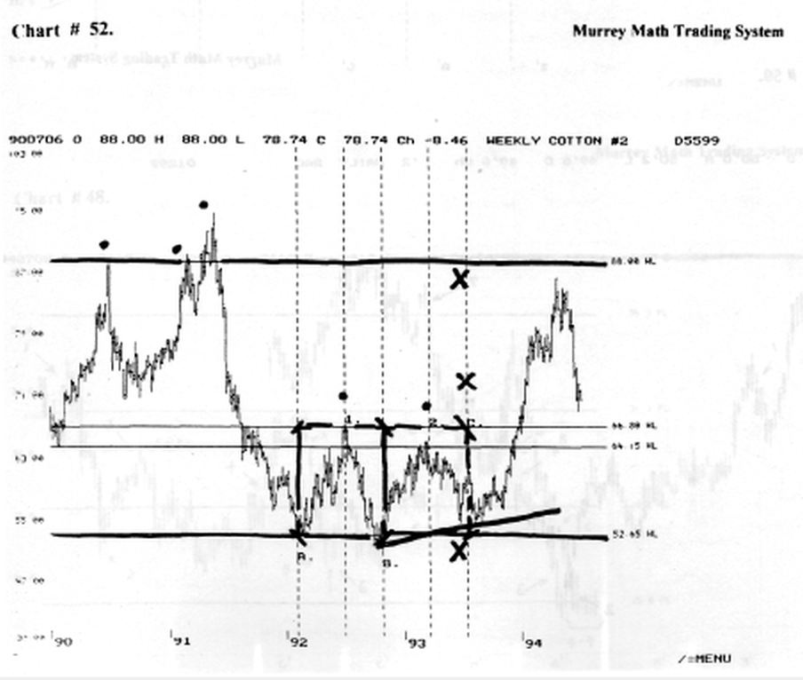

If you take the low (A) on the baseline, and go up to (1) (black dot), and take this high, and this low, and multiply this time span by 1.618, you see that it, did, right at (2) where the computer figured it would reverse.

But, if you simply use the "Square in Time" you will see, if you measure the span of time from (A) to (B), and then add it again, just the same amount, you will end up at (C), which would be exactly, the sides of 2 squares, if you measured up to 65.00, and boxed it in as a square in time.

You will notice that I didn't take the 2 lows, as W.D. Gann instructed us to do, for there is a group in California, who says to find a low and a high, and measure these distances, and extend either the: a) .618, b) 1.618, or c) 2.618, off of: 1) a high or a low, 2) 2 highs, or 3) 2 lows, by each of numbers, and you should have it.

Everyone is making it complicated again. Look at charts # 53., 54., 58. Cotton (weekly).

These 3 charts of the same commodity, taken from a different angle, yet still set in a square eliminate the need to try and figure out anymore than how it trades, inside its own little world, as it reacts against all of W.D. Gann's # 1. rule (take the high and low extremes and divide this range of fluctuation difference by8).

We are able to translate these Fibonacci, W.D. Gann, Robert Miner, and Larry William's numbers into 1/8 ths of a square, and then watch its price action, against times of 25, 50 and 75 % of where it is in its current square, not against some previous low or high.

(but you must always be aware of where it reverses, in relation to how far above or below, the last low or high was, for ultimately, it is the law of distribution, or percent ahead or behind; you are, at the poker table, that pivots a stock or commodity, based on its fundamentals against its current run up or down).

"3rd Day" (pivot or reverse sell or buy signal)

I have spoken several times about the "hangman" and it is generally a sell signal except for the exception I mentioned earlier on chart # 32. Bethlehem Steel,

where it formed a (stall out) "hangman" but it didn't open up the next Monday lower, so you would have been faked out, with a little loss, had you gone short, before it had dropped on the 3rd day.

And this what the 3rd day means. the 1st day, is actually the last up day, in a fast vertical climb, and the 2nd day, is the pivot day, which in this case, is the "hangman" and you may see it in just a minute, and the reverse day, is the 3rd day, when you short it more than 39 cents below the closing price of the last up day.

Look at chart # 57.I.B.M.

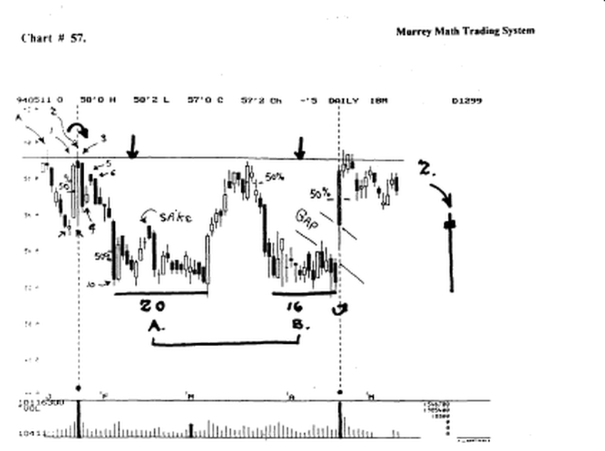

trading stocks, and looking at charts, are like going deer hunting with a "boom box" and a lot of cologne on, you can't see what you want to see, for what you are hearing, and you smell too strong for the wrong animal, to get them close to you, especially, if you are down wind.

If you look to the right of the page, (see 2) you will see a man hanging front the neck, choking on his decision to run this stock back up, on the day, by all the traders who are just plain "dumb."

Now look back to the left side and find the (2), and just like the deer, is hiding in the middle of the bushes, tall and still, the answer is starring you right in the face to sell short, or close out this profit position, and get ready to buy it back cheaper.

You should short it where the arrow is pointing on the 5, which is below day # l.'s high close, and we should not close our position, unless it closes up more than 39 cents above the upside line (see 3).

The sell signal is at the bottom of the page ,where I have marked the daily volume in a bold black line. This day was an earnings "news day."
'
This was the 1st quarter of profits, after several quarters of losing money.

The 8 million shares of volume excited a lot of brokers, and they reported the high volume, and large number of institutional blocks traded that day.

So the big boys, who really drive the market, are in there pushing it up, or someone thought they were, until the final bell, when just as the deer, who is still standing dead still among the tall shrubs, this stock, has been pelted with gun shot all day, all that happened was that it ended the day, at the very same price it started out: and that was a "hung jury." (nobody's trade counted today, for it went nowhere).

Ten days later, all those fundamentalists, who buy with a good profit margin, and profits in the black, reported back to their clients that they had, in just 2 weeks of good news, lost their clients 14 % of their usable cash in this stock.

If you look back to (A), you see that the stock had already moved up to the line, just 7 days prier, to the earnings report, and it had tanked, to get ready for the bad news, if the earnings were bad again, but somebody, declared that the news was good, and it went back up vertically, on a 78 ° angle.

It wanted to test its old high, and the same people who shorted it down, turned, and rode it up, and then shorted it again, and drove it back down, to 3.00 points lower than it had pivoted at 53.00, just 10 days earlier.

It consolidated for 20 days, and then reversed, and went back up to test its "hangman" high (2), and it fell short of the line by 39 cents, which is a sell signal, if it doesn't move up and close above the line the next day, but they shorted it once again, and drove it back down to test its old lows.

There it consolidated this time for 16 trading days, but this time, everyone got smarter, because they sat back and waked for the quarterly reports to be announced, before they jumped all over it.

The reports were good, another small profit, and it gapped up 2.00 points, on the open, and ran back up to test its old (2) hangman" a 3rd time, but it could close above the Line, only 1 day, which meant that it was tired, so it had to fall back for support, but it wasn't going to drop back as low this time.

Because it had 2 quarters of good earnings, so it would have 3, and then 4, and every low retracement, would be a buying opportunity, until it went back up to 75.00, and then it would slow down, into smaller price ranges, so that earnings could catch up with the higher prices, (late '94).

(notice how important the 50 % mark of an extremely large candle exerts itself, to be an automatic support, or resistance point for the stock?).

I have marked 3 (50 %) candies, that exerted great pressure on this stock, since the daily range of activity was extremely wide, for its normal activity.

Look at chart # IT.General Motors.(weekly)

This time the opposite daily activity occurred and the same result happened: the stock fell back down to its (resistance Line), which had now become its (support) Line.

The 1st day, again, was the last up day, and the 2nd day was a "shooting star" or as W.D. Gann called it on page on page 60, (some 200 years later) without ever talking with Muneshia Homma (Japan 1724), called it a "shooting star," because the average rice farmer in Japan could only count, not read nor write.

Many of the Japanese symbols meant words, and they had to plant their fields by hand, which meant long hours, which meant that the price went way up in the morning, then sold off hard and strong, back down to its opening price, and here once again, all brokers will tell you that the news is great.

And that large blocks are driving the price up, but in the afternoon, when the real traders step in to take a profit, they sell it off, and make an intraday profit of 2.00 points, and laugh, while everyone else went out to play golf, and count their raid day profits, that disappeared on the closing bell.

Again, on the 3rd day, at (3) we would have shorted the stock, and been right, for only 2 days, but we would have closed our position, more than 39 cents above the closing price of day (1), and we would have saved maybe 1.00 point.

Then we would have shorted it once again, when it moved back down past (3), and we would have been correct this time, all the way back down to 50.00, which if you divide 100. by 2 = the major 50 % line (MML), which we do know now, or should learn, is the greatest place to buy a stock that has fallen off its high, and has reversed on its major support line.

Once again, the answer is down at the bottom of the page, where we see that it has had a "final exhaustion day" or "evening star," on extremely high volume, which was the climax, of activity, for the real traders. The rookies tried to take it back up, to test and break through the "3rd" day but it couldn't.

This simple signal saved you 25 % of your capital ! Two Rules that are exactly opposite in meaning?

W.D Gann said, on page 61. "When there is a panicky decline, marks the end of a bear campaign, when you cover shorts and wait."

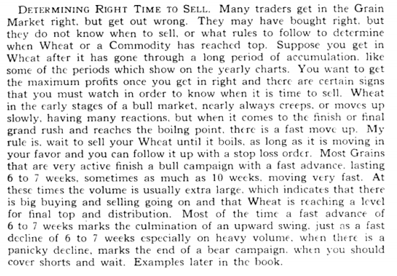

Then W.D. Gann said on page 62. "When a commodity advances or declines into new territory or to prices which it has not reached for months, or years, it shows that the force or driving power is working in that direction."

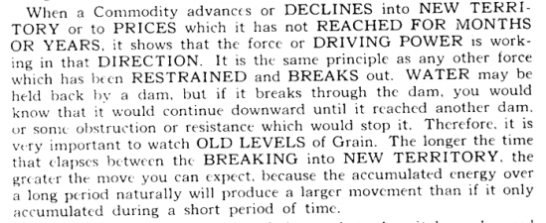

You may read these 2 these 2 observations, and stay totally confused, to the point, of not really caring, what happens, at tops or bottoms, but we should try and put more than one rule together, to form a common sense rule, out of one statement.

W.D. Gann said on page 46. "When a commodity breaks old bottoms or previous bottoms on a weekly, monthly, or swing chart, it indicates that the trend has turned down.

The market may go 5 or more cents lower and then rally back to these old bottoms. That is why it is a safe sale of wheat or any commodity with a stop 2 or 3 cents away. Sometimes the market will rally 1 to 2 cents above these old bottoms, but seldom goes 3 cents."

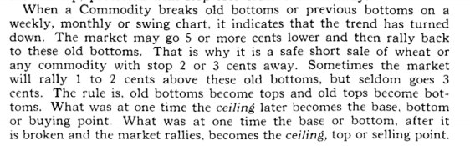

Stocks trading at extreme highs or lows, should be measured exactly, as to whether or not they go over a (MML) line by 19, or 39, or 78 cents, on an extreme high. And 19, 39, or 78, or 1.56, below the (MML) Line, to still be considered under the influence of the base support line.

You are presently learning how I deciphered W.D Gann's trading System, that allowed him to make 288 trades, in 25 trading days, lose only 11 trades. Gann turned $ 10,000. into $ 1,000,000. in just 25 trading days, without a computer, because he had already set every commodity to the same lines of resistance, or support, if they were trading close to one another, in price range.

W.D. Gann said on page 71. ""1861 - Last low in June, 55 c; holding 5c above the double bottoms, indicating strength and getting support just under 56c. The 100 % advance on the base of 28 was an important buying point."

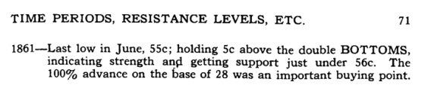

I read this statement 50 times, and 1 finally saw how he was able to predict support and resistance levels, of any commodity, by just asking the current price, when he walked into a particular pit, and asked them what the last low and high were, and that was all the information he needed to trade.

If you go back and look at Reference Sheet G., then turn over and look at Reference Sheet L, then go to Quick Reference Sheet 1.953125, where it says British pound Rhythm 1/8 th M.M.L. Lines: .0244.

You may use inductive reasoning, or deductive reasoning, to find out how W.D. Gann recognized that wheat back in 1861, might give a buy or sell signal off a 2 cent, or 5 cent move.

If you looked at these reference sheets, then you already know, that 5 cents is common slang, for multiplying .0244 (1/8 th) x 2 = .488, which is 25 % of the difference between zero, and .1953125, which is 19 cents, if you are trading wheat at 28 cents.

There you have it pure and simple: W.D. Gann told you the answer on page 34., (I have already told you in Chapter 1., and then he told you again, on page 68, but you still didn't get it, so I am here to take you through this trading System.

But, without having to use this # 1. rule, (which I told you in Chapter 1.), and you are able to take these Quick Reference Sheets, and set up anything you trade without having to know any more fundamentals, than you are able to "feel comfortable" with, and not let you get "bogged down" with "office traders' gossip."

Look at chart # 2. (DIS) Disney.

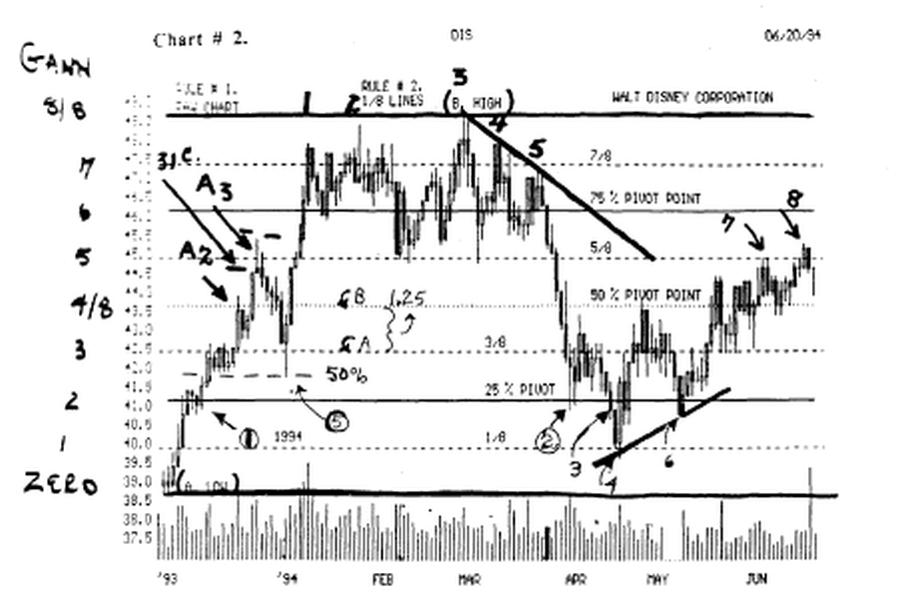
We are using W.D Gann's # 1. rule, so we set the low at (A low) and the high range of fluctuation at (B high) and then divided the difference by 8.

On the left side, you will see each l/8th, and we would want to watch and see if it reverses on the 25, 50, or 75 % Lines, as W.D. Gann said it would.

It stalled at (1) on the 25 % line for 3 days, then it moved up to (2A) at the 50 % Line, then it reversed for 2 days, then it ran up to (A3), then it closed 31 cents below the line, which was the 5/8th line.

Now this 31 cent failure to reach the line, is the same, as when W.D. Gann said that wheat couldn't make it to a 5 cent price point, so we must find the parallel, between a 5 cent move, and a 30 cent move. So here goes: If we look at chart # 2., we find that each 1/8 th equals 1.25, and 1/8 th of 1.25 = 0.15625. So, 25 % of a minor 1/8 th = 2 times this 1/8 th, which is 31 cents.

But when we divide 1.5625 x 8 = .1953125.

Now we divide .1953125 x 8 = .024414, and 25 % = .0488 cents, but since the average trader speaks in whole numbers, we would expect to say that a 5 cent failure, would be the same as saying .0488.

Minor 50% or Half Way Point (support / resistance)

Now look at chart # 3. (DIS). Disney.

I have subdivided each Gann line into equal 50 % lines, for W.D. Gann said on page 36.

"When the range between the 1/2 or 50 % point, and the 5/8 or 62 1/2 % point is 8 to 12 cents or more, and the commodity crosses the half-way point, it will go to the 5/8 point and meet resistance and then react or decline.

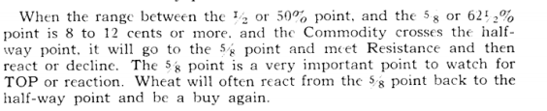

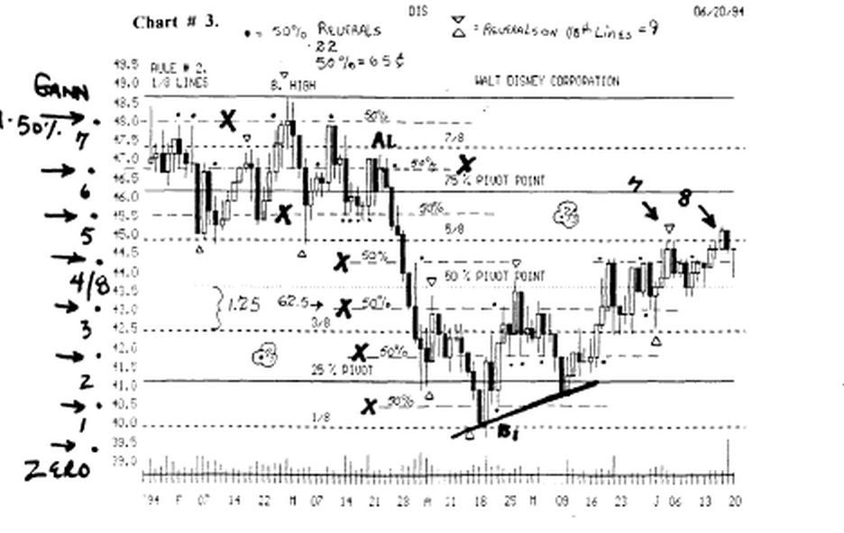

The minor 50 % line of each Gann line has been added in between each Gann line, and I have counted every reversal, major and minor.

Each major Gann line reversal is marked with a triangle and it touched and reversed: 9 times.

Each minor 50 % line reversal is marked with a black dot and it touched and reversed: 22 times.

Evidently W.D. Gann knew what he was talking about, when he observed this minor reversal point.

Look at chart # 112A. Walt Disney.

This is the same time period, except I used the Murrey Math Trading System (MML) Lines by the standard method.
This chart is divided into major and minor Murrey Math Lines, by dividing 100. x 8 = 12.56.
Then we
Then we divide 12.56 x 8 = .1953125. multiply. 1953125 x 4 = .781.

And we have the mathematical minor 50 % line without any regard to its last high or low, price fluctuation, or any basic fundamentals.

Each minor (MML) 50 % line reversal totaled 15. Each major (MML) 1/8 th line reversal totaled 15.

The unique part of comparing these 2 charts:

a) W.D. Gann Method, and b) Murrey Math Trading System, is that every major reversal, with no regard to: a) fundamentals, or b) having to hit the high or low exactly, every time; was called using both methods, but you had to guess, with the W.D. Gann method, where to place your top and bottom Lines.

But with the Murrey Math Trading System, all you do is divide 100. by 8, until you get down to the bottom of your stock's trading range, whether it is a major or minor (MML), is not important, as long as you are either:

1) 78 cents,
2) 39 cents,
or c) 19 cents, above or below it, then you have the bottom (MML) that your stock is trying to bounce off of presently.

Then, you simply count up 2, 4, or 8 lines, and include the top of its trading range, as long as it's no higher than
a) 19,
b) 39,
c) 78 cents, above the 100 % line. (there are exceptions, where it will run up a full 12.50, or 25., or 50 % line above, the 100 % line, and come back down, so you should go through the Charts by Group (pages 7., and 8.), and flip to how they were set up, and it will save me a lot of explanation, and you a lot of reading.

Look at chart # 4A. Walt Disney.

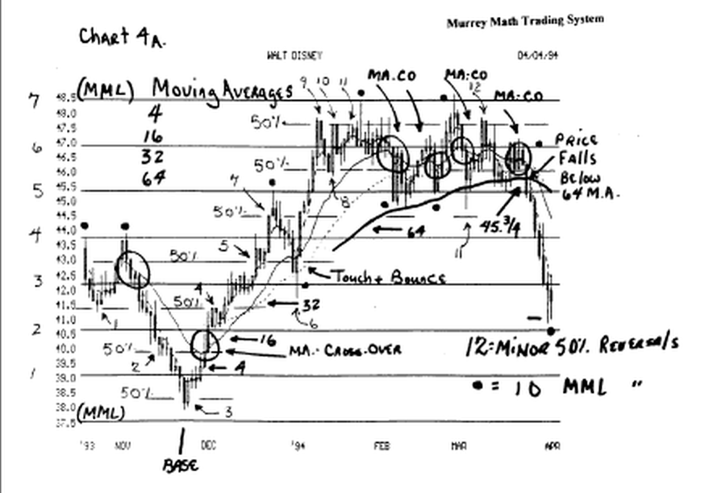

This chart is divided into major and minor Murrey Math Lines, by dividing 100. x 8 = 12.56. Then we divide 12.56 x 8 = .1953125. Then we multiply. 1953125x4 =.781.

And we have the mathematical minor 50 % line without any regard to its last high or low, price fluctuation, or any basic fundamentals.

Let's see how many times this stock reacted to both. Each minor (MML) 50 % line reversal totaled 12. Each major (MML) 1/8 th line reversal totaled 10.

This is a random sample of the very same chart, but using a non sequential time period, to predict the accuracy of the Murrey Math Lines, and we see that, here again, it touched on either a major or minor line, every time it made a major reversal.

So, if it is predictable, easy, and just as reliable, and gives you more signals, for every market off the fact that you don't have to continually keep setting, and resetting, all those Gann lines, every time you review a different stock or commodity, or Index, and you don't have to keep track of all those different 1/8 th Lines, and each new (minor 50 %) line is, within each Gann Line.

Proof W.D. Gann Didn't Choose to Tell it Exact Now, back to W.D. Gann's recognition, on page 71.

that he knew that a 5 cent failure signaled, a reversal: well now we know that 4.88 cents is 25 % of 19.5 cents, and since wheat was selling between 28 cents, and 56 cents, then we must measure reversal signals of any 25 % failure, which again, we know that if 1/8 th = 2.44 cents, then x 2 = 4.88.

And since W.D. Gann didn't want you to know the truth, he simply rounded it off, so that you would just take his word for it, and make a lot of easy profits,.

For the average trader, in 1910, had no more trading System, than 90 % of all of the traders, you do business with today. (history repeats itself)

Or they, (in 1910), would have heard of the most famous American, to have ever tried to filter through all the fundamental "b.s." and weather related news, that if you just "react" to the trend, you will make more profits, than when you try and out guess the direction of your stock, or market.

Look at chart # 56. Lumber. (weekly).

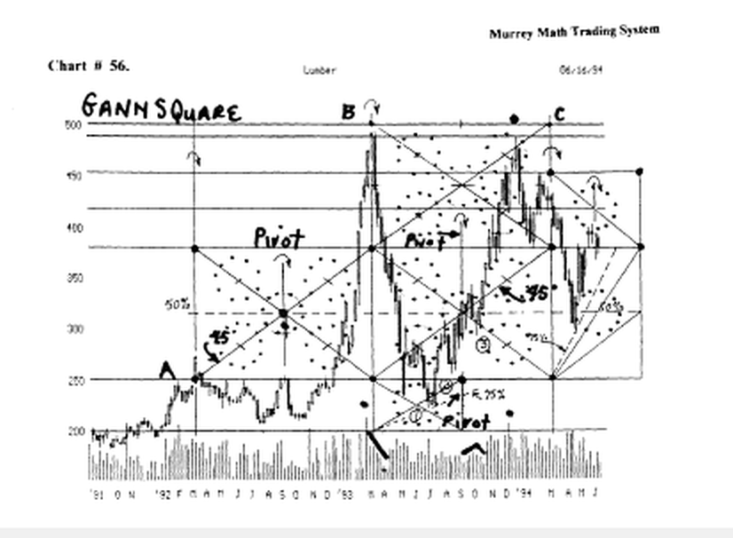

W.D. Gann said to divide the difference of the high range and low range of fluctuation, by 8.

So. we do as he said, and we take (low) 200. and the high 497. and we divide this fluctuation by 8 = 36.875.

Now you tell me how you are going to know how to enter a position that is $ 36. 87 wide ? You could lose, big time, during the day, on a reversal signal, if you were the average buy and hold trader.

If you used the simplified version of the Murrey Math Trading System, and you divided this 36.87 x 8 = 4.60, to get it down to a "baby" Gann Line.

Now that will make 25 % = 9.20, and this is just about right, for a price entry, or exit point, for presently the limit, up or down, on me day, is a $ 10.00 run on this market, and they shut it down, until enough orders come in on the other side, to justify opening up trading of this commodity again.

Personally, you couldn't trade this commodity, using W.D. Gann's # 1. rule, and he gave you no exception, in this case, except to take him at his word.

(you could lose "big time" using his rule here).

I have added the "5 Areas of conflict" so you might see more clearly just exactly what it is doing, as it runs to the right in time. (it tried to avoid it).

W.D. Gann said on page 35. "pay particular attention to strength of resistance levels."

Look at chart # 19.(MRK) Merck(weekly.

It reversed on a 1/8 th line 10 times. Look at chart # 44.(MO) Philip Morris. It reversed on a 1/8 th line 16 times. W.D. Gann high / low w/minor 50 % Lines.

Look at chart #11. (DJIA) Dow 30 Stocks.

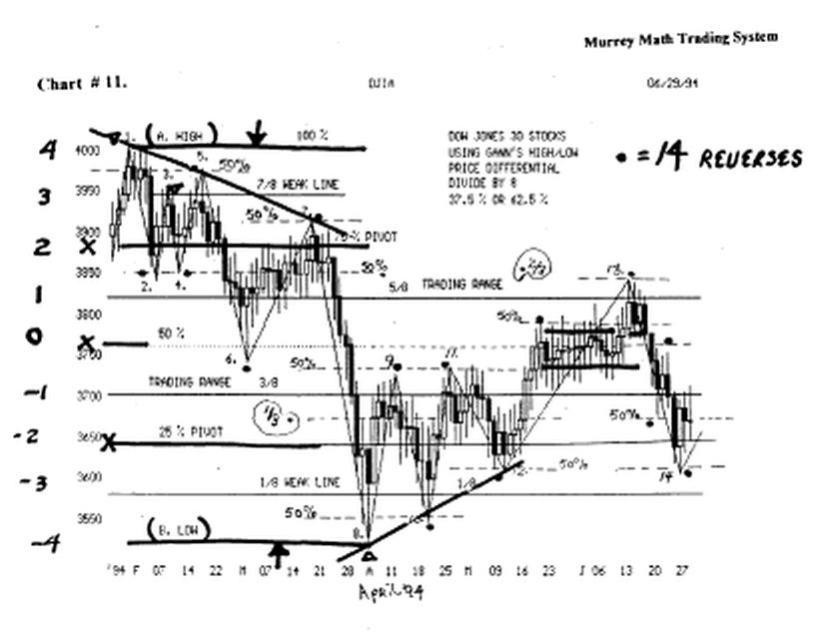
I have subdivided each Gann line into equal 50 % lines, for W.D. Gann said on page 36. "When the range between the 1/2 or 50 % point, and the 5/8 or 62 1/2 % point is 8 to 12 cents or more, and the Commodity crosses the half-way point, it will go to the 5/8 point and meet Resistance and then react or decline.

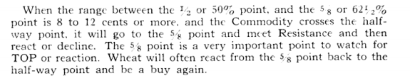

You will see 14 (black dots) right where it reversed, on the minor 50 % line, of a Gann line, which makes this (M 50 %) minor 50 % Line, very important to consider, as you watch your stocks, or markets, trade through time.

The important thing to remember here is that the Dow 30 Stocks have not broken out to a higher or weaker level, until they fell 9.6 points below the minor 50 % line, and close the day down there, and they have to stay down there more than just one day.

Now, if you understand that a market can run up above or down below, a Gann Line, and stop, on its next higher, or lower, minor 50 % line.

Then we must also deduct, that, it is possible for a stock, or market, to run above its 100 % Line, or its zero line, by at least 50 %, of the next 1/8 th Line, and still reverse, for enthusiasm will run a stock above where it should have stopped, and excessive bad news, will more than likely, drive a stock, or market, below its zero line, by up 50 % of the next lower 1/8 th, and still be under the influence of that very same line.

(remember the more important the line, the stronger the influence of the line, on the current price of the stock, or market, to want to hold around the line).

Look at Quick Reference Sheet G. and you will see the 8 major 1/8 th Lines, for any stock trading between 12.50 and 100.

Look at Quick Reference Sheet H. and you will see the 8 major 1/8 th Lines, for any stock trading between 12.50 and zero.

Look at Quick Reference Sheet I. and you will see the 8 major 1/8 th Lines, for any stock trading between 12.50 and zero.

Look at Quick Reference Sheet J. and you will see the 8 major 1/8 th lines, for any market or index trading between 500.0 and 375.

(The next most important line to watch for support or resistance, is 50 % between any of these Lines, that you see on these sheets, that match up where your stock is currently trading).

Look at chart 24. (MOT) Motorola, (weekly).
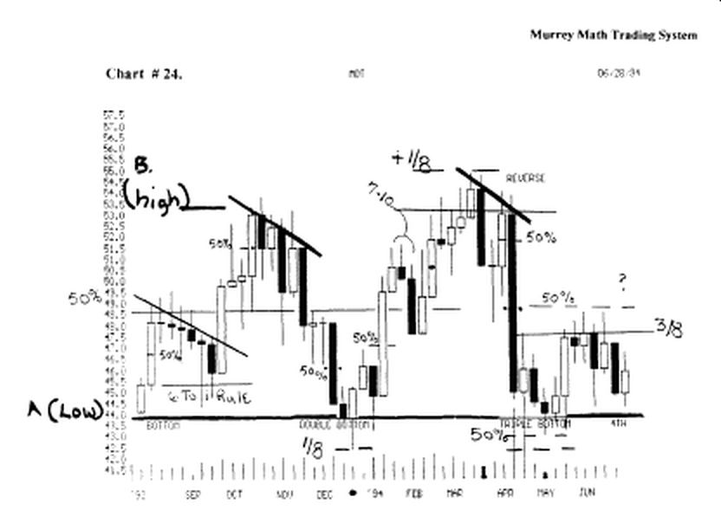

If you start at (A low) and run up to (B high), then divide this difference by 8, and tack it under the baseline, (black line), then you see that this stock ran down, as far as 1/8 th below the line, the first time, and quickly reversed, and finished the week, giving and "engulfing" buy signal, when it closed the week, higher than the closing price of the previous week.

Now we have learned that on occasion, a stock, or market will run down below the line, as far as minus 1/8 th, or it may run above the line plus 1/8 th, and still be trading under the influence of the baseline, or the 100 % line, if it can't stay there one than 4 to 7 days on a daily basis, and only one week, on a weekly chart.

(remember mat negative follow thru, will take a stock too low, or enthusiasm, will take it up too far above the line, just to have you whip lashed, because you are greedy, on the high side, or if you short something, when it is already on an old low, and it falls below its baseline).

Now back to Motorola. It ran back up above its 100 % line, in March,'94, plus 1/8 th, just as it had fallen down below the line, but it was still trading under the influence of the top line, until it could close for 1 week above the line, which it never did, and it had a "dark cloud cover" that sent the stock tumbling down, hard and fest, since it closed the week, lower than it had closed the past 4 weeks.

Now let's shift our eyes to the (triple bottom) formed in May,'94, and you will see, that it went down below the Line, but it only went to the minor 50 % line, this tune, and it closed the week, above the baseline, in a "spinning top" which meant that it was asking you traders for direction, for next week.

It had a second "spinning top" the next week, but this one, was open, which meant that it closed the week higher, and it had consolidated long enough, to want to go back up and test its old highs.

But as W.D. Gann said in 1910, and we just pointed out on the Quick Reference Sheets, it must first, close above the 50 % line, for at least 4 days in a row, and everyone was happy to sell out at the 3/8 th line, which meant that it had to fell back down for more support, to try and run up, and close above it.

6 Down to 1 Up (support rule) (daily or weekly)

Often when you have an extremely long up day candle, measured in length, by the body, (open and the close

and it takes as long, as up the 6 days, to finally, fall back down, near the opening price of the extremely long candle, and it reverses, on the 6 th day, you will get a strong upside breakout, for a short tune.

The higher off the Line, or the more days past 6, it takes to reverse, the stronger the upside will be, when it moves up.

Look at chart # 24. (MOT) Motorola (weekly).

You see where it reversed hard, and strong, after net being able to close below this long up candle for 6 weeks in a row.

look at chart # 32.(BS) Bethlehem Steel (weekly)

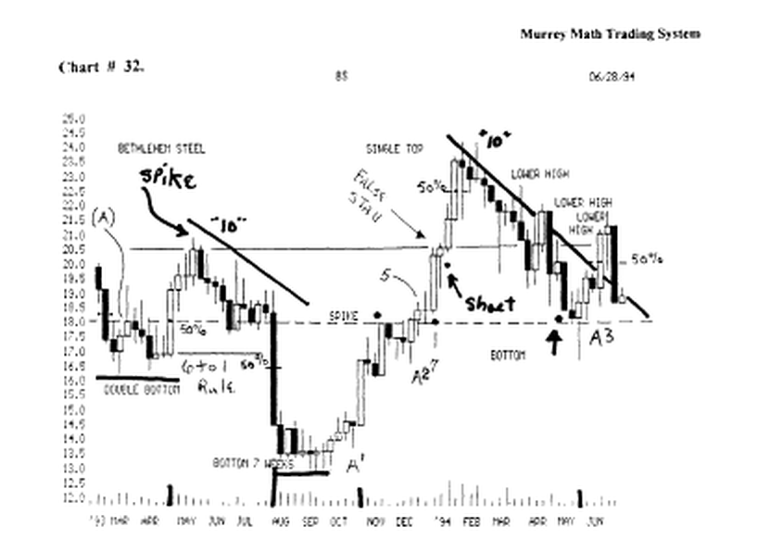

This stock formed the same pattern off its April,'93, move up, and it fell for 5 weeks, then it reversed back up to the line for 1 week, then it fell for 4 more weeks, then on the 10 th week, it formed a "spinning top" which meant, it didn't know which way to go, somebody had to make an offer higher or lower, on Monday morning, and as we see, it went up in the morning, (small upside wick on candle), then it tanked hard for the next 2 weeks.

(the long position should have been closed as soon as it closed more than 39 cents, below the 50 % line, in the long candle.

It may have stopped down at the base, but it had 2 weeks right on the 50 % Line, and they were weak, so it had lost its upside momentum, so we had to stand aside and wait.

It took 7 weeks, (4 to 7 lateral move consolidation rule) until it would move back up, but it did, right off 12.50, which just happens to be a major (Murrey Math Line).

Please integrate these trading observations into your trading strategy, as you watch your portfolio each day.

