CHAPTER 6. SPECIAL SITUATIONS
USE ALL THE RULES (NOT JUST ONE OR TWO)

W.D. Gann said on page 312. "remember that all rules work best when markets are very active and near extreme high or extreme low levels. Changes in trend occur between extreme high and low do not mean as much as a reversal when prices are near extreme high or low and are very active. Always use all the rules and not just one or 2 of them, especially when prices are at extreme high or extreme low prices."

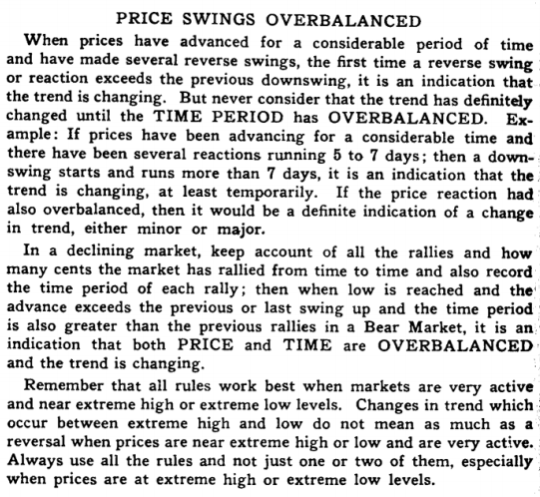

W.D. Gann was a great trader, but just read that last paragraph, and you will see why so many traders just flip a coin and trade by what someone else said on T.V., Or by just what they read in the paper.

It was incumbent upon me to organize his rules and add ours to help us establish a trading philosophy.

So, he said that we need an active market.

This is measured by price volatility, and increased volume activity.
Plus, he said that the best place to trade any stock or commodity was at the high or low price, after an extreme move.

This reinforces the notion that there are 2 places to make a profit: the long side off a low, but the high, (extreme), will fall faster than most stocks will rise, so we should take Vi of our profits by shorting a stock or commodity, after we learn all the rules to our trading System.

look at chart # 20. J.P., chart#21.:O.E.A., chart # 22. DuPont, chart # 33. A.S.A., chart # Home Depot, chart # 36. F.A.S.T., chart # 38 Dell Computer, chart #39. G.D.W chart # 40. F.A.T.N., chart#41.E.N.., chart # 43. Philip Morris, chart # 47. Comex Gold,

chart # 52. Cotton, chart # 56. Lumber:

All of these stocks would have made you a tremendous profit, if you had shorted these at their highs.

It has always been true: that anyone who doesn't sell with an 18 % profit, will not short any stock, because they think that everything is always going up, and forever.

Open Interest

W.D. Gann said on page 64. "study the past record of open interest, when extreme high or extreme low is reached, and see if the highest open interest occurs several days or several weeks before extreme high prices are reached.

When this occurs, it indicates that wise buyers, who bought when prices were low, sell out when prices are high and everybody is optimistic and buying more.

And yet the market advances to higher levels and the volume of sales daily increases, while the open interest decreases.

This is an indication that the final top is near....when the market bas had a prolonged decline, and before final low is reached, the open interest starts increasing.

This is an indication that buying is taking place.

The total volume of sales daily indicate the culmination at different stages of the market."

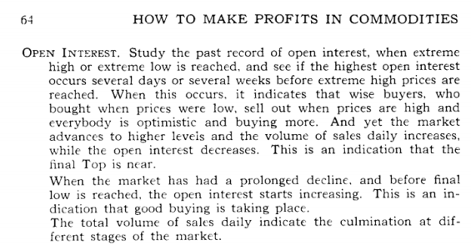

There won't be any chart to show changes in prices based on open interest.

Look at the rules we learn and trade by them and check open interest.

Speed of Prices

W.D. Gann said on page 310. "prices always move slower at low levels and faster at high levels."

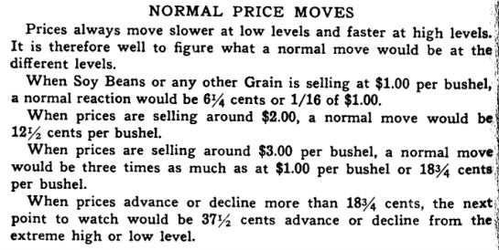

This is true only for stocks or commodities that are in a dull market at a low, and moving up fast (vertically) at a high.

l am not going to waste our time proving the point either way.

We have learned that the speed of volatility of price, coupled with an increase or decrease in volume will signal a reversal is near.

I could spend the next 5 pages cutting apart this one sentence, but let's break it down into just what we can recognize, from this last statement by W.D.. Gann.

Look at chart # 9. F.A.T.N.

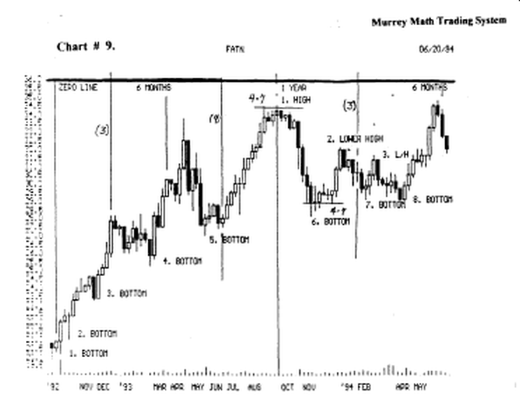
This stock didn't have any price action or volume at its high, Sept.,'93.

W.D. Gann said on page 23. 'Why reactions are smaller at high levels: in a bull market, reactions get smaller as prices go higher, because optimism and hope increase after a prolonged advance. When the buying power is greater than the selling power, traders are bidding for commodities and the price continues to work higher. Reactions are small because they are buying orders under the market, as people are waiting for reactions to buy."

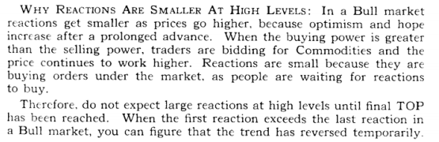

Now what would you do in this situation ? Which rule would you choose ?

Look at chart # 20. J.P.

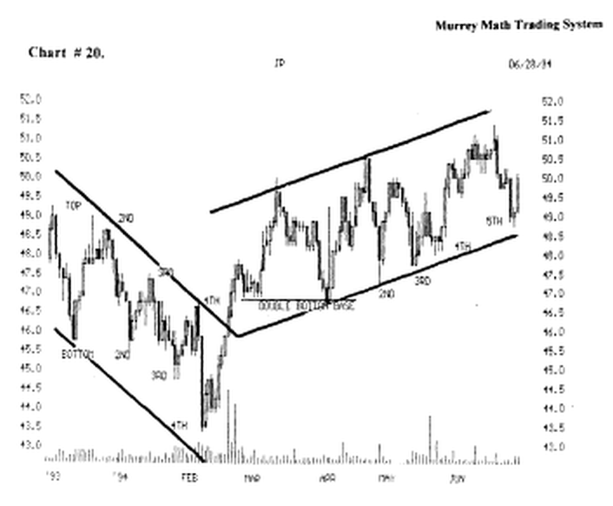

This stock based out in Feb.,'94, but it had higher volume, and it reversed up on increased volume.

W.D. Gann said on page 23. "why rallies are smaller at low levels: after a market has been declining for a long tune, people have been holding on, hoping and gradually selling out all the way down. The buying power decreases."

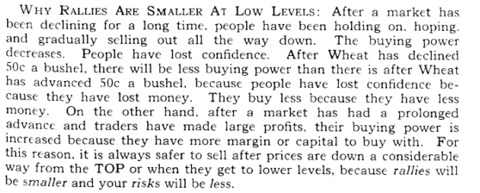
Look at chart # 33. A.S.A. (weekly).

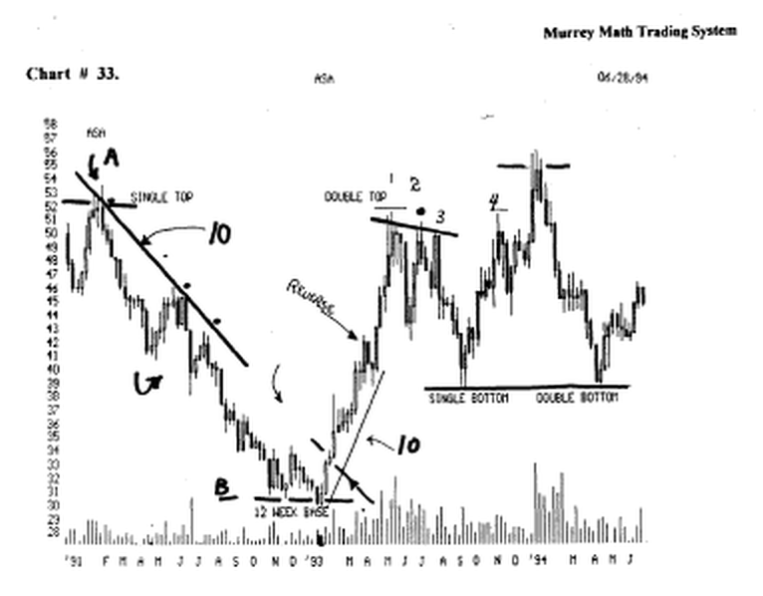

It fell for 1 year. It got no support, nor could it break above the down trend line set off its high. It based out for 12 weeks on lower volume.

Then, at the end of (10 to 12 rule), it broke out on lower volume, the first week, then the volume increased as it broke through the down trend line.

************************************************
As a general rule, what he said was correct, but use common sense and remember all of W.D. Gann's rules, before you trade using only 1 rule.
******************************************** Reversal signal day (or the final top or bottom)
( classic formation ) signal.

W.D. Gann said on page 60. "when the market reaches final top, if it is a very active market, as a rule the volume of sales are quite heavy, and grains advance rapidly.

A signal top or sign of a final top is indicated on the daily chart by the market opening high or low, then advancing rapidly to a new high and the same day breaking under the opening and closing near the low of the day....this same rule holds true on the weekly chart.

On Monday the market opens strong and moves up higher, then at the end of the week, it gets weak and falls back down, then closes just lower than the opening price on Monday....which shows exactly what it has lost or gained at the end of the time period."

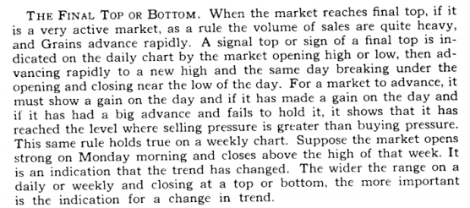

Look at chart (A) Disney.

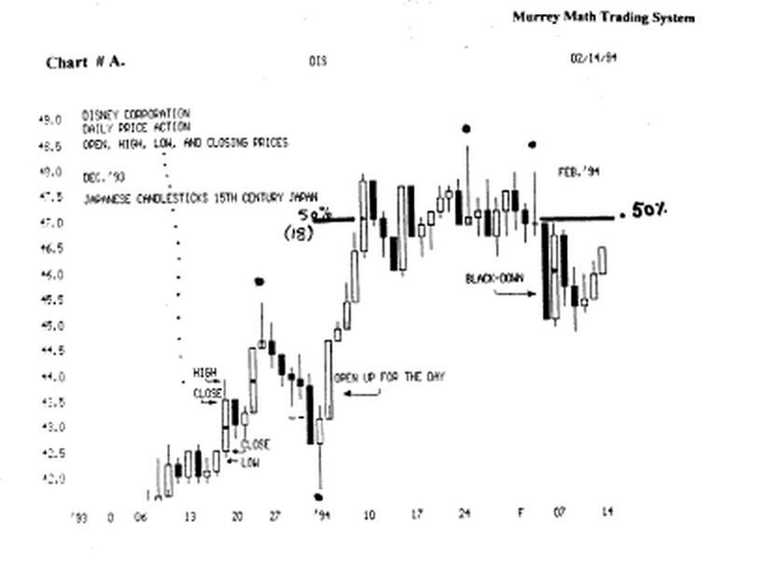

I have placed a (black dot) above these 3 different examples of the same daily activity, that show why this daily action

Signals a reverse in trend. We see that it gave us a signal from the down side, Jan.,'94.

Notice the "doji" Feb.,'94, it was the 2^{ad} signal to tell us that Disney was to go lower.

Sometimes it may be as long as (4 to 7 rule) days, before we see it fall, although we may get a strong reversal signal.

Look at chart # 13. P.N.C.

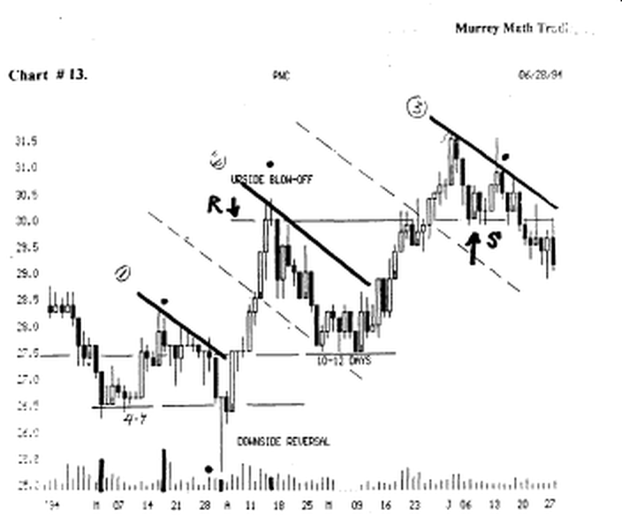

Find the (black dot), (upside blow off), this reversal signal was not as long as the Disney signals, but the effect was the same: it reversed and fell.

Notice the "classic" reversal signal at the bottom (black dot), it was a 1.4/8, point reverse.

It opened and closed on the same price on the day. And the volume for the day was lower than the past.

Look at chart 17. General Motors, (weekly).

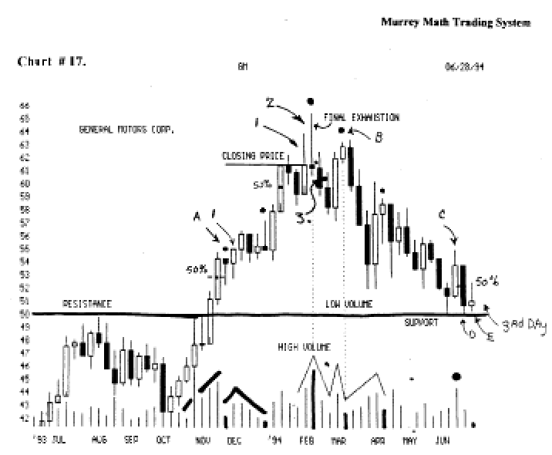

Notice that it ran up on the week almost 4.00 points, then it reversed and closed on the same price on Friday, that it had opened on the previous Monday.

It had extremely high volume, and it had made a run up from 43.3/8, to 62.4/8, so it wanted to sell off, and run back down to its moving average.

It fell for 2 weeks, thaï it tried to close and make a new high, which it did, then it had a week wrth narrow price range, with extremely low volume.

So it lacked follow through, so it fell back for support, and they sold it off all the way back down to the old (resistance) Line, at 50.00.

Look at chart # 72. Wells Fargo.

Find (a), this is a classic upside reversal, since this stock went up from 120.0 to 125.0 in just one day, then fell back to the opening price, and closed a loser on the day.

Since it had run from 103.00 up to 126.0 in just 8 days, it was tinte for it to reverse, and go back down to its moving average. Guess what ?

It was selling below this (78° angle) support level just 5 days later.

The "buy and hold" traders went on vacation after the first 17.00 point move up, and when they got back home 1 week later, not only did they owe their credit cards $ 1,000.00, they had lost $ 1,000.00 per 1,000 shares in wells Fargo.

But they were patient, and since they didn't sell with a 17.00 point run up, they watched it go down to 96.00, where they sold it and took a 7.00 point loss, but his family had a great time in Florida.

And after all isn't that what life is all about ?

Look at chart # 8. Federal Express Corp.

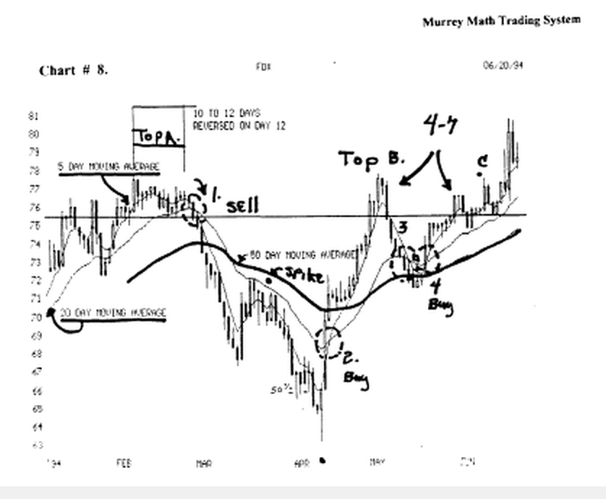

Find the (black dot), Apr.,'94, and how it had a reversal signal day, by selling off on the day, down to 63.00, then it reversed and closed the day back up at 66.00, (3.00 point reversal intra - day).

Notice that it closed higher than the previous day's activity, and it stalled out on the 50 % line of the lowest day, before the pivot, so when it crossed the 50 % Line, it had no resistance to fall back, then it broke through to the up side by 4.00 points, then 12 trading days later, it was trading up against its old high, ( 78.00 ).

Then it fell, back for support, down at the moving average, then it reversed and moved back up to the old high.
If we just "eye bail" the (top b), 78.00, and 63.00 (black dot), we see that the difference, or the fall from the high was about 37.5 % off the high.

Look at chart # 30. C.T.X. (weekly)

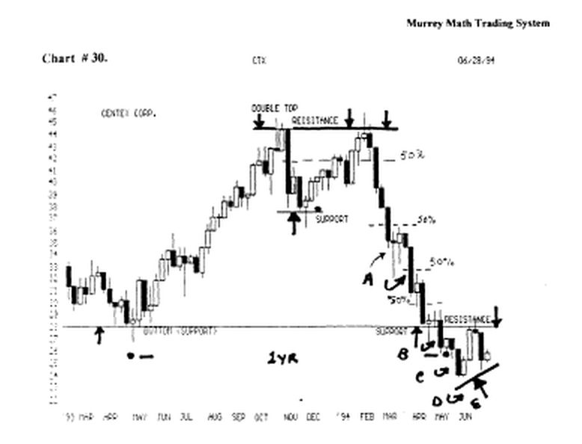

find the (black dot) Apr.,'93, and the small reversal signal that was only 1 .00 point, but the result was me same.

It gave the same reversal signal at (double top), but it took 2 weeks to fall, then at (support) it gave another reversal signal, then it went up and met resistance up at the old (double top), Feb.,'94.

Then it fell sharply back down to the support Line, but it couldn't hold, so it went lower for support down at 25.00.
Look at (a), the reversal signal in Mardi, '94. But this signal was false.

The next week it gave another reversal signal, but it couldn't move higher than the 50 % line of the last down week.
This is why we should enter no more than 50 % of our position, before it closes above the 50 % Line.

It gave the same "false signal" at (b), and at (c), but it couldn't move back above the 50 % Line, "3" times in a row.

A great lesson should be learned from recognizing these "classic" signals one must be careful upon where you enter a position, and how much you invest.

We must "buy the bounce" but we must enter only 50 % in some instances, and give up some of the overall profit, to insure that we are following the true trend of the market, or stock, or commodity.
************************************************
The most obvious question is not "how much" and "when" or "at what price", but, the more important question is "how small a loss are you willing to take, and get out, before it falls too far?"
********************************************
it is important to state here, that every example presented here, works, or proves the point W.D. Gann was trying to make, but one must learn to react to a failure of a stock to follow through and continue in the direction of the "classic signal" for we have just seen 3 instances, where the signal to reverse and move up was given.

But it couldn't break above the 50 % Line, and move back up toward the old highs.

This book, not only explains the 64 most predictable rules to winning trades, but it shall also be responsible to "fine tune" the trading rules, past just giving a rule, and leaving it at that.
Because, for every perfect rule, there is (we just saw 3 examples) an exception, that makes a good rule turn into a losing trade.

Just as the "buy and hold" trader went to Florida, after entering a position.

Look at chart # 72. Wells Fargo,

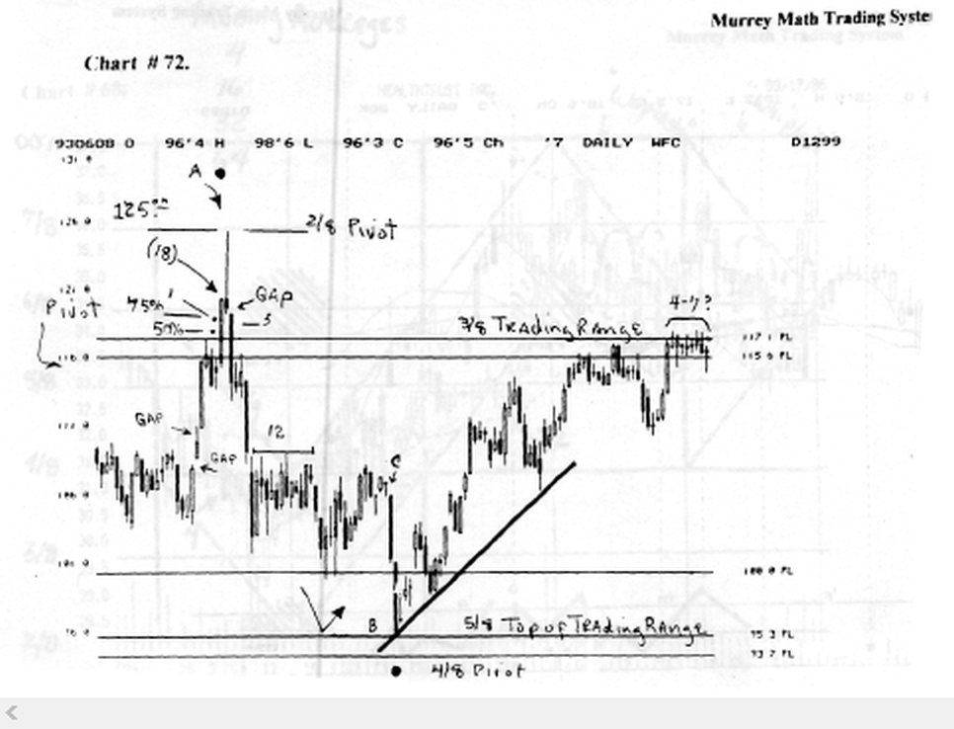

down at 103.00, (Apr.,'93), and called his broker 8 days later, and was told that it was up at 125.00, so he went back to the pool and told his wife that they had made $ 22,000.00 profit per 1,000 shares, so she decided to have them stay just one more week, and maybe they would make even more profits.

As we have already learned, it fell the next 5 days, and it was lower than it was when they went to Florida, we must keep "in touch" with what our stock is doing every day, and we should be prepared to take an 18 % profit in the shortest period of time. (we must buy at least 1,000 shares per trade).

All of the 18 % profit traders, bought at 103.00, and they immediately set their profit goal (18 %), to see where they wanted to exit.

Now multiply 103.0, by 1.18 %, and it equals 121.54.
Now let's look at chart #72Wells Fargo(W.F.C.). Find the (18), on the chart.

It took only 7 trading days to give us our minimum profit.
The next day it went up an additional 4.00 points, but we were already out of this position, although it ran on up, and we gave up 4.00 points of easy money, but the "3°*" day, it was selling for 112.50, some 9.00 points below our "sell out."
************************************************
18 % profit = $ 22,000.00 In just 7 trading days. We
should be so lucky !
**************************************** ********
W.D. Gann described a reverse signal day on page 318. ....if on this same day, it is a gap day and a lirait day (explained later), it is of greater importance for a change in trend....a reverse signal day in a declining market - after a prolonged decline the end often comes with a wide swing and a sudden sharp decline....do not overlook the fact that a change in trend can come on a reverse signal day, especially when prices have been declining for 7 to 10 days and possibly as much as 14 days without ever crossing the high of the previous day....page 319.

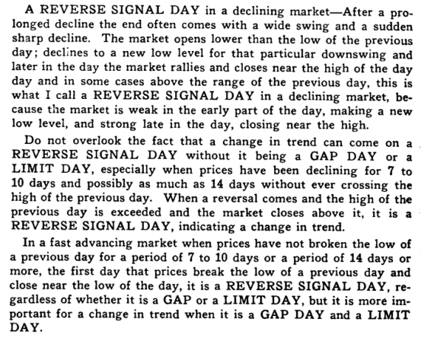
The cause of gaps is usually due to some sensational or unexpected news which comes overnight....page 320.

Exhaust gaps can occur on the extreme low day, the same as they can occur at an extreme high....buy the first time the market goes above the high of the gap day....page 321. The number of gaps that occur in a major swing or a long campaign are quite important.

As a general rule, when 3 to 4 consecutive gaps have occurred in new high territory in an advancing market or new low ground in a declining market, the price is near a culmination for some kind of a reverse move by the time me third or fourth gap is made.

But often, counting within the gaps, there may be as niany a 6 to 7 gaps before a culmination and in extreme cases as many as 10 gaps may occur. Some of them may be filled with a reaction running 2 t o3 days, but quite a few will be left before me market reverses and starts to fill the gaps."

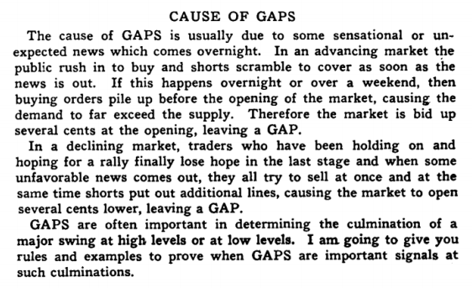

Look at chart # 73. Cotton.

See the word (gap) the 1st of May,'94. ft opened gapped up and traded in a narrow range, and closed on the high for the day.

It gapped 5 trading days in a row, then it gapped back down to old support at 80.00.

This 2nd (gap) was critical. This was to be the new ceiling. Short term.

It gapped again on day 6 through 20.

What is a gap ? This is when the daily activity of the open of the next trading day is higher or lower than the close or open of the previous day.

Notice that it never could close above the first wide gap day, the 1st trading day of May,'94.

There are 3 "classic" signals telling us that a change in direction is soon.

Look at the "doji" above the number 13. This is a change in direction signal.

The next signal came at # 14, when it gave us a small hangman, then at # 17, it gave us an "evening star" with a gap the next day.

Then at the (black dot) we had an "abandoned baby" signal. And we all can see the rest.

It fell for 13 trading sessions, so we knew that A should stall, and want to reverse back up toward its old highs.
Isn't it funny how it traded between 76.00 and 79.00 for the entire month of Mardi,'94, then it ran up vertically for 15 trading sessions, until it stalled.

We saw 20 gaps in this time period: then it got tired and sank below the very reason that sent it higher originally.

Stocks will not gap as many times as commodities. Stocks will gap once, twice or even 3 times, then they will settle down to a more normal trading trend.

But, just as they go up vertically on great news, we should expert to take a profit and wait for a retracement of at least the last 2 gaps, after it has run up too far above its moving average.

Some traders call these gaps (windows).

There is a general rule that gaps created on news will come back to be filled or touched sometime in the future.
We may not want to believe this rule, but it is better to not test it, than it is to ignore it.

Look at chart # 72. W.F.C. (Wells Fargo).

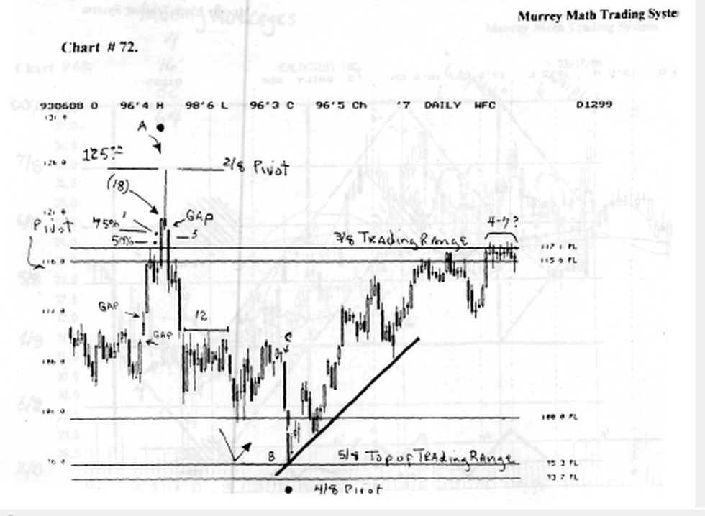

It gapped up twice in Apr.,'93, and ran all the way up to 125.00, from 103.00.

But it ran up in 8 trading days, and 8 trading days later, it gapped down past its 1st gap, closing the original gap, not even stopping to look back.

It gapped down again at (12), and at (c). It gapped again, to finally base out at 95.3/8. It gapped back up above 100.:see the (black dot).

It gapped down here 4 straight trading days. This was a definite reversal signal.

It formed a higher low base just 9 trading days later and bounced off this trend line a 3rd time, to take it to higher levels.

This stock formed a "church steeple," or a "tower top." It fell as fast and exactly as it went up to newer highs.
That was an exciting period of time for this stock to be trading.

Can you imagine: buying in at 103.00, then selling out 3 days later up at 116.00: then kicking yourself, because it went on up to 125.00, and we were out: then it fell back to 96.00 and we entered again, down at its first gapped up reversal day.
And made money on it again.

Day 3 is the critical day to mark the reversal or final exhaustion day:
"3rd Day" (pivot or reverse sell or buy signal)

I have spoken several times about the "hangman" and it is generally a sell signal except for the exception I mentioned earlier on chart # 32. Bethlehem Steel, where it formed a (stall out) "hangman" but it didn't open up the next Monday lower, so you would have been faked out, with a little loss, had you gone short, before it had dropped on the 3rd day.

And this what the 3rd day means. the 1st day, is actually the last up day, in a fast vertical climb, and the 2nd day, is the pivot day, which in this case, is the "hangman" and you may see it in just a minute, and the reverse day, is the 3rd day, when you short it more than 39 cents below the closing price of the last up day.

Look at chart # 57.1.B.M. t

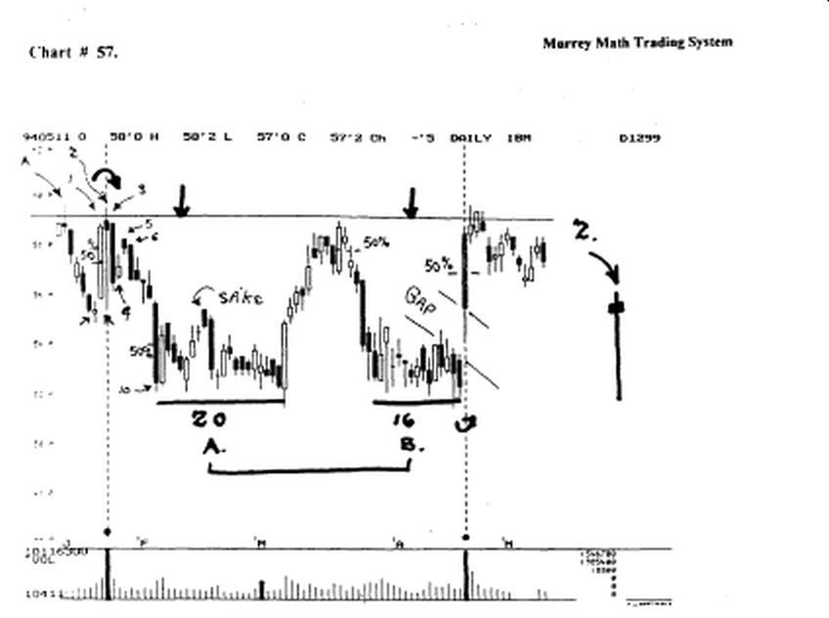

Trading stocks, and looking at charts, are like going deer hunting with a "boom box" and a lot of Cologne on, you can't see what you want to see, for what you are hearing, and you smell too strong for the wrong animal, to get them close to you, especially, if you are down wind.

If you look to the right of the page, (see 2) you will see a man hanging from the neck, choking on his decision to run this stock back up, on the day, by all the traders who are just plain "dumb."

Now look back to the left side and find the (2), and just like the deer, is hiding in die middle of the bushes, tall and still, the answer is starring you right in the face to sell short, or close out this profit position, and get ready to buy it back cheaper.

You should short it where the arrow is pointing on the 5, which is below day # l.'s high close, and we should not close our position, unless it closes up more than 39 cents above the upside line (see 3).

The sell signal is at the bottom of the page , where I have marked the daily volume in a bold black Line. This day was an earnings "news day."

This was the 1st quarter of profits, after several quarters of losing money. The 8 million shares of volume excited a lot of brokers, and they reported the high volume, and large number of institutional blocks traded that day, so the big boys, who really drive the market, are in there pushing it up, or someone thought they were, until the final bell.

When just as the deer, who is still standing dead still among the tall shrubs, this stock, bas been petted with gun shot all day, all that happened was that it ended the day, at the very same price it started out: and that was a "hung jury." (nobody's trade counted today, for it went nowhere).

Ten days later, all those fundamentalists, who buy with a good profit margin, and profits in the black, reported back to their clients that they had, in just 2 weeks of good news, lost their clients 14 % of their usable cash in this stock.

If you look back to (A), you see that the stock had already moved up to the Line, just 7 days prior, to the earnings report, and it had tanked, to get ready for the bad news, if the earnings were bad again.

But somebody, declared that the news was good, and it went back up vertically, on a 78° angle, to test its old high, and the same people who shorted it down, turned, and rode it up, and then shorted it again, and drove it back down, to 3.00 points lower than it had pivoted at 53.00, just 10 days earlier.
ft Consolidated for 20 days, and then reversed, and went back up to test its "hangman" high (2), and it fell short of the line by 39 cents, which is a sell signal, if it doesn't move up and close above the line the next day, but they shorted it once again, and drove it back down to test its old lows, where it Consolidated this time for 16 trading days.

But this time, everyone got smarter, because they sat back and waited for the quarterly reports to be announced, before they jumped all over it. The reports were good, another small profit, and it gapped up 2.00 points, on me open, and ran back up to test its old (2) hangman" a 3rd time, but it could close above the Line, only 1 day, which meant that it was tired.

So it had to fell back for support, but it wasn't going to drop back as low this time, because it had 2 quarters of good earnings, so it would have 3, and then 4, and every low retracement, would be a buying opportunity, until it went back up to 75.00, and then it would slow down, into smaller price ranges, so that earnings could catch up with the higher prices, (late '94).

(notice how important the 50 % mark of an extremely large candle exerts itself, to be an automatic support, or resistance point for the stock?).

I have marked 3 (50 %) candies, that exerted great pressure on this stock, since the daily range of activity was extremely wide, for its normal activity.

Look at chart # IT. General Motors.(weekly)

This time me opposite daily activity occurred and the same result happened: the stock fell back down to its (resistance Line), which had now become its (support) line.

The 1st day, again, was the last up day, and the 2nd day was a "shooting star" or as W.D. Gann called it on page on page 60, (some 200 years later) without ever talking with Muneshia Homma (Japan 1724), called it a "shooting star," because the average rice farmer in Japan could only count, not read nor write, for many of the Japanese symbols meant words, and they had to plant their fields by hand, which meant long hours, which meant that the price went way up in the morning, then sold off hard and strong, back down to its opening price, and here once again, all brokers will tell you that the news is great, and that large blocks are driving the price up, but in the afternoon, when the real traders step in to take a profit, they sell it off, and make an intraday profit of 2.00 points, and laugh, while everyone else went out to play golf, and court their mid day profits, that disappeared on the closing bell.

Again, on the 3rd day, at (3) we would have shorted the stock, and been right, for only 2 days, but we would have closed our position, more than 39 cents above the closing price of day (1), and we would have saved maybe 1.00 point.

Then we would have shorted it once again, when it moved back down past (3), and we would have been correct this time, all the way back down to 50.00, which if you divide 100. by 2 = the major 50 % line (MML), which we do know now, or should learn, is the greatest place to buy a stock that has fallen off its high, and bas reversed on its major support Line.

Once again, the answer is down at the bottom of the page, where we see that it has had a "final exhaustion day" or "evening star," on extremely high volume, which was the climax, of activity, for the real traders. The rookies tried to take it back up, to test and break through the "3rd" day but it couldn't.

This simple signal saved you 25 % of your capital !

Look at chart # 72. W.F.C. (Wells Fargo), it ran up at (1) from 155.0 to 120.0, then at (a) it ran up again from 120.0 to 125.0, then reversed back down to close below the close of the previous day.

This day was a gap day.

Then, on the pivot day (3), it gapped down again, and fell below the 75 % point of the last up day.

Then it couldn't hold the 50 % line of the last up day, then it really tanked.

If it can't hold above the 50 % line, of the last up day, the down side is under way.

We see the result: a large sell off.

Look at chart # 42. Gaylord Entertainment Corp,
(weekly).

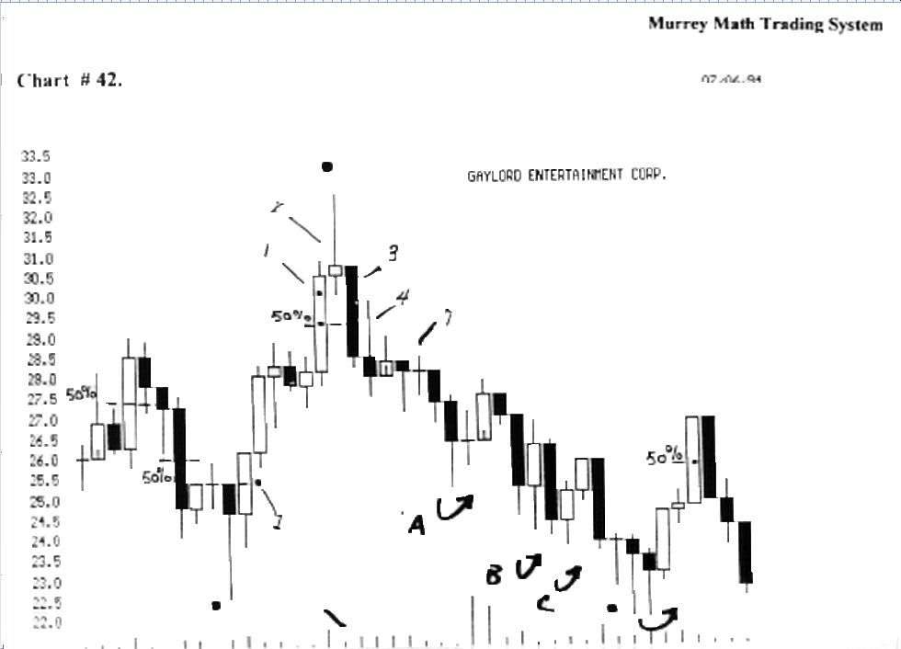

This is a classic example of a final exhaustion reversal, along with the influences of the 50 %, and 75 % support or resistance of the last up day.

ft formed a "reverse hammer" at (4), then it moved sideways for 3 more weeks.

Until, on week (7) it formed a small "doji" signaling a reversal in direction soon.

ft fell the next week all the way back down to just 39 cents below its previous low at 22.4/8 back in Nov.,'93.

Then, in May,'94, it formed a "doji" (black dot), the next week it formed a "morning star" then it formed another "morning star" then it finally turned up on the 4th week. It may take 4 weeks to turn it up or down.

Look back to chart # 72. W.F.C. (Wells Fargo): and our final exhaustion gap.

We must come to the conclusion that all stocks want to zig zag through time, not go straight up or down.
When it gets ahead of its moving average too fast, we must expect it to reverse and try and gain its equilibrium, and come back to its moving average.

It is easy to sit here and look at the past and say why it did what it did.

But, we must "buy the bounce" and sell the bump" of any stock. The more extreme the last run, the more pronounced should be the bounce.

Just "eye bail" each high / low retracement and look and see if it reversed after a retracement of 12.5 %, 25.0 %, 37.5 %, 50.0 %, or 62.5 %, or 75.0 %.

We may observe that most moves are 25.0 % or 37.5 %: which is about 3.00 points.

How many times would you have been correct and not left much profit on the table, if we had sold out every time it went up 2.50 points

We would have won 7 tunes, using this simple rule. We would have pocketed 21 points, or $ 21,000.00 profit, per 1,000 shares traded.

And this stock has ended up losing 1.00 point the past 9 months.

But, you didn't know the future, (where h has ended up, before h gets there), so we must sell every time we meet our profit objective, then let the future take care of itself.

Had we bought in at 56.0, we would have made 21.0 points from point (b).
Only 3 moves lasted longer than 3.00 points.
So why do we stay long, and let it retrace, and lose time?

Please find the word (weak) and look at the descending stairs of volume as the stock price fell. It had no volume, then it reversed on extremely high volume and went up for 8 straight trading days.

The Japanese said that no market should run up more than 10 days in a row, and we should sell all 78 ° angles that run up more than 37.5 %. Because the odds are that this upsurge is due to news !

Notice all the high volume at the 8th trading day.
It started the day at 59.5 and finished the day up at 62.0. This was a 2.50 move up in just one day.

Notice that it didn't even stop at the old high back in Feb.,'94.
The final topping out day, it opened the day at 62.00, then it moved up to 63.50, then finished the day back down at 62.3/8.

This is called a falling star.

We should look for a fall within 3 or 4 days (4 to 7 day rule).
It fell on day 2, Then all the late "traders" bought it back up to 62.00, on the 3rd day.

Then it had a small trading range on day 4, then the volume, fell back to less than 50 % of the final exhaustion topping out.

So, it fell just as fast as it rose, and fell (- 4/8.5), and stopped on a minor 50 % line between 2 Gann lines, then it went back up 50 % of the last high and low.

W.D. Gann said was the greatest resistance area, so it fell back for support, and stalled on the 50 % Line, which W.D. Gann said was the greatest place to buy a stock moving up.

And then in June,'94, it reversed off the 50 % line, back up to the 7/8 line, which is weak, then it fell back down to the 5/8 line, (top of the trading range), and it held above this line after 4 tries to fall, and it finally pushed back up to its old high.

3 months later, then it fell back to the 7/8 Line, which is weak, and it reversed back up toward the old high, but it could only go back up just 50 % (of a minor Gann Line).

Between the 100 % line and the 7/8 line.

It formed a lower high in August,'94, then it tanked when it couldn't go up to the old highs for the 3rd time. Notice that it stopped on the 5/8 line for 2 days, and it couldn't hold for support ( 4 to 7 day rule ), and on the 3rd day it closed below the 5/8 line.

Then it fell again back down to the 50 % line, which is major support, which should stall this stock, and it did, but for just 1 day, then it fell further back down toward the 3/8 line.

Now, we must use our brains for just a minute. Fibonacci said that all stocks want to stall after a 3/8 (37.5 %) fall, and it did.

After (-2/8.5) on the 5/8 line, then it stalled below the Line, after a (-3/8) fall.

Then it finally stalled out down after a Fibonacci ratio (- 5/8) retracement.

It stalled on a "Gann" minor 50 % Line, and retraced back up to the major 50 % line, which had previously been support on the way down, now becomes resistance on the way back up.

It fell back down to want to form a double bottom.

We would gain invaluable insight to the reactions of this stock, if we paid close attention to the direction of the U.S. 30 year treasury bond interest rates.

Look how many times this stock reversed after we set our (a) and (b), and after it had run 2/8, 3/8, or 5/8, or that it wants to pivot on a "Gann" minor 50 % Line, between Gann Lines.

The "buy and hold" traders want the (+ 5/8) move of 7.5 points, but we got only 1 in 10 months, and it went against them, and since they won't trade after a (-1- 2/8) move, they stayed and prayed every night, and said "l am in it for the long term, besides, it is a great stock."

We would have entered 11 trades over the past 10 months.
We would have won 9 of 11.

And would have sold every time we had made 3.00 points, so we would have made done it 7 times.

So we would have made 21.0 points, or 40 % in ten months, by just getting in every time it falls 2/8, 3/8, or 5/8 retracements.

We should pray for it to fall, so we could make a trade, on the way back up.

We never want to buy a stock, if it has already run up more than 3.00 points.

Why ? ft would stand to reason, that if any expert asked you to buy a winner, our first question should be: how high is it from its last low ? Then you will save yourself the "whip lash" of buying at the high, if it has already moved up past 3.00 points.

And the odds are greater of falling, than to keep moving up.
Remember, the faster a stock moves up, above its moving average, the faster it will retrace.

So, the faster we should sell, if it moves up past (+3/8) (+4/8), or (+5/8).

Ail stocks want to fall faster (vertically), than go up.
So we must not wait more than 1 day past our profit price, to sell on the high.

Or we will always wait another day, then another day, then another day, and we are still in our original position, ending up losing time, and unable to make up for the double lose, (time and profits), with only 3.00 points instead of 6.00.

But, if I trade more often, I must pay more broker's fees, which are extremely high !

Is there an alternative ? The world bas an answer for those traders, with a legitimate question.

Just the cost of one paper, and the cost of 2 phone calls, will net you a broker willing to run a transaction through the markets for just $ 65.00, per trade.

This brokerage firm, will not confuse you with one of the 40 "gossip reasons" to why individuals buy and sell every

These rules never guarantee anyone that he or she will ever make any money on any trade, because, even W.D. Gann lost 24 trades out of 288 in a 25 day trading period.

So we must accept small loses as a part of small gains. No system is perfect, just as these rules, are only guide Lines, to set up the best odds that we are buying or selling with the "general trend." ********************************************
Simple trading system to test on paper only

Just find a good stock (good fundamentals). Then wait for the stock market to fall 100 points, then let it hold for 2 days, find a stock in the top 20 stocks, that has fallen with the general market, and has reversed on a Gann line or a "Gann" minor 50 % line, after a fall of at least ( -2/8 ) or ( -3/8 ).

Then, look in the newspaper, Investor's Business Daily. then turn to the Sectors section.

This section tells us the leading sectors in the market today.
Then find a stock in top section; then find the stock alphabetically in its exchange.

Then we look at the 2 sets of numbers assigned to this stock, to tell us: 1) its position in its own sector, 2)and its profitability percentage over the past 5 years.

So we want a stock that is an (A) and above 85. Then we buy 1,000 shares.

We should place a stop 50 cents below our entry price.
And plan to sell it when it goes back up 3.00 points above the pivot point.

Never stay in your position, if your stock falls 50 cents below your stop.

It is impossible to always make much profit, but it is very simple to place a stop, as soon as you buy your stock and protect yourself against large losses.

A stop is just as important as the entry point.
************************************************
The entry price point is critical ! It must be as close to the "bounce Line" as possible.

The closer we buy near the bounce, the greater the odds are that we will make our 3.00 points.

We should never expert to make more than 3.00 points, on any up move,(stocks priced below 50.00 and higher than 12.00).
We say this as a general mie, which must be adjusted for each of the 8 different rhythms, that all stocks, or markets fall into, and which shall be discussed later, in the chapter, on each of the 8 rhythms, so that we don't fall into the same trap as everyone else, that we use 1 rule to cover all markets.

This trading System is based on Math (100%), at all times, with no exceptions, to the rules.

And, the longer we wait for the price to rise, (for confirmation), the less we shall make.

So we shall take our entry price, then go back down to the low (bounce) price, and deduct this difference from 3.00 points, and be happy to make this amount of profit for that particular trade.
************************************************
Remember that it took 10 up moves, that sold off, to finally get to the top.

And it took just 1 vertical fall, to wipe out 5 months of "praying" for it to go to new highs.

Move up your stop to protect profits

As your stock moves up, and especially, if it goes higher than our 3.00 point profit goals, then we should place a sell stop, 50 cents below our profit goal. As our stock moves higher, we keep moving up our stop to protect our profits.

If we get a (+ 2/8) or (+ 3/8) or (+ 5/8) profit, and it is up against an old high we should be ready to sell the first time it touches the old high.

And if it fails to reach the old high, or the Gann line, or the "Gann" minor 50 % line, by 19 cents or 39 cents for 2 to 4 days in a row, we should close out our position, and pocket the profits, and wait for it to fall, so we may buy it back again.

We should expect to trade several times on the way up to a new high, or previous high, but the trades on the way down will not last as long, or move up as high, as we would expert, when it is advancing.

We should expert only a (+ 2/8) or (+ 3/8) bounce, when a stock is going up in a falling market.

We got only a (+ 2/8) swing in Sept.,'94.

Traders love to take a profit on the way up, and anyone will sell out at any price on the way back down. So we should place a stop just below where we want to protect our profits from a fast, steep fall.

Let's use our brains again: how can we expect to make 3.00 points on a $ 12.50 stock, or only 3.00 points on a $ 87.50 stock.

We should expect a 3.00 point move off a stock trading between $ 37.50 and $ 62.50..

We must use the Law of Exact Proportion, and eut down our number of points proportionally, so that we would expert to make only 65 cents off a $ 2.00 stock, and more than $ 4.25 on a stock over $ 87.50.

All stocks, commodities, bonds, indexes exert an exact rhythm of price movement, as a reflection of its current price, and multiplied by 37.5 %, 50 %, or 62.5 %. We are able to measure the Fibonacci ratios exactly, by trading, using the Law of Exact Proportion, as it relates to these markets.
50 % of long candies (exert -support / resistance)

Look at chart # 42. G.E.T. (Gaylord Entertainment) (weekly).

Look at the(4) 50 % lines of long candies that exerted pressure on the price activity into the future.

When and if these 50 % Lines are broken, the direction will gain support or make it break down to lower lows.

It may take as many as 10 to 12 days, for a stock or market to break through the 50 % line of a long candle.

Look at chart # A. D.I.S. (Disney).

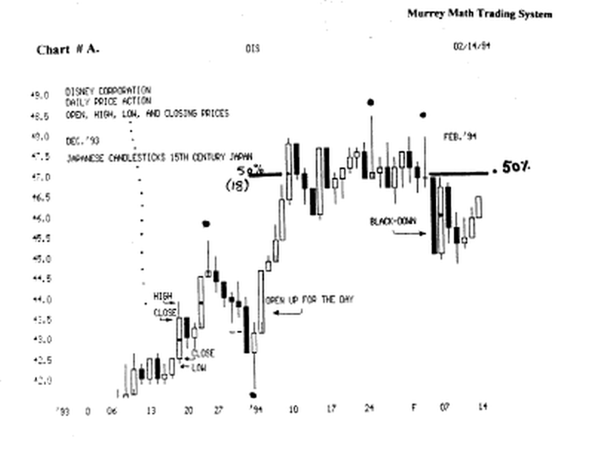

Find the (black dot) in the long up candle on the 10 th of January,'94.

That exerted the resistance pressure, for 18 trading days, before it finally fell back lower for support.

Look at chart # 5. G.E.T.

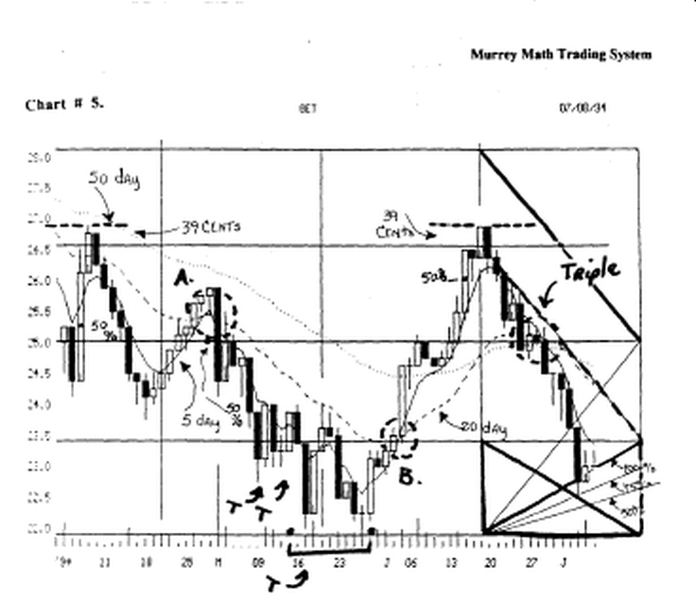

Find the first 50 % line, and see that it took 4 days to fall below this support line.

Look at the big fall in May,'94.

And it couldn't even get above the 50 % line the next day, then it fell fast to lower lows.

Find the June 15/94, long up candle, and that it reversed the next day off this 50 % Line, and 4 days later, it touched the 50 % line, and ran back up to close just 1/4 above the 50 % line.

The 5 th day it tanked.

Look at chart # 7. S.H.N. Shoney's (weekly).

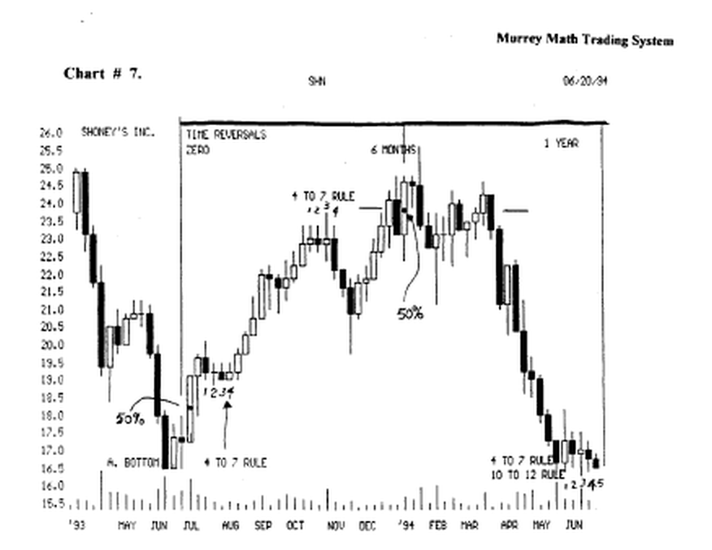

Find the 50 % line on the low. ft fell below the 50 % line, but it ended the week above the 50 % Line, and it finished the week above the previous week's high.

Then look at the 50 % line, on the 6 months line, it affected the support / resistance for the next 12 weeks, then it broke down and tanked on the 11 th week.

Look at chart #12. Munsingwear. (weekly).

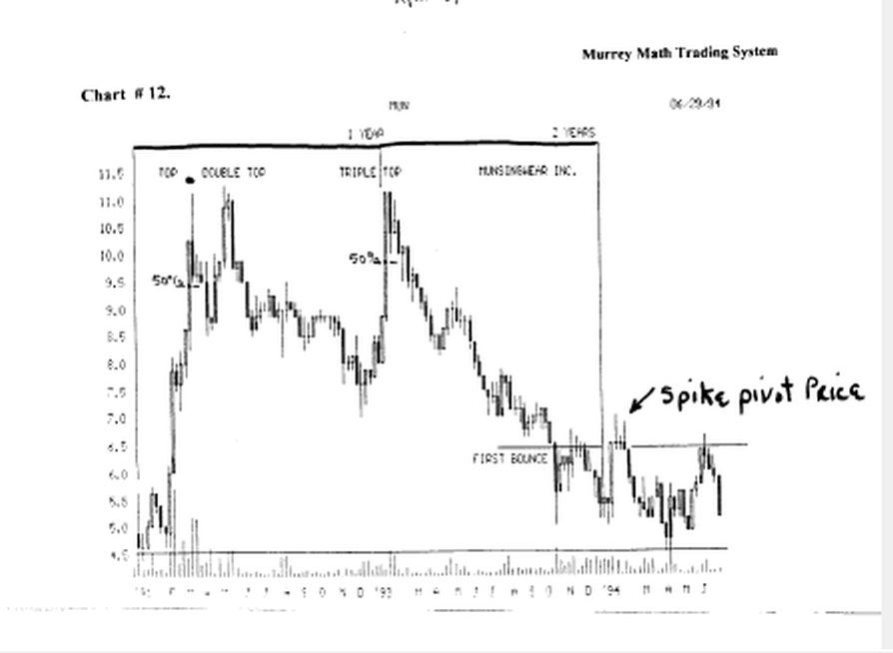

Find the 2 50 % dots in the middle of these 2 big up moves, and how it reversed off these lines of support until they can't hold it up any longer.

What 2 factors would make it break down ?

- time - how many times has it tried to hit the Line,
- how far does it trade above or below its 50 % line (it can't fall any former than 19 or 39 cents below the line)
- this is dependent upon the current price of your stock -
the higher the current price, the wider the spread that it could fall and still reverse, which shall be explained later in the math section.

Look at chart # 14. Merck. MRK. (weekly).

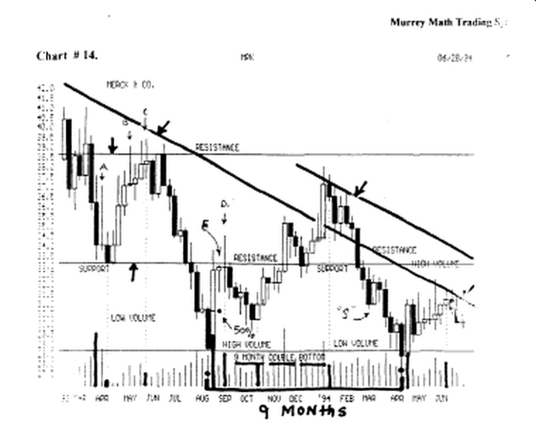

find the 50 % line, it fell below it by 39 cents, then reversed, and made a long run back up to 37.4/8.

We should short up at ( d ), and we should get out 50 % when it runs up against the 50 % line on the down side.

And if it reversed,. we don't lose much profit. We would go long again above the 50 % line.

Look at chart # 15. J.P.M. (weekly).

Find the 50 % line. Find the (a) "doji" and how it closed the week on the exact 50 % line.

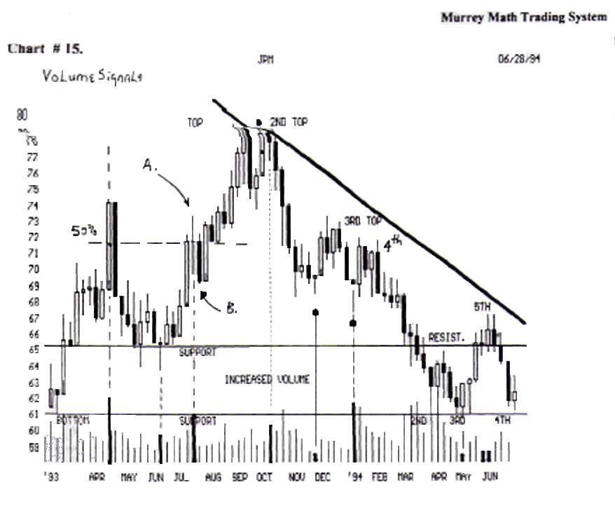

It closed below this line, more than 39 cents below the line, then it reversed the next week, and broke out above the 50 % line from 72.00 all the way up to 78.4/8.

We should go back and read the page 57.(S) Reversal rule. I am referring to (b) down week below the 50 % Line.

