Murrey Math Trading System Setting up Murrey Math Lines

Chapter One Part II A : Setting up Murrey Math Lines

We sport Part I, of this chapter, learning how to set our high / low "range of fluctuation" using the "best guess" method of starting of starting our trading System.

W D. Gann, when he asked us on page 34. "to take the extreme low and extreme high of any important move. Substract the low from the high to get the range. Then divide the range of fluctuations by 8 to get the range. Then divide the range of fluctuations by 8 to get the l/8 points, or 12. 1/2, 25 %, etc., which are resistance levels or buying or selling points."

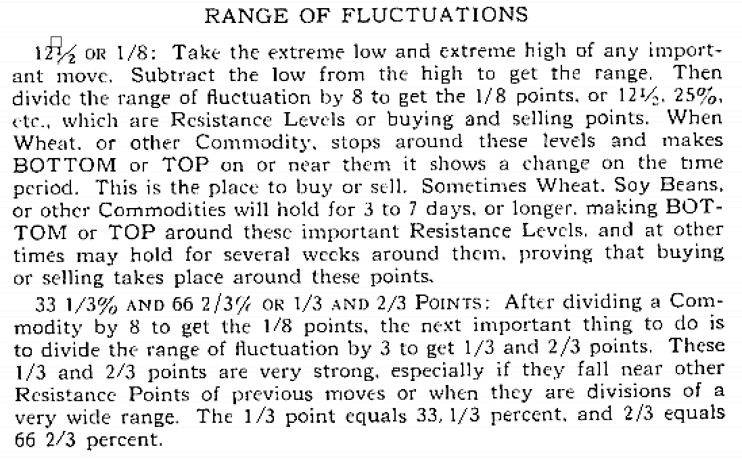

If we took W.D. Gann, at his word, to the Nth degree, one would have to go all the way back to a stock's all time high and low, to get the long term "feel" for what it is trying to do.

But, if 90 % of all traders are "buy and hold" investors, then, all they want to know, is one side of the price equation, and that is the low, looking back 6 months, for they only want to buy and then hold it for a long time, because, if it is a good buy today, it shall be a great buy next year.

Sadly enough, the U.S. Economy, usually runs in time cycles closer to 5 years in length. So, what would be a good long term investment today, may be when the market is within 12.5 % of its high, and you would have to wait, from 18 months, to 36 months, to get back your original position, if you always plan to "buy and hold."

And sadly enough, "buy and hold" investors, by definition of their title, don't want to have a clue, about where to "sell" any stock.

Just look at the price action of I.B.M. and D.E.C., over the past 12 years, and one would have to concede that these stocks may have been bought at around 50.00, and held up to as far as 175, and 200, and 'watched" faithfully, as they fell back down to 40.5/8, and 28 .18, here recently, only to have them rebound, somewhat.

Any trading system philosophy works. if your entry point into the market is set up with good timing, but, if your timing is off, then your "buy and hold" trading philosophy will cost you:

1) time, 2) money, 3) client confidence, which ultimately, is the driving force behind future investment participation.

So, if one astute "buy and hold" expert, took on 100 new brokers, to pass on this great trading philosophy, back at October 1987, they would have entered the market, when it was just 2 weeks short of the "Black Monday" of October, that sent the market down, that had almost finished running up, some 23 trading days in a row, for no more reason than "pame buying" at a top in a market.

After the "tickets" settled, some 2 weeks later, the 100 new "buy and hold" brokers were "solidly" entrenched in this "time honored" trading system, that proves itself to be true.

For they had told their clients, that if the market had gone up that fast, and that far, then everyone should enter a position, and get in, so they could keep nding the up wave, to even higher highs.

Basic fundamentalists, don't want to have their "attitude" messed with, by having a technicalist hint that any market is too high, and that it should correct itself, and fall back for support, at a lower price level!.

They learned the # 1. lesson of "buy and hold" of entering a vertical market too late in the up run, and it took the next 18 months, for the S & P 500 Cash Market to move back up to its old highs, and for them to recoup their losses, from October, 1987.

Then, the S & P 500 it sold off again, then it finally, moved back up and tested its old highs, then broke through, for good, the 2nd time.

The "buy and hold" investors were right again: if you wait long enough, you will always make a profit, from any trade, as long as the corporation stays in business.

But, sadly enough, all of those "innocently ignorant" Mutual Fund investors, who always thought that all one had to do, was to put your after tax profits, into a growth fund, and it would grow steadily each year, and just look at one's statement, at the end of each month, with no regard to trying to trade it, just as one would watch their children grow, without any guidance, or supervision, were sadly informed, at the end of the month, in October, 1987, that they too, had lost at least 25% of the accumulated value of their mutual fund portfolio.

Look at chart # 202 and 203).

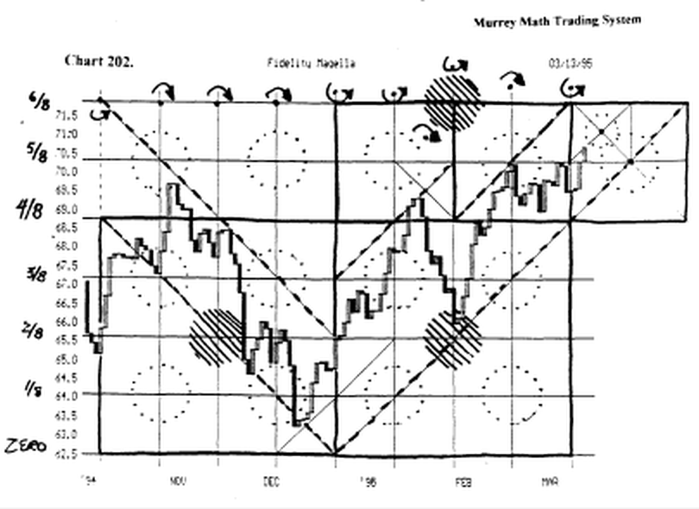

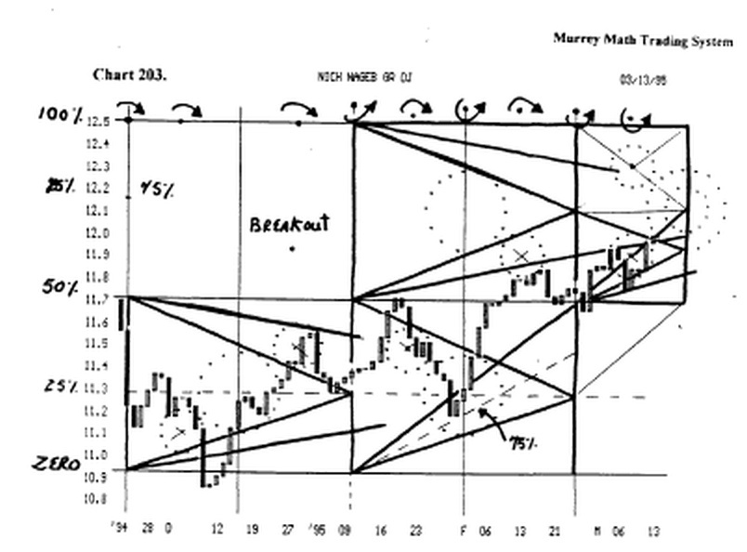

So, we have the one group, the "buy and hold" group", who want to only buy good stocks, at a low price, and hold on to them, as long as they are selling at a higher price, than where they entered the trade, or we have the "W. D. Gann school," who pick the extreme high and the low range" and plays this internal set of l/8th lines, then there is our group: trading under the purely mathematical fractal method: "The Murrey Math Trading System."

The "buy and hold group" requires that you buy only stocks, of good fundamental value, that are low in price.

But low relative to what, we might ask ?

The Murrey Math Trading System bas pre-set support lines for every stock, just below, where it is currently trading, and if it can't hold this price, we would close our position, or short the stock, to the downside.

Look at chart # 172. Chrysler. (C) (daily).

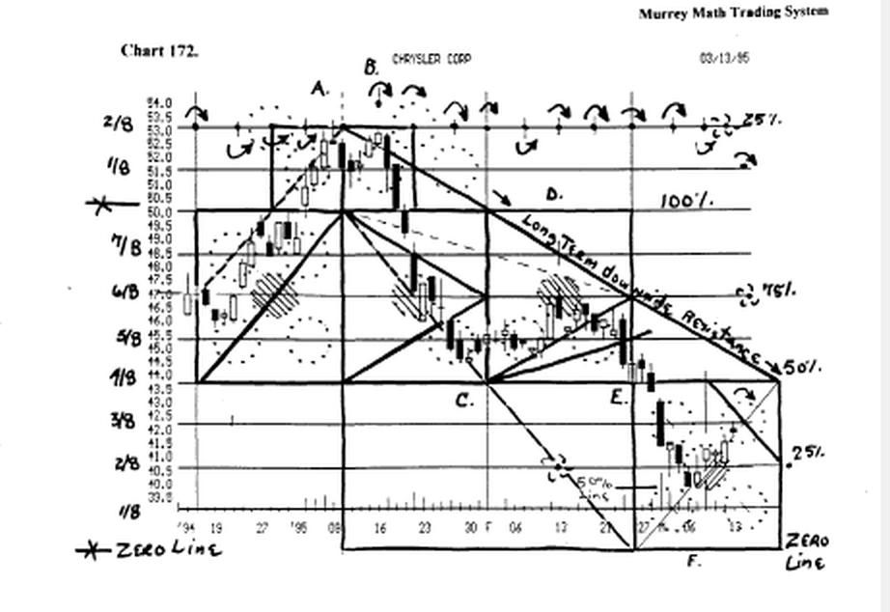

A perfect example of a stock failing to hold its pre-set support line, may seen easiest, through a "real life experience" occurring yesterday through the phone call I got from a friend of mine, Margaret M., who asked me to run the "Murrey Math lines" on the stock, Chrysler.

Her broker fell that since it had sold off, from 53.125, on a double top, that back down here at 43. 1/2, was a good safe place to go long. After all, it had sold off almost 24 %, from its high back up at 53.18.

When she called, 1 told her that the "Murrey Math Line" that it must hold was 43.75.

And we would have to see this stock close the day, up at 43.7/8, before we could hope for it to be closing above its support line, and that it must close above this price for 4 days in a row, to be considered, having built up enough of a stalled-out base, for other traders to come in and want to buy it back up toward its old high at 53.125.

We watched it close the day at 43.1/2, and on its low for the day, on higher volume, than the amount of volume, for the previous day's activity.

This was our signal to give it one more day to prove, if it could reverse, and close above 43.75.

It violated its pre-set support line, by closing the day, below the Line, and the last sell of the day, was a sell, which was even more "bearish."

It opened the next day down, and at this time,(the very-next day) it has slipped down to 42.125, on higher volume.

She called me today, and we have decided to watch it for the next 3 days, and make it prove to us, rule # 1. (in the simplest trading System, no matter whose System one is trading, and that is, is this the bottom ?

We decided that we will know that it has bottomed out, because of:

- it reverses off its low, and closes up on the day more than 50 % of the previous day's range of activity,

- it sits on 42.125, for at least 4 days in a row.

We would gladly be 75 cents late getting in, than to just jump in, on the first day, and watch it fall, the 2nd day to a new low.

We would have a trading "stop" that would protect our entry position, just as we would have a "trailing stop" to protect our profits, after we enter a position.

Pure math told us, that just because it was 23 % cheaper, than its last high, it still wanted to fall even lower, for more support, where traders will come back in and want to support it, by buying more than they want to sell it.

"Murrey Math line" 42.125th is a good support line for this stock. If it were to close the day, at this price, then we would first, check the general direction of the Dow 30 Stocks, and the "Fosback Seasonality" of the overall market, and enter a "buy" for this stock up at 40.3/8, and stay long, only if it closes the next day above our entry price, we would expect to sell 50 % of ' our position, back up at 43.3/4, when it hits this ceiling, which had just been our support line, just 2 days ago.

The only guarantee is that if it runs from 40.125, back up to 43.3/4, you will never, ever lose money if you sell 50 % of your position, each time your stock runs up against a ceiling, or upper resistance line, which was once support.

Ironically, it fell the next day to 40.125, where everyone came in fast, to buy it off its low, back up to 40.7/8 for the day. This formed a "morning star."

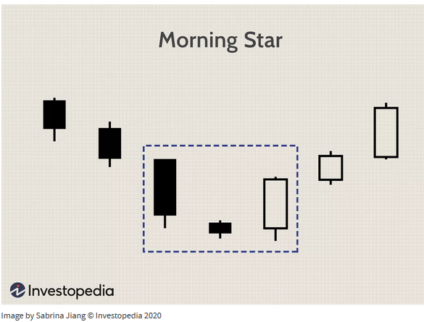

- A morning star is a visual pattern made up of a tall black candlestick, a smaller black or white candlestick with a short body and long wicks, and a third tall white candlestick.
- The middle candle of the morning star captures a moment of market indecision where the bears begin to give way to bulls. The third candle confirms the reversal and can mark a new uptrend.
- The opposite pattern to a morning star is the evening star, which signals a reversal of an uptrend into a downtrend.

But, the general market is selling off its all time high, and today, is the last trading day of Fosback's Seasonality" and it is also Friday, so the odds are greater that it would want to consolidate, so we have "time" on our side.

Besides, it must be able to hold up here, and not fall below its closing price from yesterday, to prove to us that it wants to move higher.

Presently, it is 3 trading days later, and it has closed down at 39.3/4: which is 4.00 points lower, than where her broker had advised her to buy Chrysler.

It must close higher than the previous day's close at least 2 days in a row, and above its support Line for at least 4 to 7 days in a row, to prove that it has stalled out the downside action.

My friend Margaret M. called me Friday morning, with the Dow 30 stocks up over 50 points, and Chrysler was still selling down at 39.3/4, and so we decide to put in a buy order up at 40.125, so we would be in our position, on the upside. It finished the day, at 41.1/2, up 3/8 ths on the day, with 2.1 million shares traded.

We feel good that it has reversed its downside retreat, and we shall get ready to sell out if it touches 43.3/4, within the next 3 to 5 days.

Today, the Labor report came out, calling for a slightly inflationary bias, but the U.S. Dollar was up strong, and everyone took this momentum into the stock market, and tried to set another record high, for the Dow 30 stocks.

Lastly, one must follow the direction of the U.S. 30 Year Bond Market, and the direction of the U.S. Dollar.

If both of these are falling, then any great upside move will be stalled out. (this sounds like we are following "fundamentals" but this is called "common sense" that astute "traders" acquire from years of being "whip lashed" and not knowing why, because their "scope" of "what is really happening" is either too wide, or too narrow, to be able to integrate it into our "entry" and "exit" points of trading.

Incidentally, the U.S. Dollar tanked Sunday night, all over the world, so the Dow 30 stocks were down 35 points on the open Monday, kept the downward pressure on Chrysler, to want to fell, even lower, and it did.

The only way to know how smart you were, in what you just did, is to always take a profit, with 50 % of your position, and you are always on the winning side of your trading philosophy.

"The Murrey Math Trading System" forces you to avoid the one "Human Characteristic" that must be mathematically controlled, and (it can only be handled with math) and that is "greed." You must always set a price to profit objective, with 50 % of your shares invested, each time you enter a position.

This allows you to "always" make money on even,-trade you enter, or to never lose any more than the amount of your "trailing stop" which shall never be any lower than 7/8ths below your entry price.

They can never take money away from you, that you have already taken out of the market, in the form called "protected profit."

Besides, if it moves higher, your 50 % equity, will keep growing, and the next time it stalls out you will close out that position, and wait for a retrace, to re enter your position, at a cheaper price.

The "buy and hold" people in the back of the room, are raising their arms, wanting to dispute the very stock that I have just used as an example, for they are wanting to tell me that they bought it back at 6.1/4, when all the papers were saying that it was going bankrupt, just to hold it all the way up to 53., so that it doesn't bother them to give back 11.0 points, for they are still 36.0 points ahead.

Remember that is the same thing the "buy and hold" team adhered to, when I.B.M. and D.E.C. were selling up at 175., and 200., just a few years ago.

And their same logic lost them all their profits, plus all that time in the trade, when they could have been finding another stock back up.

Then, we must sit and wait for a stock to raake a wide advance or decline, so that it meets the initial requirement, so that we may set our l/8th retracements, off this internal difference, and then play the poker game off 2 "givens" which are the high and the low.

"The Murrey Math Trading System" is similarly simple, for it too, requires only one price to begin with, and that is the current price, at lunch time today (or any day, for that matter, for we know that a lot of people go to work, just to eat their lunch).

Presently, it is 2 days later, and Chrysler has fallen down to 40.3/8, which is 3.00 points lower, than where her "broker" had called and told her, that it was a good buy, to reverse, and move back up.

In order to set up our trading parameters, one must start with only the current price at lunch time each day.

Now, we may start making some definite inferences about its future.

We need to now ask the same question that the "buy and hold" investors asked, and that is, "what was the last low ?"

And we need to ask the same question that W.D. Gann needed to fill in the equation, and that is, "what was the last high ?"

We purport to understand that since all stocks travel through a perfect fractal, to the right through time, all one has to know is the current price, to "feel" the rhythm for any particular "publicly" traded stock or commodity, or Index.

Just as your brain already knows about the "Square in time" before you are aware of it, so does your brain know how to set the Law of Exact Proportion, to the price of Bananas, golf clubs, cars, boats, or houses, but you don't have a clue how to set a pure mathematically set of "price action" support or resistance lines, that are already setting there in front of you.

Ironically, find any stock, that is trading between, any of only 8 different "Murrey Math rhythm Settings" and any other stock trading in that same price range, will want to move with and against the same set "constant" price support and resistance lines.

************************************************
So, this trading System, reduces the amount of time, needed to set up all your support and resistance lines, for all that is required is any set of 8, which is always an exponent of merely its current price.

This trading System has never been presented to the financial world before. But it is 18 months old.

You are going to have to listen, learn, believe, and trade successfully, within the restraints of its rules, to be able to share this universal knowledge, with your family, and pass on to your friends, and fellow traders. ****************************************

Copernicus, was held to be a "heretic" for daring to say that the "Sun" did not rotate around the earth each day (and you still believe it, for you have no proof otherwise, right now, today, unless you have been in a space capsule, rotating around the Earth, or sitting in a Landing Module on the Moon).

Just as equally laughable, was the notion that the Earth was flat, when all one would have to do, is to drive down to Florida, and look out to the horizon, and walk as far as one could see to the left and to the right, and these 2 added distances would equal 12.25 miles, which would equal an exact l/8th of a larger number, in proportion of the number 25,000 miles, which for us, is close enough, to the circumference of the Earth.

One might simply ask the obvious question: "How does one observe an object (the Earth at the ocean) that appears to be curved, exactly where one is standing, then as we walk left or right for an additional 6.10 miles, we find that the water filled horizon continues to look curved to the point that we are now standing, just as it looked curved, back at the previous point of reference, along the same beach ?"

If one were to reduce themselves to the size of a basketball, then one would draw the conclusion, that yes, the Earth is round.

"But, this is a ridiculous analogy, for anyone one knows, that there were no basketballs at the time Columbus, who went to the church, and then on to Queen Isabella, with the notion, that by sailing west from Europe, one would reach India," one astute student of the game of basketball retorted, from the back of the room , when I was on a roll, building credibility, in my trading System !

I merely smiled and said that I should have known that, one individual. would have brought up, the names of Edwin Hubble, or Pythagoras 1,000 B.C., who had already addressed all geometrical rationales to whether or not the Earth is, indeed, round, or for that matter, that a basketball is really round, (actually the basketball is more round than the Earth, but that is a discussion for another group).

Why do I even go to the trouble to try and parallel the stories about the Earth and the Sun, and the fact that the Earth is really round ?

Simple ! You are perplexed, and others shall laugh at you, when you try and help them improve their trading entry or exit points based on the purely mathematical fractal trading System that Never Ever considers the Fundamentals of the stock or market you are trading.

"The Murrey Math Trading System" pre-sets the support and resistance Lines for every stock, or market, years in advance, long before it ever gets up to that price.

How does it do it ? Simple !

This is the basic premise of "The Murrey Math Trading System," which states: every traded stock, or market, or Index, is currently trading,(current price) within 12.5 % of a larger 12.5 %, which it may sometime, in the future, trade at 12.5 % of a higher exact mathematical price.

Conversely, it may also be: at its current price, and trade down into a lower 12.5 %. of a lower 12.5 %, and even fall into a lower 12.5% of this smaller 12.5 %.

All moves of a stock, reflect, price movement, up or down, always, directly proportional, to its current price, and the direction in which it is now trading:

a) up to its next larger 12.5 %,
and b) down to its next immediate 12.5 %, below its current price.

****•****************••*******•*«**••***«**«*«**
The semantics, logic, rhythm, and math of what I have just said are so diametrically opposed to what you have been taught about trading all stocks, that you want to reject, dispute, disbelieve, or even ignore, the simplest fact, that, if you follow, my simple trading System, you will make more money, with less effort, and with less time spent in the stock market.
************************************************
You will learn how to stay out of the market 40 % of the time, and be out, the correct 40 %. Or more simply put, you will not always enter a "buy" position, just because you are told that a stock is cheap, and presently a good "buy and hold" opportunity for your portfolio

This trading System is a little bit more complicated than the 10 Commandments: One must be instructed, how to:

- set the 12.5 % mathematical lines,
- recognize the mathematical high / low (support
resistance) your stock is trying to run to,
- set the vertical price lines, and their significance,
- set time into the future that stocks want to reverse in the future,
- set the speed lines of resistance and support,
- set the 5 "areas of conflict" all stocks react to as it trades to the right in time.

This mathematical trading System cannot be explained, without a detailed explanation !

If it could, it wouldn't be able to worth learning ! That is why you must go through the entire book to learn how every stock, or market, is running, against its current price, and its next higher or lower 12.5 % multiplier, or division, of its currently traded price.

Since this is an exact, and detailed system, centered around, pure math, on must learn all 3 of the interrelated price rhythms that a current price of 62.1/2, is subject to simultaneously: short term, intermediate term, and long term.

Then, when those "fast market" 'doubters," come running into the room and raising their hands to proclaim that this trading system doesn't work on a long terra basis, we simply point them to the 3 stock charts on General Motors (charts # 4,5,6) to see that, as the price accelerates, and moves through one square to the next, we don't have re set anything, but our nund set, from one smaller square to the next larger square, which is exactly 12.5 % larger or smaller than our present trading square.

This trading system takes you only 5 minutes, per stock, or market, to evaluate, even if you start from scratch, and set the:

- "Murrey Math Lines,"
- the vertical (time lines), and
3) the 'Five areas of confusion".

After these lines have been set, as we said previously, we don't have to set them anymore, and we ask the most obvious, and pertinent questions:

- what was the last high or low, and
- how far can we expect this run up or down, to move
mathematically.

This mathematical "Square" which is a fractal, helps us determine, 2 things:

- how far up or down it will run, and
- how fast we expect it to stop, based on how fast it takes off, when it reverses, at whatever price point.

A far more important factor is the time factor: which is never, ever considered, by 90 % of all traders, when they evaluate the possibility of entering a "buy and hold" position of a stock, (if one just wants to "buy," when a stock is low, then time into the future, is a negligible factor, to the ignorantly innocent trader).

W.D. Gann says on page 56. 'Time is the most important factor of all and not until sufficient time has expired does any big move start up or down."

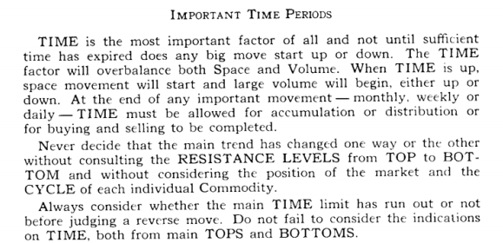

We shall discuss the time issue in detail in Chapter 4 (Buying and Selling with and against highs and lows).

But, I might say, here and now, that you shall see, in its simplest form, that all stocks want to, and do, reverse near the same "pivot days" into the future, as a direct exponent of a square drawn off the start of each new quarter of the U.S. 30 treasury Bond Market.

You shall be able to review most of the Dow 30 stocks, which will suffice, as "typical" examples of a normal stock, when referencing this trading system.

So, just as we did, in Part 1., of this chapter, when we went into much detail explaining exactly how W. D. Gann expected us to get started, so that we may trade our stock the most profitably, I must start with you, from ground zero, step by step, to guide your thinking into a more in depth, and completely integrated mathematical expression of the current price of our stock, at lunch time.

There is not enough time, or paper, to give you enough examples, to have this trading system sink right into your head, on the first time I present it to you.

I might add here, that I have shown this trading system to "mathematical geniuses," "seasoned brokers" with at least 20 years trading actively in the markets on a daily business, "millionaires" who have participated in the markets on the highest exposure levels, and "learned M.B.A. executives, and persons with a "photographic memory" and all of these astute, active traders, have not seen how to integrate a stock's current price, into a 3 level mathematical rhythm simultaneously, with no regard to fundamentals, or W.D. Gann's # 1 rule.

This "Murrey Math Trading System" never been presented to anyone, to date, in this world, except to my Personal friends, who have traded it successfully for the past 18 months.

I didn't feel compelled to run right out and tell the world that, yes, I now have the easiest, quickest, most logical, comprehensive, detailed, with no exceptions, trading system, that works for every traded stock or market, in the world, today, or one hundred years from now.

be true, until they change our way of adding or subtracting, from the current base 10, to the base of 9, which our congress, has considered recently, no doubt, if it were known, to help those who can't add very well, to just get close to "ten."

And from this time forward, it shall be attributable to me, into the future, and should you decide to add this trading system to your own book, or computer software, or any kind of presentation through any media form, please call me for written permission.

W.D. Gann expressed part A. of this concept, on page 68, but he left it at "natural numbers."

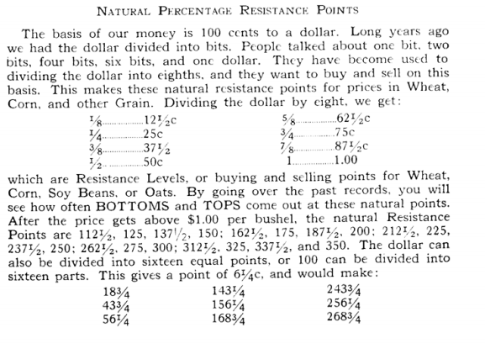

Maybe it was luck, or by design, that W.D. Gann said what he did on page 34., by quoting Faraday, and outlining his basic premise, that math formulas, and his commodity trading System, must hold to exact percentages of corresponding, exact, reciprocal percentages, in a ratio, that is either exponential, or squared, but always proportional to a greater or lesser exact percent.

Then, humorously enough, Gann made up, a 'trading scheme," just 2 paragraphs later, on the same page, that was close enough to the truth, for everyone to make plenty of profits, but off just enough, for him to hold the upper hand, in all of his trades, for Gann already had all of the "natural numbers" memorized.

Ironically enough, or by design, on page 68, exactly "double" the number of pages, that W.D. Gann, had quoted Faraday, on the subject of how exact all math calculations should be, Gann introduced his 8 sets of "natural numbers" and listed them as follows:

1/8 = 12.5
2/8 = 25.0
3/8 = 37.5
4/8 = 50
5/8 = 62.5
6/8 = 75.0
7/8 = 87.0
8/8 = 100.0

Then, just as he had done, back on page 34., Gann spent type next 2 pages filling your "mind" with 64 of the most "common" numbers that commodities want to run to, when they are trading.

So what are you to believe ?

I saw through both of these attempts to present you with the truth. then confuse you with some "traders B.S." so that Gann could keep the upper hand, when he was trading against his fellow "brokers."

You must realize that W.D. Gann had figured out every commodity market mathematically, and he was not going to divulge all of his findings, down to the N th degree, for he felt that everyone else was just as smart as him, but he was wrong !

He was forced to having to prove that he was right, by publishing his trading results each day, in a newspaper, to gain any kind of credibility, with the established "fundamentalists" who were always listening for it to rain in Chicago, so they could sell wheat "short" in Kansas.

Since W.D. Gann had already memorized all of his "natural numbers," he didn't have to go into all of those mathematical recalculations, every time, a stock, commodity, or market, formed a new set of high / low extremes, front which one would have to go and re-set their 1/8 th lines, inside this new width band.

The pure efficiency, in time, of this purely mathematical, fractal trading System, is that, once you memorize a set of lines, for one stock, these lines hold true for the next stock, that travels into the same set of "Murrey Math Lines" for all stocks at the same price level, must move up or down, in a direct proportion to the greater and lesser, of at least 2 sets of "Murrey Math Lines" simultaneously.

I shall go into precise detail, explaining exactly, how this mathematical trading System works, as you evolve into this trading System, to the extent of being able to predict the support, resistance, and the odds of how far any stock, or market, might run up or down, in any direction, before it shall stall out, and consolidate, or reverse.

One might be asking, at this time: so what is the difference between what W.D. Gann told us, but still tried to hide, and what you have offer ?

This pure mathematical trading System takes a perfect square, 100 x 100, and divides it by Fibonacci's classic multiplier (12.5), which equates to W. D. Gann's "natural numbers." (these are really Fibonacci's numbers: for Gann said that all markets, at extreme highs, or lows, may be predicted to reverse at a percentage of 12.5, or 1.125 % of this high or low price).

"Natural numbers" are the natural support and resistance levels, where anything trading near (above or below) one of these lines, should be expected to stall out or reverse, when it touches one of them.

But, enthusiasm, will push a stock higher, on good fundamentals, and lower on bad news, so these lines don't appear, to always be as predictable, as Fibonacci and W.D. Gann acknowledged.

But, you must take my word for it, right now; just because a stock doesn't stop, exactly, on one of these "natural numbers," it always wants to.

But, we must address it in full detail, later in this chapter. Please be patient: the pieces will fit together, exactly, as we add to our trading System.

You shall now learn the most unique aspect, of this exact, Mathematical fractal trading System: these "natural numbers" (12.5) shall be subdivided into lesser "natural numbers" which shall be 1.5625.

Now, you shall be on the threshold of being able to trade any stock, or market more efficiently, by making an exact entry or exit, based on one of these "natural numbers," (proportionally reduced to 1/8 th of its normal price).

It may be necessary to divide the number 1.5625, to its 1/8 th proportion, which shall be: .1953125.

You now see that I have divided 100.0 (the square of 10 squares of 10, forming a square of 100 x 100) by 8, by 8, and again by 8.

This creates the "3rd dimension" in trading.

Ail stocks, or markets, may be predictable, in reverses as minute as 19 cents, after one is able to decipher the exactness of this trading System.

Now, you might be able to see how W.D. Gann could stand in the pits, and trade commodities, with a pre-set chart in his head, and know when to enter or exit a trade, and enter 288 trades in 25 days, and lose only 11. "Can we hear an Amen ?"

But. you may be asking yourself, "what about cotton⁰" It is currently trading at less than $ 1.00 per pound.

Well, if you haven't already done it, we must divide 19 cents by 8, and we find that a 1/8 th line shall be: 2.4414 cents.

Now, we shall be able to use the same set of rules, that we use for: the Nikkei Dow (17,768), to the S & P 500 Cash Market(487), to Wells Fargo (150), and Motorola(56.1/4), to General Electric (50) and Chrysler(40), to Columbia-H.CA. (37.5), to Cracker Barrel (22) and Shoney's Inc. (14), to Genesco (2), and H.C.CA which is currently trading at 62.5 cents.

And if you have to ask, l will save you from having to raise your hand, by saying, "yes" you must divide 2.4414 by 8 to get .0030518, to find a 1/8 th line for trading the British Pound.

We should be able to trade everything "tradable" off any set of these lines that match our stock, or market's current price.

I want to mention again, that the "3rd dimension" of trading is one's ability to take one's current price at lunch and set the next larger times 8 l/8th, and 1/8 th of a lower price.

Since we are in a straight line of thought, as we have subdivided the number 100 by:

its 1/8 th to be 12.5,
then . 12.5 by 1/8 th toi.5625,
then 1.5625 by 1/8 th to .1953125,
then . 1953125 by 1/8 th to .0244141,
then ..0244141 by 1/8 th to .00305.

Since most stocks want to achieve the price of 100, we started with the square of 10 x 10, and worked it down to how we might trade the British Pound. (it might be noted here, that we may have just as easily started from zero, and come forward, till we got up to the price of the British Pound, and continuing up, till we are able to trade a stock all the way up to S 100, because this is a fractal square.

It is critical that you understand, that as soon as you see your stock's, or market's, current price, on T.V., or in the paper, your brain, automatically sets the smaller 1/8 th line, and larger 1/8 th multiple line, for we are now trading in the "3rd dimension."

We shall discuss this basic premise, in more detail, as we travel through the intricate details of this trading System.

Now you are able to fit, one piece, of the puzzle together: that all stocks, or markets, are trading, as a price portion, of a perfect fractal, that allows any trader, who knows the rules, for one market, to immediately shift to another market, and keep the same rules, without regard to its current fundamentals, or news related influences, and trade, and enter, or exit, within a few cents, mathematically (1/8 th of some exact 1/8 th) and make a profit.

There is little need, to have to follow a market, for months, or years, to get a "feel" for a trading System, that uses exact price points, and a "Square in Time" that frames our trading time cycle.

I shall only mention briefly, the time cycle, here at this time, for it shall be broken down in exact detail, later on in the chapter: Time into the Future.

But, it should be said here, that just as your life span runs through a square, your stock, or market, is also running through a time cycle.

We shall learn how to set 3 of them for each stock, or market you trade.

They are quite easy to set, and they stay set, forever, once they are set.

There are 2 additional Major Revelations to be seen, when one moves 19 cents above 100.

But we shall only mention them briefly here at this time, and break it down, into more detail as we go into the section peitaming to it specifically.

But, here goes ! If a stock, or market, moves the smallest 1/8 th into the next square, then we must start trading on the influence of this new square.

And. the rhythm that dominates a stock, or market, shall be that of the last square, it was in, until, it moves above the 25 % line, of the next perfect fractal.

Any trader able to see these 2 principles, this early into our trading System analysis, is smarter than 90 % of all "traders" out there today. Just as we expected all stocks to want to trade up to and reach 100 per share, we would expect every index to reach 1,000.

We must make this obvious exception to the stock rule here and now, and that is that one "broker" raised his hand in the back of the room, but before he could get the question out, I wanted to answer his question, when we are going to retract our last statement, as soon as 1 have made it, by saying that Berkshire Hathaway is presently trading at a per share price, of more than S 25,000 per share. You are now recalculating our square to move our "perfect" fractal up to 100,000 to accommodate it.

If our money is based on the base of 10., then our first square shall be 10, then we would find our next perfect square to be a square of 10 x 10 squares of 10, which would be a square of 100.

So our next larger square shall be a square of 10 times 100, a perfect square of 1,000; then our next square shall be a square of 10,000; then our next square shall be a square of 100,000 and etc., so we are able to trade this very expensive stock, or even the Nikkei Dow, off the very same 1/8 th retracement lines, as one would trade the British Pound.

Since we are in a straight line of thought, we shall divide:

100,000 by 1/8 th to be 12,500, then
12,500 by 1/8 th to 1,562.5, then,
1,562.5 by 1/8 th to 195.3125, then,
195.3125 by 1/8 th to 24.4414, then,
24.4414 by 1/8 th to 3.05175

Next the 10,000 square 1/8 th is 1,2500, then,
1,250, by 1/8 th to 156.25, then,
156.25 by 1/8 th to 19.53125, then,
19.53125 by 1/8 th to 2.4414.

The next 1,0000 square 1/8 th is 1250, then,
125 by 1/8 th to 15.5625, then,
15.5625 by 1/8th to 1.953125,then,
1.953125 by 1/8th to .24414.

You are now able to take the current price of any stock, or any market, and set it inside its square, as it trades up and down to the right through time.

Remember, that all stocks, or markets, want to first run to the major 1/8 ths of its square. And then we go to the next lower 1/8 in to be able to trade.

You may be asking me, "How do I know what my square is ?"

Well let's use some examples, to clarify, this basic fundamental, from which we may not go forward, unless we grasp one's ability to place anything's current price in its proper place.

Remember, we shall address the 2 major revelations one must "see" any price inside its appropriate square. Let's look at the following:

96.7/8 perfect square = 100, 378..0 perfect square = 1,000, 4,000 perfect square = 10,000,
36,000 perfect square = 100,000.

These 4 are easy to see, but mere is no way for us to trade them, until we set our 1/8 th of this perfect square, that gives us 4 "Murrey Math Lines" on either side (above and below it).

Let's set the *Murrey Math Lines" for:

96. 7/8 = 100.0 100 %
= 98.43 7/8 th
= 96 87 6/8 th
= 95.31 5/8 th
= 93.75 4/8 th
= 92.18 3/8 th
= 90 62 2/8 th
= 8906 1/8 th
= 87.50, zero line,
3780 =
390.62 100% 388.67 7/8 th 386.71 6/8 th 384.76 5/8 th 382.81 4/8 th 380.85 3/8 th 378.90 2/8 th 376.95 1/8 th 375.OC zero line,
4,000 = 5,000 100 %
= 4,843.75 7/8 th
= 4,687.50 6/8 th
= 4,531.25 5/8 th
= 4,3 75.00 4/8 th
= 4,218.75 3/8 th
= 4,062.50 2/8 th
= 3,906.25 1/8 th
= 3,750.00 zero line, 36,000= 37,500.00100%
= 35,937.50 7/8 m
= 34,375 6/8 m
= 32,812.50 5/8 m
= 31,250 4/8 th
= 29,687.50 3/8 m
= 28,125 2/8 th
= 26,562.50 1/8 th
= 25,000 zero line

Please look in the front of this book to: Murrey Math Quick Reference Sheet for Murrey Math Lines, to circumvent the need to use a calculator, when you want to set the Murrey Math Lines at a price level that you presently haven't yet memorized.

Rather than dispute the truth, on any subject, no matter what it is, we shall simply ask you to take, as gospel, one of the major revelations which is:

a) anytime our price moves thru from one square to a larger square, we must consider the same 1/8 th price rhythm factor that we had just left until it moves above the 25 % lines of the perfect fractal square.

Now, what does all that mean ?

We shall address this revelation, a little later in this book. (please be patient).

Setting up the Basic Murrey Math Lines

(these lines should cover 90 % of all stocks).

The goal of all stocks would be to reach 100.

So, we take 12.5 % or (1/8 th) of this square price, and we set each major 1/8 th retracement to be:

Major "Natural Numbers" 100.00 - 0.00 ("Natural Numbers") M.M.L. - Murrey Math Lines

100.00 100.% 8/8 th (top of square) 87.50 87.5 % 7/8 th 75.00 75.0%6/8th 62.50 62.5 % 5/8 th
50.00 50.0 %4/8th
37.50 37.5% 3/8 th
25.00 25.0%2/8th
12.50 12.5% 1/8 th
00.00 zero line

It must be noted here and now, that as soon as a stock trades below 12.50, we must treat it as it trades in its own square, with its 100 % Line, now being 12.50, not 100.00.
'j " . -
Look at Charts by Group: Stocks Trading from 12.50 to zero.

Now, we must set the appropriate color for each 1/8 th line. These color lines shall hold true, for every 1/8 th line, no matter if we are trading the British Pound (at .00305) or the Nikkei Dow (at 12,500.)

The Appropriate Color for each 1/8 th Line are:
(M.M.L. Line) v

8/8 th line 100 % Line', Blue
7/8 th Line 87.5 % Line Yellow
6/8 th Line 75.0 % Lines "Pink
5/8 th Line 62.5 % Line Green
4/8 th Line 50.0 % Line Blue
3/8 th Line 37.5 % Line Green 2/8 th Line
25.0 % Line Pink
1/8 th Line 12.5 % Line Yellow
Zero Line Blue

We must commit these MML. Lines to memory.

Mathematical Significance of Each Major MML. (Murrey Math Line)

8/8 th Line(Ultimate Resistance) (Blue)

This Line is the hardest to pierce on the way up, and gives greatest support on the way down.

(It may never make it up thru this line).

7/8 th Line Weak (Stall and Reverse) (Yellow)
This line is weak, if it runs up too far too fast, it will reverse fast, when it stalls here

6/8 th Line Pivot (Reverse) (Pink)

This is the 2nd most critical line, to force a stock to reverse, when it is moving up or down

5/8 th Line Top of Trading Range (Green)

All stocks want to trade 40 % of the time inside its 5/8 th and 3/8 th Lines. If a stock has moved up thru the 5/8 th Line, and trades above it for more than 10 to 12 days, it is said to be selling at a premium, to what one wants to pay for it, and it will want to stay above this line in the "premium area," but if it breaks this line, you know that it has tired, and wants to back off, and trade down lower, for more support, and get back down into its "comfort zone" between 5/8 ths and 3/8 ths.

4/8 th Line (Major Lie; Resistance / Support) (Blue)

This line is the greatest price point of resistance or support Line. This price point is where it will have its greatest support above the line, and its greatest resistance below-this line. W.D. Gann said that this price level, was the greatest price point to sell and buy against.

3/8 th Line (Bottoms of trading Range) (Green)

It is hard to get into this trading range, but once it holds above this line for 10 to 12 days in a row, then it will want to trade inside the 3/8 th and 5/8 th lines 40 % of the time.

2/8 th Line Pivot (reverse) (Pink)

W.D. Gann said that the 2/8 th and 6/8 th lines are the .2nd most critical lines for pivoting (reversing).

l/8th Line Weak (Stall and Reverse) (Yellow)

This line is weak, if it runs down to this line and holds, it will reverse fast. But if it falls to this line and can't hold, it will fall back down to the blue line, which is the zero line, which is major support.

0/8 th Line (Major) Support / Resistance (Blue)

This Line may pose some a bit of confusion for traders.

You must commit these Lines, colors, and how they react, on each of these lines to memory, for in so doing, you shall know how your stack shall react each time it encounters one of these lines. (see figure A. and memorize these Lines, prices, %, and colors).

But, since all stocks, or markets, are trading in the "3rd dimension" we may have as many as 3 different zero Lines simultaneously.

We shall start with the obvious zero Line which is zero. But, we must hold that thought for a while !

Now, we must stop right here, and learn a new concept, about price-action, that W. D. Gann saw a long time ago, and that is that a price exactly above the 50 % Line of any "range of fluctuation" will react just as if it were exactly below the that same 50 % line.

But then, you have already read this and learned it just a few pages ago, when we set up the colors for each 1/8 th, and when we described the price-action attributed to every MML. Line,

Hopefully, common sense dictates that the price-action raie would be the same for line above and below the 50 % line, but in the opposite direction, from what it would be expected on either side of the line.

W.D. Gann said that the 50 % line, in the middle of any high / low 8/8 ths retracements, is where the greatest support or resistance shall occur. (we call them M 50 % lines. Look for the section called M 50 % Role)

Remember that all stocks will react to a 50 % line, even if it is:

1) 78 cents,
2) 6.25,
3)50.0,
- 500,
- 5,0000,
or any 50 % of any 1/8 th (MML.) line, within any set of 8/8 .ths.

I hope that you are able to decipher, from what we have already explained to you, that I don't have to go into any further detail, about what each MML. line means: otherwise please refer to the Quick Reference Section to check and see if what you think the line to be, is really what it should be.
«««»*»«*«»•««•«*«»«««»«*»»*«««»«»»•«*»»»»»«»»«»«
It is critical that you understand, right here and now, that every rule that WD. Gann observed, and recorded in his book, is 100 % applicable, to everything we do in our trading system, except, 2 rules:

1) his #1. rule,-----
2) and his oversight, of not going into detail of dividing the "range of fluctuation" by 8, a second or third time.

««•••••«•s»»»*»»*»»»»»***»»»»»»»»»»»»*»»»»*»*»**
You decide for yourself: did he know everything, that we know, but intentionally, failed to give us the pure math lines, or, did he really not know that one must divide each 1/8 th retracement line into 1/8 th ⁹
»*»»»»«»*»»«»**»«»*»»»«»»«»»«»•»««»»»«»«««»»««**

The most perfect example of how W.D. Gann's "range of Fluctuation" is not the most credible way to trade, is easiest seen in the use of his # 1. rule on the price action of coffee, for the past 9 months.

Look at chart # 12. Coffee.

Its high / low range was too wide to ever enter any trade position, close enough to not get all the profit you deserved, or not continually be "whip lashed" within just one 1/8 th of the overall "range of fluctuations."

We have spent an inordinate amount of time showing you 2 things:

a) we want to set our M.M.L. Lines on exact math lines,
b) and we must subdivide each larger M.M.L. Line, into smaller exact l/8th increments, that will dictate, exactly where we shall enter or exit a trade.

A perfect example that every stock wants to run to exact 12.5 % (1/8 th) increments of a perfect fractal square of 100, since the stock we shall use as an example is trading between 25.0 and 75.

Look at chart # 184 A. Telephonas de Mexico (1 year) (daily chart)

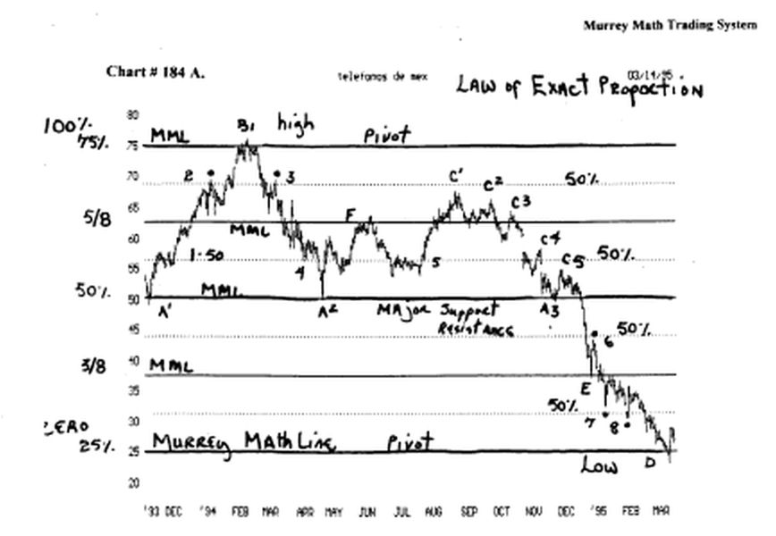

Let's start from the beginning, just like we knew nothing at all about anything.

# 1. The current price is 26.1/2. So, we go to the perfect square of 100, since it is the next square up from 10, since we use the base 10, to count.

- 2. We take the number 8, which is 12.5 %, and divide it into 100.

- 3. We draw each 1/8 th increment, which shall be:
- 12.5, 25.0, 37.5, 50.0, 62.5, 75.0, 87.5, and finally, the 100% line of 100.

Please look back to the chart and see if this stock wanted to get support and resistance, along these Lines. You see that it did: (A1), (B1), (A2), (A3), (D), and (E), and (F).

Why did this stock chose to reverse 7 times on lines that we just set off dividing 100 by 8 ?

It is a law of nature: a part of the law of exact
proportion, as it relates to price movement in time !

Notice the dotted lines, which represent the 50 % line, between each major 1/8 th of 100. These 50 % lines would represent, as W.D. Gann called them, "minor 50 % lines," which are important to watch for reverses, if a stock runs past its major support or resistance Lines.

We see that it reversed 8 times on these "minor 50 % lines, within a 15 month period, for this stock.

It is so critical that in J line,'94, that it sat on this "minor 50 % line for 20 trading days, trying to decide if it wanted to go back up, after falling from 75., back down to 50., then back up to 62.5, then it reversed and fell back down to its "minor 50 % line."

And sat still. and moved laterally for 1 month, then it reversed. and moved back up, and tried to make it back up to the "minor 50 % Line," at (C1), at 68.3/4, but it failed to make it to the Time, so we know to sell out with a profit, and wait for it to go sideways, or it will fall back down for support.

At (C1), it failed to reach the "minor 50 % Line, so it fell back for support, and it fell 5 straight times, to a new high, so it tried to and support on the (A3)

Line, and it couldn't hold, which was as 3rd try, to hold, for support, and it made a feeble effort to move back up to its "minor 50 % LINE," AT (C5), at 56. 1/4, but it failed to make it back up to this Line, and it broke below support of over 12 months, which signaled a bigger fall coming.

It fell all the way down to (E), the 37.5 % (3/8 th) Line, and reversed exactly on this major line, and tried to go back up, but it failed again, on a "minor 50 % line," at 43. 3/4, then it fell back down to the 3/8 in line, 37.5, then it tanked again, and fell all the way down to the "minor 50 % Line," 31. 1/4, and it missed the Line, by a few cents.

So it revised, and tried to run back up to 37.5, but, it just barely touched the Line, and fell, again, back down to (8), for a 2nd touch of the "minor 50 % line," but it barely broke the Line, which is a bad sign, then it reversed, and tried to move back up to 37.5, for a 2nd and 3rd time, so it tanked, and fell all the way back down to the 2/8 in line, 25.

h broke the Line, and immediately reversed, and found support, on yet another Murrey Math Line.

Locate chart # 184 B. Telephonas de Mexico.

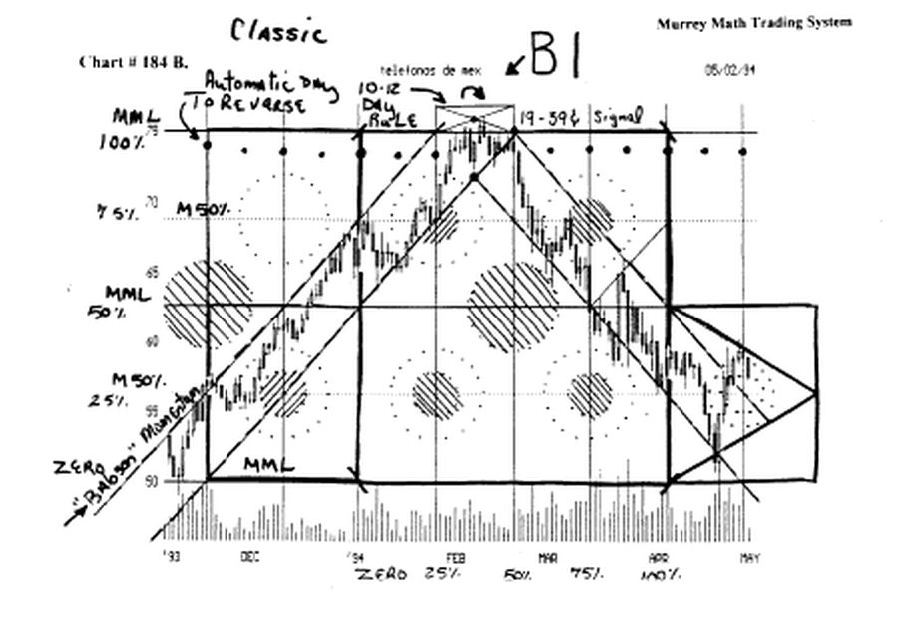
We have taken the base of 50.0, and let it be the zero line, (we must always start all zero Lines at either, a zero, 2/8 th, 4/8 th, or 6/8 th line, minor or major, and always make our squares either 2, 4, or 8 horizontal lines), and our 100 % Line, shall be 25 % of 100, so we shall be trading off a square, inside the larger square of 100.

Look at the chart for several minutes. You shall see that all support or resistance Lines, are set off our "Square in Time," and not the action of the stock.

But, isn't it funny how it followed our "Babson" speed momentum lines.

Since we set our 100 % to start at 50, and 75, we should set each 12.5 %, at 3. 1/8 points. This is an ideal long term trading range, for most traders.

Please go back to Figures (A, B, C, D, E, F, G, H, I, and J). Just look them over, casually.

You see that everything we do, is set off pre set parameters, long before our stock reaches its current price level. We don't need fundamentals to trade.

Some innocently ignorant traders, say that anyone, can sit and draw a bunch of lines, after a move has already been seen, and then, predict, what it would have done. We use these lines to trade !

But, please look at the black dots at the top of chart # 184 B, and chart # 184 C. and you tell me how many times this stock reversed, into the future, right on the day it was predicted to feel the effects of a shift, in its rhythm.

On chart # 184 B (B1), we see that it fell on its 3/8 ths line, (in time), and on chart # 184 C (D), we see that it reversed on its 5/8 ths line.

If we look at chart # 184 D, we see where we set our "time to reverse into die future Lines." We would have been correct 9 of 10 times, over the past 15 months.

But if we add our time Lines to our horizontal (Murrey Math Lines), we are able to trade off all our signals, that are reflected off all the Figures, we have just reviewed, a little earlier.

Look at chart # 184 C. and we set the zero line at 25.0, and the 100 % line at 50.0.

Here again, we would expect our trading range to be every 3.125 points, inside this 25 point square.

Look at chart # 90. Bankers Trust. This stock is a Perfect chart.

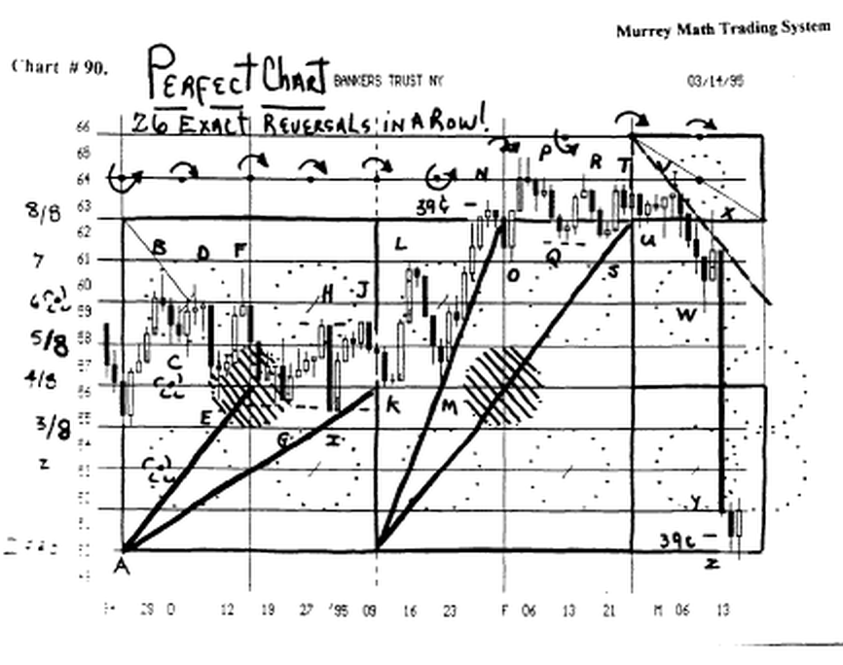

We set the Murrey Math Lines, (horizontally), and the seasonal time lines, (vertically), and then we watched it trade into the future.

It reversed 26 times in a row, off one of our lines.

Please review your Figures (A, B, C, D, E, F, G, H, I,
and J) And you will be amazed at how this stock reacted off our squares, and off W.D. Gann's rules (except his # l rule, which we don't use).

Look at chart # 189 Hewlett Packard.

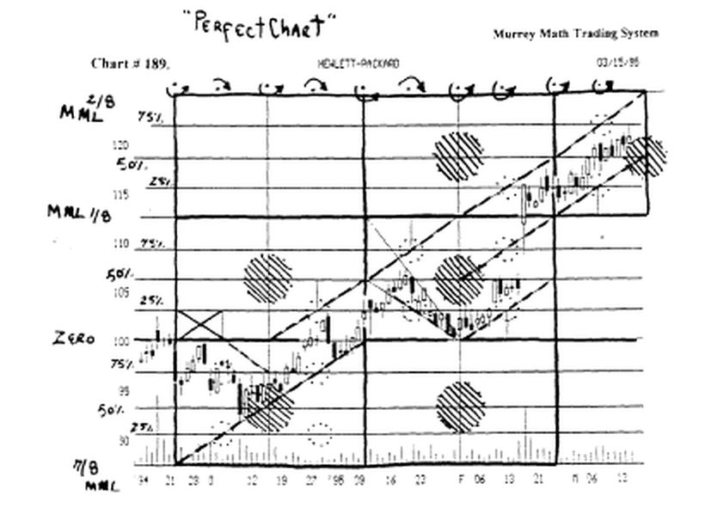

This a Perfect chart.

Just look at it, and you will be amazed how simple it would have been to buy and sell, against its "Babson" momentum lines.

HP was always careful to avoid the "5 areas of conflict," as it moved to the right through time.

We used no fundamentals, or any current price action to set the price and time rythm for this stock !

Notice that this stock is running on a rhythm of 12.50 points for a run, or at least 6.1/4, since it is near 100 in price. This confirms the fact that all stocks shift their rhythm, as their price increases.

Look at chart # 197. Nikkei Dow. (3 year chart). This is a perfect chart.

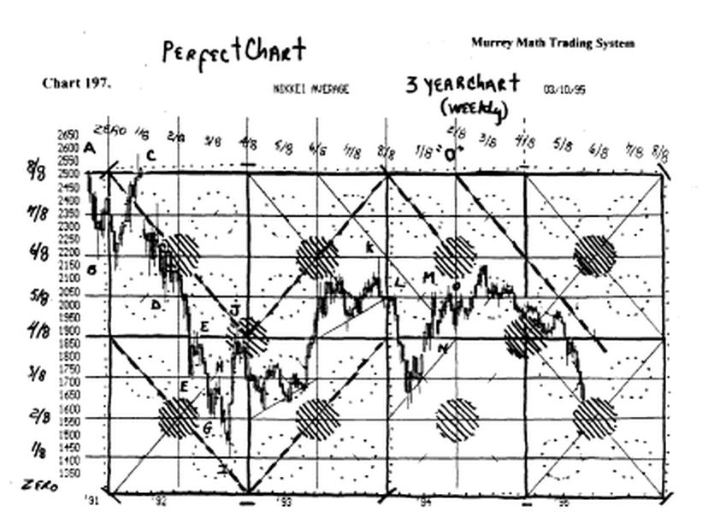

Since it is trading around 25,000, we must set our perfect square fractal, at 100,000

So, each 12.5 per cent shall be 12,500.

We divide this 12,500 by 8, and we get 1,562.5.
Then we divide 1,562.5 by 8, and we get 195.3125.
Then we divide 195.3125 by 8, and we get 24.4414.

We should set our 1/8 th Lines at 1,562.5.

Then, expect to trade, on moves as small as 24.4414 points.

It reversed 15 times on a purely mathematical 1/8 th of a pure math fractal square.

Please go back and review all of your Figures, and you will see that it reacted "right on schedule."

We set the 25 % line, as our zero line, and the 25,000. as the 100 % line, since it is always the 1st major resistance level for any stock, or market.

Look at chart # 198. Nikkei Dow. (9 months).
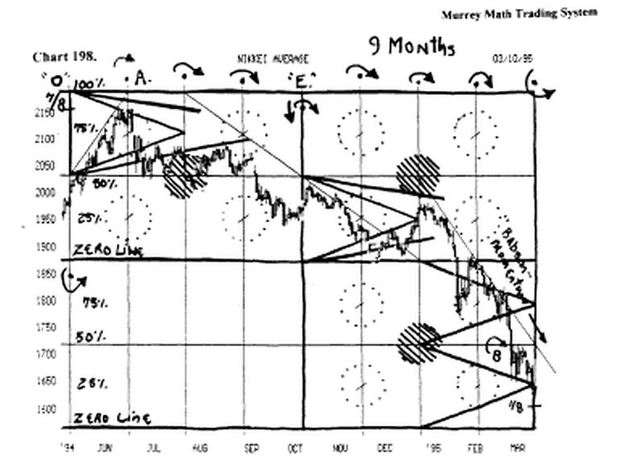

We have corrdnued this seasonal time line, that forms the vertical lines for our Square in Time.

Please match up the "o" on chart # 197., and chart # 198., which is just a closer view, (9 months), of time into the future.

We see that we must continually review the 3 aspects Long term, intermediate, and trading view) of this Index. We are able to shift from one of these 3 views, by moving into a larger or smaller square.

I call this the 3rd dimension of trading.

Look at chart # 199. Nikkei Dow. (90 days).

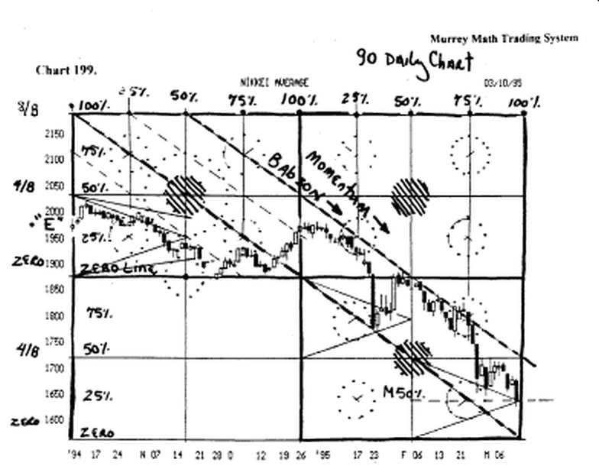

This is a trading range, for this Index.

Notice the "Babson" momentum Lines, that it can't break above, so it will have to go lower, for more support. We would expect it to reverse, and want to retrace, as soon as it reaches its 100 % day (in time).

It reversed (up) 416.57 points, after it hit the end of its square in time. But, we can't expert this Index to move much higher, until it can close 4 days in a row, above the "Babson" Line, and stay 4 days in a row above the "minor 50 % Line."

••«•«••«••y*************************************
Now, it is possible, since we set our MML. Lines, off increments of 100 %, 50 %, and 75 %, and 25 % Lines, that we are able to shift our zero line up or down, on increments of at least, any 50 %, of any set of 8/8 ths lines, and use the same set of rules, for the zero line, when the low is actually setting on the 50 % Line. How about them apples ?

