Process:
I started every morning by zooming out. I trade 5M bars.
So I zoom I start with a 1 hour chart (zoom out, look left) to see what price is showing me:
(right now looks like I took the "snapshot" this am, too far zoomed on this attached, but will come back after the trade is over
and edit a better view of how I actually started)
Found 3 key Support:Resistance areas relative to current price (not all you could see):

Crossover
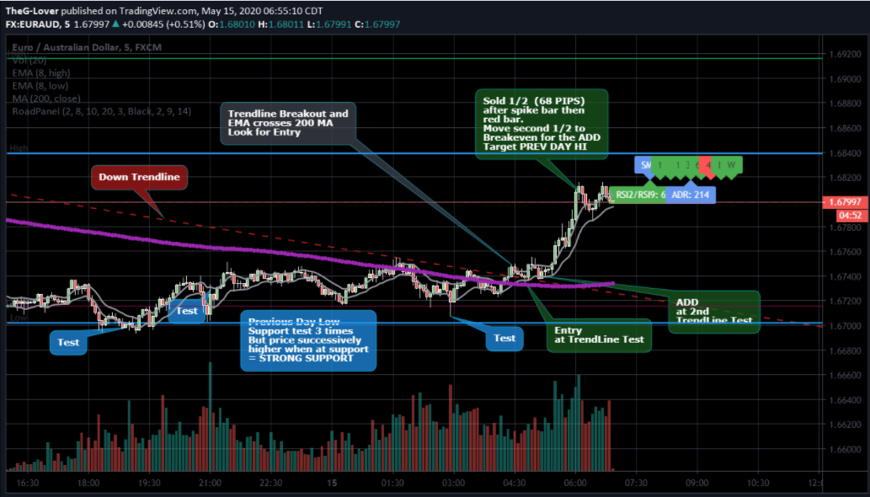
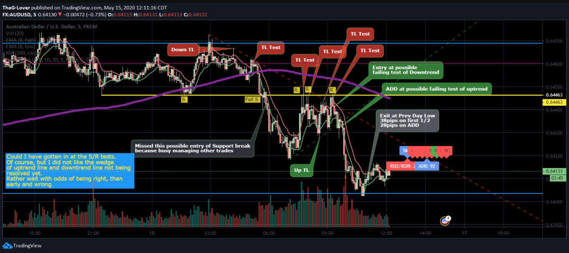
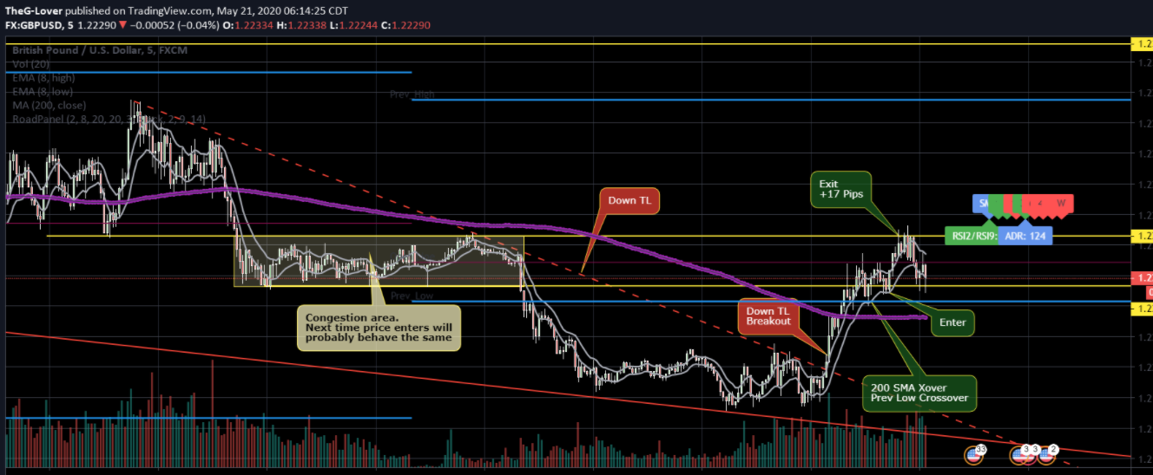
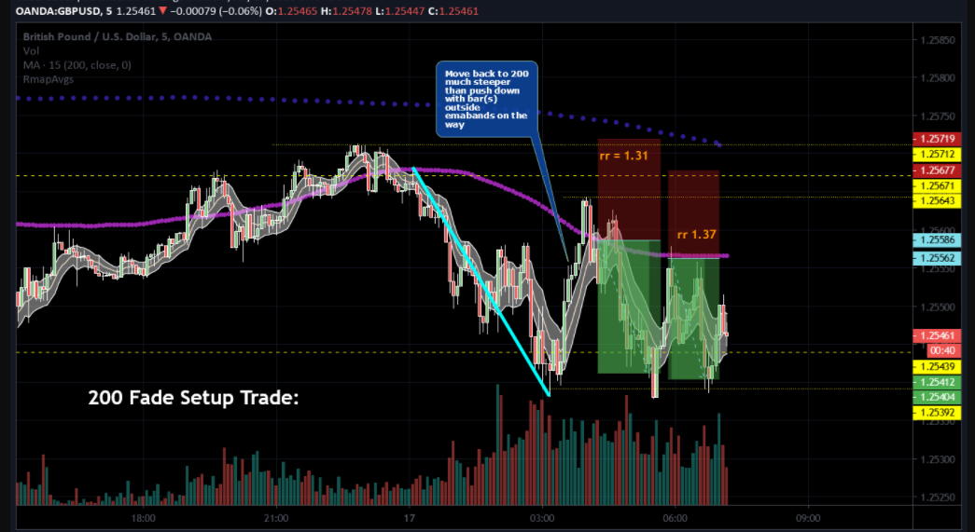

Failed Crossover
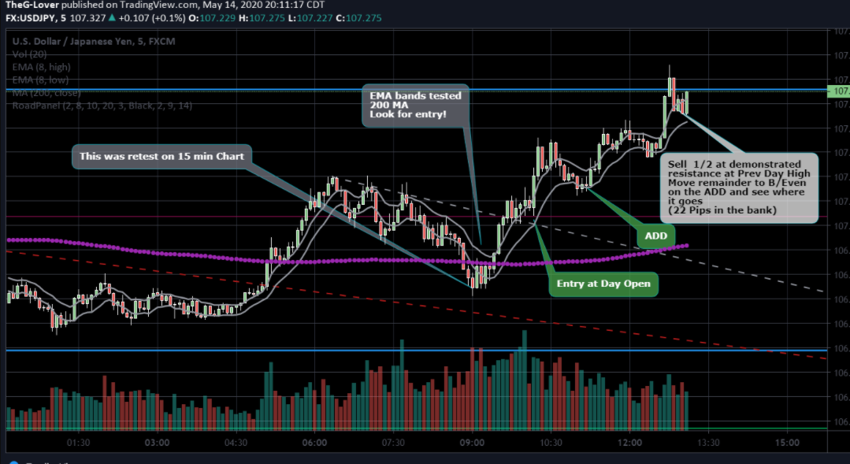

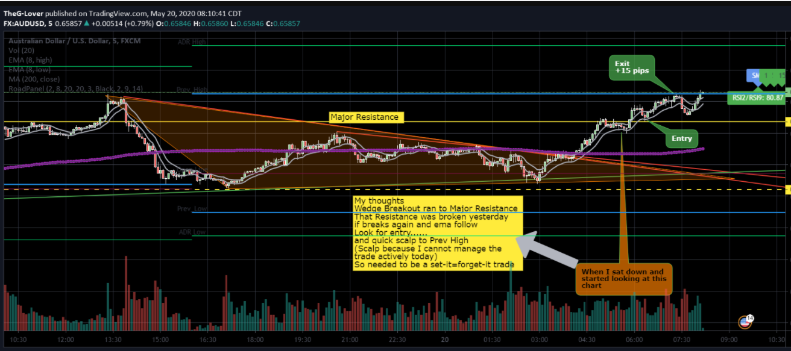
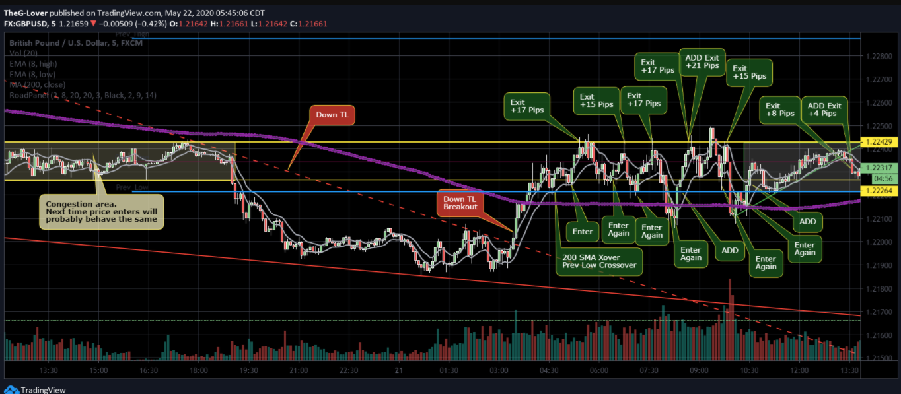
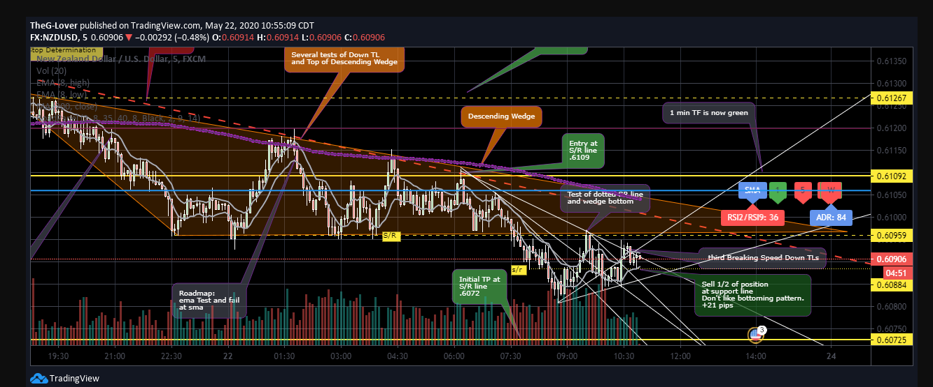

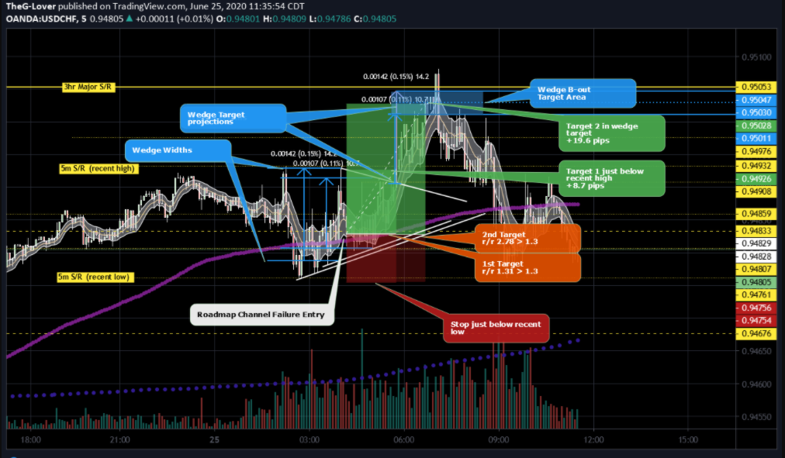

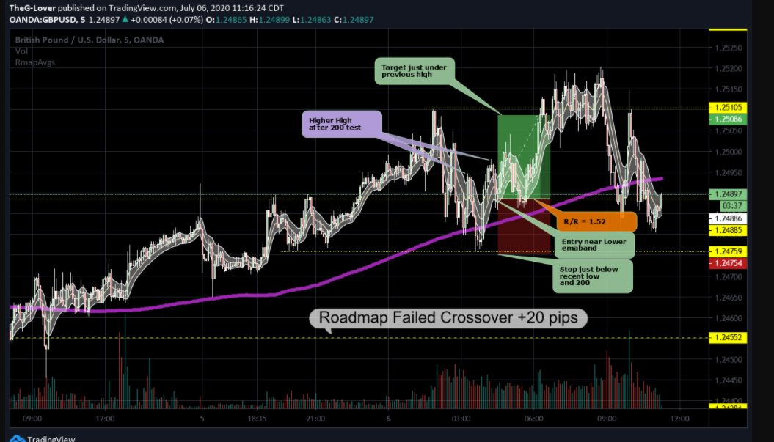

PUSHBASE:
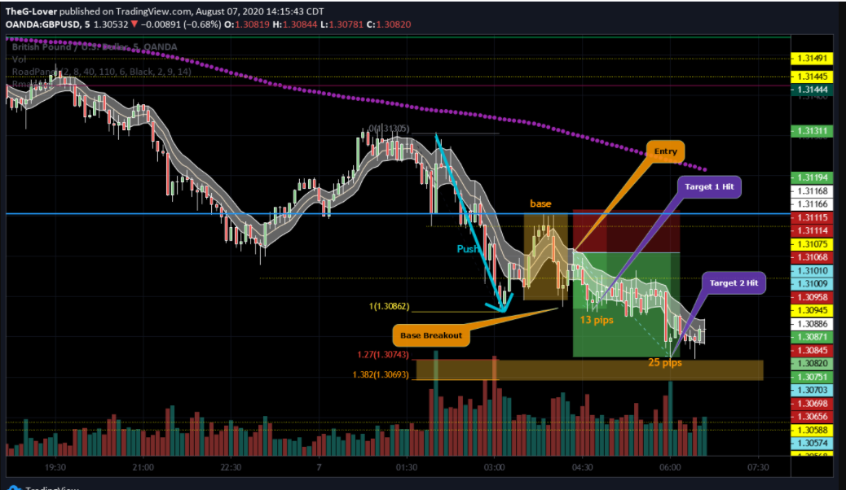

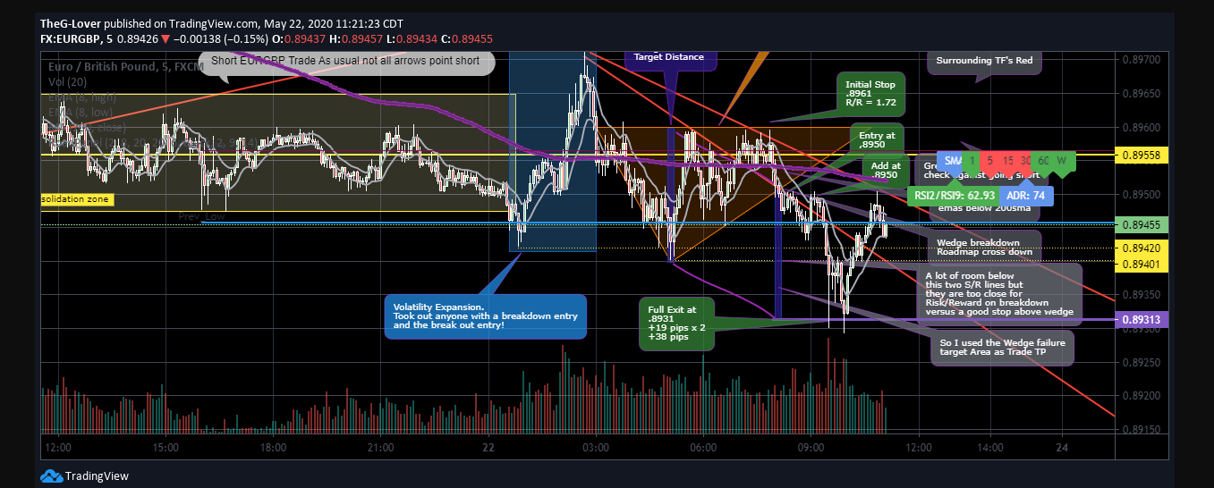
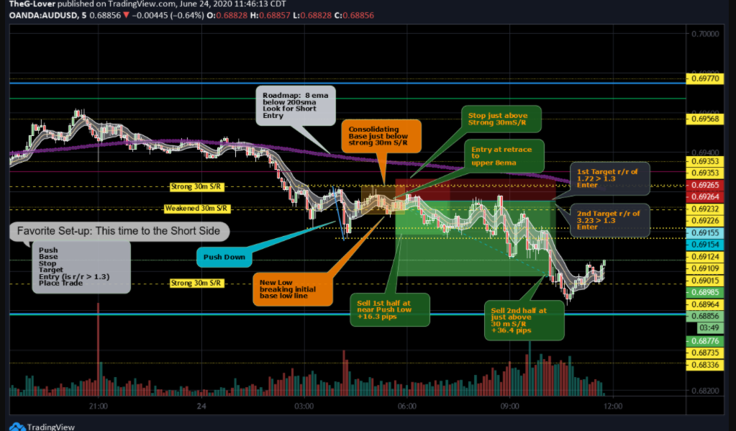

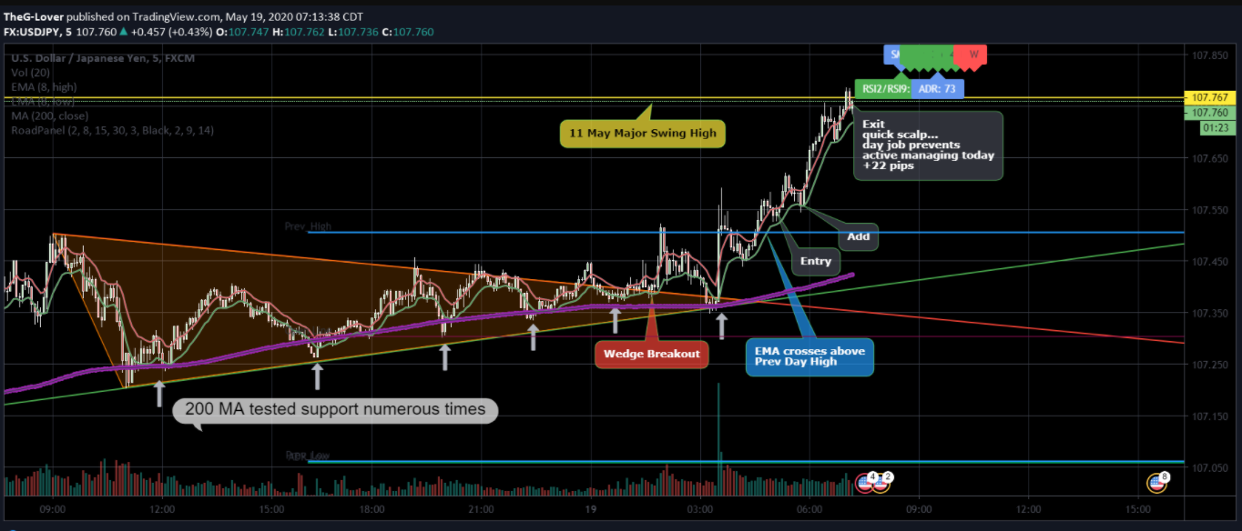
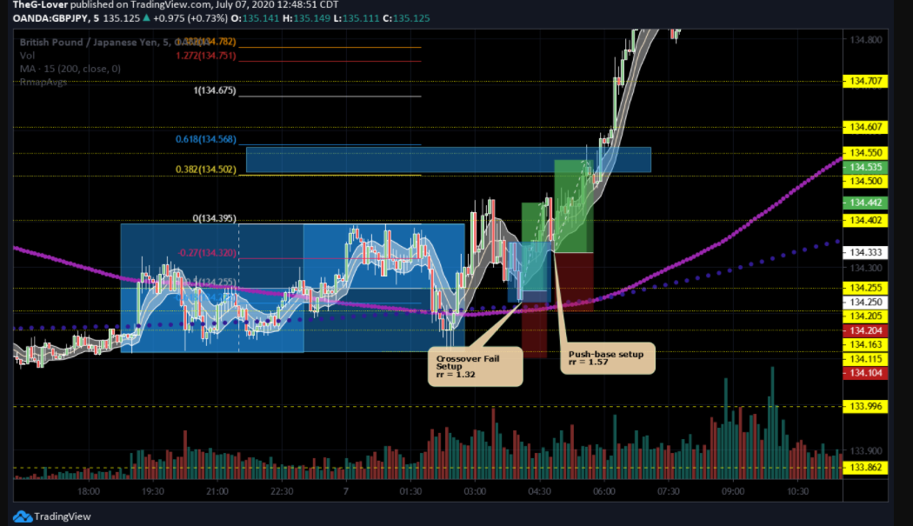
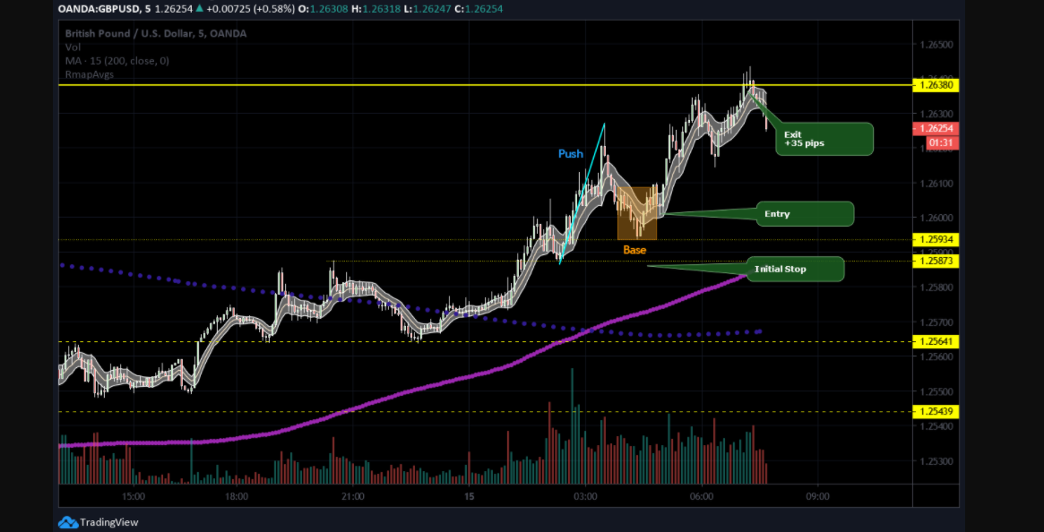
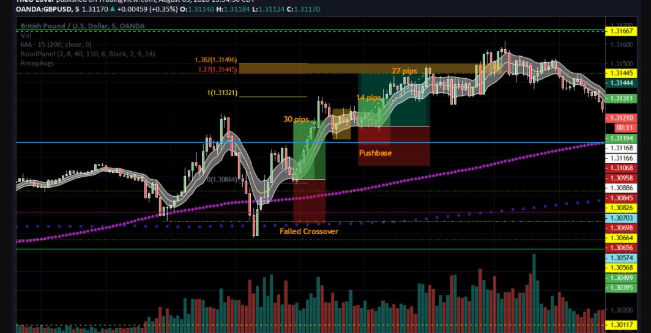

200 FADE
I want to get in as soon as possible, because these setups can turn quickly, many times it is just one bar that would hit my entry... of course some times it blows thru the 200, it is not 100% winners.
But to say I just set my entry at 200, would not be the whole picture. When I see price has pushed away from the 200, I keep an eye for the retracement to begin developing, so I already have my stops and targets relative to price structure around the 200. If there is support/resistance very near the 200 on the retracement side, I may actually enter there...and not wait for price to hit the 200. Always, making sure that my entry relative to my stop/target gives me a minimus of 1.3 r/r.



