https://cmillion.ru/en/sh-8/
Hedging is the safest strategy on the market!
Expert Advisor based on correlation and co-integration of currency pairs.
Strategy description:
The robot works with smart hedging, the safest strategy on the market. He is hedging (insuring) orders of two highly correlated currency pairs, so no matter in which direction the market moves, the drawdown will be minimal, and the profit will be guaranteed! The sh expert Advisor trades on a split of currency pairs. When correlated instruments deviate from their course, the expert Advisor bets on a return to the correct rate.
Correlation
Correlation (“correlation, correlation»), – statistical relationship of two or more random variables (or values that can be considered as such with some acceptable degree of accuracy). In this case, changes in the values of one value accompany a systematic change in the values of another value. The correlation coefficient is a mathematical measure of the correlation of two random variables.
Cointegration
Cointegration is a property of several non-stationary time series, which consists in the existence of a certain stationary linear combination of them. Co-integration is an important property of many economic variables, which means that despite the random (poorly predictable) nature of changes in individual economic variables, there is a long-term relationship between them, which leads to some joint, interrelated change.
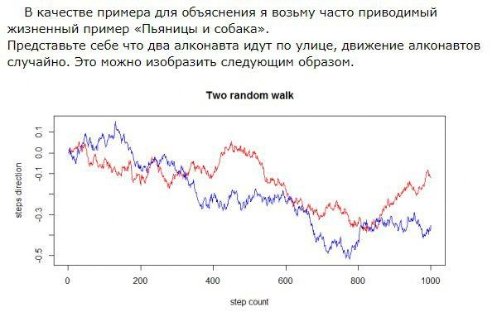
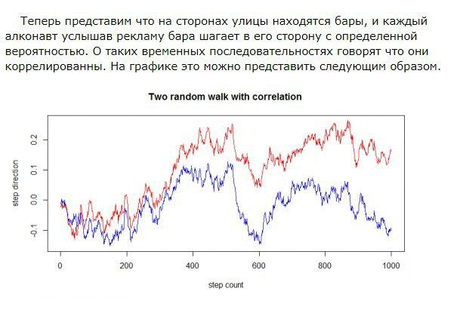
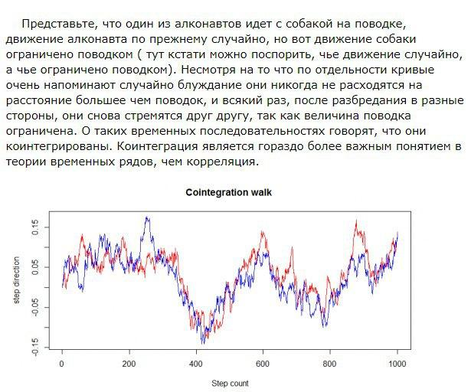

How the strategy works:
Choose two currency pairs with a high correlation and co-integration coefficient. Most of the time, pairs move the same way. But there are times when couples diverge from each other. At this point the adviser opens counter positions as shown in the screenshot below:
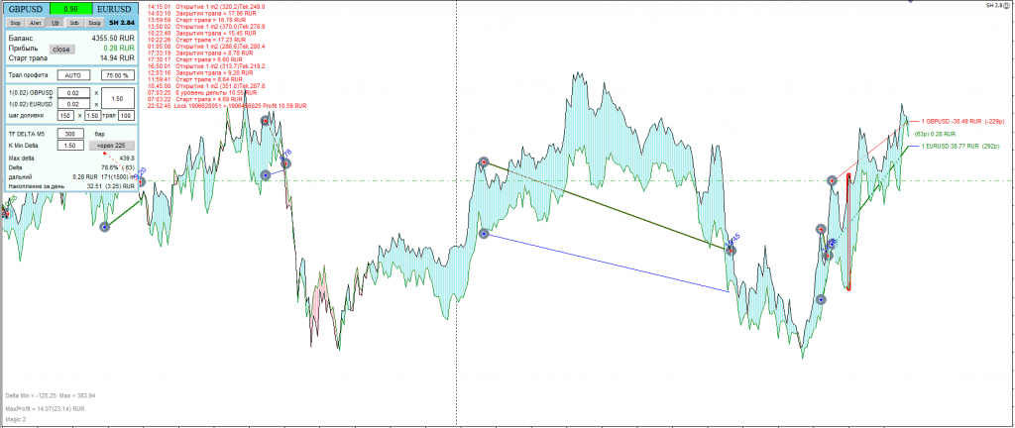
the closing of transactions occurs when the currencies converge again and give a total profit. Let’s analyze the principle of hedging (insurance) in this example. We see that the sell position is open for GBPUSD, and the buy position is open for EURUSD. As long as the currencies run in parallel, their total profit will not change. If there is even a very long trend in one direction, for example, up, then we will get a loss for GBPUSD, and about the same profit for EURUSD. Thanks to this trading principle, we do not get large drawdowns. One deal always protects the other! The total profit for us occurs when the pairs approach each other. And at this moment, the adviser starts a profit trawl and takes the maximum possible profit.
These currency pairs are taken as an example only. This is not an ideal to look up to! But they show the principle of trading well because they often diverge and give a large number of transactions. Keep this in mind when choosing tools! If You want to get the most secure trading, you need to select pairs of instruments with a very high correlation. However, there will be very few transactions. Many people are tempted to put the correlation in the opposite direction. For example on EURUSD GBPUSD to trade in negative correlation or on-the-EURUSD-USDCHF – positive. This type of trading can bring a large profit in a short period of time. But it is this kind of trade that will sooner or later lead to a complete drain, since in this case, the pairs do not insure each other, but rather push the trade into the gap. If you want to trade safely, be sure to correctly consider the direction of correlation. The correlation coefficient on some pairs can show both positive and negative correlation on short sections. In this case, check the correlation sign for a longer period, such as 2000 candles. If the sign can change there, then it is better not to contact such pairs, since they most likely do not correlate with each other.
Advisor parameters: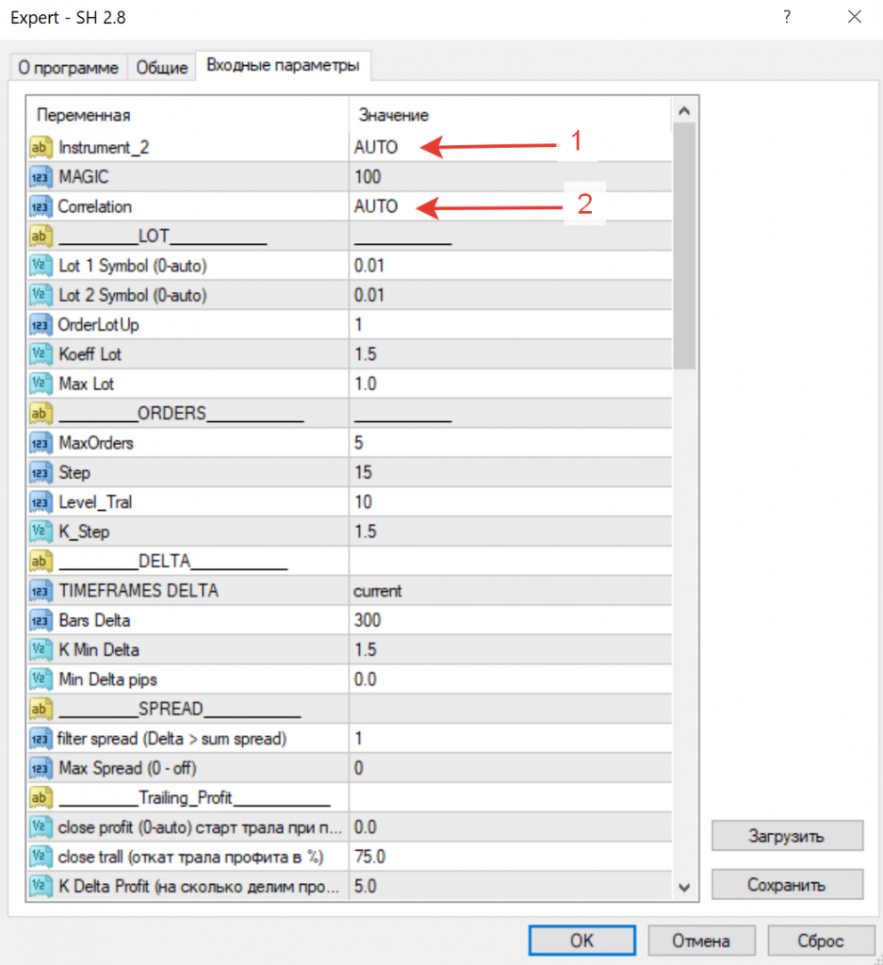
The advisor takes the first instrument for trading the one in which it is installed.
Instrument_2 = “AUTO”;
The choice of the second instrument for trading. If you leave the field empty, the EA offers a list of the most correlated instruments to choose from: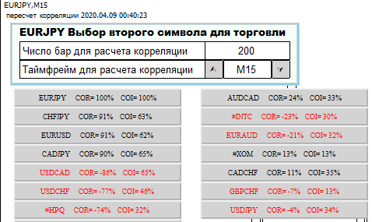

In this window, you need to select the second instrument for which you will trade in the future. To prevent the advisor from offering this menu after restarting, you need to enter the selected symbol in the Instrument_2 field. If you write a specific instrument in the Instrument_2 line, for example USDCHF, then the advisor will work with it.
If the word AUTO is added to the Instrument_2 line, then the Expert Advisor selects the second instrument based on the first from the list in it:
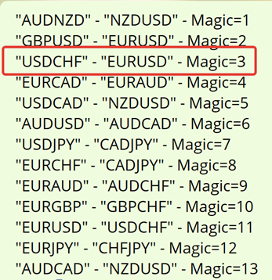
In this case, the advisor also changes the magic number for the convenience of analysis and trading in the basket. For example, we installed an advisor for the USDCHF pair and set Instrument_2 = AUTO. The Expert Advisor selects the second EURUSD instrument and puts magic on all deals = 3.
The list of tools listed here may vary from version to version.
MAGIC = 100;
Unique item number. It is advisable to set it differently for each Expert Advisor so that identical pairs on different Expert Advisors do not overlap. If the Expert Advisor chooses a pair in AUTO mode, then he sets the magic himself and you can not change it.
Correlation = AUTO;
Select the type of correlation between positive “+”, negative “-” and automatic.
If you specify the Correlation = AUTO parameter, the EA determines the type of correlation by the sign of the correlation coefficient at the time of opening positions.
AUTO mode is recommended for advanced users. In AUTO mode, the correlation sign can be reversed in accordance with the behavior of currency pairs. And the direction of transactions depends on the sign of correlation. If the sign change in AUTO mode occurs when a series of orders on the chart is open, then your add-ons may open in the wrong direction. It is possible to use this in a strategy to accelerate the exit from a drawdown, but it can violate the basic principle of hedging. In most cases, it is recommended to fix the correlation sign "+" or "-", depending on the selected pairs.
Lot 1 Symbol (0-auto) = 0.01
Lot 2 Symbol (0-auto) = 0.01
The volume of starting orders for the 1st and 2nd instruments. If you set 0, then the advisor will calculate the lot of the second instrument based on their point value and volatility. (Automatic calculation is recommended for advanced users only). Do not confuse it with the calculation of the lot from the balance. He does not depend on this!
Topping up
The ideal option for trading with this advisor is when it opens no more than 1 pair of positions and closes this pair by profit. Then the next cycle ... But if there was a de-correlation or the wrong instruments were chosen, the EA can open additional positions at more favorable prices. Positions are opened using virtual pending orders. At the start, the EA shows a line on the chart and moves it behind the price at a specified distance. And when the price rolls back, when it crosses the line, it opens a refill.
OrderLotUp = 2 - From which order we start increasing the lot.
K_Lot = 2.00 - Change factor for subsequent lots.
Maxlot = 1 - The maximum possible lot of the opened position
MaxOrders = 4 - Limit the number of orders
Step = 15 - The first step of adding orders.
If after placing the first pair of orders their loss in pips becomes more than the one specified in the Step parameter, then the next refill is opened. On 5-digit quotes, the EA increases Step by 10 times. The step size indicated on the graph itself is true, already changed for the number of characters.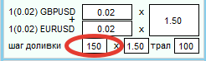
K_Step = 1.5 - Step ratio of additional orders. With Step = 100 and K = 1.5, the second step will be 150, the third 225, and so on…. Those. with each new top-up, the step will increase.
Level_Tral = 10 - Distance to the virtual add order.
Refill orders are not opened immediately when a drawdown is reached. They are placed as virtual pending orders at the Level_Tral distance from the current price. Further, this virtual pending order moves behind the price at the same distance until the price opens it on the opposite movement.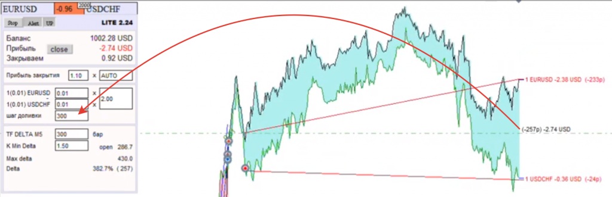
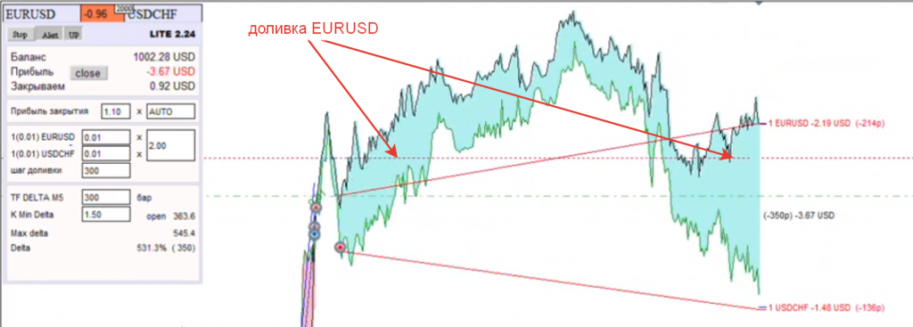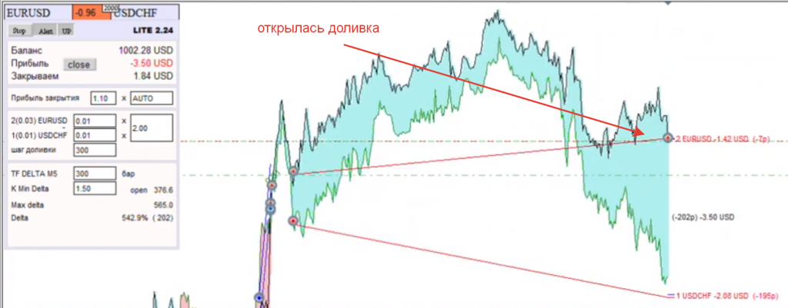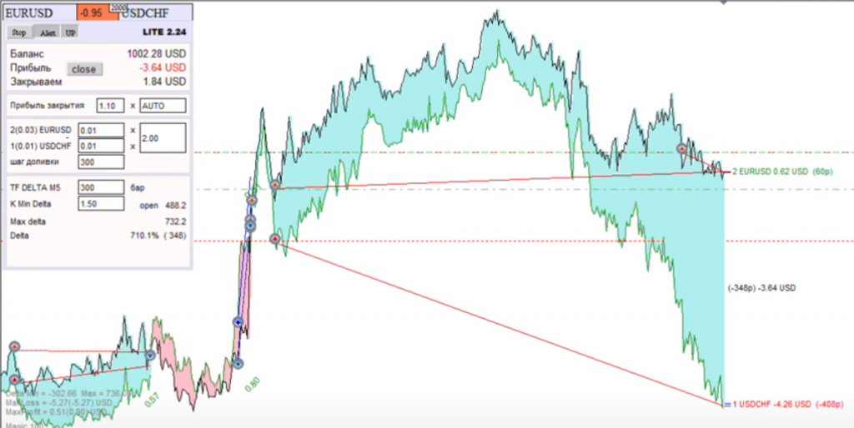
Calculation of the divergence delta of instruments.
TIMEFRAMES = 5; - TF by which we calculate the correlation delta.
BarsCorrelation = 300; - The number of candles to calculate the correlation
K_Min_Delta = 1.10; - The division factor of the maximum delta defines the minimum delta entry as DELTA_MAX / K_Min_Points. Used to change the minimum entry delta of the first positions.
Min_Delta. - The minimum delta for opening the first positions. Will open only if delta
SPREAD (spread filters)
NoOpenSpread = 1 - filter spread (Delta> sum spread)
Do not open if delta is less than NoOpenSpread. Example: spread on EURUSD = 2 spread on GBPUSD = 3. Total (3 + 2 = 5). Deals will be opened only if the delta is more than 15 (5 * NoOpenSpredDelta)
NoOpenSpread affects only the opening of the first pair of positions.
MaxSpread = 0 -MaxSpread (0 - off)
Do not open or close trades if the spread for one of the pairs is greater than the specified one
Exception - manual closing and operation of virtual pending
Trailing Profit
close profit (0-auto) start trailing profit in the deposit currency
close trall (rollback of trailing profit in%)
K_D = 5 - The coefficient by which we divide the profit when calculating. It works only if close profit = 0. In this case, the starting profit of the trawl is calculated depending on the current delta divided by the coefficient and multiplied by the sum of the products of the total volume and the value of a point of each currency.
Profit = DELTA / K x (tick_value1 x L1 + tick_value2 x L2)
tick_value - currency point value
L1 - total lot of all positions of the first currency
L1 - total lot of all positions of the second currency
The trail will be turned on when a profit is reached, for example, 10 usd, and when a rollback is 50%, it will close everything. If the profit immediately went down after the start, it will close at 5 usd. If the profit has grown to 150 usd, then it will close at 75usd on a pullback and the negative will not go further. If you want the advisor to immediately close orders when the specified profit is reached without trailing, then set the trailing rollback
close trall = 0.
Close Delta
CloseRevers = true - CloseDelta closes when delta is crossed if profit is greater than Min_Profit
Min_Profit_Delta = 0.00 - Min Profit (minimum profit in currency 0-off)
Close Loss
CloseLoss = false - Close Loss closes at loss
Loss_Close = 0 - lossprofit (loss in currency 0-off) closing when a loss is reached
Stop_Trade = true - StopTrade stops trading at start
Close Time
MinuteClose = 1500 - Minute Loss Close (0 - off). In this parameter, we indicate the number of minutes after which the advisor will try to close the position at the expense of the accumulated profit.
Scalping
Scalping - closing the last two trades when a profit is reached. This function is disabled initially and I do not recommend using it without much experience, as it can delay the process of closing the series. Its essence is that it monitors the last pair of transactions and when this pair in total gives more profit than indicated in ProfitSkalping, it closes only this pair without touching the rest. Works only when opening the second or subsequent pairs of orders.
ProfitSkalping = 0.0; - Scalping profit. (Cumulative profit of the last 2 positions)
Correlation
CorrOpen = 0.0; - Correlation open. Minimum correlation size
CorrClose = 0.0; - Correlation Close (0 - off) (close if the correlation is lower and the profit is greater than Min_Profit
Min_Profit_Correlation = -10.0; - Min Profit (minimum profit in the deposit currency)
BarsControlCorrelation = 300; - Bars Control Correlation
Cointegration
Cointegration = false;
CoiOpen = 0.0; - cointegration open (0 - off) minimum cointegration size
CoiClose = 0.0; - cointegration Close (0 - off) (close if cointegration is lower and profit is greater than Min_Profit _Coi = -10.0; - Min Profit (minimum profit in the deposit currency)
PercentProfit = 10.0; -% profit closing (% profit for closing long-range and with a decrease in correlation)
TIME (filter by time)
TimeStart = 1; - TimeStart (start time of the advisor)
TimeEnd = 23; - TimeEnd (time of the end of the advisor)
Deals are opened only during the time period from TimeStart to TimeEnd. If TimeEnd is specified less than TimeStar, then the EA will trade at night.
LOCK
Start_Lock_Orders = 0; - Start Lock Orders, 0-off (the number of open knees to open a lock order)
PercentLock = 100.0; -% Lock (% volume overlap)
MinProfitLock = 1.0; - MinProfitLock (minimum profit of lock overlap)
Level_Lock = 10; - Level Lock (distance to the lock order)
A locking order is placed for the same currency pair for which the advisor opened a specified number of main orders (Start_Lock_Orders). The Expert Advisor sums up the profit of the locking order with the loss of the very first position of the same currency. If this amount reaches the MinProfitLock value, the EA closes the lock and 1 far position. Please note that it does not close in pairs, but only for the currency in which the lock was. After that, the advisor restores the imbalance at the expense of a virtual order.
The LOCK function is very dangerous and shouldn't be used unnecessarily!
Equity Profit (close when equity increases)
Equity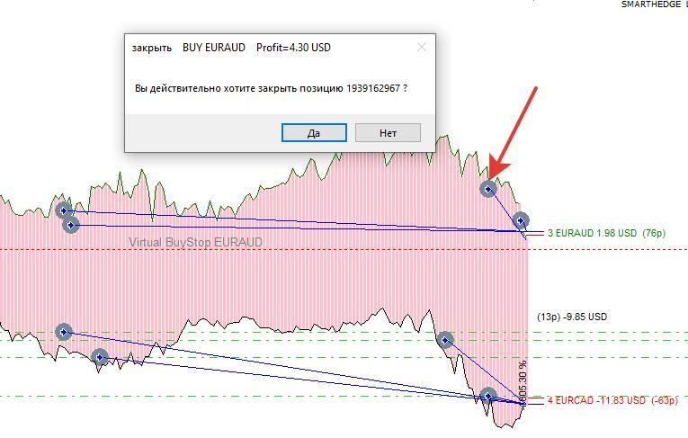
If you closed a position with your hands or the advisor, when closing, could not close some direction due to requotes, then an imbalance of orders occurs and the principle of hedge trading is violated. To restore the balance, the Expert Advisor places a virtual pending order in the direction of the missing direction and trails this order after the price until the price catches it on the opposite movement. Next, the advisor opens an order and restores the imbalance. The operation of the virtual top-up order is described above in the "Top-ups" section
The Expert Advisor can be tested on history only in the MT5 terminal. Real-time trading is supposed to be on HEDGE MT4 or MT5 accounts.

