CALENDAR EVENTS AND PLAN FOR THESE WEEK 7/14/2019
My trading week will start on Tuesday with NZD news wich expected to be dovish (in short term) for NZD wich will make to price reach my interesting zone S61 to S100, because there are several pairs conditions are not the same in all of them. My chosen pairs for trading during these event will be: NZD/CAD were realy price action shows levels of real resistance and NZD/USD wich also shows levels of resistance wich expected to be reached but overall trend in higer time frames remain bearish for me
00:45 | NZD |  | CPI (QoQ) (Q2) |  | 0.6% | 0.1%

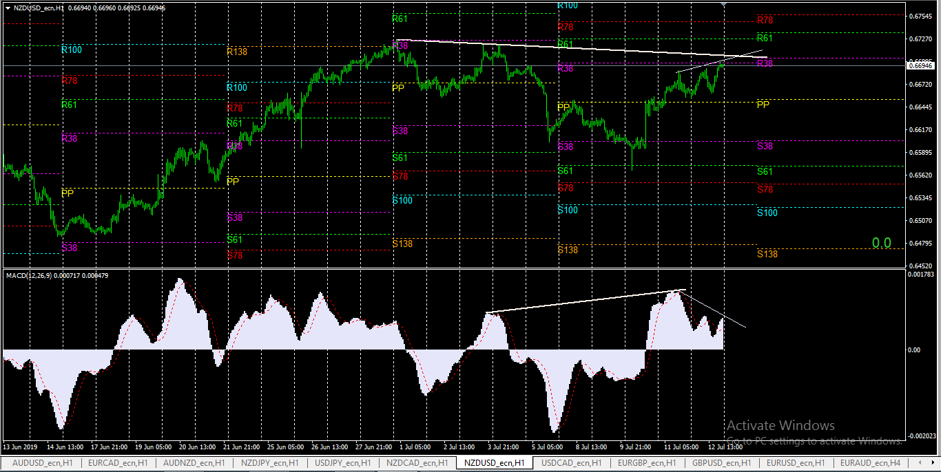
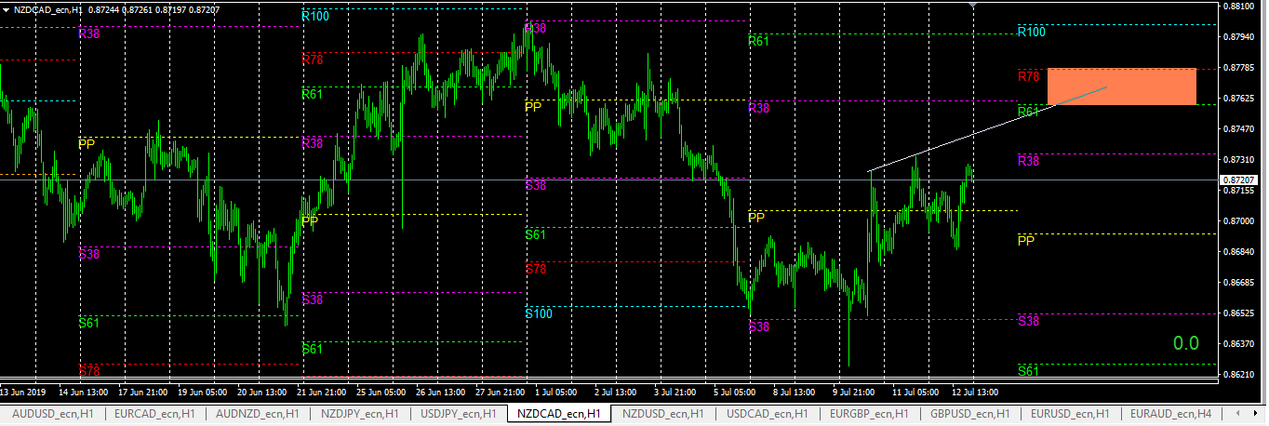
10:30 | GBP |  | Claimant Count Change (Jun) |  | 18.9K | 23.2K

After that in 10.30 come GBP in place were expectations are also negative wich I expect to make another drop on these GBP pairs wich also can give as good possibilities. Mine chosen pairs during these event are GBP/USD and EUR/GBP


