WAVE STRUCTURE

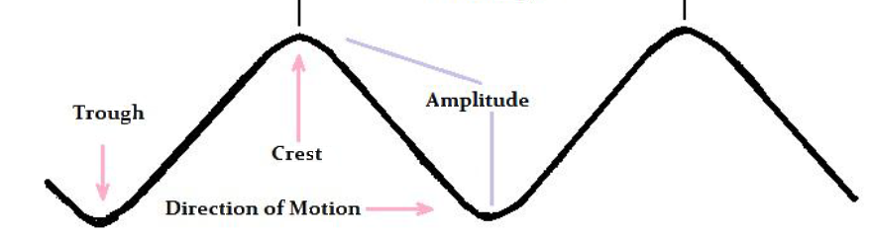

A cycle wave is measured traditionally from crest to crest and is defined as the "Wavelength" with the vertical height from the trough to the crest known as the degree of "amplitude.“

This is the basic formation of a proportional cycle wave regardless of the medium through which it passes.

When the wave structure is consistent, whereby the wavelength does not vary, we call this a Transverse Wave.

In addition, we can look at electricity to understand why cycles perhaps exist.

We all know that there is "direct current” which is what you have in a battery known as DC current.

Electricity generated at power plant is "alternating current" where a cycle has been introduced.

Direct Current cannot travel any real distance for the medium through which it travels reduces its speed (wavelength) and thus the current will be unable to provide a sustainable power source.

To solve this problem, a cycle was introduced which enables the current to self-generate oscillation between crest and trough.

This is why the sun beats like your heart.

If the sun was a DC system void of any cycle, the instant its energy diminished just slightly, it would blow itself out.

Thus, we ourselves need to sleep at night performing the same cyclical function of self-renewal.

The overall cycle of the sun is about 300 years between its crest (peak in output) and trough (minimum in output); hence, the oscillations between ice ages and periods of global warming.

Sometimes the energy wave that constitutes the cycle can be Transverse whereas it purely passes through the medium whereby the amplitude reflects the strength of the energy being transferred.

A Transverse Wave tends to be symmetrical whereas the wavelength and shape is constant.

There are also much more destructive formations such as the Longitudinal Wave which causes a temporary change in the medium through which the energy is passing.

In water, sailors have told stories of "Great Wave” or "Rogue Wave” that appears out of nowhere;

What these are can be simply explained as a "cyclical convergences” whereby numerous cyclical waves combine together and produce an abnormally "giant" or "large” wave that causes the amplitude of the individual waves to blend together producing the huge abnormal event.

This famous Japanese print known as the “Great Wave” does not portray a tsunami caused by an earthquake.

The Great Wave pictures what its title denotes, simply a large okinami, which actually means a "wave of the open sea."

Until 1995, these “Great Waves” or “Rogue Waves” were known only from stories of sailors.

The 1972 movie Poseidon Adventure depicts an ocean liner turned upside down by one of these waves.

In 1995, there was the first measurement of such a wave known as the Draupner wave or New Year's wave .

It struck the Draupner oil platform in the North Sea off the coast of Norway on January 1st, 1995.

This provided the first opportunity to actually measure such a wave carried out by Engineer Paul Taylor.

The platform survived this event, but the wave, measured with lasers, was 84 feet high (25.6 meters) in a sea where the average wave was 39 feet high (12 meters).

These Great Waves or Rogue Waves are a product of the Superposition Principle.

This is important to understand for as we will see, this also affects the global economy.

In physics as well as in systems theory, the Superposition Principle, or Superposition Property, states that, for all linear type systems, the net result at a given point in time that is caused by 2 or more stimuli becomes the SUM of the individual stimuli results that are created individually.

Therefore, if we take the Great Depression of the 1930s, there were many stimuli that took place at that same point in time.

But let us narrow our focus to look at just 2 effects.

First, there is the Great Dust Bowl that wiped out the farms at a moment in time when agriculture accounted for 40% on the employment within the civil work force.

Secondly, we now add the Sovereign Debt Defaults of 1931 where most of Europe, China, and South America all defaulted on their national debts wiping out capital formation that continued to the closing of 3,000 banks in the United States.

These 2 trends converging at the same point in time created a “Rogue Wave” within the Business Cycle that was abnormal because of the combined effect known as constructive inference (the Superposition Principle).

So that the Dust Bowl (input A) produces response X and Sovereign Debt Defaults (input B) produces response Y and therefore input (A + B) produces a magnified response (X + Y).

The Multidimensional Wave

Now you understand the Superposition Principle, we are ready to look at Multidimensional Waves.

This can be illustrated by light itself, which travels in an electromagnetic wave combining 2 components.

The wave is constructed with the electric and the magnetic fields together, but positioned separately at 90° angles.

Electromagnetic waves can be imagined as a Self-Propagating Transverse Oscillating Wave of electric and magnetic fields combined.

Instead of the frequencies of individual waves combining under a constructive inference to create one giant wave, now we find the 2 distinct waves combine creating a real synergy, in this instance, allowing light to travel.

Einstein posited the theory that light is made up of particles of photons, which may appear to be contradicting wave theory.

But tests have shown that at times light behaves like a wave and at other times like a particle.

We need not go down this road since it is not the subject-matter at hand.

It is sufficient to state that wave theory still applies to light.

I am bringing this up primarily to illustrate that altering the wave length creates different effects and this is what we will explore in the Business Cycle.

While in economics the Austrian School understood the cyclical nature of the economy, others in academia reject any such notion calling it numerology and voodoo because if there is a hidden order, then their power to manipulate the economy many not exist.

Consequently, they will fight tooth and nail against any notion of a Business Cycle since that mitigates the entire idea of Marxism/socialism and thus political manipulations.

We can see that an electromagnetic wave is a dynamic multidimensional structure.

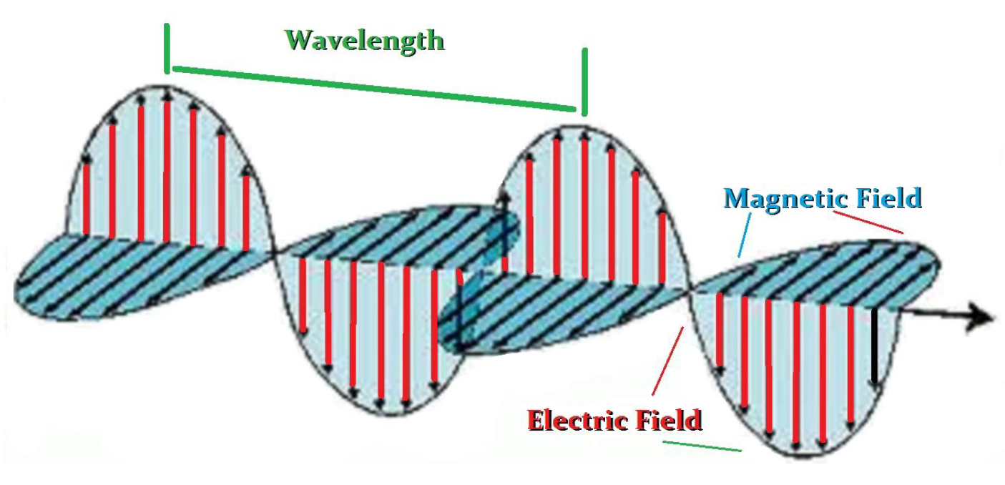

The combined 2 forces enable the ENERGY to be transmitted great distances.

Thus, we can feel the warmth of the sunlight thanks to this mechanism within nature.

Therefore, this provides a Self-Propagating Transverse Oscillating Wave.
The 2 ENERGY structures of electricity and magnetism maintain the integrity to transfer this ENERGY contained within the wave.

Electromagnetic waves are classified according to the frequency of the wave structure or wavelength.

The electromagnetic spectrum allows for the varying of the wavelength and this produces completely different effects.

There is light which we can be seen known as the “visible spectrum” and if we decrease the wavelength, we no longer can physically see the light as we enter the ultraviolet light and continuing to decrease the wavelength brings us to the x-ray and then gamma rays.

If we increase the wavelength beyond the visible spectrum we arrive at the infrared waves, microwaves, radio waves, and Television waves.

Altering the wavelength will alter the effects.

This is important to remember for we will see the same phenomenon in the Business Cycle.

The wavelength will vary according to the sector.

In other words, the longest wavelength among the class sectors such as commodity, stocks, bonds, and real estate will be the real estate market whereas the shortest wavelength will appear in the commodity sector that is influenced greatly by the forces of weather more so than real estate.

The overall structure becomes highly dynamic.

Now we can embed encrypted waves within the television and radio waves to provide even more information.

But as you can see, cyclical waves can be very complex and the measurement of the wave length can vary producing a host of different effects.

Using the sun alone, we can move from seeing things the eyes cannot capture while increasing the wave lengths allows us to even cook food or view television.

The Sound Waves

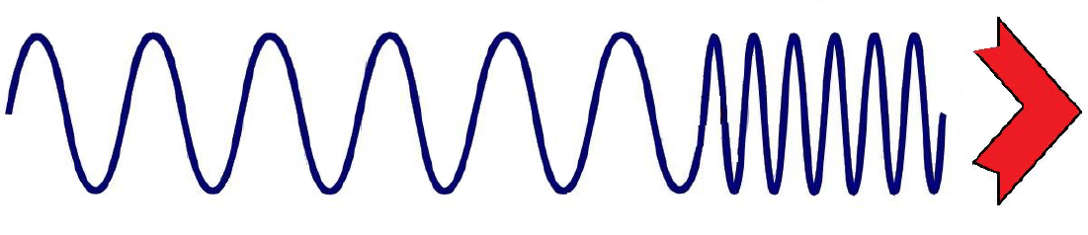

A major contributor to understanding the cyclical nature of how all things actually move is none other than Christian Doppler (1803-1853).

Doppler demonstrated also that ENERGY travels in waves.

His work was published in 1842 and can be easily explained concerning sound movement (waves) by standing on the curb of a street and simply closing your eyes.

You will instinctively be able to tell if a car is coming toward you or moving away.

What is taking place is that as sound travels, the cyclical wave formation begins to degenerate.

The wavelength dissipates the further it travels from its source.

Thus, the closer an object comes toward you, the louder the sound becomes because you are listening to cyclical waves that are closer to the source and thus well defined.

As illustrated below, if 2 people take a rope between then and move it up and down slowing the wavelength will be of a greater distance reflecting less ENERGY.

The greater the force in moving the rope, the greater the ENERGY created and the shorter the wavelength as the amplitude will increase.

In sound waves, if an object is moving away from the listener, the wavelengths are widening and the amplitude is diminishing.
This means that the sound is dissipating as well.

Unfortunately, this technology of understanding the cyclical nature of the wave structure is also applied in radar.

That worked well in time of war, but it has enabled the police to find a new revenue source – speeding tickets based upon this same principle.

This principle has enabled science to determine that the universe is still expanding for light in the visible spectrum also shifts to the red when an object is moving away from the observer.

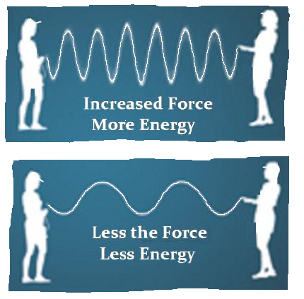

So you can see, cycles are the method by which ALL energy is transmitted.

Those in economics who refuse to even investigate the existence of the Business Cycle impede our progress in understanding our economic society just as those who called for the death of Galileo for daring to say the sun was at the center of our solar system rather than the earth.

If you simply throw a stone in a standing pool of water, you will see firsthand how energy travels in cyclical waves.

The impact of anything on the surface of water causes waves to emanate from the impact zone.

If you look at the moon you will see the impact of a meteorite also sends out waves in a circular fashion.

It matters not what we look at, energy travels in a cyclical wave formation.

Everything functions in this manner be it the 4 seasons or flu season.

The Black Death that killed about have the population of Europe in just 2 years between 1348 and 1350, and on average there were reoccurrences about every 17.2 years in 1360–1363; 1374; 1400; 1438–1439; 1456–1457; 1464–1466; 1481–1485; 1500–1503; 1518–1531; 1544–1548; 1563–1566; 1573–1588; 1596–1599; 1602–1611; 1623–1640; 1644–1654; and 1664–1667.

It makes no sense that is EVERY field of science respects the cyclical nature by which energy moves, yet in the field of economics they claim it is the single exception to how energy moves?

Panics strike when the majority is on one side of the Business Cycle.

Government has investigated every stock market crash in search of some short-player who overwhelms the majority.

However, that has just never materialized.

President Herbert Hoover apologized for the investigations he launched.

He wrote in his memoirs, “…when a representative government becomes angered, it will burn down the barn to get a rat out of it."

That is precisely what took place.

It was a witch-hunt and as always, the theory proved false.

Understanding the Business Cycle and how things actually function is vital to our financial survival both individually, as well as a nation.

If we fail to understand that a market crashes not because of some mythical short-player who overpowers society but because during the course of a Business Cycle people become convinced that it will not end and everyone who thought of buying has already done so running out of buying power, then is you scare them with some event, they will act like herd or while animals who all stampede because others are doing so and have not actually witnessed the threat that another on the periphery saw and panicked.

There are numerous critics of those individuals who chose to explore the element of TIME in economic and market forecasting.

A classic example is the debate concerning Kondratieff's work which has come to be known as Long-Wave Theory or the K·Wave.

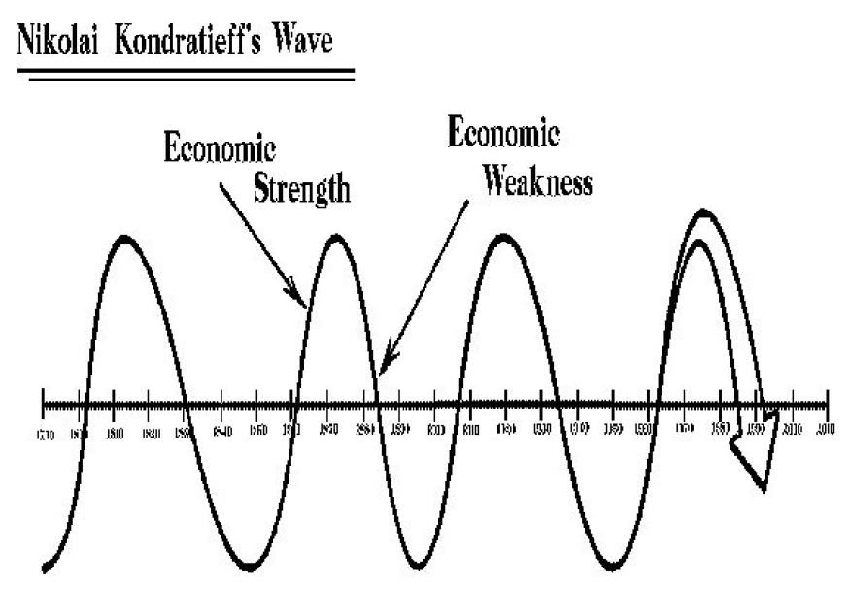

The primary argument has been that the K-Wave is not a wave at all for it lacks regularity varying between 50 and 60 years in wavelength.

Critics of Kondratieff long-waves of economic activity have on the one hand perceived that if a cycle exists, then their own future is perhaps predetermined.

That conjures up internal fears that go against the very belief that man is superior because he possesses the divine quality of free will.

Timing models and cycle theory do not eliminate the free will of mankind, nor does it suggest that the future of an individual is predetermined.

Any psychologist can explain the collective behavior of a mob.

While the individual within the group may be sympathetic to the actions of the mob, he still possesses free will to either leave or remain part of the crowd.

Clearly, we can predict a mob behavior, but we may not be able to predict who will stay and who will leave.

This is the Heisenberg Uncertainty Principle that means we may be able to predict that say out of 10 trillion atoms of radium, there will be 1 billion that will emit gamma rays within 24 hours.

However, we are unable to predict whether any individual radium atom will emit a gamma ray!

The next problem argued that the K-Wave is inconsistent and not a cycle at all, merely shows the ineptitude of the critic.

They clearly have no concept about cycles for that reveals only their own ignorance.

The K-Wave is a Longitudinal Wave not Transverse.

Such fears about cyclical theory are unfounded.

Scientific research has proven beyond a shadow of a doubt that the universe is governed by the influence of cycles.

Not only is our planet dependent upon a regular cyclical journey around the sun that provides us with the 4 seasons, but the sun itself is nothing more than a thermodynamic system dependent upon a cycle of pulsating energy while our whole solar cycles also moves.

Physics has proven that unless a cycle existed within the energy system of the sun, it would have died a long time ago.

Cycles extend life.

Our heart does not pump at a steady uninterrupted rate.

Instead, it pulsates and thereby insures a longer life span.

Every night our body needs sleep to rejuvenate and enable us to face another day.

It is fundamental that most who are critical of cyclical analysis expect everything to be a nice neat wave structure – TRANSVERSE.

However, life would be boring if cycles only came in one shape.

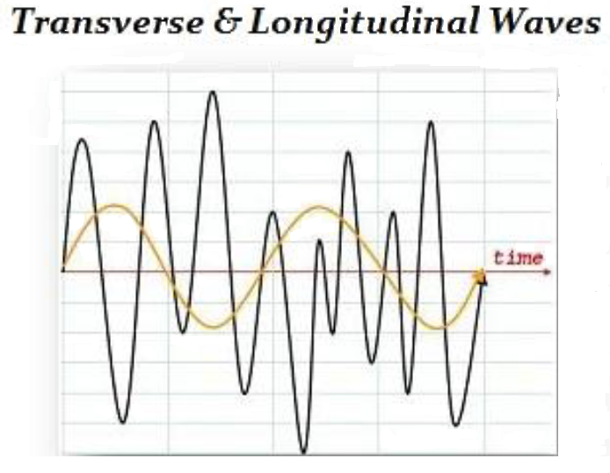

A TRANSVERSE wave is symmetrical whereas a LONGITUDINAL wave varies in wave length between each peak; however, there is a much broader repetitive pattern.

