My trend following

Down trend
H4:
FS30_5 appears red confirms by the yellow dot appears above price + the MAs cross down + Trix is below zero + stochastic cross down
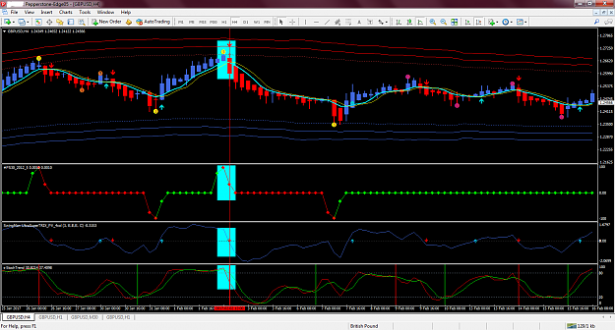

Up trend
H4:
FS30_5 appears green confirms by the yellow dot appears below price + the MAs cross up + Trix is above zero + stochastic cross up
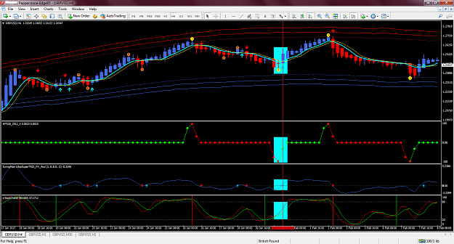

The price action must be aligned on H4 and H1 first of all.
Down trend :
FS30_5 must be red on H4 and H1 ---- High Probability
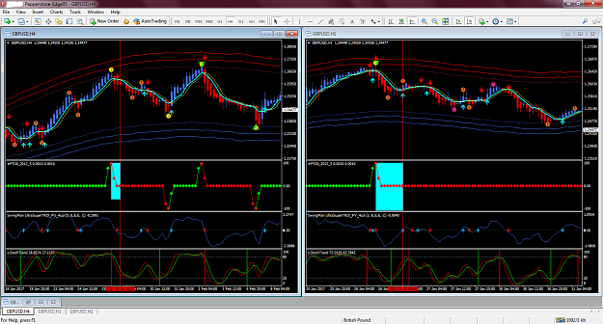

Up trend :
FS30_5 must be green on H4 and H1 ---- High Probability
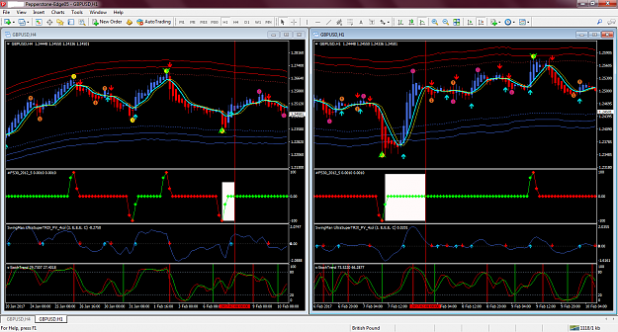

Once the alignment is in place then we can looking for an entry signal.
Down trend
M30:
FS30_5 appears red confirms by the yellow dot appears above price + the MAs cross down + Trix is below zero + stochastic cross down
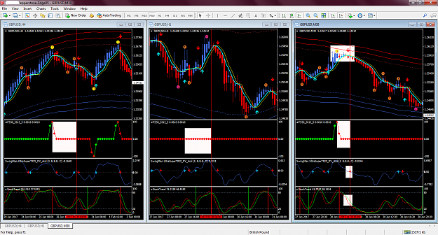

Up trend
M30:
FS30_5 appears green confirms by the yellow dot appears below price + the MAs cross up + Trix is above zero + stochastic cross up
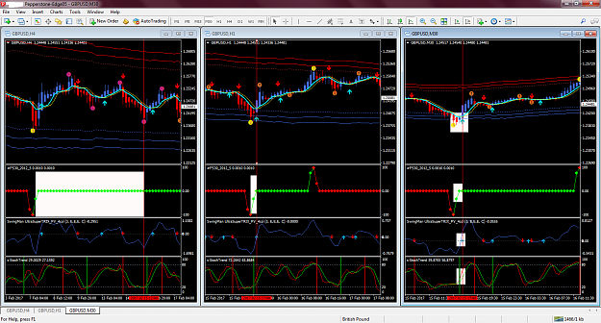

Counter trend
I prefer to enter a trade on H1 or M30 not below.
Before entering a trade on counter trend, one must waiting few signals to happen.
1) FS30_1 is appeared
2) Yellow dot is appeared
3) Price must trade near the band of the channel
4) FS30_5 is forming
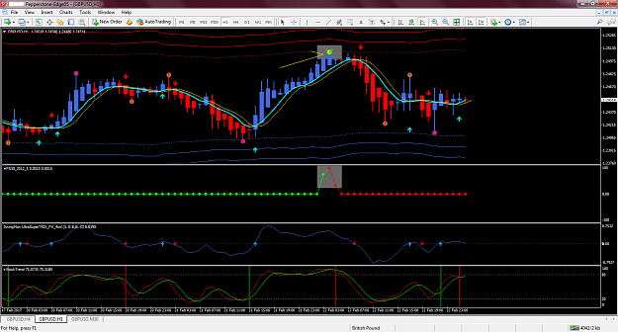
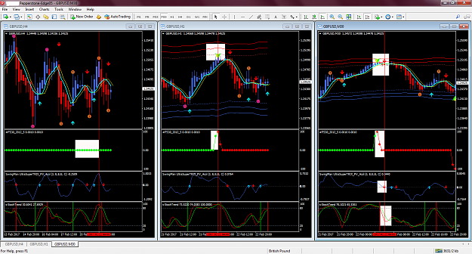
Stop loss and Take profit
Stop loss is placed below the yellow dot
Take profit is exited when FS30_1 is appeared (green arrow)



