Full 2016 vs Jul to Oct 2016 Optimisation for Performance Back Test Comparison for Period Oct to Dec 2016
CCI AUDUSD H1
Optimisation Runs for full year 2016 on a $1K account
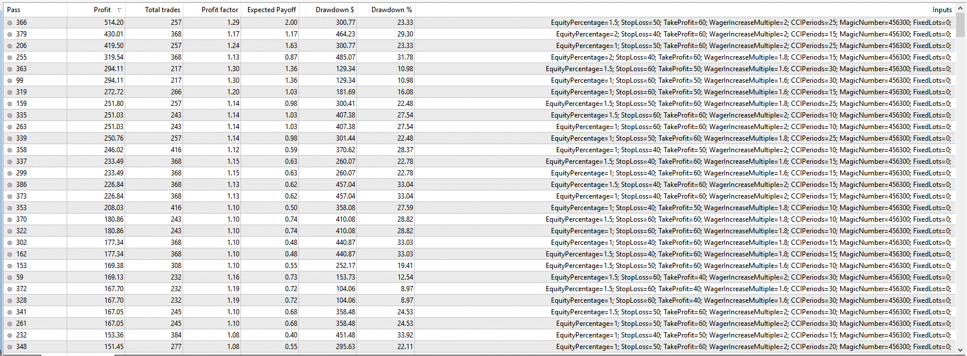
Back test from Pass 363(highest Profit factor, acceptable DD) for full year 2016
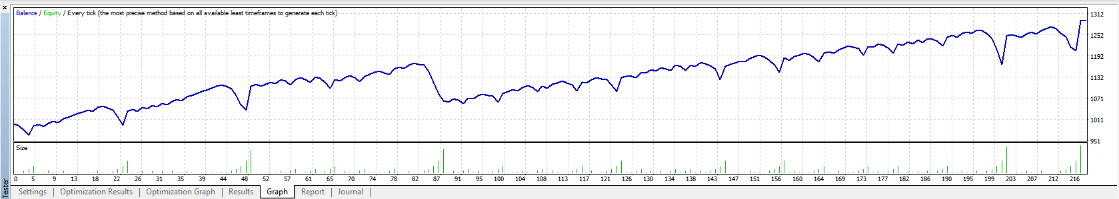
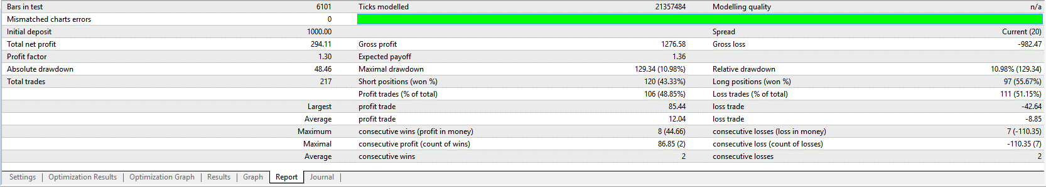
Using Pass 363 from full 2016 optimisation settings for period Oct to Dec 2016
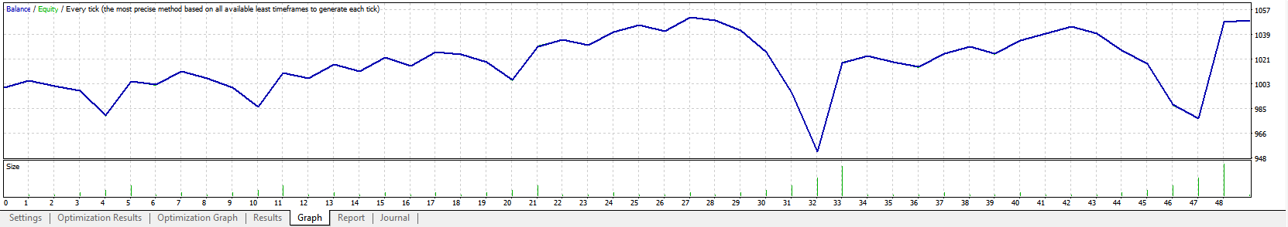
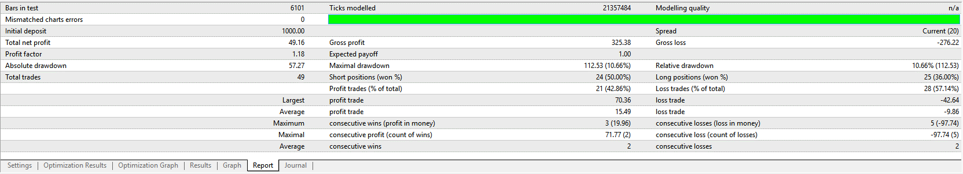

Optimising run for period Jul to Sep 2016
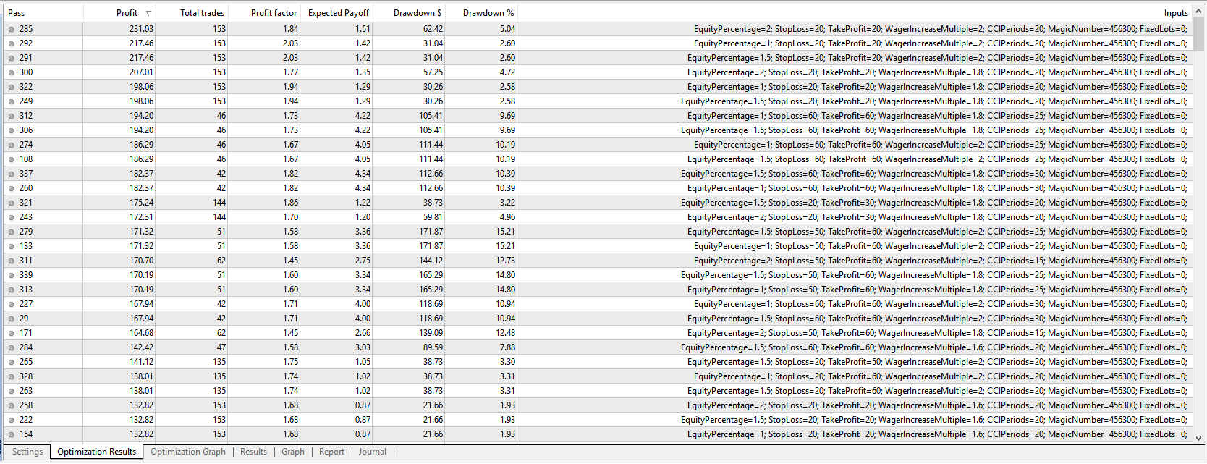
Selecting 2nd Highest profit/ highest Profit factor settings (Pass 292) for back test period Oct to Dec 2016
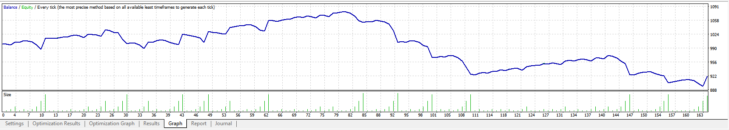
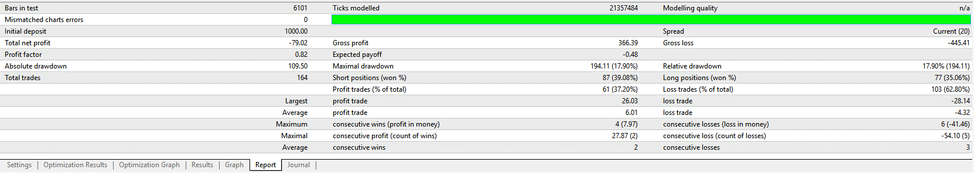
As above but using optimisation with fewer trades (Pass 312), about same number of trades and similar DD as full 2016 optimisation


