Ziggy Spreadsheet

Before going into the spreadsheet there is something you absolutely have to know, Dale has made it extremely clear that;
- We shouldn’t be entering trades that are triggered by what is becoming known as a monster move, ie if price is suddenly spiking up or down and has covered a wide range in a couple of minutes, we should stand aside.
- When we have a macro news event we should exit any trades that we have open prior to that news event breaking.
This spread sheet does not take either of those points into account, it works on the basis of every trade triggered is in the spreadsheet, but it then removes all trades that would be entered heading into the news period or during the volatile period afterwards. It also removes all trades that have previously had the level tested, tests are really a matter for the eyeball to detect, however to sure I was being consistent I have determined a test to be where price has got within 5 pips of the level and then moved 15 pips away from the level without having touched it.
What this means is my spreadsheet is mechanical, it doesn’t try to take into account any actions that you might choose to take by way of protecting yourself etc. For this reason it will not, cannot, reflect the results that Dale has achieved – but it certainly does reflect what anyone following the thread could achieve with just a little bit of effort.
Some important points to note as looking at a spreadsheet someone else has put together can lead to a great deal of confusion.
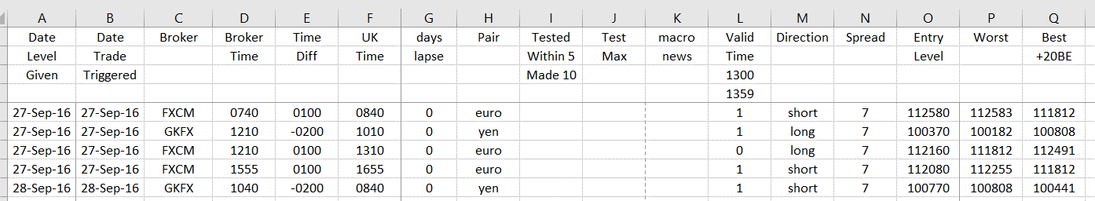
This is the collected data,
col A is the last date that the level appeared on Dale’s daily sheet
col B is the date it triggered
col C the broker MT4 platform I got the data from, this is actually important because the small differences can mean the difference between entry, stop or PT
Col E & F is converting the time to UK time
Col G & H should be obvious
Col I notes if a test using my definition above has been made & col J how far that test moved from 5 pips before the level
Col K denotes if there was a macro news event
Col L is the time I have chosen to void, this can be changed by simply changing the start & finish time of the void period, the spreadsheet will update. If you don’t want any void periods enter a 1 in cells L3 & L4
Col O is the trade level
Col P is how far it moves against before the “best” which is recorded in Col Q
You will find 2 tabs, 1 is prepared using the 12 pip stop the other allows for a 20 pip or greater stop.
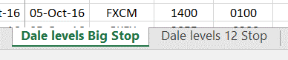
When you are looking at the data you will see some trades recoded where the level wasn’t actually touched, this is because I wanted to see the impact of moving the entry point to before the level, I’ve shown below how this part works.
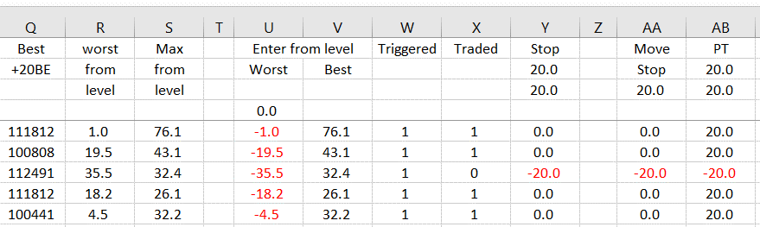
Col R is the worst the trade would get to if left to run
Col S is the best it gets to after having reached that worst, the spreadsheet takes care of whether or not a stop is taken before a possible PT
CELL U4 if this is kept at 0 then any trade that did not actually touch the level will not be recorded in the results, so if you type -1.0 then it will record any trades that got to within 1 pip of the level etc, similarly if you type a positive number it will record trades that get that number past the level, this results in Col W having a 1 which denotes “trade triggered”. If any value is put into cell U4 the stop & PT are amended to take account of it, eg if you enter a trade 1 pip early, your stop will be 1 pip greater & your PT 1 pip less.
If there is a “Yes” in either the tested field Col I or in the news field Col K then the X col will have a zero, this means those trades will be taken out of the results, the same is true if there is a 0 in col L due to the time being invalidated.
Col Y in Cell Y2 shows the stop you are prepared to risk, you can amend this. If you are want a stop of 12 or less you’ll need to look at the tab for 12 stop, and if you are looking for bigger stops then use the “big stop” tab. Don’t touch the figure in cell Y3 as this uses the stop you put in cell Y2 and adds/subtracts anything you use as an entry before/past the level.
Col AA is used to move a stop to breakeven, this really wants to be left at 20 as that is the basis I put everything together on, if you change it the results may not be accurate. It is used simply to ensure if the spread is the only thing that prevents a PT then the result will be BE rather than a loss.
Col AB is the PT, put whatever PT you want into Cell AB2, it will actually use AB3 for the calculation, this is your PT level adjusted for any entry you take either before or after the level.

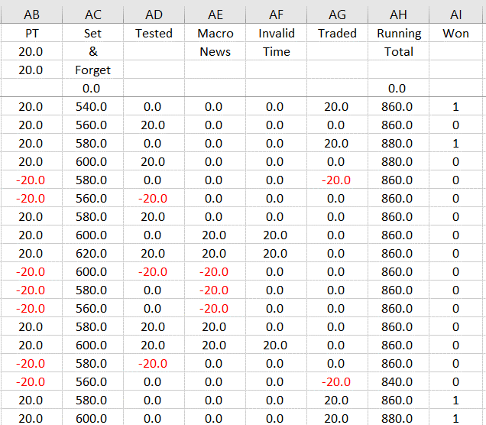
Col AC gives the result on a set & forget basis, ie you enter every trade regardless of if it’s been tested or there is a macro news event.
Cols AD – AF “take out” any news or tested trades, also any time period you chose not to trade. There are instance where a trade appears in 2 or even 3 of those columns, but they are only removed once. The “managed” result appears in Col AH and AI is a recognition of a winning trade.

The next section is about the financials
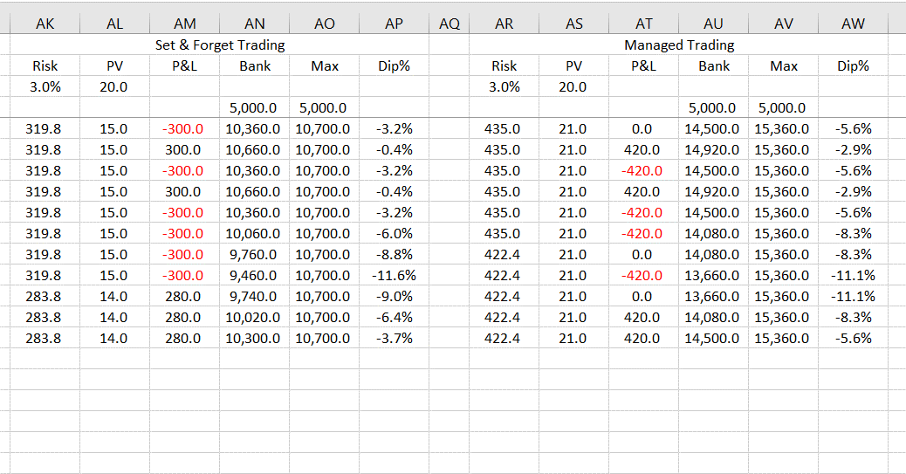
It shows the result of how your account would progress either on a set & forget or managed trading basis, using the following information.
Enter your start trading bank in cells AN4 & AU4, enter the percentage you are prepared to risk in cells AK3 & AR3. It is calculated on the following basis. At the start of each day your opening bank x your risk determines your £ risk, which is divided by your stop level to give you a integer pip value. This pip value is used for all trades on that day, it is then recalculated again for the next day.

Down to the bottom of the page
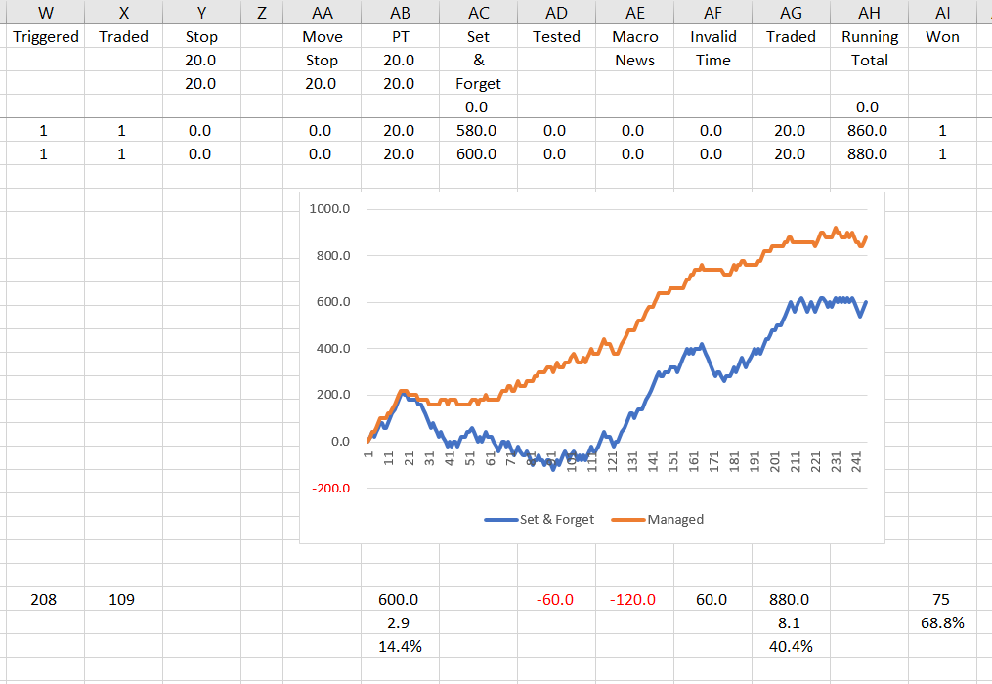
Here you will see how many trades were triggered, how many were actually traded after cutting out the news & tests, the totals of cols AA – AI, the strike rate & the resultant graphs. Let me draw your attention to in this case only 109 trades were taken from a possible 208, yet the pip haul is greater than taking all trades, this ought to demonstrate why avoiding news & tests is so important. It isn’t the fact that it is more profitable, it’s the fact it is so much more consistent.

Finally the totals in the financial section.
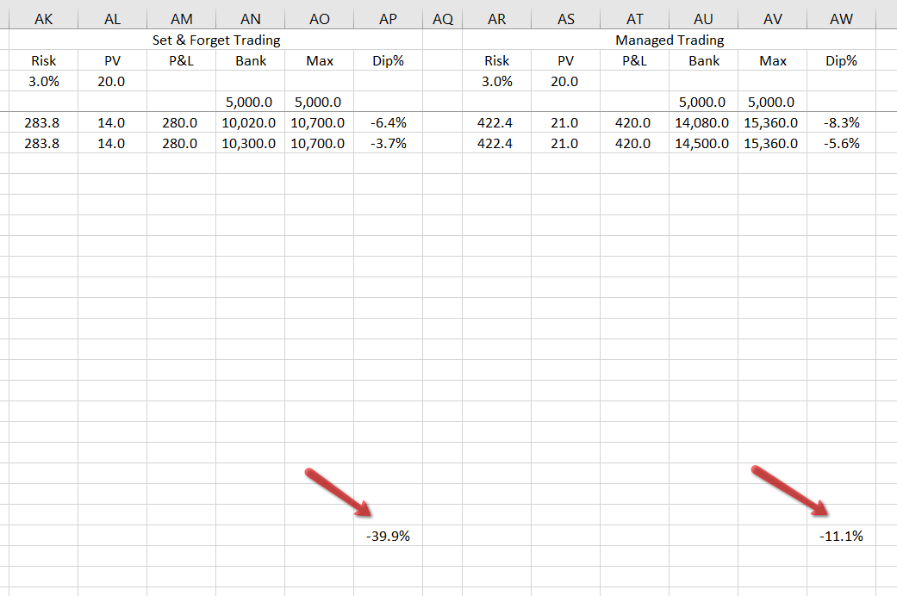
The balances are self evident, the arrowed figured represent the worst draw down you would have encountered.
If you are operating with a modest bank you could chose to use a higher risk level, these figures will give you an indication of how much your greatest drawdown would have been to date. I used to kid myself about the level of drawdown I could mentally handle, I can tell you your actual pain threshold when you a several thousand £’s down and your bank has halved or worse is immense and will almost certainly cause you to make bad decisions. Focus more on the drawdown than the growth, slower growth is far better than big drawdowns, a 50% drawdown requires a 100% increase to get back where you were.
I hope this all makes sense and that you find the spreadsheet useful/informative. And if any of the detractors have bothered to read this far and look at the spreadsheet they might just begin to realise why this thread is so popular.
BIG thanks to Dale.
One final note, I believe this data to be accurate but I cannot be 100% certain I haven’t mistyped a figure here and there, even if I have it doesn’t change the fact that this process is a stonkingly good way to trade.

Cheers Ziggy

