Following several PM’s and things I’ve seen in the thread I thought I’d try to put something in writing to help a few folks in trying to find levels of their own, this is never going to be a comprehensive write up, but hopefully it will help a few.
Let’s look for a stand out obvious situation, as these are going to be the best place to start.
Using the example of 30th Jan. for EU
Here we have a 30 minute chart where we have 2 clear examples of price rejection.

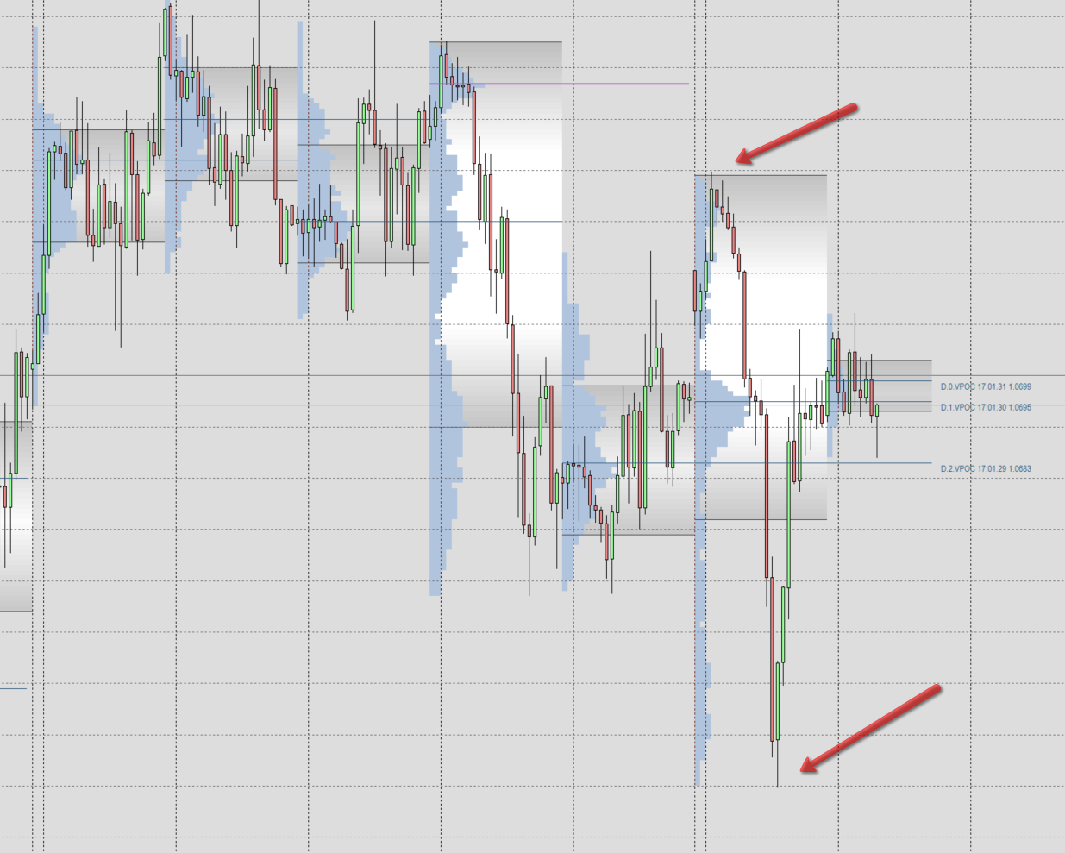
Conventional methods would wait for either of these 2 turning points to be breached and put in some kind of confirming price action bar such as a pin bar or an engulfing bar, and having done so enter a trade for the reversal.
What we are trying to do is catch the first response as price enters these area’s and get something out of that response, we are not trading for the home run all the way back to the other end of the range, but riding on the coat tails of the bigger traders. So we want to find a location where we can expect to see a reverse reaction as price moves into the “zone”.
Akif has helped enourmously by producing the volume profile tool Akif_Rectangle_Volume_Profile, lets put that profile on the page, which we do using the rectangle drawing tool.
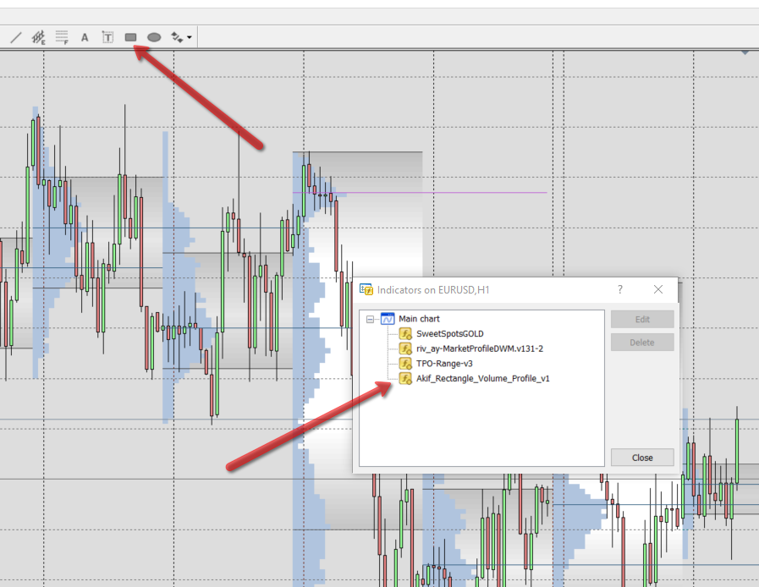
Draw a rectangle around the extreme turning point
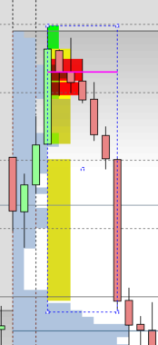
Then move down a timeframe – first 15 mins. Move the rectangle to cover any consolidation and the breakout of that consolidation.
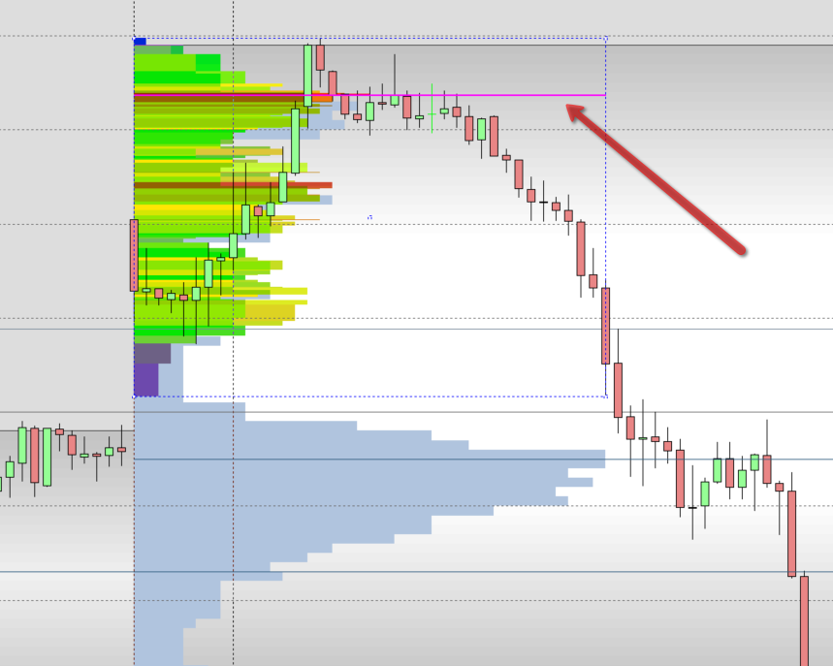
If necessary move down to smaller time frames, but in this example it isn’t necessary – the greatest volume within that range took place at the pink line POC.
Now this may not be a great example, but it demonstrates the process of finding your own level.

One more time at the bottom reversal
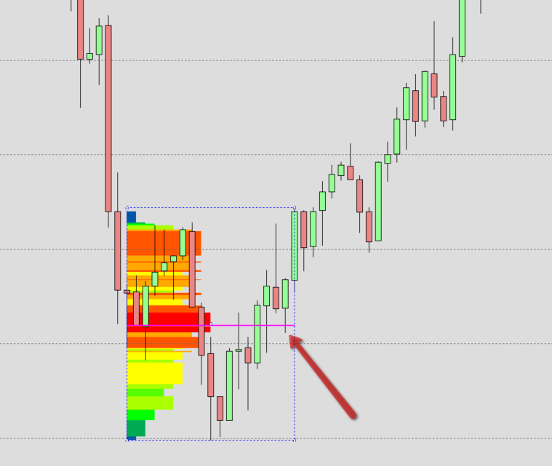

This is where those levels appear on the bigger chart
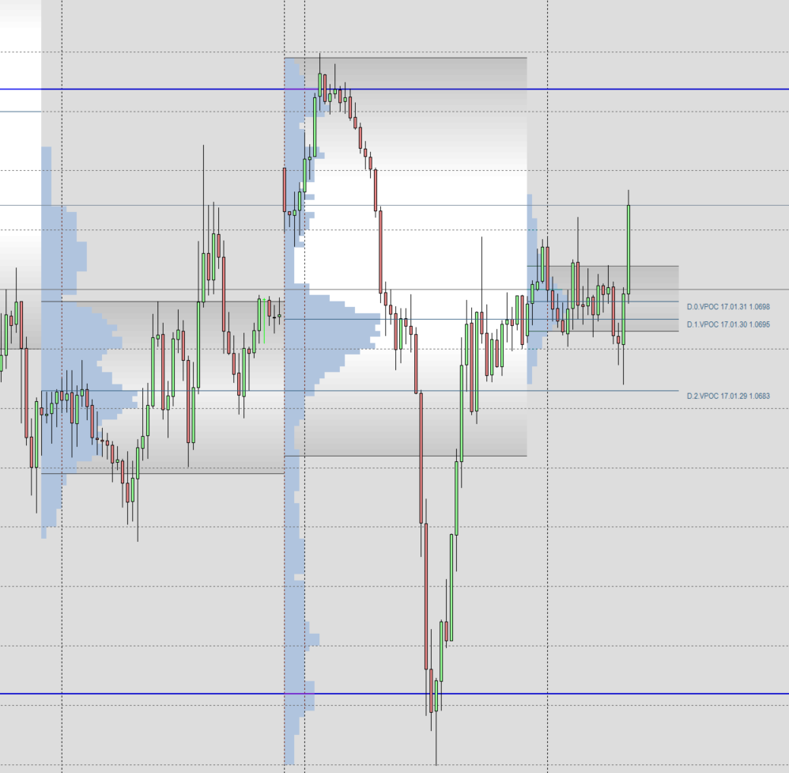
Having done this make sure you know where they sit in the bigger picture, and decide if you still think it’s an appropriate place to trade from.

Both of these reversals were rapid & I’ve used them to display the process, some of the best situations come from a strong move away from a congested area, I had a level that I traded from yesterday afternoon that several people asked about, this is how I found that level. First on the 30 min chart I located an area I was interested in
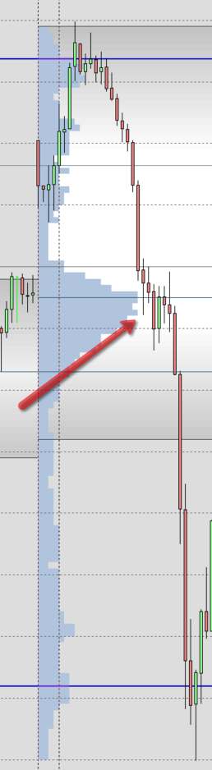
Then I dropped down in time frames and put Akifs profile on
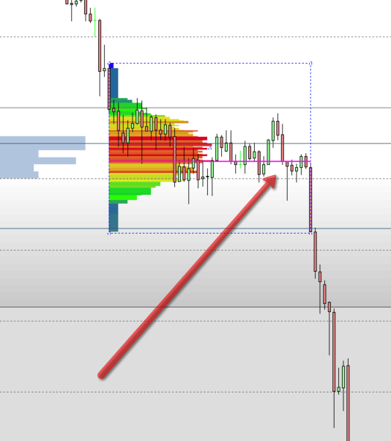

And this is the reaction when price got there
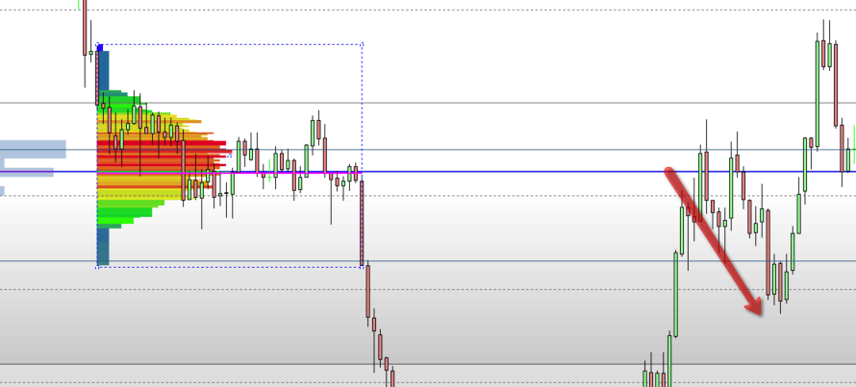
In truth my own entry was a little high as I had also used the tradingview platform to find this level, and I also considered that 1.0700 lurking just above might be a magnet.

I would urge any who would like to find their own levels to do a bit of practice using Akif’s profile

Cheers Ziggy

