I’m going to try to put down some information that I hope will help new traders to gain a better understanding of why & how price moves, and how this knowledge might be used in preparing some kind of map for the days trading. I must say at the outset I am no expert, this is just information that will hopefully turn a chart with a lot of up and down movements into a page of information.

What makes price move? This is the most basic element and yet one that many traders do not understand, it is crucial because it is what makes everything else happen. Many traders believe that when price moves up it is because there are more buyers than sellers, this is wrong there are never more of either, the buy trades are always exactly the same number as the number of sell trades.
Think of it this way, if price is sat at 1.5000 and a market order is placed to buy then in order to be filled it must be met by someone willing to sell, if the first available offer is at 1.5001 then that is where price must move to in order for the buyer to be filled. If the byer places a limit order to buy at 1.5000 and no sellers are prepared to offer to sell at this price, the order goes unfilled and price does not move.
Why is this so important, well for retail traders placing orders it is most likely our small orders will get filled within a pip of where price is when we hit the “buy” button. But put yourself in the shoes of a hedge fund manager, or bank trader, who needs to get millions of “widgets” bought. If they hit the buy button they will get some filled at 1.5001, then when all offers at that level have been consumed will get some filled at 1.5002, some at 1.5003 and so on until the whole order is filled, and that could mean some as far out as 1.5020,30,50 etc. That would soon leave the trader unemployed because he has gotten a net fill at a “bad value” price, his average across all the contracts traded could be say 1.5010 or worse.
Had a large order hit the market all in one go the price would have shot up the chart in a blink of an eye as all of the order has been filled. We’ve all seen it happen, and most often after a major news event, and when you here the phrase “fat finger” it is where a trader has placed an order with an extra zero or two in the quantity field, which sometimes causes the “flash crash” events. But in the main we see price moving up and down as these market orders are filled at the available offered “pending orders” on the order book.
So that is what makes price move. So now lets put ourselves in the shoes of the big players, they have large orders to get filled and must get those orders filled on behalf of their clients at what are seen to be “good value” prices. Ask yourself will a hedgefund wait until price has moved 200 pips up the chart before placing their buy trades, or will they have gotten their trades on before or as the move started? The answer should be obvious, and this is where retail traders for some reason do something they would never do in any other walk of life. Who walks into a shop wanting to buy something and says, “oh that’s far too cheap, I’ll wait til the price goes up and then I’ll buy it”. Hedge fund managers buy at wholesale prices and sell at retail prices.
This is where the levels that Dale puts out are placed, where the major players are most likely looking to buy & sell themselves. They wont all turn into winning trades, but the process Dale goes through is trying to locate the most likely “value areas” that the big players who still have orders to fill are likely to get involved. Remember what makes price move, we place our tiny retail trades at the same place and try to profit from the fact that the big player trades cause the price move.

How can we find these trading locations?
I do not have the skills that Dale has, but we can all get an ideas of whereabouts these levels might be. This is because the big professional traders leave their footprints on the charts, we just need to become trackers and find out what these footprints look like and see if we can find them
Before going any further let me point out that RSI, stochastics, MACD etc are totally useless for these purposes, it’s not just that they tell you what has already taken place, it’s that if you change the timeframe on your chart the indicators tell you something different. You may look on one timeframe and “see” price is overbought, switch to a different timeframe and “see” price is oversold – how can it be both at the same time? We need something which tells us exactly the same thing no matter what timeframe we use, well price will always be the same, and so will the quantity of contracts traded at each individual price – and this where Volume Profiling becomes our tool of choice. True volume profiling can only be carried out on a futures chart, because 100% of the futures contracts traded are visible, as is the precise location that each contract was matched at. The forex market which we deal in does not have a central exchange, so we will never see 100% of the volume, but using the major pairs as we do, and using a major FX broker for our chart, means it is likely that our information on our MT4 platforms will be very similar if not exactly the same.
So what does a volume profile show us and what should we be looking for?
The chart below is the aussie/usd chart for 5th Dec, it’s on a 15 min time frame but the highlighted info would be identical on every timeframe.
So the chart itself gives us where price has traded through the day, and the blue shaded section gives us a histogramme (English spelling ) of the volume of trading that has taken place at each price point on the chart. We have no interest in how long it spent at different points, only the volume of trades and the resultant price action. To labour this point, if it sits at the same place all day and has little volume traded it tells us nothing, if on the other hand it has a large volume traded and price suddenly moves it tells us a lot.
So what is this chart telling us. First it tells us that price spent the early part of the day consolidating and that during the course of this time a significant volume of contracts were traded. Then having made a low of the day price reversed and kept on climbing. So now we have the first big player footprint, the big players were accumulating long positions and most likely forced price down to the low point of the day in order to wrong foot the sellers and stock up on good value long positions.
Price then did shoot up the chart, made a high, and again consolidated with a significant volume of contracts traded. Is it likely that the professional traders waited for price to make a high before stocking up on long orders? Of course not, so we now have our second footprint. This high volume area is most likely to be the professional traders taking profit by selling at retail prices their stocks which they bought earlier in the day at wholesale prices, they may even now be stocking up on short positions.
The other items to be aware of on the chart are:
- The position of the VPOC, the volume point of control. This is simply the location where most contracts were traded during the day, it represents the exact location of where the highest volume of contracts were traded in the day. The reason it’s important is that every single professional trading house will have their VPOC in the exact same location, and it is very often used as a target to move to the following day – which is why sometimes you’ll see people say “closed my trade at the VPOC”. Until this level is touched it in known as the naked VPOC.
- The grey area is known as the “fair value” area, at the extremes or this area you have the value area high & the value area low, again all trading houses have the exact same information, and if you think back to the comment that fund managers must get value fills for their clients, it gives a clue as to where they might be interested in trading.
The VPOC and the value area both build up over the course of the day, and often change during the day, but once the day is over they are cast in stone.

So come the start of the next day we have a map that we can use, it’s never a perfect map but it is the best we have and we know that every professional trading house has the same map. So we plot out the areas we will be interested in becoming involved at, and we hold our discipline to ensure that unless and until our areas are visited, or tested, we simply do not trade.

Take a look at the chart below and try to read into it what took place over the day, and where you might be interested in trading the next day.
I’ll follow up after the chart below.
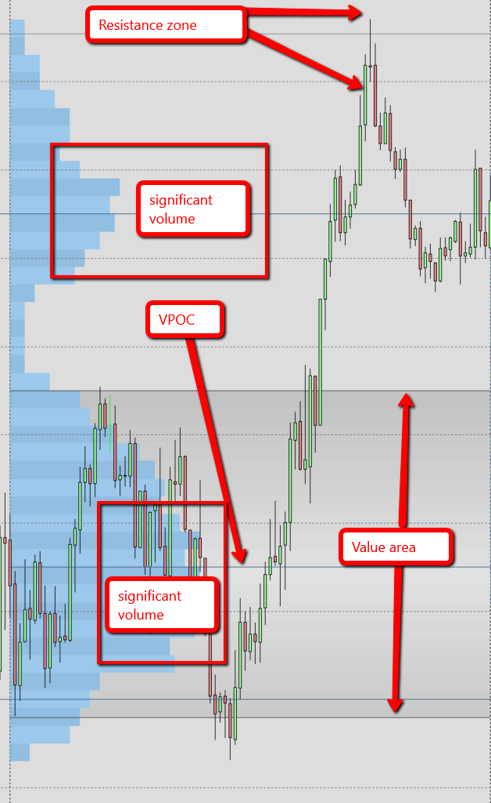
Coming into the next couple of days this is what we have.
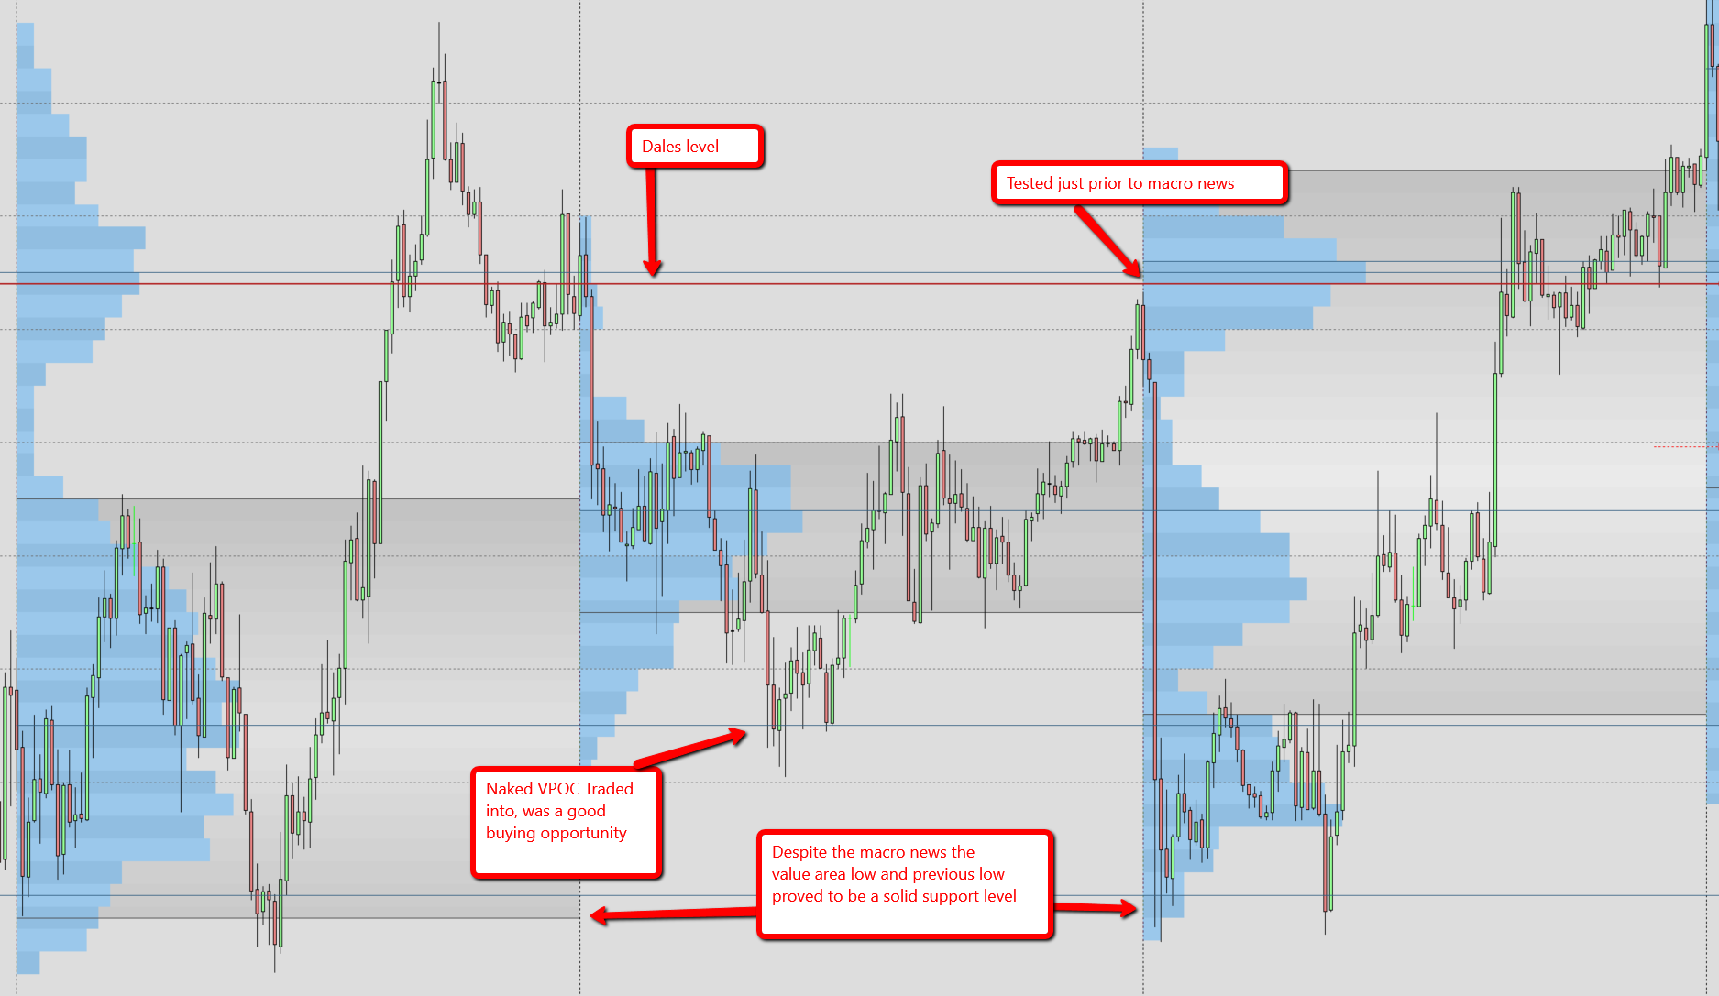
Our map gave us a clue what to expect, the naked VPOC was touched and gave a good target for anyone holding a short position, such as those professional traders who stocked up on short positions near the high, it actually also provided a buying opportunity .
Dales level was tested just prior to the macro aussie news, in actual fact the news just after this wasn’t the main news event, that came 3 hours later, but there were political comments made that caused the sudden drop.
That sudden drop when it hit the value area low & potential support zone was actually stopped dead in its tracks.
The day 6th Dec was pretty much a “nothing” day with all the price action being contained within the range of the prior day. This day tells us nothing about the actions of the professional traders so we have to wait until we do find some more footprints to give us some locations of interest.

This form of trading takes patience, but does give us the locations where we expect to find some activity, with observation and practice we can hone our skills and at least trade like professional traders by only opening trades at “value” locations that give us a high probability of success. If we only ever take trades that we’ve mapped out to have a good success probability we wont go far wrong. When a trade does fail we have no reason to be angry with ourselves as we mapped out our battlefield and carried out our plan, and when it succeeds we have some money in the bank and know that it wasn’t down to luck. Trading in this way over time has the potential to become life changing. It is not by luck that Dales trades are so successful, by working at it there is no reason we can’t get similar results

Almost forgot, what can we learn from low volume areas? From what we learnt above we know that if price moves rapidly through an area with little volume traded it means there was no interest in trading at this location, we simply passed through it. This can cause an order book vacuum, traders, or at least professional traders, tend not to place orders in vacuums and as a consequence, where a price area is traded through rapidly in one direction it will often do the same in the opposite direction. Look back through the charts and you can see it happening, this can be useful when holding a position and taking a few extra pips of profit……….. but importantly if the pro trraders don’t take new positions in vacuums neither should we.
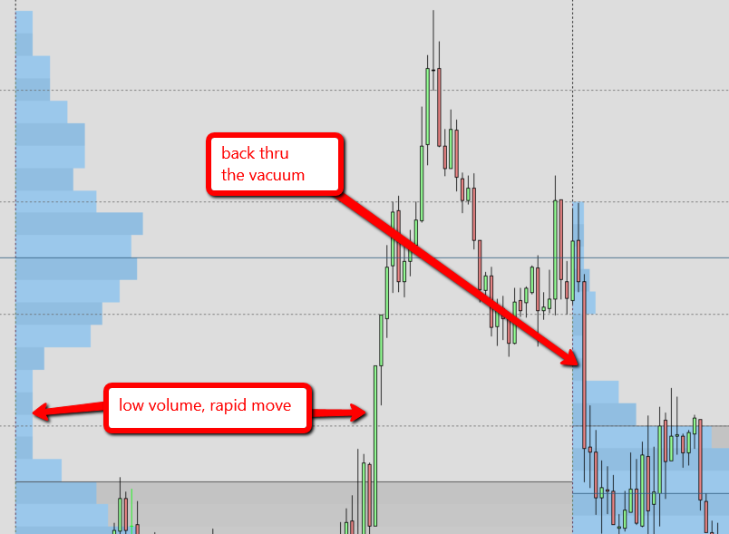

A cautionary note. Pro traders also use profiles that fit the chart, by which I mean they will have volume profiles that stretch over several days covering the current range, the profiles we are using cover each day as a separate profile. So we must look back to make sure our “map” doesn’t conflict with the bigger picture, an analogy is to think of a battle field, it’s all well and good outnumbering the opposition right in front of you, but if just over the horizon there is a massive army waiting for you your chances of success have just been dramatically reduced!!
Be careful, read what the charts are showing you, set your traps in zones of interest and you have a very good chance of becoming significantly better off than your average retail trader .

Hope you find this helpful, cheers Ziggy

