My Trading System (MTS)

Charts setting:
TMA (Upper band, RIPT, Lower band) : Define probably of the area of reversal and the zone of buyer and sellers.
Moving Average in the price world
Long Term Trend : 200 EMA
Market Trend : 21/55 EMA
Price action : 5/8 EMA & SMA

Oscillators in the indicators world
Market Trend : Macd(21,55,8)
Price action : CCI&SMA(13, 8sma)

Where and how to trade
M15:
Very good TF to use as a day to day trading. We can grab at least 20 to 35 pips with Stop Loss (SL) as 25 to 35 pips. RR:1:1
Long Trade:
- 21/55 EMA cross up
- Wait for price closed below the RIPT (High Probability and recommended)
- CCI is below -100 (recommended)
- Goto M5
Enter a trade
M5:
- Wait for price to closed in or below the lower band.
- Then go LONG when 5/8 EMA&SMA cross up confirmed by CCI(M15) cross up the MA (8sma).
Additional info.: Enter a trade above the 200 EMA
NOTICE:
On M15, up trend is developed then Macd on H1 crossed up

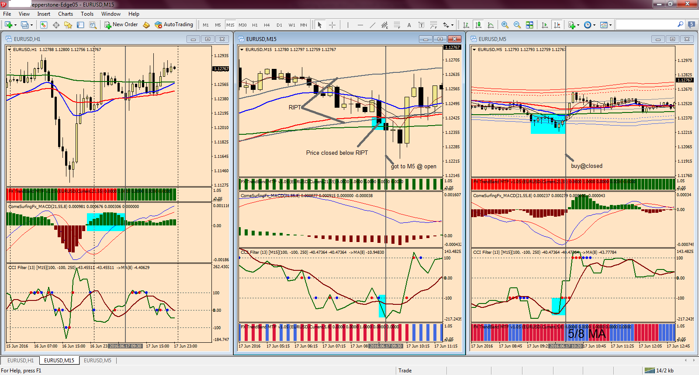

Short Trade:
- 21/55 EMA cross down
- Wait for price closed above the RIPT (High Probability and recommended)
- CCI is above 100 (recommended)
- Goto M5
Enter a trade
M5:
- Wait for price to closed in or above the upper band.
- Then go SHORT when 5/8 EMA&SMA cross down confirmed by CCI(M15) cross down the MA (8sma).
Additional info.: Enter a trade below the 200 EMA
NOTICE:
On M15, down trend is developed then Macd on H1 crossed down
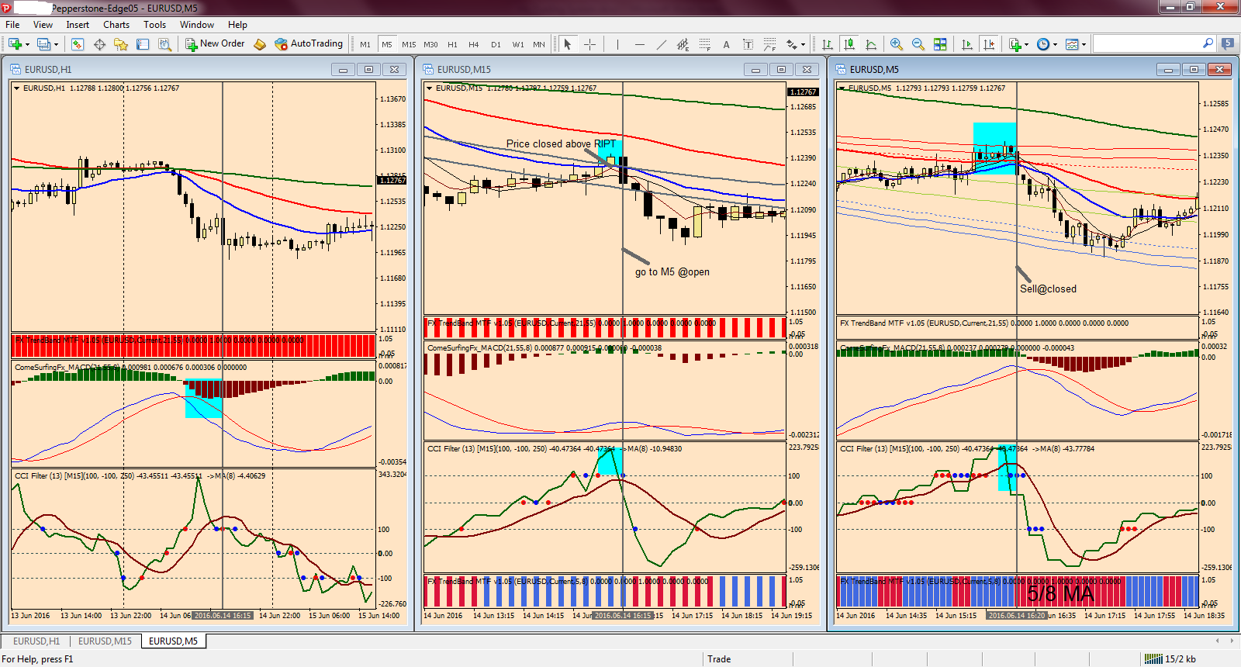

Stop Loss (SL)
For short trade
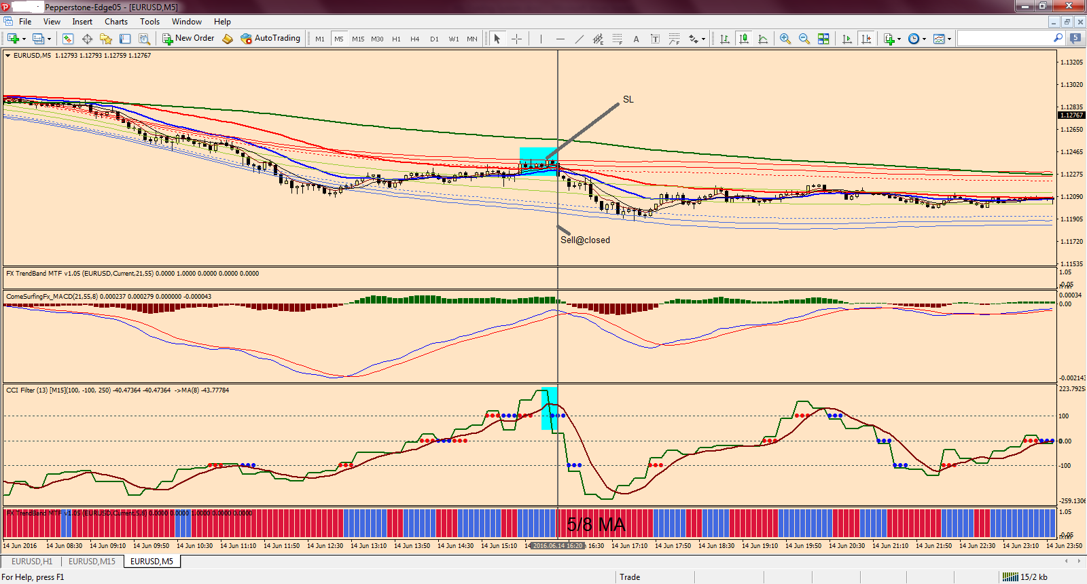

For long trade
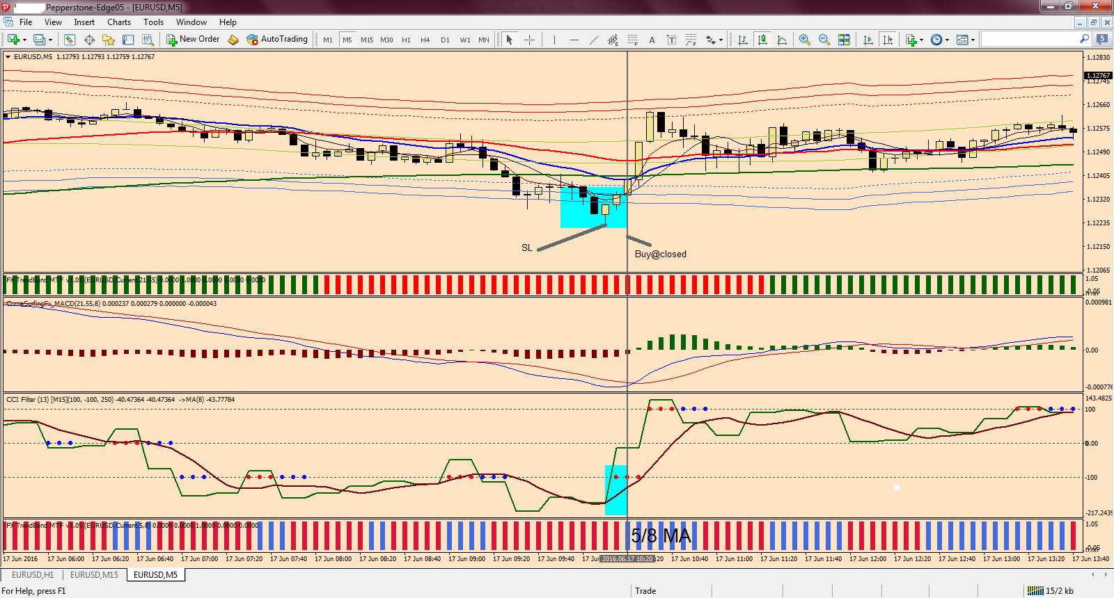

Take profit
It is up to you

Still coming …..

