S & R method
It can be applied to all trading platform and need very minimal training or experience in forex. The reason is because this method doesn’t use any indicator at all. All you need to know is how to draw 2 types of line:
1) Horizontal Support line
2) Horizontal Resistance line
Before the Internet trading era, we trade currencies based on fundamentals and the use of the two lines. Now, I don’t see why we still cannot use it.
The Daily Chart
Now, open your daily chart (candlestick preferably) on 3 major pair (GBPUSD, EURUSD, AUDUSD) and watch closely. Take 1 minute and tell me what you notice (Don’t read the text below yet!!)

THERE IS NOT A SINGLE BAR EQUAL TO THE BAR NEXT TO IT!
Based on this fact, you can safely assume that, the highs and lows of a daily candles are unique EVERYDAY.
Now do this:
1) Draw support and resistance on any of the previous bar. Support is the lowest price of the candle and Resistance is the highest price of the candle. Draw horizontal lines.
2) Do you see the next candle penetrating the lines?
a. YES: That’s your trade
b. NO: Not your Trade
SELL when it penetrates the support line and BUY when it passes the resistance.
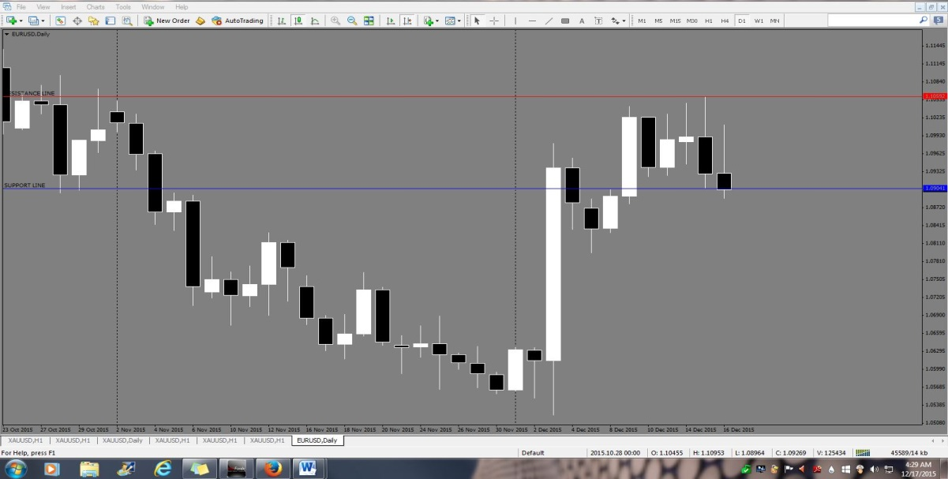
Now do this:
1) Back test on as many candles as you like, minimum 20 candlesticks
2) Study the number of pips for every available trades (minus spread)
3) How many candles give minimum 5pips?
4) How many candles give more than 10pips?
5) How many candles give less than 5pips?
Now you have the answer. ARE YOU EXCITED? You should be!
HOW TO TRADE THIS METHOD?
The Preparation
Upon the start of a new Daily candle;
1) Draw the Support horizontal line
2) Draw the Resistance horizontal line
….on yesterday’s candlestick please!

Draw the horizontal lines and determine the trend. This way, you can expect where the price will go. It is either towards the Support (bearish) or towards the Resistance (bullish).
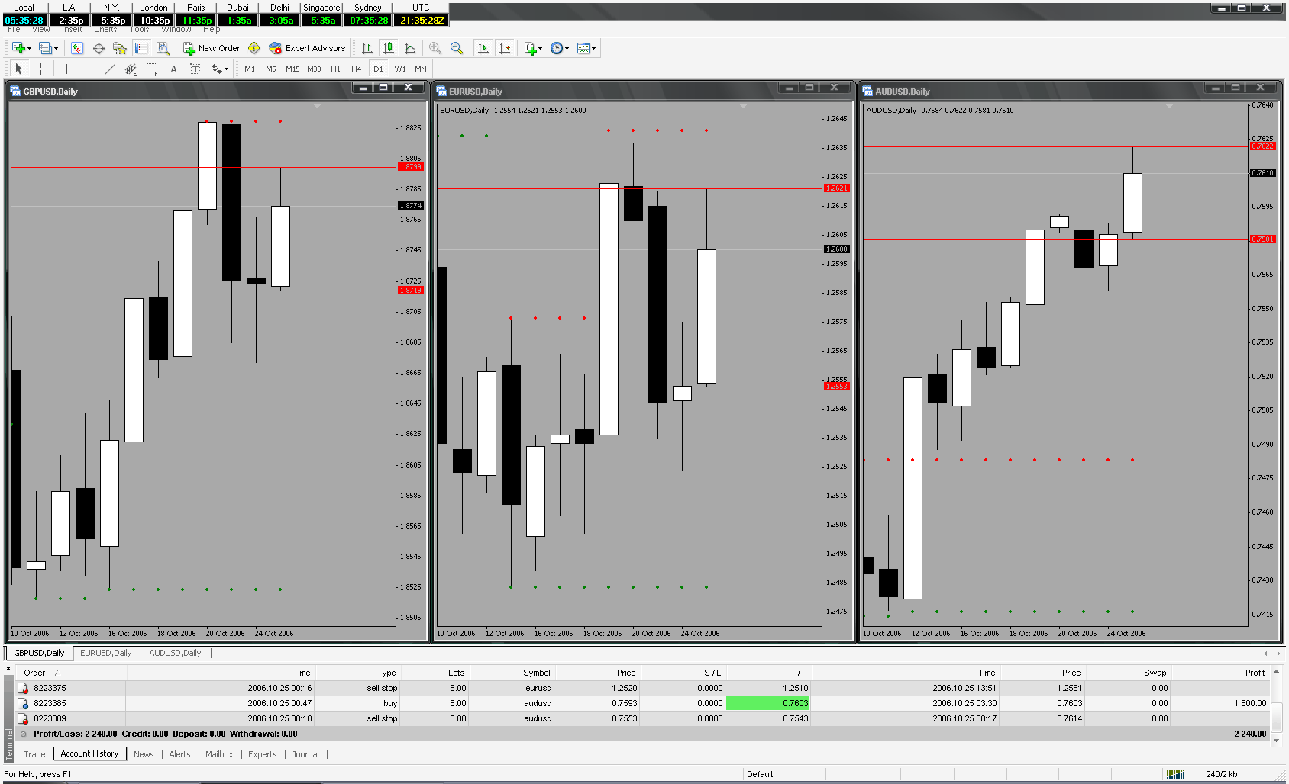
Taking the trade
It all depends on you, whether you want to babysit the trade or ready and leave the trade.

Either way, you can still profit from it.

Babysitting – Put a pending stop buy or sell stop orders. Wait until it penetrates either line, move your stop loss accordingly and deploy trail lock when you have to.

Ready & Leave – Like the above, but with an assign take profit and stop loss. I would recommend a 5pips or 10pips maximum.

Why? Because, some bars only (very few) gives maximum 5pips. This way, losing trade is almost non-existence! But just get 5 pips as a newbie until you understand the system more. In the near future, you can ride the profits.
Things to remember and my recommendation only:
1) Pick low spread pairs because of obvious reason.
2) When placing pending orders, please don’t forget to include the spread plus 1 or 2 pips as an extra precaution because I don’t want the order to be executed on the line and the price reverse.
3) Watch the monthly / weekly highs and lows. I would avoid a trade when it is near to the H&L. Price might reverse against your favor before it hits your take profit.
4) Don’t trade too many pairs, maximum 3 pairs only, GBPUSD EURUSD AUDUSD. Why? Your margin might not allow it.
5) I usually use stop loss of 20-30.

I hope you find the SUPPORT & RESISTANCE method helpful and simple to use and….

Welcome to forex market

Re-written by: Trading Emperor

