Day To Day Trading (DTDT) System

There are 3 different ways of setup ready to trade.
H1:
1) Looking at trend (Nautilus indicator)
2) Turning point (MBFX system indicator)
M15:
3) Looking at small trend (Nautilus indicator)

  - 1) Looking at trend (Nautilus indicator)

Uptrend
H1:
Nautilus indicator is blue
M15:
a) Price is trading below the Nautilus indicator (Blue or Red, it doesn’t matter)
(If Nautilus indicator is blue aligned with the one on H1 then we have a high probability of setup)
b) Boxes appear on CCI and Stochastic
M5:
B0: Price is at or in the lower band
B1: Price closes above the 2 Mas confirmed by macd is below the zero line and gains it momentum
+ Boxes appear on CCI and Stochastic + heiken Ashi is blue
Long = Bo + B1

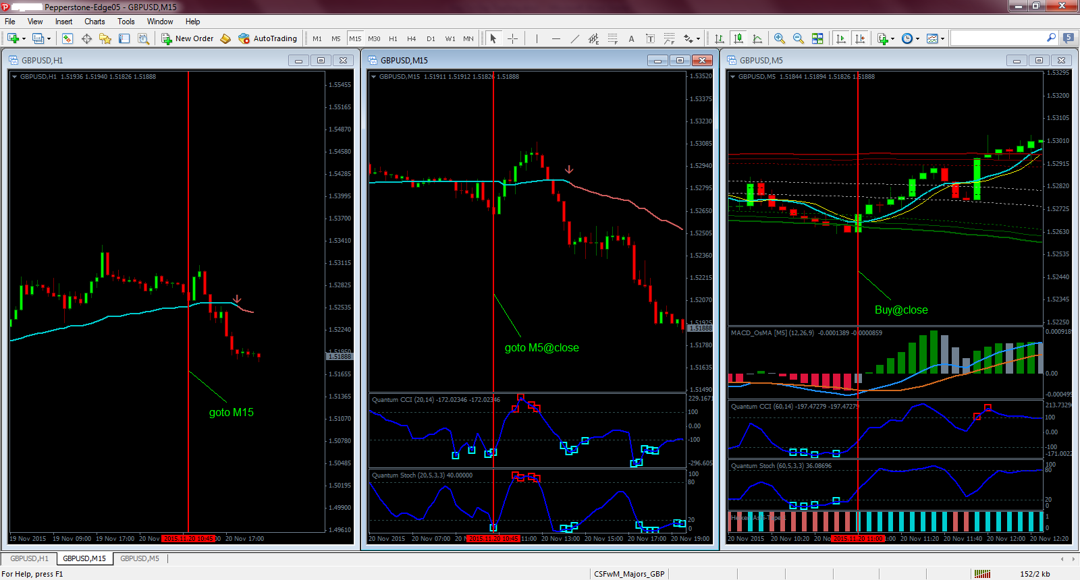
Chart1: Looking at trend (Nautilus indicator) - Long Trade

  - 2) Turning Point (MBFX system indicator)

Reversal upward
H1:
Price closes in or below the lower band
M15:
a) Price is trading below the Nautilus indicator (Blue or Red, it doesn’t matter)
b) Boxes appear on CCI and Stochastic
M5:
B0: Price is at or in the lower band
B1: Price closes above the 2 Mas confirmed by macd is below the zero line and gains it momentum
+ Boxes appear on CCI and Stochastic + heiken Ashi is blue
Long = Bo + B1
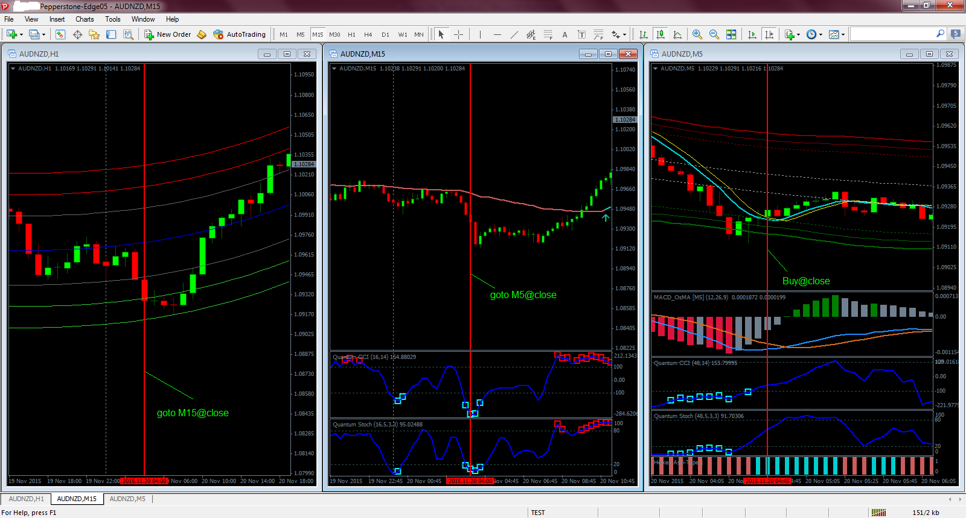
Chart2: Turning Point - Long Trade

3) Looking at small trend (Nautilus indicator)

Uptrend
M15:
Nautilus indicator is blue
a) Price is trading below the Nautilus indicator
b) Boxes appear on CCI and Stochastic
M5:
B0: Price is at or in the lower band
B1: Price closes above the 2 Mas confirmed by macd is below the zero line and gains it momentum
+ Boxes appear on CCI and Stochastic + heiken Ashi is blue
Long = Bo + B1

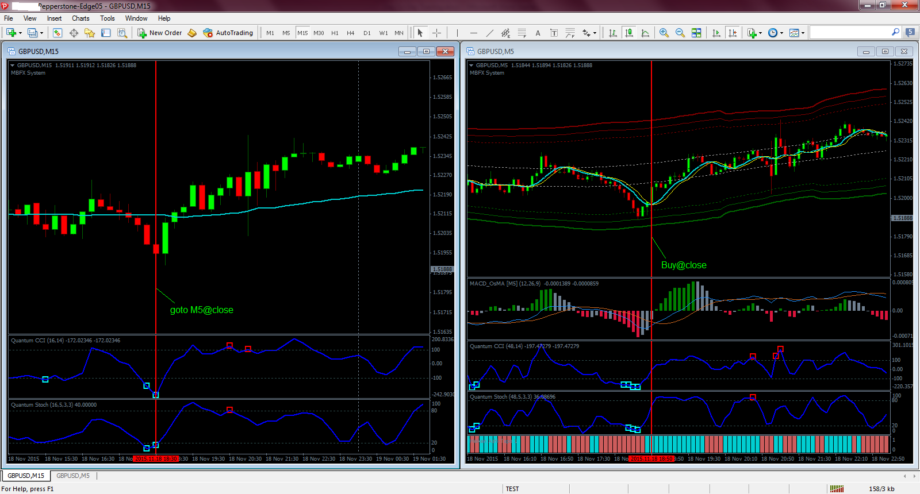
Chart3: Looking at small trend (Nautilus indicator)

