The Dashboard
Is a Manual/Automatic trading console which aims to enhance our trading ability by giving us a clearer picture of the Forex market and increasing our chances of success.
If you have enabled automatic trading, Forex pairs which meet the preset trading criteria will be traded automatically. Alternatively, you can view the dash signals and place trades manually.

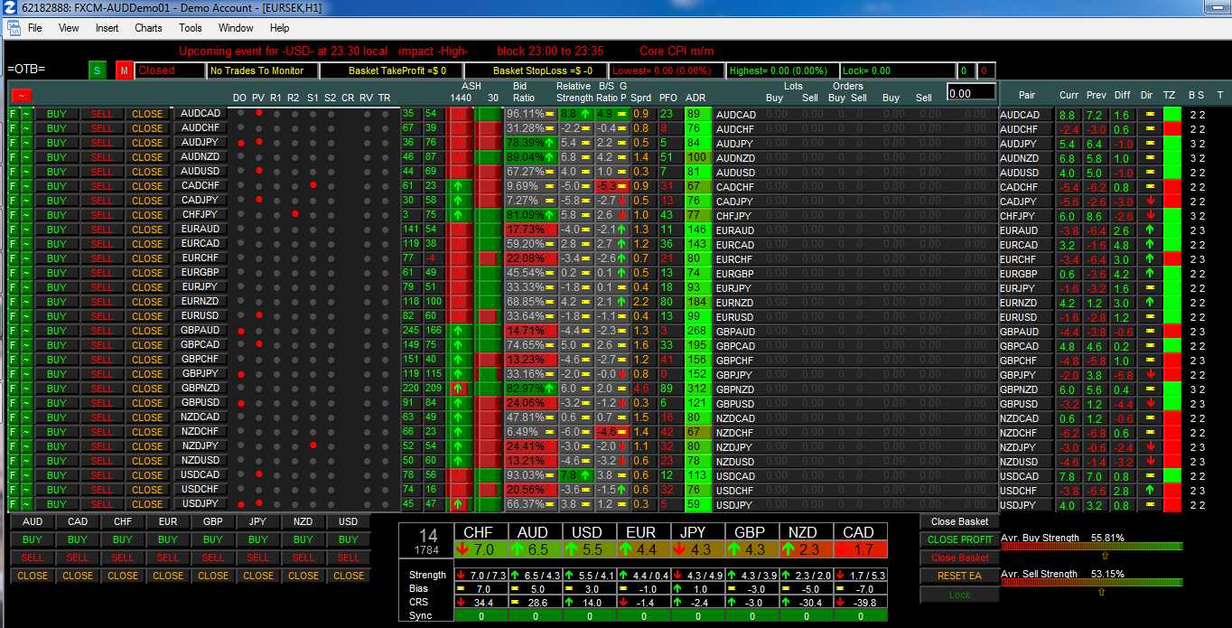

Signals & Controls
Many of the indications are self-explanatory, the remaining ones are explained below.
Looking at the dashboard, the red dots indicate significant zones (you can enable these in the EA settings).
DO: daily open
PV: daily pivot
R1-R2: daily resistance
S1-S2: daily support.
CR: negative correlated pair detected when trying to enter a trade.
RV: reversed trade detected.
TR: trailing the trade.
ASH: Absolute Strength Histogram
PFO: Pips from Open
ADR: Average daily Range
Curr: current pair strength
Prev : previous pair strength
Diff: the difference between curr+prev (GAP).
Dir: direction of the difference (GAP) and only when exceeds the minimum GAP settings on input
TZ: trade zone (are we above or below DO

In its very simplest form the dashboard uses Bidratio, Relative strength, Buy/Sell ratio and a sync index of 3 to 4 as filters.
You can change these settings by right clicking on the dash and selecting Expert Advisors/properties
When you are happy with the settings you can save them in a set file.
The default set file is named OTB (Out of The Box)) and the name is displayed in the top left corner of the dash.

Filtering
There are 11 possible signal filters and 14 trade filters.
Combining the signal codes with the filter codes you see on the screen will give you a better picture of the market.

If you do not want particular filters ON you should either turn their setting to false
or set them to a value of 0 or to a high enough figure which will never be reached.
- Halted (News,ADR,excluded)
- Spread
- Outside session
- # Profitable baskets reached
- # Losing baskets reached
- No more lots available (money management)
- Max Total Trades per pair
- Max Total Trades overall
- Max Trades per pair Per Session
- Correlation Filter
- NoTrade Zone around Daily Open
- NoTrade Zones around Support/Resistance
- Already in opposite trade
- Only Add Profit
- Minimum Pip Distance previous trade
- Sync Index

Filter signal codes:
1 - Master/Slave filter (if used)
2 - Bid Ratio
3 - Relative Strength
4 - Buy/Sell Ratio
5 - ASH 1
6 - Bull/Bear Candle 1
7 - ASH 2
8 - Bull/Bear Candel 2
9 - Previous Daily Candle Direction
10 - Pips From Daily Open Direction
11 - Pair GAP
Trade filter codes: (This is the number shown on the last column of the dashboard ( far right))
1 - Halted (News,ADR,excluded)
2 - Outside session
3 - # Profitable baskets
4 - No more lots available (money management)
5 - Max Total Trades per pair
6 - Max Total Trades overall
7 - Max Trades per pair Per Session
8 - Correlation Filter
9 - NoTrade Zone around Daily Open
10 - NoTrade Zones around Support/Resistance
11 - Already trading different direction
12 - Only Add Profit
13 - Minimum Pip Distance previous trade
14 - Sync Index
15 – Spread
As you look to the right top corner of the dashboard most of the time there is a number below the B and S". These numbers are displayed on the dashboard so you can use see the filter that STOPS a trade.
The first column way to the right hand side of the dashboard displays the number which tells us why the trade signal is not generated (Buy/Sell). The second column is the number why the trade isn't entered.
In addition to the signal filters there are the trade filters which are checked after a buy or sell signal is given.
If instead of a number you see the text BUY or SELL with a number next to it, that number represents the filter which blocks the trade signal. (e.g. 2 means that the trade is not placed because the Bid ratio is too low).
BUY 15 means all filters passed (so counted in sync) but trade was not taken because the spread is too high (it is higher than the spread you have chosen in the settings).
SELL 14 means all filters passed (so this SIGNAL is counted in the sync index) but 14 means the sync index is still too low.
Pairs that passed the filters are counted in the sync index so as soon as the sync index is high enough trades will be placed.

Correlation Filter:
If the systems gets a trade signal if will look through the current open trades and the correlation table.
If it finds a highly negative correlated trade in the opposite direction and in loss it will not take the trade.
If it finds a highly positive correlated trade in the same direction and in loss it will not take the trade.

Absolute Strength Histogram (ASH)
This indication is used to determine the change of market trends.
The default timeframe is the daily (1440 mins) This timeframe can be changed in the options but note that the EA won’t run if your metatrader doesn’t have history for the chosen timeframe.

Bidratio
The bidratio is divided in two groups 50 to 0 (sell) and 50 to 100 (buy).
The "Average Buy strength" all bidratios above 50 added up and divided by the number of (in %) . "Buy pressure"
50 to 0 is the "Average Sell strength" all bidratios blow 50 added up and divided by the number of (in %). "Sell pressure"
The Sell strength scale is reversed so the lower the overall below 50 bidratio goes the higher the scale goes.

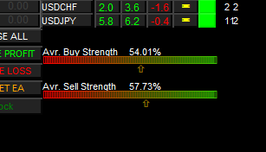

Sync index
The sync index is user selectable and is used for group trading of pairs which meet our preselected trading conditions and which fall into the same major currency group. Eg all EUR pairs
If you have enabled automatic trading, trades will be placed automatically, otherwise you can view the sync signal and place trades manually.

This index is shown as a single digit number.
When the dashboard is set for automatic trading, it will make groups of trades when they align up to the sync index. If for example the sync filter is set to 5, as soon as you see a green 5 or red -5 appear in the sync window, the corresponding 5 trades will be opened.
If the sync index shown for EUR is +7 it will buy all 7 eurxxx pairs.

It is always possible that one trade of the group is not taken but that could be due to our selection of trade filters. For example, a pair having a large spread. If the filter indication signal comes on and stays on, that trade could join the "group" at a later time (when the spread is in range then).
Pairs that passed the trade filters are counted in the sync index so as soon as the sync index is high enough trades will be placed.

For the sync feature to work, it requires a text file eg EUR7.txt
This file goes in MQL4/Files .ex4 in MQL4/indicators
You have to create a .txt file for every currency.
The .txt file content for 7 JPY pairs is
7
AUDJPY
CADJPY
CHFJPY
EURJPY
GBPJPY
NZDJPY
USDJPY
The sync only counts if there is a total alignment of all selected filters and in that case the pair indicator before the trades light up green or red.

Cumulative Relative Strength
From my observation of the CRS, apart from the details the "Absolute Strength" and "Relative Strength" gives us, the “Cumulative Relative Strength" goes a bit further to really show which currency is really riding the market at any particular time through considering its current overall Relative Strength pair-wise.

Looking at this picture I can say that although the NZD is leading in terms of "Absolute Strength"
its Cumulative Relative Strength is not that super strong unlike what the AUD had sometime this week with a 51-57 and the closest being just around the mid-20s.

Any currency that runs away from the park in the "Cumulative Relative Strength" simply has dominance and you can trade it with much more confidence without fear of reversal for quite a while.

In the screenshot shown below we can at a glance see that the CAD and the USD are extremely weak.
If you look carefully, you can also see that although the USD has a higher
"Absolute Strength" than the CHF, with the USD in 5 out of 7 of its pair
weakening while the CHF is just weakening in only 3 of its constituent pairs
though having a lower "Absolute Strength".

Again look at the GBP with just 0.1 above the USD in the "Absolute Strength" but it has just one pair in which it is actually weakening against at the moment. You can't go against the GBP in this state it is in at the moment. All at a glance!

Then again, look at the AUD and the NZD, the NZD definitely is the leader of the pack at this very moment, in all 7 pairs it is leading the way. We have our Master/Slave in sync here and definitely this is the leader and a trade to go for.
Without even taking up a chart, you have information at your fingertip that tells you that the CAD is weakening in all of its 7 pairs. The USD also is weakening against five of its pairs.
Trading either the AUD or the NZD against the CAD and USD at this moment probably for the next M15 candle, the chances of you winning the trade are extremely high because before these values will reverse, you would have taken your 15pips or so out of the market. Fast In Fast Out - period. Basket
trading this way would be really cool.

Thus "Absolute Strength" as Jibala rightly pointed out to hanover does not really give the full details of the currency and its strength pair-wise, "Relative Strength" does that better.
Consequently, the "Cumulative Relative Strength" should does to a large extent tell us a better story.

Troubleshooting
If you have loaded the EA to a chart and the chart goes blank check the MT4 options under Experts
You should have the boxes “Allow DLL imports” and “Allow live trading” ticked.

If the EA is partly loaded and it isn’t running click on the journal tab (in terminal)
and look at the error message.
If the message is the EA was removed this could be due to many factors.

- Missing Currency pairs
Before loading the dashboard to a chart, make sure that you have the Market Watch open and all the Forex pairs available. Right click on the Market watch table and select SHOW ALL
If not all pairs are available, then use an earlier version of the dash eg G or install the dashboard on a demo account from a broker who has all the pairs eg, Pepperstone.
- No history file for 1 or more currency pairs.
Start MT4, open Navigator, click on scripts, find the script names LoadAllHistory and drag+drop it on the chart. This should load history files but the process can take a while to complete so let it run for an hour or so.

- A setting is not right e.g. you have chosen ASH1 Period 30 and the MT4 doesn’t have chart history on this timeframe.

- Other settings could be wrong, eg, you have chosen to use your own currency pairs and 1 or more pairs isn’t available by your broker or when you are entering currency pairs you have accidentally entered a full stop instead of a comma.

- Etc. etc. etc.

Codes for the next release. V3P
Signal filters
PRM = Primary filter (CRS,SYNC,Bidratio)
BDR = Bidratio
REL = Relative strength
BSR = Buy/Sell ratio
AS1 = ASH 1
MC1 = M Candle 1
AS2 = ASH 2
MC2 = M Candle 2
PDC = Previous daily candle
DOD = Daily Open Direction
GAP = GAP

Trade filters
HLT = Trading halted (ADR,News,Excluded)
SES = Outside session
STP = Stopped on #baskets profit/loss
LOT = No more available lots
MXT = Max trades per pair reached
TOT = Max total trades reached
MXS = Max trades per session reached
COR = Correlation found
OPS = In daily open save zone
S&R = In support/resistance zones
WDR = Wrong direction
OAP = Only add profit
MPD = Min pip distance
SYN = Sync filter
SPR = Spread
RSI = RSI
CAN = Once per candle

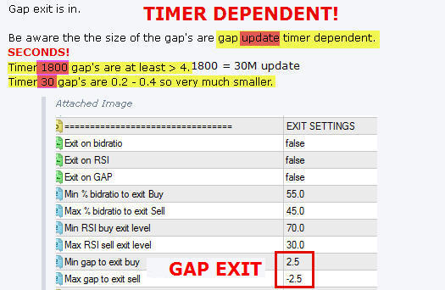

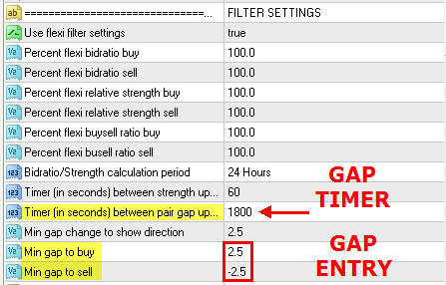
The 'Dots':
The first 6 columns are the no-trade zones you can set in the settings.
DO daily open
PV daily pivot
R1-R2 daily restsistance
S1-S2 daily support.
CR is negative correlated pair detected when trying to enter a trade.
RV it is a reversed trade.
TR it is trailing the trade.
You basically look/analyze this ENTIRE BLOCK...
to
discern WHY a trade is NOT happening (yet)....
to help determine:
what/why you might want change: eliminate/add or increase/decrease in auto settings.
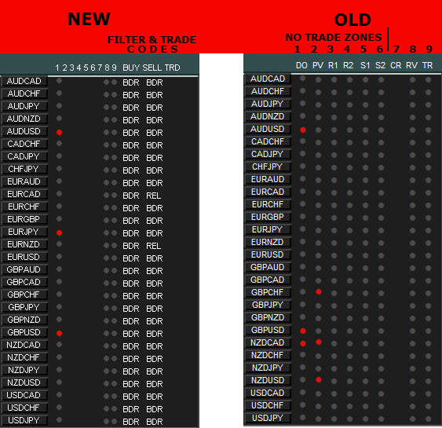
M1/M2 is displayed here (raised button)
Attached Image
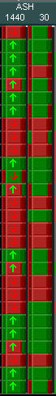

GAP is displayed here (Absolute Strength gap).... not CRS-Cumulative Relative Strength 'gap'
Attached Image
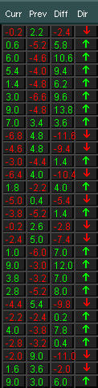

CRS-Cumulative Relative Strength current 'value' is displayed here
(CRS gap 'difference' & direction (from previous value) is displayed by arrow..
YOU control 'buffer' on arrow 'change'. YOU control value 'updating'. YOU control previous 'candle agreement')
Attached Image
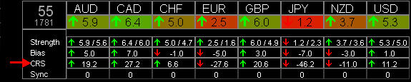

Gap exit is in.
Be aware the the size of the gap's are gap update timer dependent.
Timer 1800 gap's are at least > 4.
Timer 30 gap's are 0.2 - 0.4 so very much smaller.
Attached Image
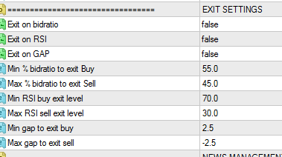

Things to love about the NEW V3P
Attached Image
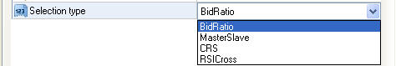
Attached Image
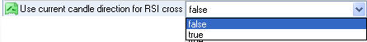
Attached Image
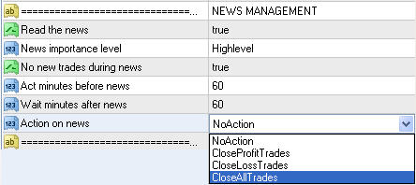
Flexi Filters:
Attached Image
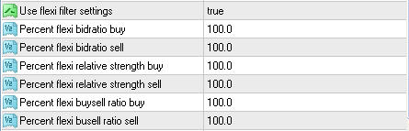
Flexi Filters:
FI: The bidratios are (now) based on the average above and below a cutoff point trying to follow the market a bit more.
FI: BUY bidratio average is (now) just those bidratios that are ABOVE 65% divided by the number of.
So.. If the bidratio for a certain pair goes above that average it is seen as a BUY signal
instead of using a fixed value like 80 or 90% of all 28 averaged (the old method).
Same goes for Relative strength and buy/sell ratio.
I added a selectable percentage for each value (in %) in case you get too many signals (go to 110%) or too few (go to 90%).
I would leave it at 100% for now (until it is tested).
3 Internal 'Dynamic' Exit Triggers:
Attached Image
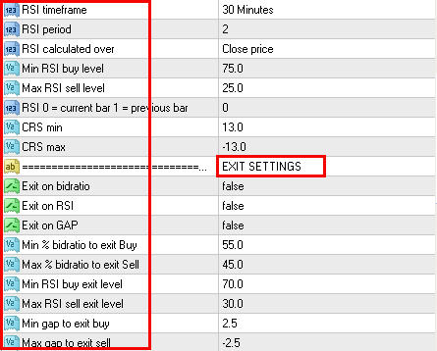
Attached Image
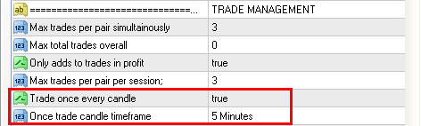
Signal and Trade Codes:
Attached Image

