The Rebooted FOREX approach according to Wab
The more simple approach:
Here is the same chart we have been looking at - just a bit further advanced.
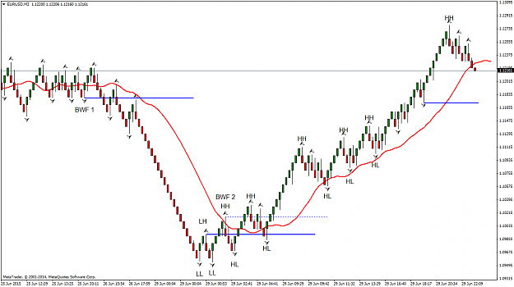
You will notice a red moving average line. This the Teeth line of the Bill Williams Alligator, an 8 smoothed MA of the median price displaced 5. (The settings are visible in the Alligator and it is the same red line that is shown in the Alligator.)
Now the Teeth line has a special relationship with certain Fractals. If you look at the fractal labelled BWF 1 (Bill Williams Fractal 1) it is the last fractal to the left of the Teeth line and below the Teeth line. When price penetrates that fractal below the Teeth line it is sell signal.
Similarly, the fractal labelled BWF 2 is the first fractal where price is above the Teeth Line. When price penetrates above that fractal it is a buy signal. (I showed that buy signal with a dotted blue line to compare it with the solid blue E line that was drawn from the first HH.)
More recently on the chart, is a third horizontal blue line. By definition it is not a LH. However, if price were to drop through the Teeth line and then penetrate this blue line it would become a BWF sell signal. Chances are that a down fractal will form first and the potential BWF sell fractal would be adjusted to the new down fractal level. That fractal will then also become a LH and also mark a potential E line.
The E line and the BWF fractal entry are often one and the same. Two methods combined to give the same signal. When they are different, one confirms the other.
Now all of the stuff that I had on the previous chart, while nice and informative, can be reduced to this simple version of the same thing. HH HL LL LH and the BWF /Teeth combination tells you a tremendous about what the market is up to.
The Teeth line has another attribute which is very powerful:
A trending market avoids it and a corrective market will correct back towards it. On the second chart, counter trend lines drawn at 1, 2, 3 and 4, present opportunities for long trades. The down fractal and interaction with the Teeth line help determine where to draw these counter trend, trend lines. A break of these lines is an entry signal, or it can be an alert that the recent HH is about to be broken as well. Both breaks are valid entry signals and lead to various trade strategies.
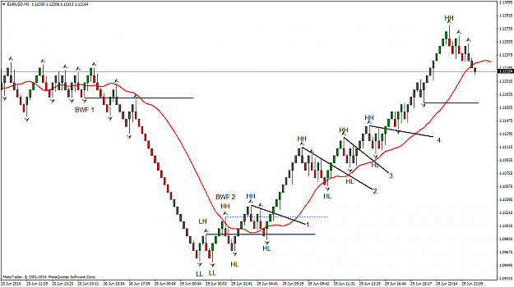
Bonus: The Teeth line also makes a great trailing stop when you give it an extra pip or so as a buffer.
I hope this is easy enough to follow. At first it may be a bit overwhelming but soon it is a matter of eyeballing a chart and knowing what is going on. Consider that this is the present EURUSD chart in the midst of a financial crisis and I let it speak for itself.
Next, I think we should look at some chart and practice this idea.

Practice.
Wick on the 30 pip bricks. 10 pip brick trend reversal, BWF and then entries on counter trend, trend line breaks.
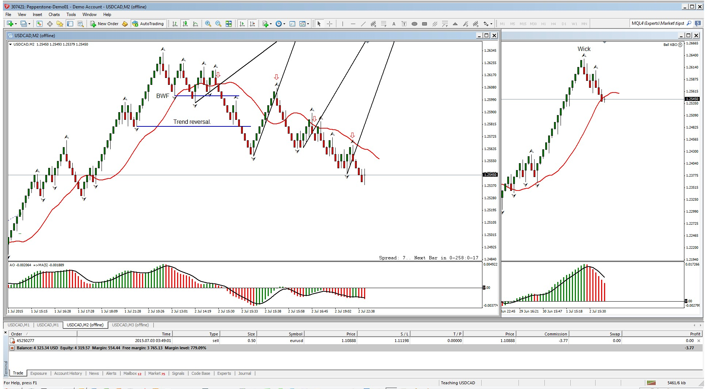
When you finally figure something that works do you keep it to yourself or share it? How about if you have several things that work?
Well, I have shared several things here: Trend Reversal entries, Counter Trend Line Entries and the BWF signal. None of these are really my own discoveries. Nor, I suspect, is using higher and lower brick frames to try and discern the overall trend. I don't really think there is too much that has been missed by the many keen minds that have studied charts. I have to give credit to Bill Williams for his material and I wish I had run across Clive Pakenham a lot earlier (thanks for that link mor707.)
As for Bill Williams ideas being old, the Law of Gravity is pretty old too and it still works very reliably.
I do think that while many people have found many great ways to enter trades (and close them) there has not been as much attention paid to managing trades. That is where I will take this discussion next.
When the dog finally catches a car - what to do with it becomes the all-important question?
So I would now like to introduce the concept of what I call FOREX trade management.
FOREX is an acronym and it stands for Flat, Oblique, Reward, Entry and Extension.
Before I start, if anyone is familiar with similar studies please give us links to look at them. What I propose here may not be unique or even original, but it is my explanation of what I do in my own terms. I hope that you find it useful and if it is an original approach allow me to claim it, before all the hucksters jump all over it and try to sell it.
"FOREX" trade management is my methodical approach to both the identification of a trading opportunity and management of any trade taken. It is price action based and evolves from the HH HL LL LH reversals and subsequent corrections that we have already studied and drawn E lines and counter trend lines on. I hope to make it very mechanical in nature, following rules each time and thereby reducing the emotional component of taking and managing a trade.
As always, lets begin with a chart example, one that has a reversal pattern, or in this case, two reversal patterns.
Attached Image (click to enlarge)
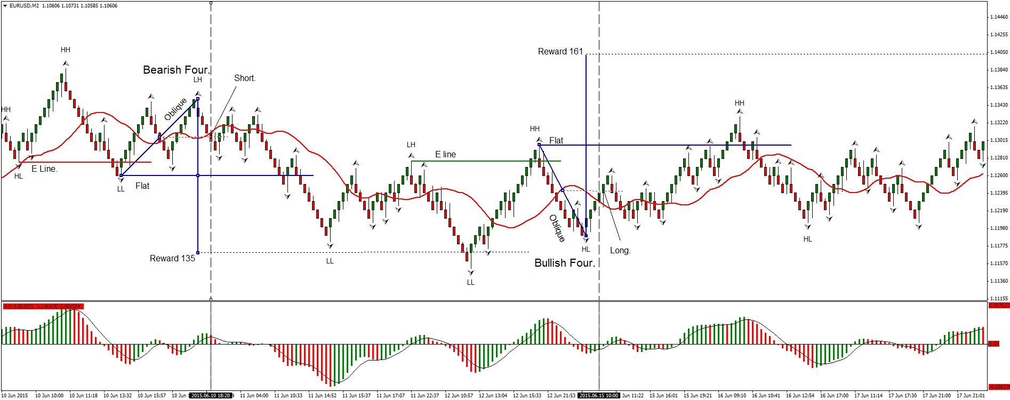
By now you should be able to identify the E lines where a HH HL LL LH trend reversal can take place and where it actually does. Entering a short trade on the Red E line is an acceptable strategy. We draw a flat (horizontal blue) line there and extend it to the right. When the LL fractal forms below the E line break we expect a LH fractal to form on what is now a count trend. We draw an oblique line (also blue) from the LL fractal to the LH fractal.
We are using Renko bars with wicks and we know a wick just about always forms on a Renko color change reversal pattern, so we can pretty much pick out that LH fractal as it forms by looking for a wick. Our oblique line joins the LL and LH fractals and while we wont always get his right until after it forms we will get good at it with practice and a little help from the AO.
We know indicators lag, so we need to give the AO a bit of time to catch up. (More on that in a minute.)
Next we construct the vertical component of the figure four. This is done by dropping a vertical line from the LH end of the Oblique line through the flat line. This is the reward line. The middle of the Reward Line must be on the Flat line as shown. This will graphically locate the reward that we hope to gain from this structure. (In this case the reward was 135 pips when the price target at the end of the reward line was hit.)
Now, back to the problem of the lagging AO, if we wait to enter our trade at the midpoint of the Oblique line, the AO has changed color. This is a confirmation of our strategy if you give credence to indicators.
By the time price has moved to the middle of the Oblique Line we have our Entry. A brick reversal pattern formed earlier and we enter at the 50% level as the AO confirms momentum. I left the Oblique line selected to show its midpoint and placed a dotted red line to the right of the midpoint, to show where the entry is achieved.
A stop is placed just above the top of the oblique LH fractal. (More Bill Williams stuff.)
The whole thing is done by drawing three lines on the chart, at the correct places, to make a figure four.
Orders, stops and take profit levels are intuitive after that.
We have a Flat an Oblique a Reward an Entry and an eXtension. (I have not discussed the extension yet. This is already a pretty big post.)
"FOREX."
Further to the right on the chart the process is repeated with a bullish trend reversal. Here we have an inverted figure four. Reward this time is 161 pips at the end of the vertical reward line. The price level was hit off the right hand side of the chart but I did not compress the chart to show this.
For now, there is a lot to digest here. Do some homework. Try it out on a lot of charts and see how it works. Strategy is next and coming up there is also a very neat dynamic tool to do this with.
and this is how that trade finished ...
Attached Image (click to enlarge)

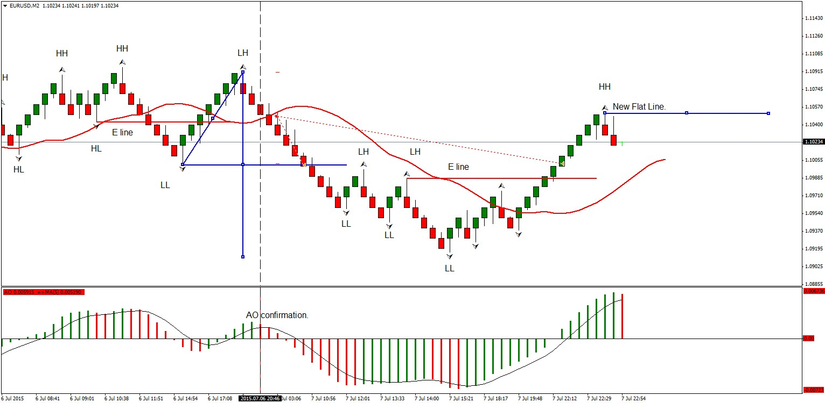
Price just about hit the Reward level then pulled back. I took two lots, closing one at the Flat line to guarantee a profit.
I moved my stop to the Flat line for the second lot, locking it a profit on that lot. I mentioned that the Teeth line was a
good place to move a trailing type stop when nervous, but I didn't do it on this trade. If I had also been watching this trade,
I would have see a new E line form and that would definitely had me close the second lot. As it was I was not able to monitor
it and have to be satisfied with two lots closed at the Flat line.
A bullish, new, Flat line is shown with an HH fractal. Now we watch for the Oblique line to end on a down fractal draw an inverted
Four and repeat.
Here is how I played the inverted four; which was the next reversal trade.
Once again you nailed it with your inverted Four eurix. Good job.
Attached Image (click to enlarge)

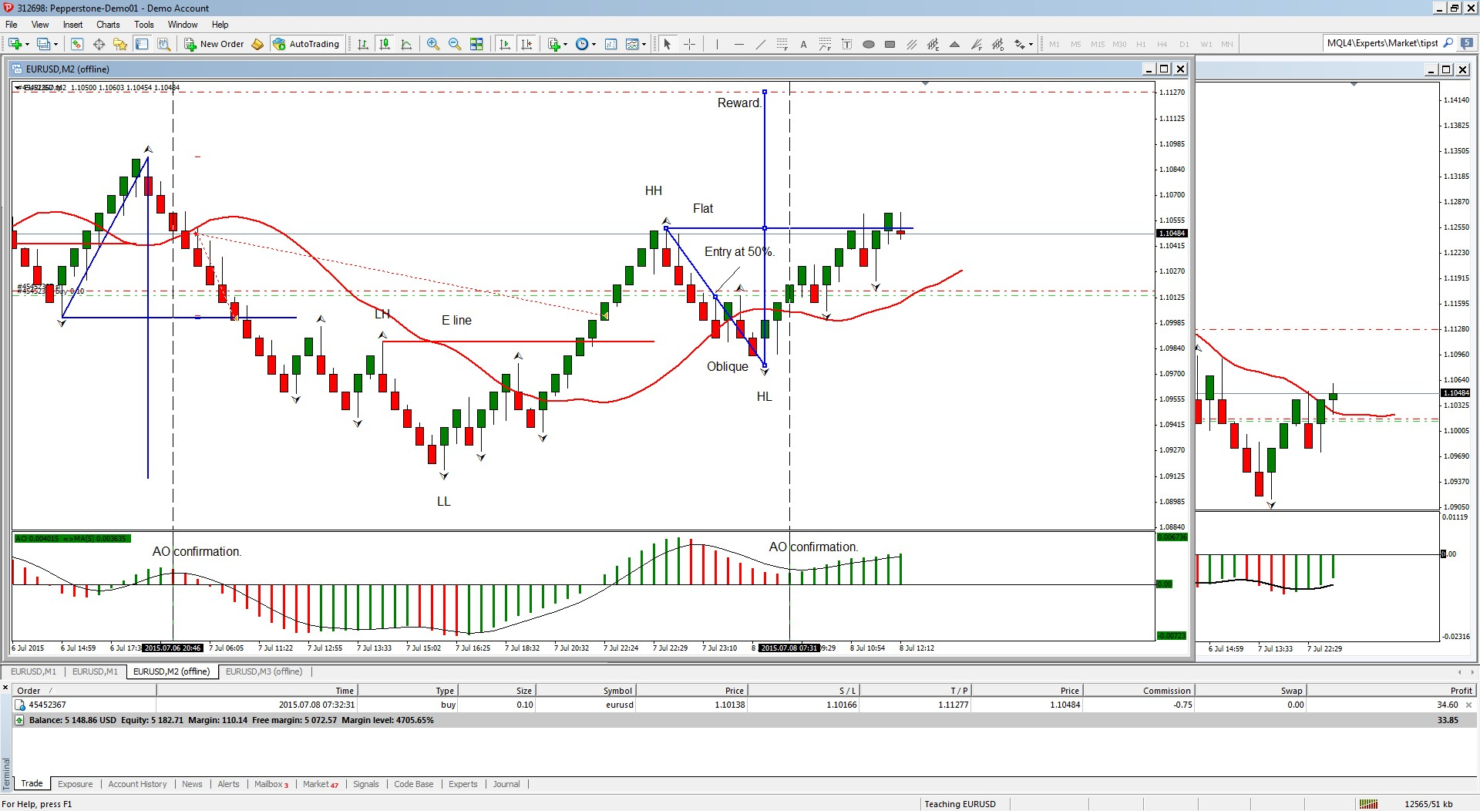
When price hit the Flat line it closed my first lot. I Moved the stop on the second lot up to protect it from losses and at that
point left it to its own devices. A one win, no loss possible, situation. As it turned out, that is what I got. One win at the Flat
line and a stop loss hit just above the 50% level.
In both of these trades, I was looking for a trend reversal. As we go along we will learn how to use the Four in other places.
Bear with me on the Teeth line and you will see how I use it. In both of the trades so far the Teeth line has not really been that useful.
It will make sense as we go along.
As for brick size, it works on any chart, not just Renko Charts. Renko is a lot easier though. A 10 pip brick size is my preference here as it
moves along at a nice pace for teaching purposes. With smaller brick sizes you will get Fours that give very small Flat line targets. As we
get into the extension aspect you will find that smaller Fours have their appeal. The basic FOREX trade is there but how it is used will depend
on each trader.
Think of a 1,2,3 or an A B C D or a Ross Hook or an Elliott Wave trader. They all basically trade the same thing based on different understanding
of the same chart. My Four is an attempt to make the trading process very visual and achieve comparable results to other proven methods. Is it
different, or does it overlap those other methods? Yes to both questions.
You will find your own comfort level and adapt how you use this.
Here are some order strategies to consider:
Early entry when the bricks change color this has the advantage of a small stop loss, but will be difficult to catch if the correction has more than one wave in it. It is best to avoid this depending on your risk aversion. If you are wrong, a smaller Four will result which can still be profitable but may get stopped out.
Enter at the 50% level of the Oblique - often has the advantage of a confirmation from the AO. Sometimes this entry is actually only slightly beyond the color change of a brick reversal in a very tight four. I prefer to see a bit of separation there but that is a matter of preference.
Enter at a 61.8% level instead of a 50% level. (Or enter at both if you are really aggressive.) The 61.8% entry is built in to the Extension tool. Along with the extended target, X, at 161.8%
Logic behind taking multiple trades:
Always T.P. on one lot at the Flat then move your stop up to the entry level plus a pip or two. This covers costs and generates a secured profit. This makes the second lot a free trade and guarantees a profit if the Reward Target is not reached. This is a very important strategy. The object is to take a profit and protect your account first and then try for the larger profit if/when the market reaches the Reward level.
Set your target just a bit before the Reward level. If a lot of people ate looking for a double it is good psychology to exit just before the rush.
If price action is a concern trail a stop a pip or so above the Teeth line. Anytime you get into a trade with a small four and price is quite well removed from the Teeth line, it can move along way before it moves back into the Teeth line.
As for success rate, you will just about always hit the Flat line if you have read the trend correctly and trade the trend reversal patterns, however there iare more situations that we have yet to discuss, where the four can be applied.
In my next post I am going to give you a neat little tool that really makes the study of Fours a bit easier - as if it wasn't easy enough already.
Okay, as promised:
There is a neat little tool that already exists in MT4, the Fibonacci Expansion Tool. Just change the settings like this.
Attached Image
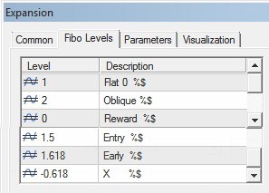
Now you can use the Extension Tool to draw a Four, or an inverted Four, on a chart. It does have the advantage of displaying a 61.8%
early entry level and the 1.618 Extension - the X of the FOREX acronym.
Personally, I find the Four easy enough to draw with trend lines but most traders enjoy any shortcuts that are available
and this displays the labels and prices that are important.
Some examples of Fours that are not based on trend reversals:
I call these Correctional Fours. These are based on corrections against the trend. The price crosses the
Teeth line and forms a fractal. As long as the AO is below the zero line these work well.
(Of course you reverse that rule for Bullish Fours, where you will want the AO above the zero line.)
Attached Image (click to enlarge)

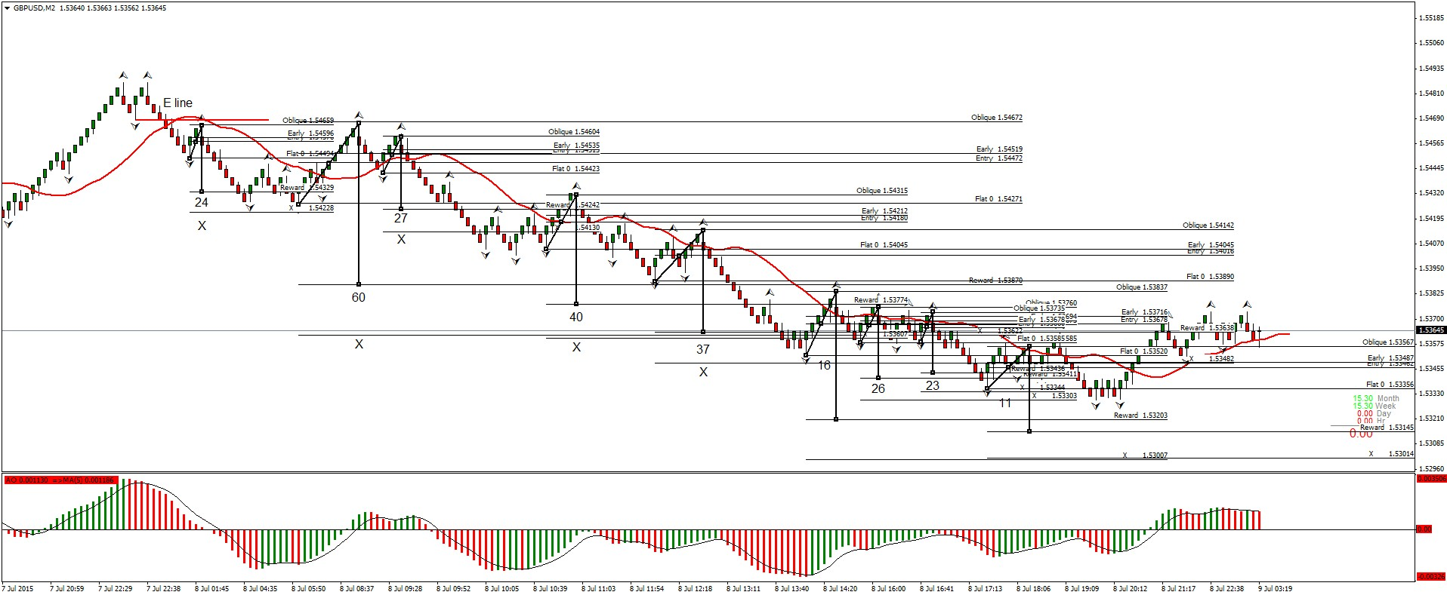
Each Four shows the pips it wins on one lot, with all calculations from the 50% level. Trades that have an
X are ones that went to the extension level at 161.8%
Each trade at least made the Flat line.
Look for a trend reversal. trade it and then trade the counter trends that come along. Keep adjusting the
potential E line and then go the other way.
And how has the EURUSD been doing? Some trades made the Reward level, all made the Flat level.
Pip returns at the Flat and at the Reward are shown. Present Four Trade is still in progress with profit
taken on the first lot, stop needs to be moved now.
Attached Image (click to enlarge)

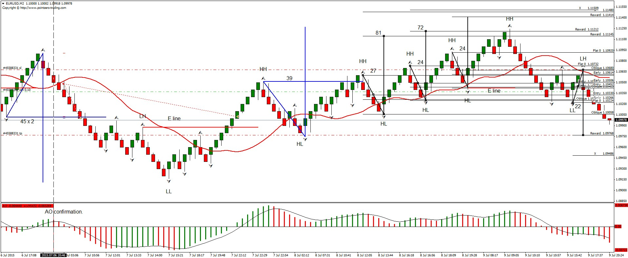
Now we start to focus in on the current wave structure. We have a good idea of what the larger waves are doing and we now get ready to analyze the waves inside of the more recent ones. We can eyeball the HH HL LL LH structure or use fractals to draw this in.
A very sharp eye will notice that there are smaller HH HL LL LH structures in between the fractals. (Hint look just to the left of the last LL.)
If you used smaller bricks on a separate chart, this would show up and be easy to see. That is why I like both a HBF chart and a LBF chart
work with.
We are going to look for trades on this smaller scale but always keep an eye on that bigger E line. It is very powerful.
Attached Image (click to enlarge)
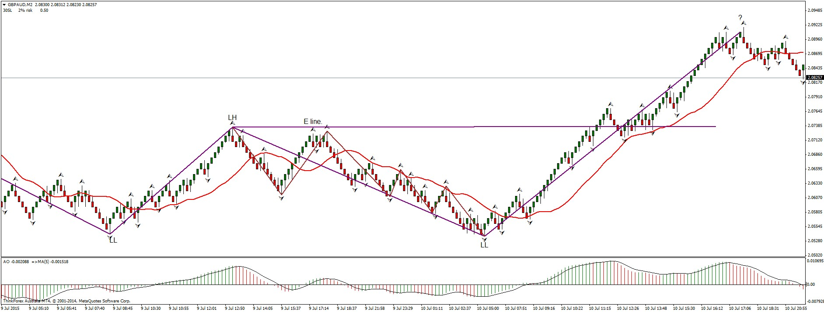

Now we do our detailed analysis:
This reveals the places that we can trade a Four on this particular structure. Our reversals become easy to find because we
know where to look for them. The red E lines and the Bill Williams Fractals show up and alert us to trend changes. Once we know
the trend direction we look for counter trends that (preferably) cross the Teeth line. Drawing a Four follows.
All market charts do this.
[On one occasion, several years back, I did this exact analysis on the OEX and refined it further and further down until I was right in the M1 charts.
I caught a turn on M1 that evolved all the way up with each wave degree until I was up over $20k in a few hours, on call options. It was a thrilling ride.]
Attached Image (click to enlarge)

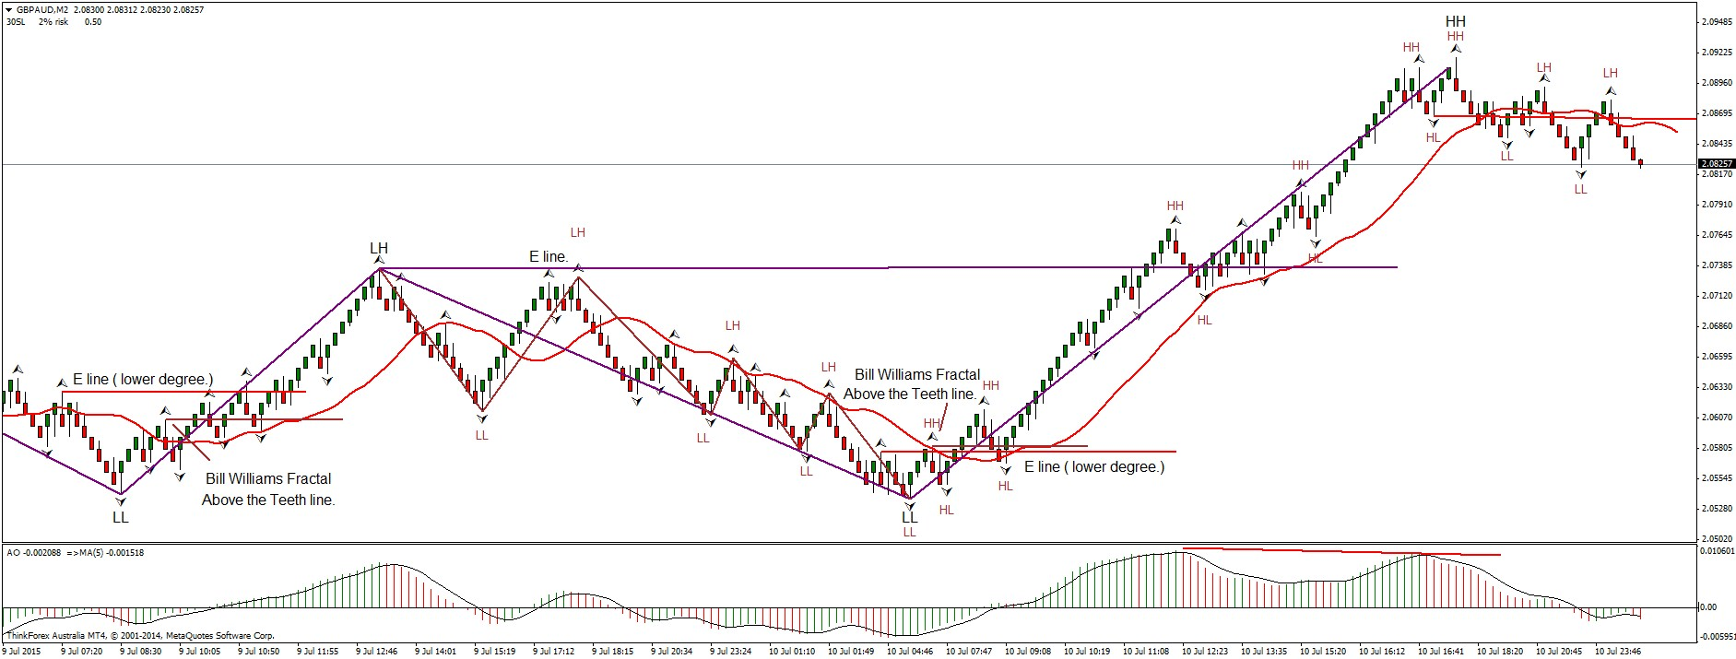
Now, see how many trades you could have done here from the counter trends, just drawing a Figure Four.
Bill Williams uses break out trades as price moves past the latest fractal in the trend. By using Four on the counter trends, we can gain on that by an extra 50% to 61.8% per trade.
I hope all this analysis of the GBPAUD clears up some of the confusion. I still haven't got to the BW Fork. It will help further.
One more thing:
The divergence on the AO tells me that GBPAUD is at the end of wave three and now in wave four. The market is always choppy in a wave four. I expect a trend reversal to the upside will be the next good trading opportunity.

The BF Fork.
The BF Fork is a combination of the E line or the first fractal level past the red Teeth Line and a trend line. You may recall that the E line and the BW Fractal line may often occur on the same fractal. Either way we extend a horizontal line from the E Line Fractal or the BW Fractal to the right. We know that when the price breaks either of those levels, or both, that a trend reversal has occurred.
The HH HL LL LH count confirms this with the E line and the BW Fractal line can give an early warning or be used by itself.
Now if we look at the last two significant fractals and use the Tom De Mark method of drawing a trend line, using those two fractals, we find the trend line is the handle of a fork and the E line or BW Fractal Line is the tine.
Let’s look at a chart to see this:
Attached Image (click to enlarge)

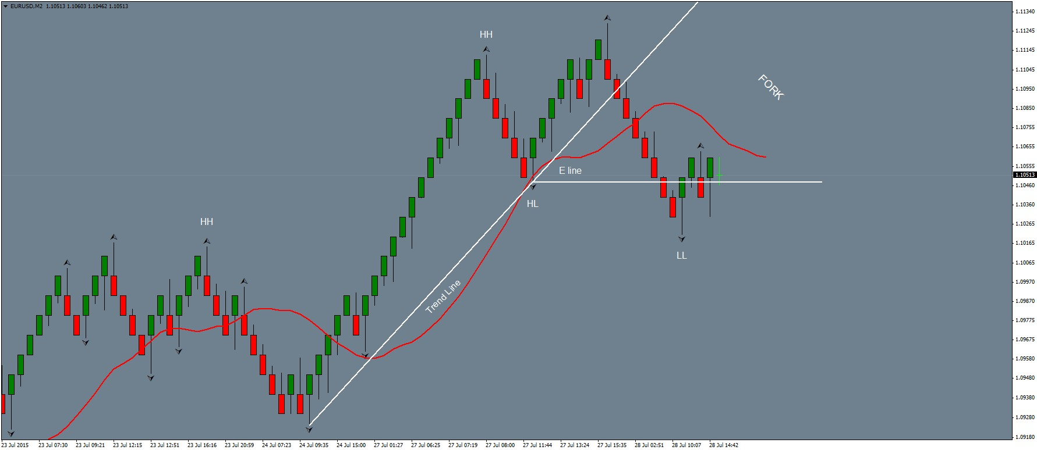
This is the current EURUSD 10 pip Renko chart, forming a Fork as I write this. The Trend line has been broken, the E line has also been broken. The two of them form a fork which I call the BW fork. (B for my last initial and W for William. A little vanity there.)
The BW Fork is a powerful visual indicator. If price goes back above the tine (trend line) of the fork then the reversal becomes suspect. Price most often breaks below the E line or BW Fractal Line (They are the same in this example, but can be different as we know.) Then price most often moves back up into the BW Fork area. Once it is back in the fork it often forms a fractal and that is the fractal that Elliott calls wave two. (Note it may not form a fractal all of the time, but looking at a LBF or a LTF chart will reveal that there is always one there.)
So how to trade it?
The safest method is to open a trade as it crosses the E line again. That puts us in a third wave and Fibonacci comes into play.
Let us see how this one works out.
-------------------------------------------

Here is another example that where I am presently trading a figure four.
The game begins with a trend reversal and a Fork displayed in white lines. Note how the E line (in yellow) was later to the party than the Fork.
I missed a reversal trade there however, I then located a Four (shown in yellow lines) and traded it for 110.2 pips from the 50% entry level to
the Reward level.
A second four, shown by a diagonal black line joining the wick to wick of two opposing fractals was not traded because I was already in a trade.
It was also a good potential trade, in case you had missed the first one.
Then I took another four, this time with white lines and I am presently near the reward level on that one. In fact. I just checked and it closed for another 111.5 pips, so I updated the chart to show it. Not often I post just as a trade is concluding like this. Nice when it happens.
Attached Image (click to enlarge)

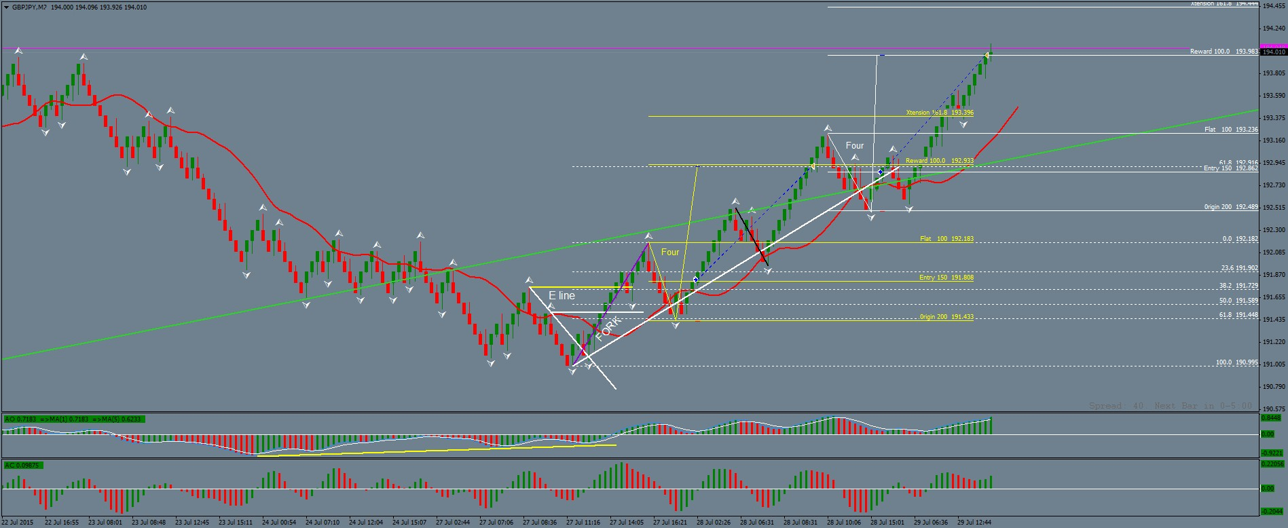
Did I use any indicators? I did look at the divergence on the AO and the Teeth line for the BW fractal.
Study this chart. It is good example of a BW Fork, an E line trend reversal and three figure four trades. Best of all it is an example of theory and practice
working together perfectly.
having said that, there was a trade that I missed. I missed it because I arrived late but we will get to that type of trade in a bit. Check the purple Fibonacci
line with its dotted white Fibonacci levels and see if you can spot it. After the new HH we get a LH at the 61.8% level. A trade taken there would currently
be up 269 pips. It can be done. Has been done many times.
Now that we have dealt with HH HL LL LH, E lines, BW Forks and Figure Fours, we are ready for Fibonacci. Stay tuned.
----------------------------------------------------
I might as well just carry on with the Fibonacci material as this is such a good example.
I cleaned up the chart to illustrate the concept more clearly. When you get a trend reversal, there is an opportunity to draw a Fib
on the first HH and see at what Fib level the first LH will form. This one was at the 61.8% pullback level. The sweet spot is around
61.8% with a fractal, although a fractal may not always form on the pullback. This time one did.
Attached Image (click to enlarge)

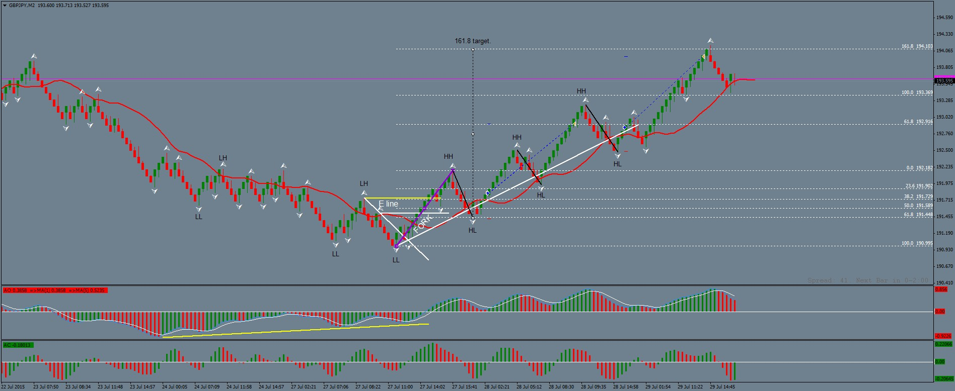
The pullback gives us a wick to wick line for a Figure Four trade. I placed the first black line there to illustrate it.
The Fibonacci is drawn in purple. With a 61.8% pullback, it gives us an entry at the 61.8% level and a target at the 161.8% level. You
can see how that worked out. A Fibonacci constructed in this manner is very powerful. Even though I missed it I was confident with the
figure four trades that followed because the reward level for each was inside of the 161.8 Fibonacci target.
So there you have it - Fibonacci Reversal Trades and Figure Four Trades. Priceless.
So how about the EURUSD trade started yesterday?
I took a 0.1 lot trade on each of the Fibonacci levels. The trick now is to know when to exit.
The Alligator is wide open, so I am looking at the 100% target though the 61.8% target is just about there.
Attached Image (click to enlarge)

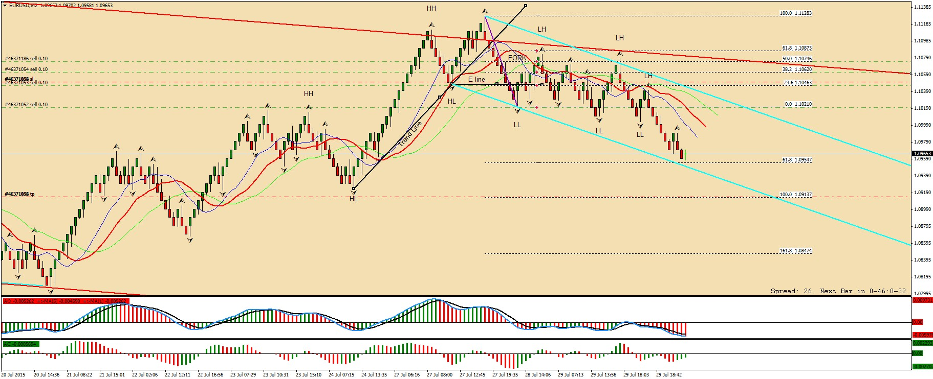
I will have to decide in a few hours, as I am away tomorrow and will not be able to monitor the trade further
-------------------------------------
EURUSD Trade Closed.
Good enough. I have to head out of town in a couple of hours and won't be back until Monday night.
The blue channel seems to be holding for now so I won't stay in.
This move was corrective in nature with all the overlapping waves. Hoping to get to a 100% level is too risky for me at this point.
The AO has three green bars and AC has a buy signal. Maybe it will challenge the upper, red trend line and break out higher next.
Locate the potential E line, keep an eye on the BW fractal in relation to the Teeth Line and see what Fibonacci tells us, when a
trend reversal and a BW Fork comes along.
Attached Image (click to enlarge)

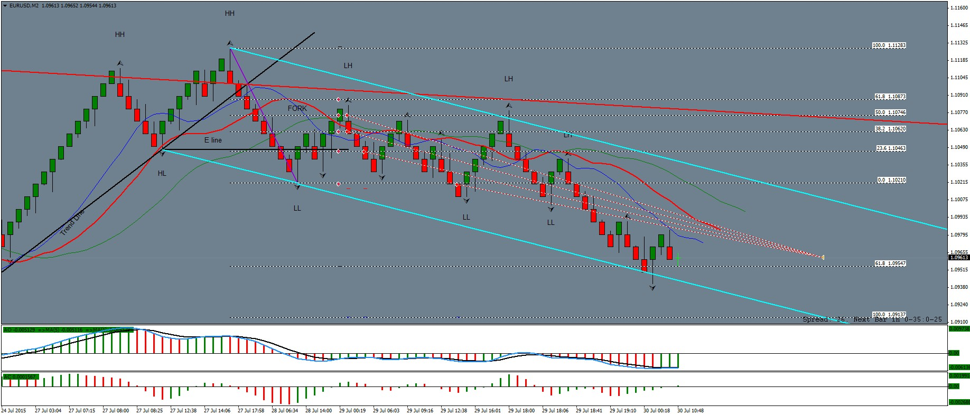
Take the cash and let the credit go. 72. 54. 34. and 27 pips banked.
---------------------------------------
When I trade I have an indicator that changes the background color. It is more for auto trading, enabling me to tell at a glance which direction my robot has taken a trade. I will discontinue its use here, as we do not need it.
I will also just stick with only the 8 shift 5, smoothed median moving average (the red line in the Alligator), fractals and the AO. The main indicator is always going to be price, with the HH HL LL LH analysis revealing a potential E line. The current trend line that works with the BW fractal or the E line to form a BW Fork. Usually this matches with divergence on the AO.
I realize that I have referred to other indicators:
The MACD 5 34 5 which is nearly identical to the AO.
De Mark lines, which you can basically determine yourself without the messy indicator cluttering up the chart.
The Alligator, from which we only use the red Teeth line from. (8 shift 5, smoothed, median moving average.)
I will keep charts white with only the AO, fractals and the Teeth moving average. I will be adding Fibonacci extension and retracement lines and explaining a lot more about those in due course.
Trend lines are also essential in illustrating the E line, the BW hook and figure four trades.
In the next chart, I have shown the last trade that I took before I was out of town. I closed it off at the 61.8% level because I could not be there to manage it.
As you can see it would have easily made the 100.00% level. As we go along I will show you how to get the best out of a trade like that, instead of a mere 61.8%
The chart shows divergence on the AO, a BW Fork and A Fib retracement. I also have the HH HL LL LH analysis as it was at the time.
So here is some homework:
Attached Image (click to enlarge)

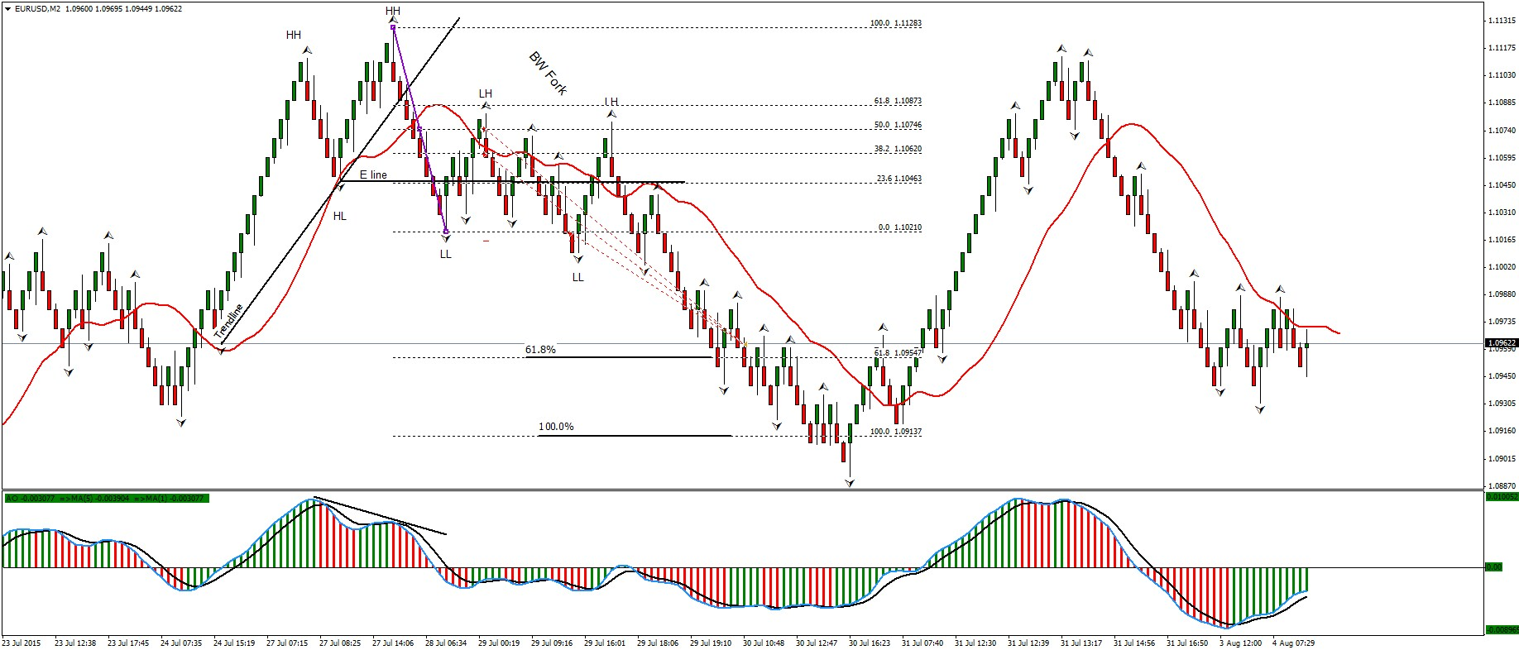
Continue the HH HL LL LH analysis and determine the next two trend reversals with BW Fork analysis.
Check the AO carefully as you go for any divergence.
By the way, the two moving average lines on the AO are a dodger blue 1 SMA and a black 5 EMA of the AO. You can add those if you like, but they are not essential.
Do not worry about posting any solutions, I will do that and you can compare your efforts with mine. Please do the analysis before you look at the answers
-------------------
Answers:
Make sure you have tried to find the HH HL LL LH trend reversals and BW Forks in the previous chart before you go further.
Scroll down.
Answers are below.
Attached Image (click to enlarge)

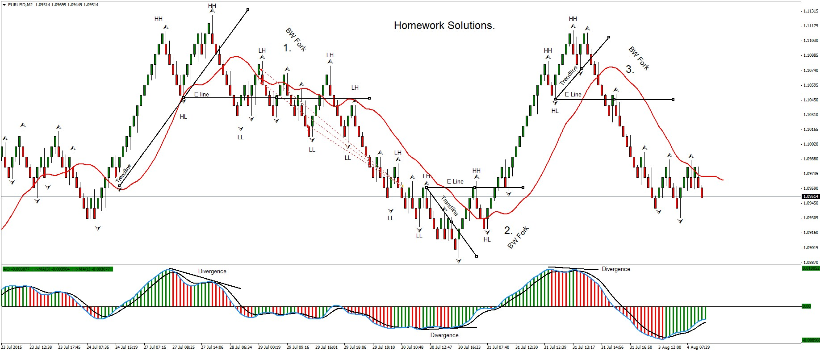
-------------------------------------------------
Meanwhile, don't forget the Figure Four Trades.
Here are some that were available and the one that I am currently in.
I colored the potential trades A, B, C, and D and left the current one (E) in black.
I didn't take any of the earlier ones as I was traveling. I also entered this one late
but I figured it is good for some pips as it broke belwo the last fractal.
So far, it is on its way to the Reward level, up 47 pips with 22 locked in.
Attached Image (click to enlarge)

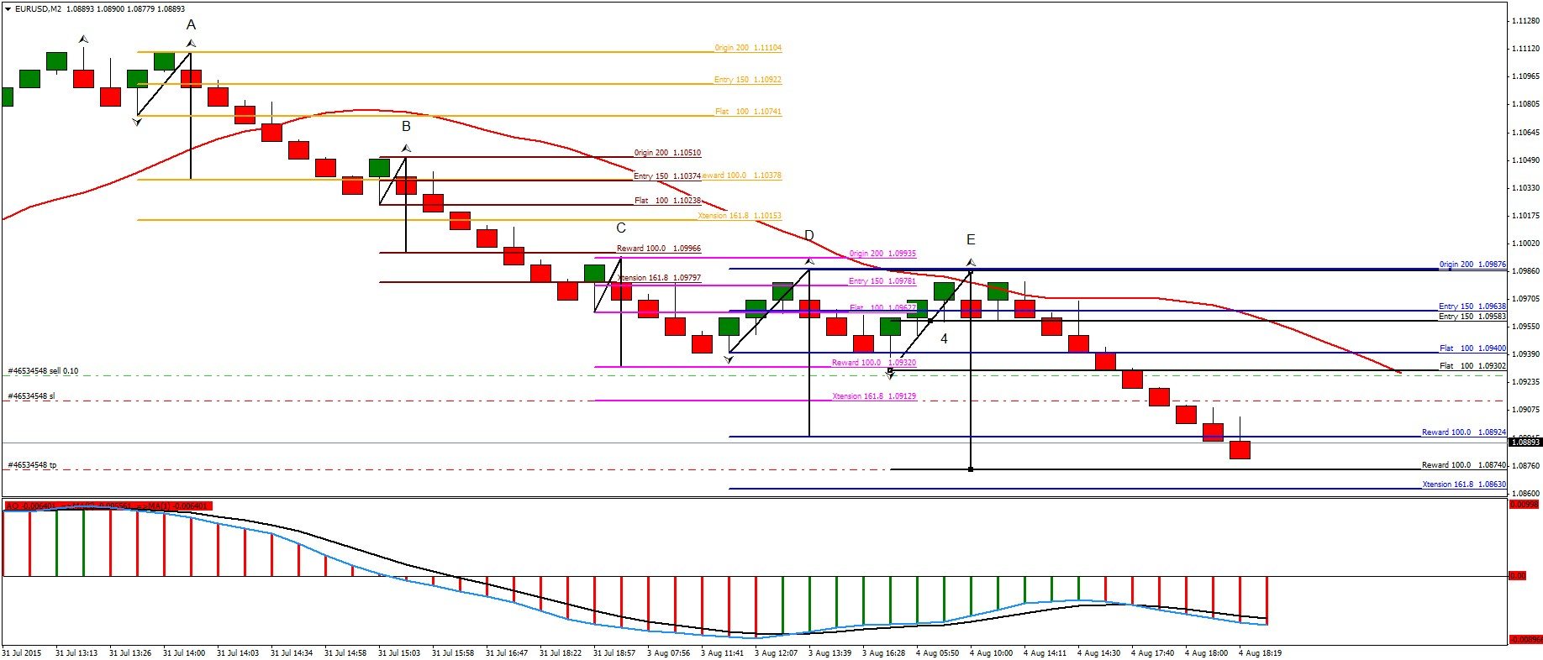
-------------------------
Trade closed at the Reward Level.
Attached Image (click to enlarge)

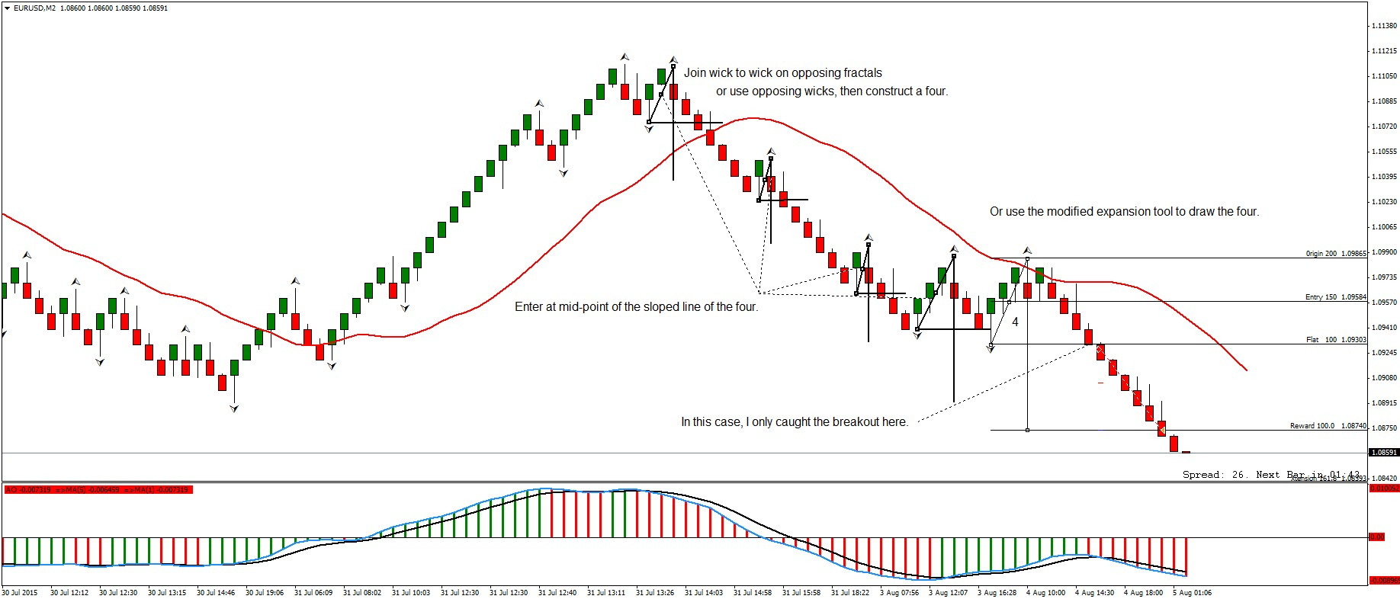
The diagonal line of each Four can be drawn from fractal to opposing fractal, wick to opposing fractal or occasionally from wick to wick.
Renko Bricks are great for this.
The trade I just took was taken late, I like to enter at the midpoint of the Four Diagonal fifty percent level on the Fib Expansion Tool as
shown. However, a late entry can still be taken with confidence, as you have a good idea where themarket will go and can decide accordingly.
I could also have gone for the extension target but I had to leave the trade to its own devices as I was busy doing other things. Being able
to place a pending order and a predefined stop and stop loss are great when you have more things to do than just trade.
When I cover the trailing stop opportunities in this type of trading you will see that there are ways to handle those situations, but we
will continue to take little steps and master each before we move on. A trailing stop on the Teeth line would be very good here but I
will leave that until later. I will come back and talk about that as this chart develops.
You will have noticed that I do live trades here. If your teacher does not show you live trades and the rational behind them as
they develop... move on. Hind-sight is easy. Doing it in real time is what separates the nuggets from the gravel.
-------------------------------------------------
I like to enter on the 50% of the diagonal of the Four. However, as you have noticed, that is often not possible in smaller Fours. So you ask a very good question.
If you use a fractal to fractal diagonal for the Four they are generally bigger. As the wick forms on the opposing fractal you get an advance clue. I place a pending order on the 50% level and adjust it as the diagonal of the Four develops. Start at the wick and adjust as the next wick in the opposite direction forms.
On small Fours the 50% level can be hit with one brick, before you can actually place the trade there.
(You can see on the last trade that I missed the 50% entry and still made money by trading the break out past the fractal as there was a good Reward Level to try for. So even with a missed 50% entry there is still a trade to be had.)
We also have a one minute chart to look at. To date, I have not really talked about the M1 chart a lot. I will soon get around to explaining how I use it to time entries.
Your question is a very good one and I will answer it in detail after I add two brick sizes to one chart. Let me do that next and then I promise to really open it up with some M1 discussion.
-----------------------------------------
OK. It is time to really ramp this up a notch (again.) I hope that this actually makes things more simple - though at first it may be confusing.
I am going to show you how to add a second layer to any Renko Chart and also to the M1 chart. I hope this will start to answer Calcue's question and some previous questions about the 30 pip brick chart and its relationship to the 10 pip brick chart.
Here is where they become one chart.
I have attached a zip file with the Renko Shade 3 indicator and its sound files. You will have to find the sounds folder in your MT4 and copy the NBU and NBD wav files into it.
Add the RenkoShade3 indicator to your M2 chart (the 10 pip brick chart) with these settings:
Attached Image (click to enlarge)
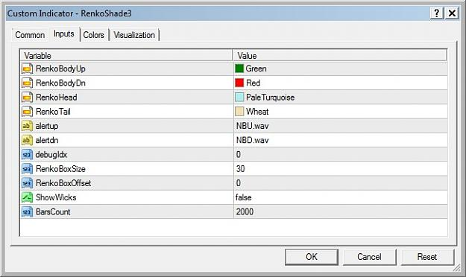
Your chart should look like this.
Attached Image (click to enlarge)
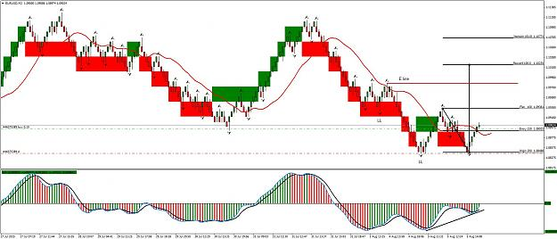
I have a trade going so you can check that out too. The divergence on the AO tells me we are changing direction
I am not sure how this one will go so I will be cautions and maybe just take profit at the Flat level.
I can't post for a while now as I have other things to do, so have some fun and see what a 30 on a 10 tells you.
Don't forget to zoom way out. Also experiment with turning the 10 pip chart off by setting it to line display with no color in the lines display properties.
Believe me, this combination of 30 and 10 on one chart is powerful. When we involve the M1 it is even more so.
-------------------------
I want to remind everyone on the importance of the big picture.
Too often we can get focused on an immediate trade and have no idea on how it fits in with the larger trends.
Here is a way to deal with that. First of all, go to properties and set the line graph color to none.
Attached Image
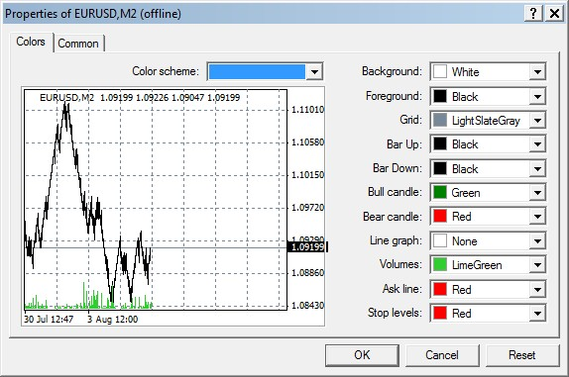
Then set your Renko Shade 3 to show 30 pip bricks on the 10 pip brick chart. Zoom out as far as you can and then display a line graph.
(The template that I made available a few posts back is set up for this.)
You should now get a chart that looks like this ... of course you have to add the HH HL LL LH labels.
Attached Image (click to enlarge)
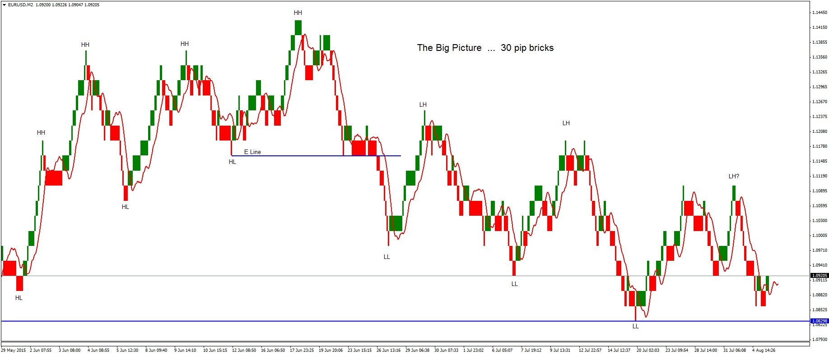
You now have the Big Picture and know well ahead of time where to expect the market to give you some great action.
Look where price would break below the last LL and confirm the LH?
Now turn the candles back on and you can play the 10 pip bricks within the 30 pip brick structure.
One other thing, note the crossover of the Teeth line when the bricks change color. That alone is a really powerful and useful feature.
------------------------------------------------
Thanks for fielding the Renko Shade question Bat. It is good to see the thread developing with
people helping each other.
I am going to be away for three or four days tomorrow (going prospecting.)
Meanwhile, here is my take on the 10 pip AUDUSD:
Attached Image (click to enlarge)

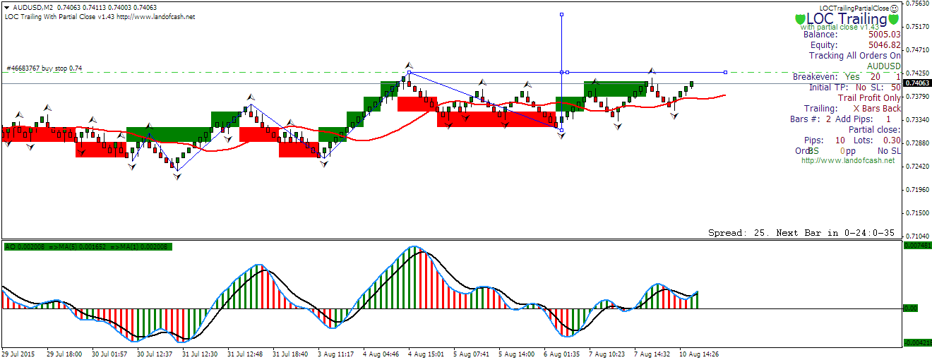
I have a buy stop at the level which is basically the neck line of an inverted head and shoulders.
I will let LOC manage the trade.
(LOC is a commercial product which I use. I am not affiliated with it at all, just a happy user.)

