Day to Day Trading system
THE BIG DOT CIRCLE IS VERY IMPORTANT TO DETERMINE THE BEGINNING OF THE TREND
The big dot circle is produced by the SSChannel indicator.—Verified, the author

Determining Trend in HTF
H4 : BIG DOT CIRCLE (blue/red) appears confirms by the tick bar(blue/red) in the TradeMonitor + macd (blue/red) above/below the zero line + momentum (blue/red).
DOWNTREND : The chart1, H4, below illustrates how to determine the down trend.
H4 :
DOWNTREND : Red Big Dot Circle (RBDC) confirms by the Red Tick Bar (RTB) appears in the TradeMonitor + macd red below the zero line + momentum red
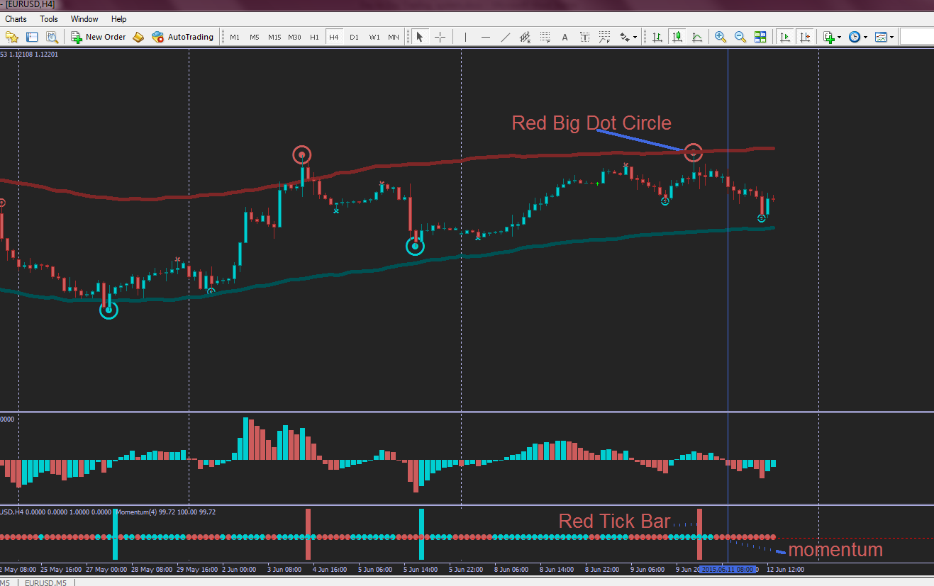
Chart1

KEEP IN MIND, WE ARE IN A DOWNTREND FROM H4

1) Selecting the high probability of signal
M15 : See chart2
RBDC appears above the RIPT – Very important
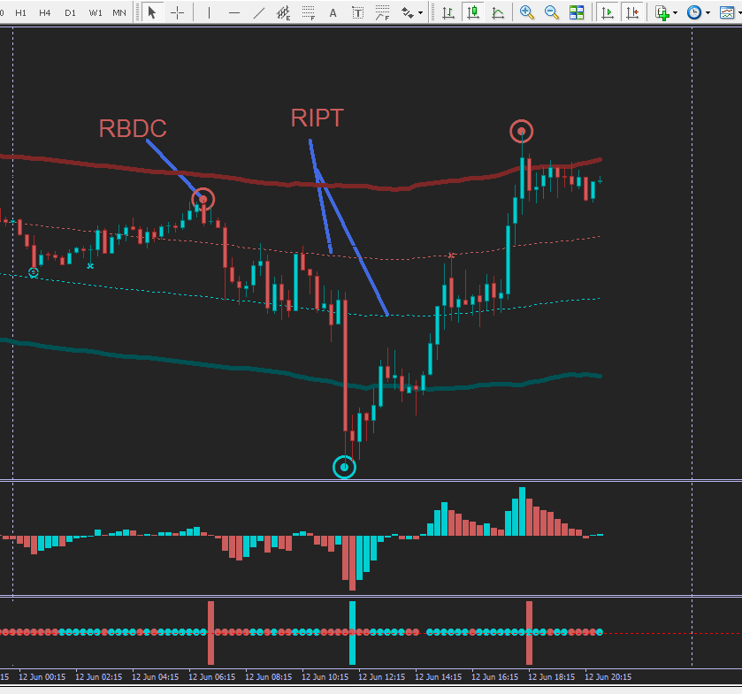
Chart2

2) Selecting the high probability of signal continuous
M15 : See chart3
The RBDC is already appeared then we have to wait the red small dot circle (rsdc) if the Blue Big Dot Circle (BBDC) is not formed yet. On the chart3, the blue small dot circle appears ( This represents the retracement of the Red Big Dot Circle. As soon as the red small dot circle appears we can do the monitoring in M5 for pinpoint.
rsdc appears above the RIPT – Very important
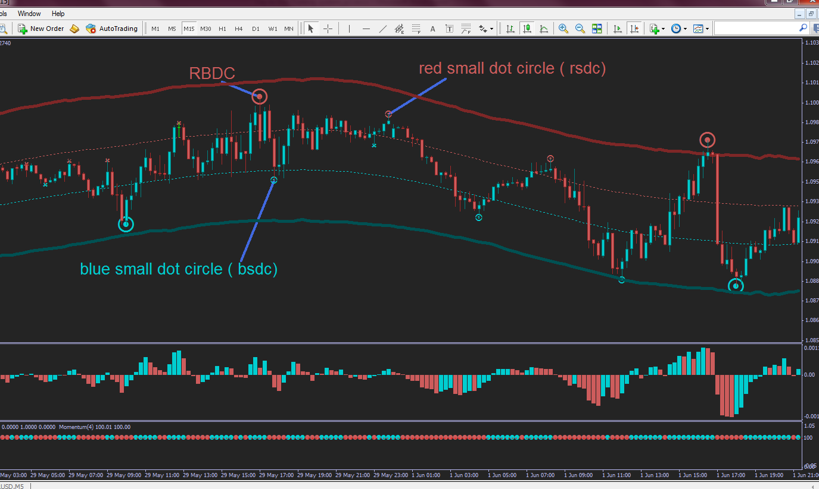
Chart3

GOTO M5 FOR PINPOINT

PINPOINT
M5 : Always sell above the RIPT with the Red Big Dot Circle (RBDC) signal. – See Chart4
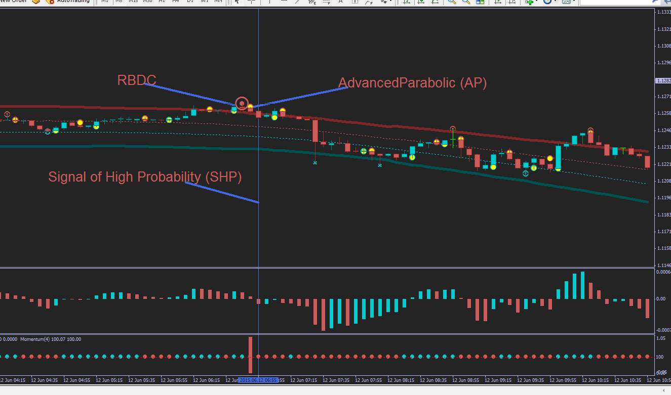
Chart4
Go short = RBDC appears + red avancedparabolic(rap) confirms by macd red below the zero line + momentum red

KEEP IN MIND, WE ARE IN A DOWNTREND FROM H4

Counter Trend : Always take the blue small dot circle (bsdc) for high probability signal in M15
M15 : See chart5
The blue big dot circle (BBDC) appears below the RIPT. We don’t have to take that signal. Because the signal might move . Then, probably, the red small dot circle (rsdc) appears. We can take this signal (rsdc) because we are still in the downtrend. But take only the signal located above the RIPT for short trade. Later, the blue small dot circle (bsdc) appears below the RIPT. This signal (bsdc) is aligned with the blue big dot circle. We can take the blue small dot circle as a counter trend signal.
The counter trend is short lived. Don’t be so greedy.
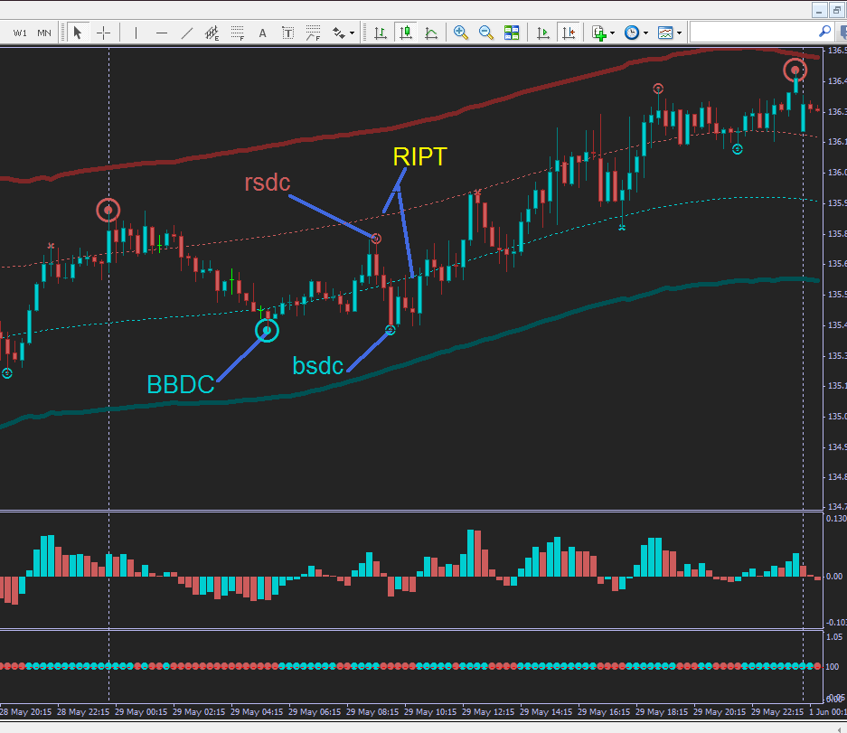
Chart5
KEEP IN MIND, WE ARE IN A DOWNTREND FROM H4

Stop Loss (SL) and Take Profit (TP)

M5 : See chart6
SL : Put at the high of the candle alerted the red big dot circle.
TP : Take profit at the RIPT area for TP1 and for TP2 at the low channel
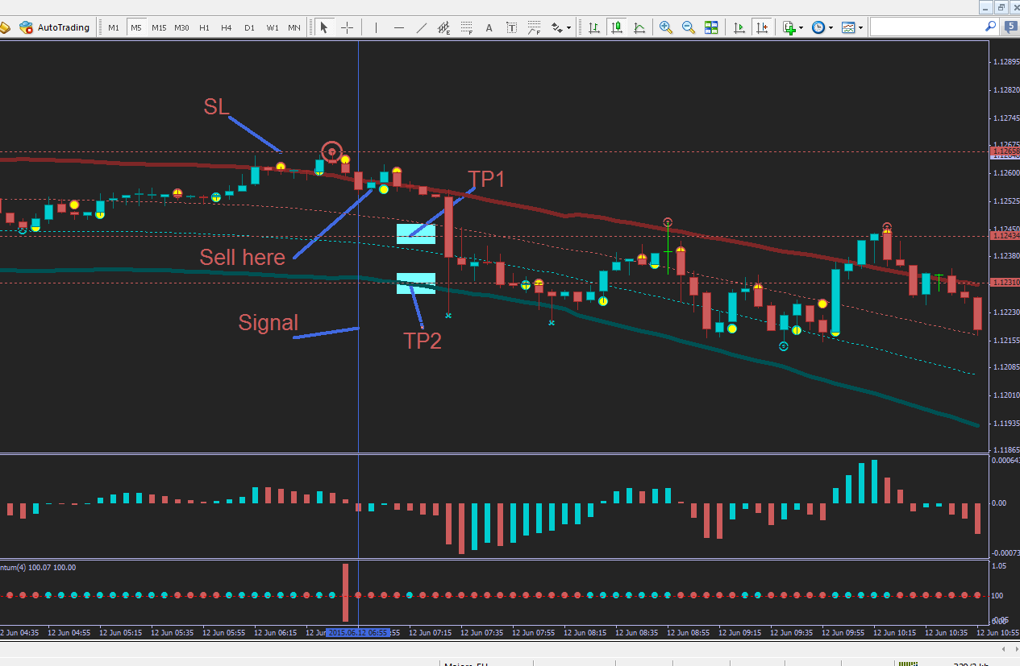
Chart6

