KEEP IN MIND, WE ARE DOWNTREND FROM H4

1) Selecting the high probability of signal
M15 : See chart2
RBDT appears above the RIPT – Very important
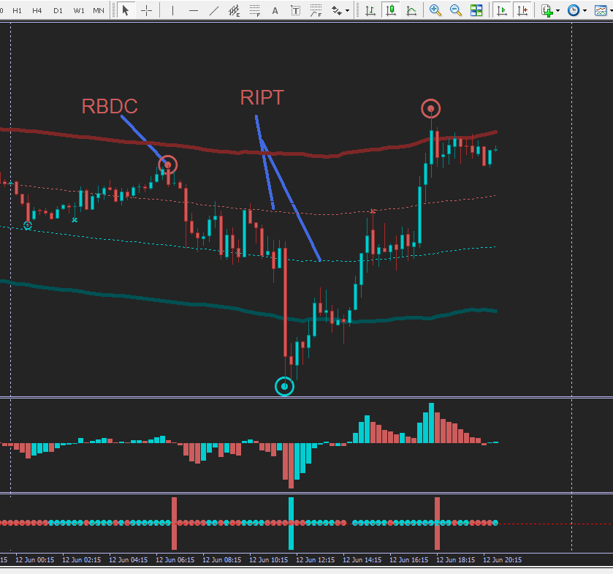
Chart2

2) Selecting the high probability of signal continuous
M15 : See chart3
The RBDC is already appeared then we have to wait the red small dot circle (rsdc) if the Blue Big Dot Circle (BBDC) is not formed yet. On the chart3, the blue small dot circle appears ( This represents the retracement of the Red Big Dot Circle. As soon as the red small dot circle appears we can do the monitoring in M5 for pinpoint.
rsdc appears above the RIPT – Very important
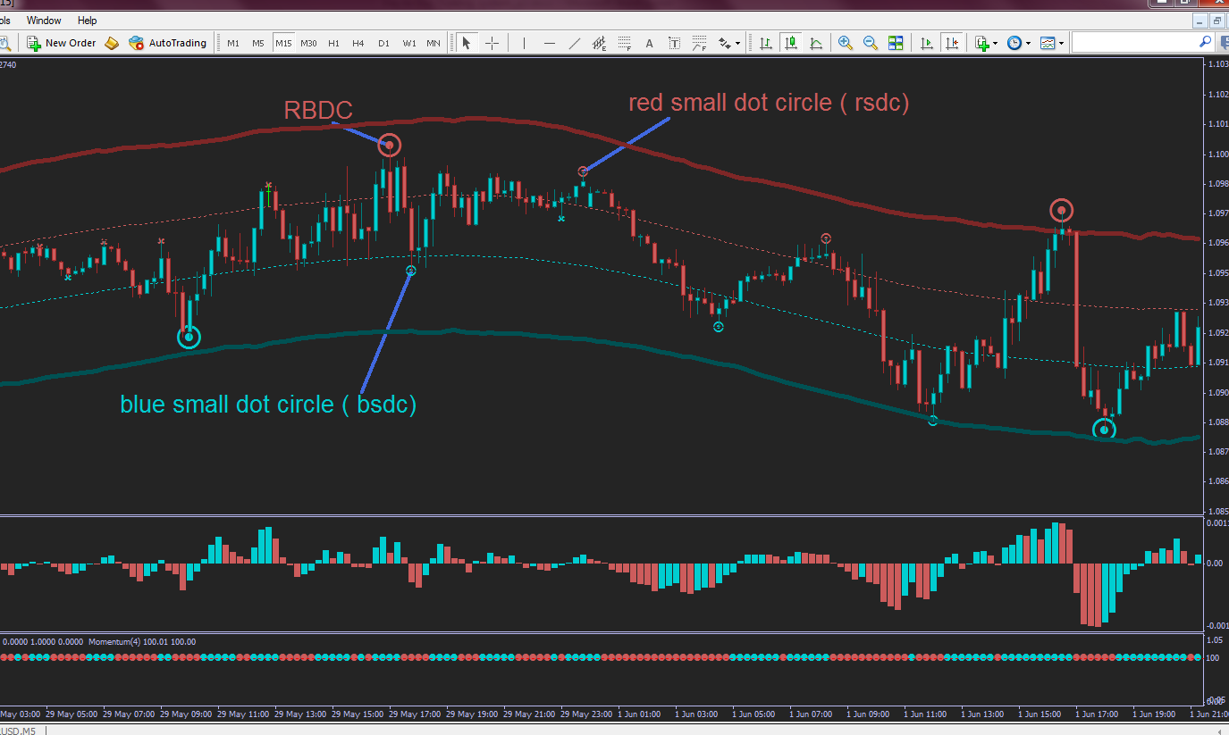
Chart3

GOTO M5 FOR PINPOINT

PINPOINT
M5 : Always sell above the RIPT with the Red Big Dot Circle (RBDC) signal. – See Chart4
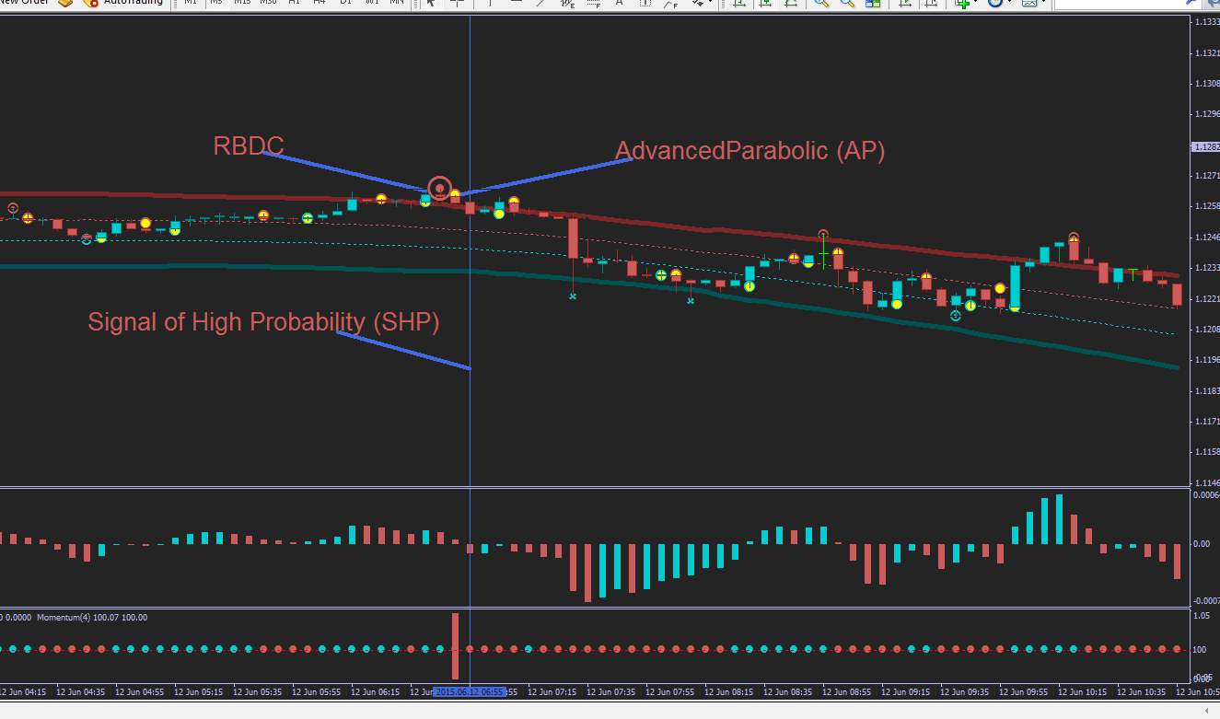
Chart4
Go short = RBDC appears + red avancedparabolic(rap) confirms by macd red below the zero line + momentum red

