Come Surfing Forex System

This system is based on the trend following.

The trend is determined by the cross of 5/10 EMA and combined with the Trix histogram above or below the zero line in H4.

The entry is used the M2 renko chart with 7 pips box size.

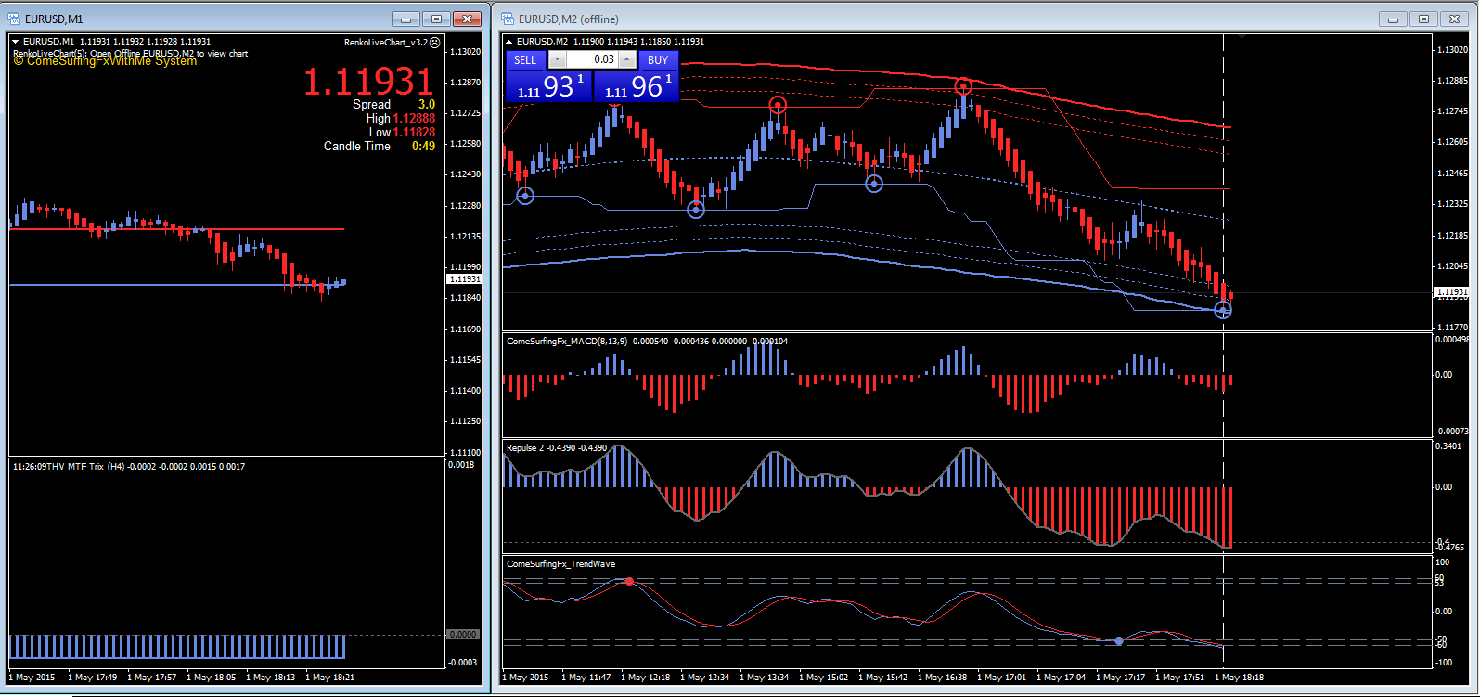

  - I. Determine the trend ( H4 )
This is a basic trend with high probability
Up trend ( High probability)
5/10 EMA cross up + Trix histogram is above the zero line
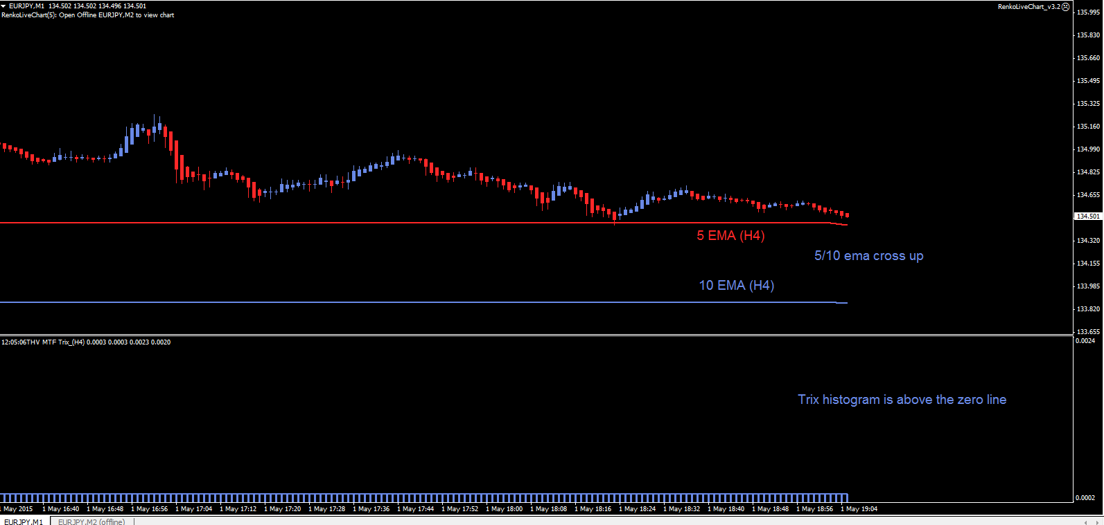
Down trend ( High probability)
5/10 EMA cross down + Trix histogram is below the zero line
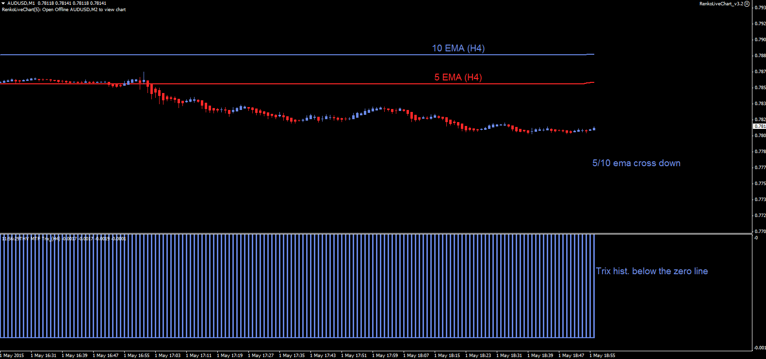

  - II. Entry (M2) Renko chart – 5 pips box size
Go long (high probability)

Price closes in the lower channel + blue dot circle appears

Candle is blue and is confirmed by :

i) MACD is blue

ii) Repulse bar is increased or blue and above -0.4

iii) Trendwave cross up
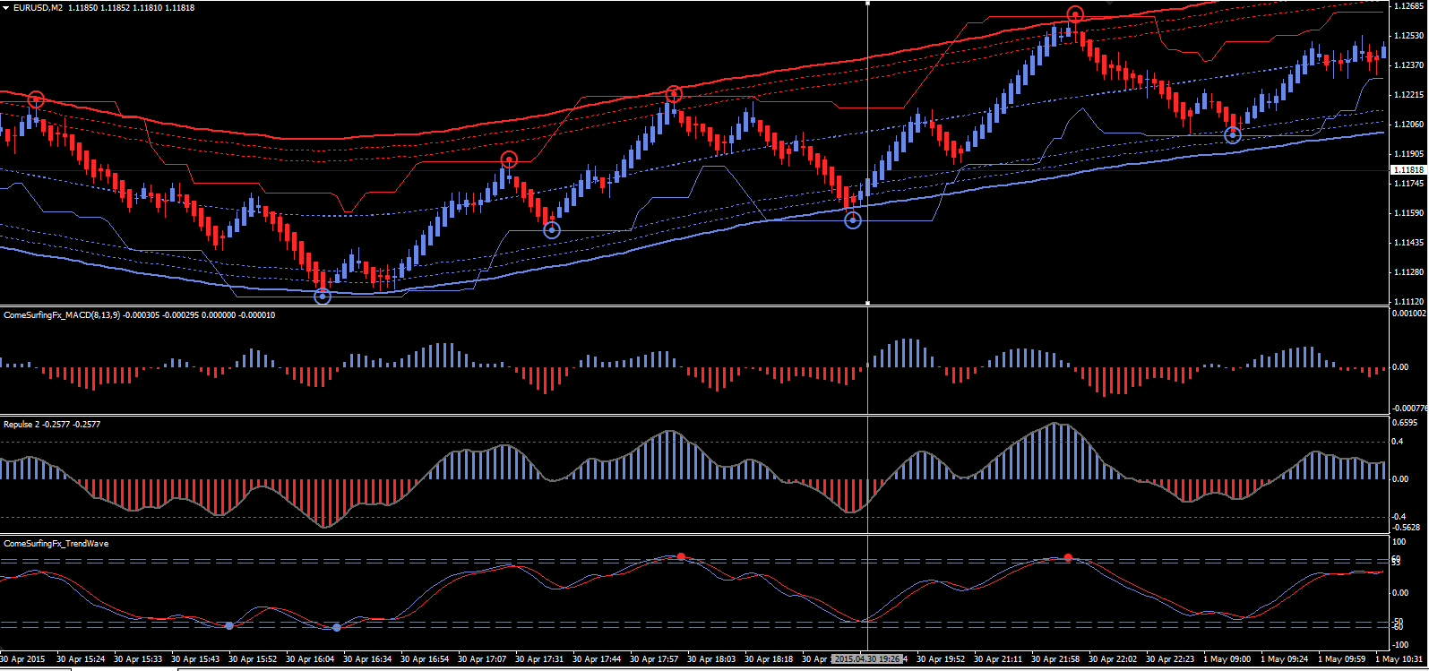

Go short (high probability)

Price closes in the upper channel + red dot circle appears

Candle is red and is confirmed by :

i) Macd is red

ii) Repulse bar is decreased or red and below 0.4

iii) Trendwave cross down
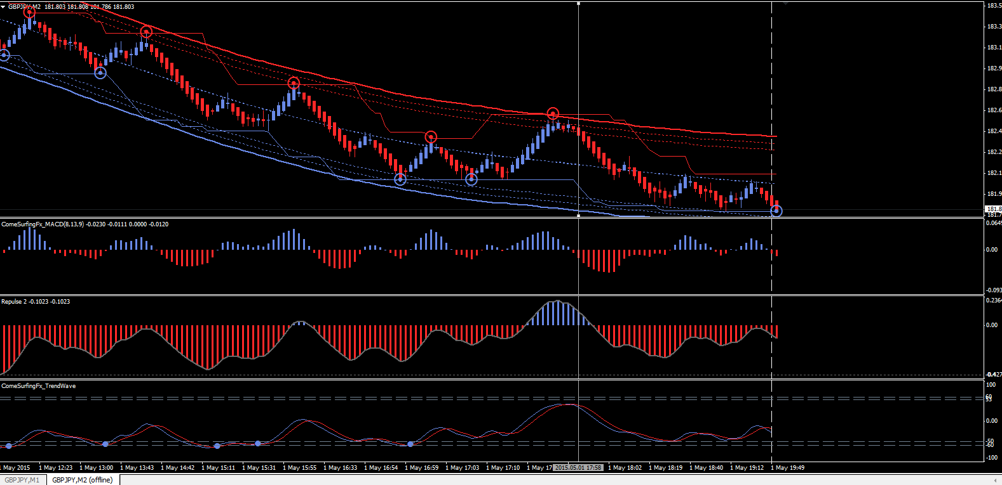

  - Take Profit ( TP ) and Stop Loss (SL)
Long trade
TP and SL are illustrated on the chart
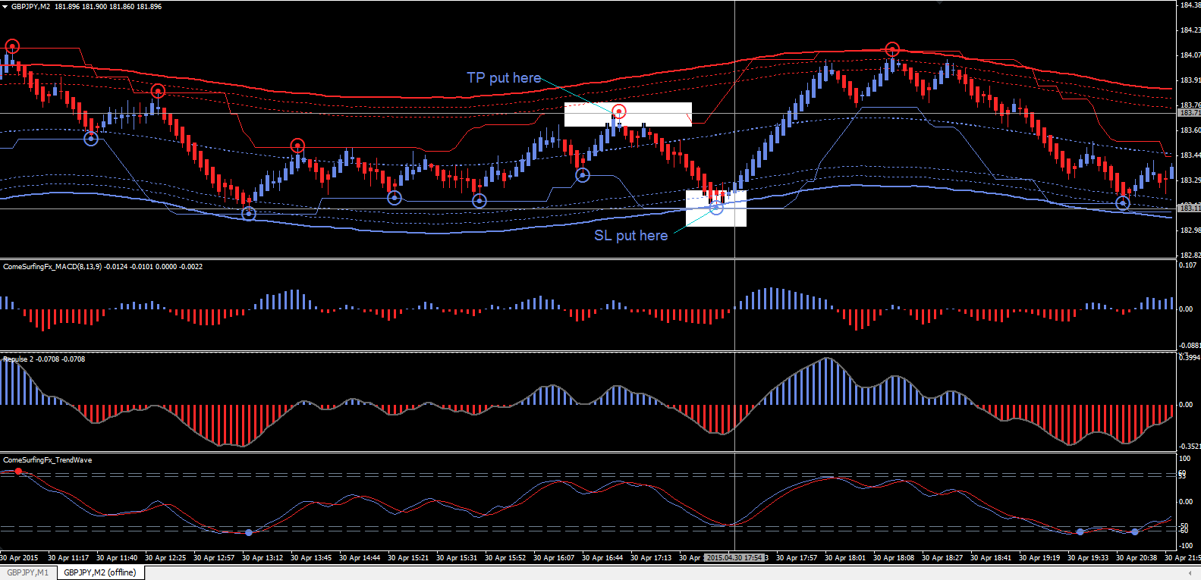
Short Trade
TP and SL are illustrated on the chart


