Fundamental Analysis
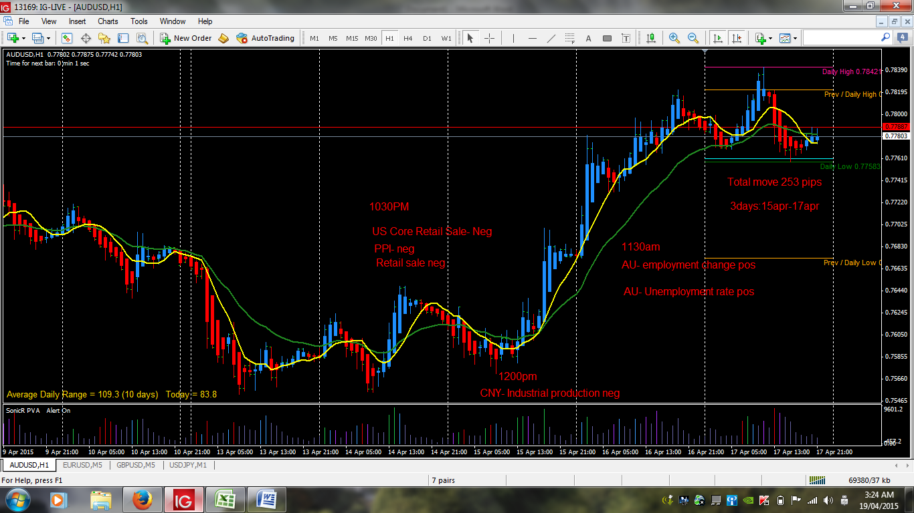
April 14
10:30 pm- US core retail sales, PPI came out negative result, the MM has anticipated the outcome or already know the out before it came out. So two massive volume bars appear. But the next day China’s industrial production become a small negative bear bias causing a drop on the previous nights bull rally, but since Australia has a strong economy still it start to go up anticipating the positive outcome of the employment and unemployment results. When a positive result came out the rally lasted for the next day too causing a massive 253 pips price move on the Australian dollars.

