Trade Journal

Recording the trade from start to finish

Trade Number: |  | 1 |  | Entry Date: |  | 19/10/2010
Long or Short |  | Sell |  | Entry Signal |  | Range Breakout
Symbol: |  | AUD/JPY |  | Size: |  | 3 lots
Entry Price |  |  | 79.25 | Stop Loss |  | 79.90
Chart @ Entry:  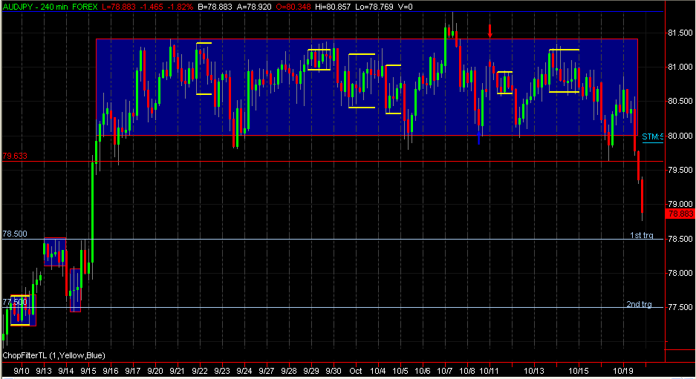 |  |  |  |  | Chart @ Exit:

Reasoning Behind Entry
The pair is in a tight range on daily, resistance at 81.80 and support at 79.6, support has been broken and I sold just below the 4hrly bar that penetrated the support.

Feelings/Thoughts during the trade
Strong feel about the trade because the pair had broken to the upside from an asymmetric triangle, but it has failed to follow through and has been stuck in a range between 81.80 and 79.60

Final Thoughts for the trade
Price broke out to the downside, the breakout was good with some nice long bearish bars, but I noticed that after a few bars, the follow through was not as I would have wanted so I moved my SL to BE. Moving SL to BE was the right decision because price later broke to the upside, so we avoided a loss.
Exit Date | 20/10/2010 |  |  | Exit Price |  |  | SL
Profit or Loss | 0 |  |  | 79.25 |  |  | 79.90

