The Momentum Trend M15-M5

The system is used THV MTF TRIX’s histogram on M15 to determine the direction.
The entry trade is performed in M5 with a high probability.
Indicators :
- Synergy or Heiken Ashi candle
- RenkoStreet_Trend
- TMA Line
- THV MTF TRIX
- Entry Signal Stop
-Renko channel
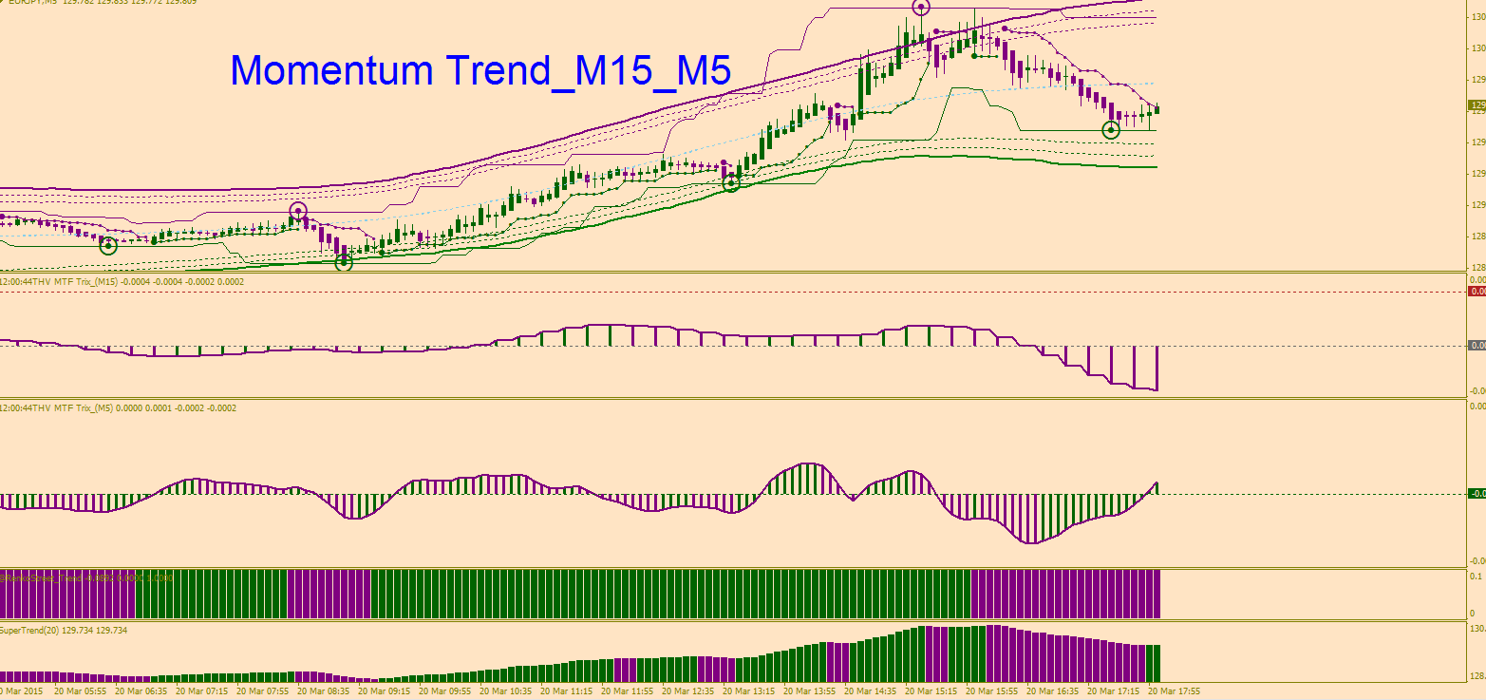

Enter a trade –M5--

Long Trade : Below the middle channel or around the lower channel (To validate the signal)

Step1) THV MTF TRIX’s histogram of M15 above the zero line (to validate the direction) important
Step2) Green Circle touched the green support line (Renko channel)
Step3) THV MTF TRIX’s histogram of M5 below the zero line (to validate the signal) important
Step4) RenkoStreet_Trend and Supertrend painted green


