OUR DEEPEST FEAR
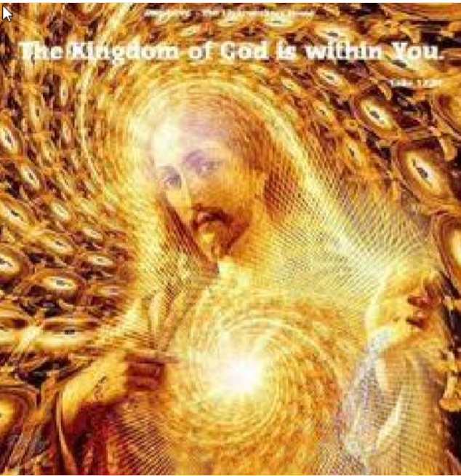

“IF our deepest fear is not that we are inadequate?
If our deepest fear is to face the fact that we are eternal, free, sovereign multi-dimensional, multi forms, panoramic, cosmic beings of light, powerful and sovereign beyond measure?
Is it our light, not our darkness and suffering that we tolerate and to which we are deeply identified and attached) that most frightens us?
We ask ourselves, who am I to be brilliant, gorgeous, genius, stupendous and exceptional?
Actually, who are you not to be?
In your original and essential true nature you are a star of the Universe, a real unique personal individuality, made in His Image, the Alpha and Ω, a Holy Grail, gorgeous above human’s wildest dreams.
Your playing small does not serve the world.
There is nothing enlightened about shrinking so that other people won't feel insecure around you.
We are all meant to shine, as children do and to manifest the majesty and glory we are.
It's not just in some of us, it's in everyone.
And as we let our own light burst out, we unconsciously give other people permission to do the same.
As we are liberated from our own fearful paralysis, our presence, magnitude and our magnificence automatically liberate others.

Beyond the myriad of self-improvement projects and endless mystical idealized states with which the spiritual path is strewn, lies, here in the present unfolding “here-and-snow” moment, the simple and exquisite taste of our own Being and Presence! Sweet and fluffy unconditional love and compassionate understanding, golden melting and merging all-embracing pure love, the pearly taste of our preciousness, dignity and self-worth in creating and playing in the material world of form, the sparkling of our own essential uniqueness: the living shining pulsing Star in the black luminous holy night, the potentiality of all-knowing of the eternally expanding unknown, the rock solid, brilliancy and radiance of our truthful presence and basic trust in the infinite goodness of existence, Our living pure joy of pure understanding of the interconnectedness and unity of all life, our pomegranate strength and living power to preserve what is good, right, just, worthy and pure, the holy living daylight and melting water of our basic and natural glorious humanness.

Ad vitam aeternam sumus semper omnino et undique noster unique
aeternum viventem gemmis et dilecti sidereum Rex Illud de Lumine

Coming Out for Going Home

“An idea whose time has come now”
and

« Nothing is as powerful as an idea whose time has come » - Victor Hugo

(Original text from Marianne Williamson (www.marianne.com) – Freely inspired from the modest life experience of Harry Smulders, Green Donkey, F-24610 Saint-Méard-de-Gurçon – tel: +33 5 53804401 – cell/mob: +33 6 40 51 85 54 – email: harry2025@orange.fr )
What about taking the words of the Christ literally: and IF our true normal human nature were:

Ad vitam aeternam, sumus semper omnino et undique Rex Christos.?
That truly is scary and completely insane?

