tips for the new comers to this business:
whichever system or method you adopt to trade, entries and exits are critical. often times, you will be experiencing you just missed the entry by 1 bar. do not chase the price. wait for the next opportunity. as much as entries are critical, so as exits. know your target before entering the trade. also, avoid friday setups especially after london close. have a nice trading everyone.
/just a small trade in asia. tg1 might hold. selling climax was seen 30 min ago.
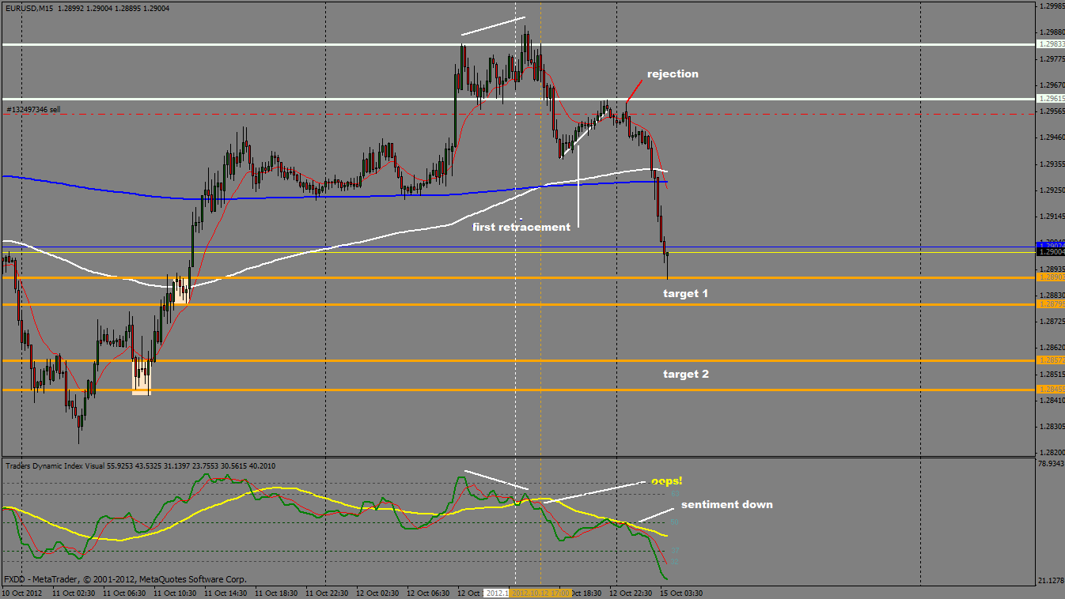
looks to me it's consolidating right above the previous cluster zone (weekly). smells like accumulation.
bullish hammer right above that cluster zone as well.
/just a little heads up for bulls. approaching previous swing high (4hr). high volume kicking in. not much progress in price wise the last 2 candles (15 min).
/just because price reaching adr doesn't mean you go short. adr reaching it's limit is a guide only, hence good for the tp. larger tf still dominates. yesterday, market's been in accumulation phase after london to asia with 4hr momentum compressed. today, the market just released. meaning, momentum is very powerful and could still be at the beginning stage or in the middle of it, plus we don't have any evidence that the price has topped, except reaching adr and some volume figure. ask yourself if that gives your enough conviction to go against a powerful trend. you need to have a bigger picture in the background always, even if you're trading down to 5 min, 15 min tf.
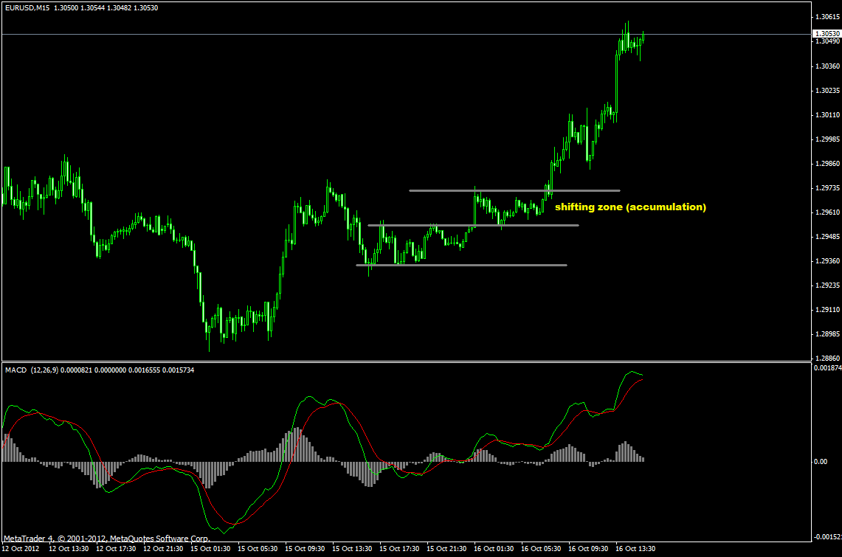
now we got something to work with the shorts. london close in 2 hrs however. you need to decide whether it's worth the risk or not. for me, i will wait for price to either pull back or consolidate then look for long opportunity.
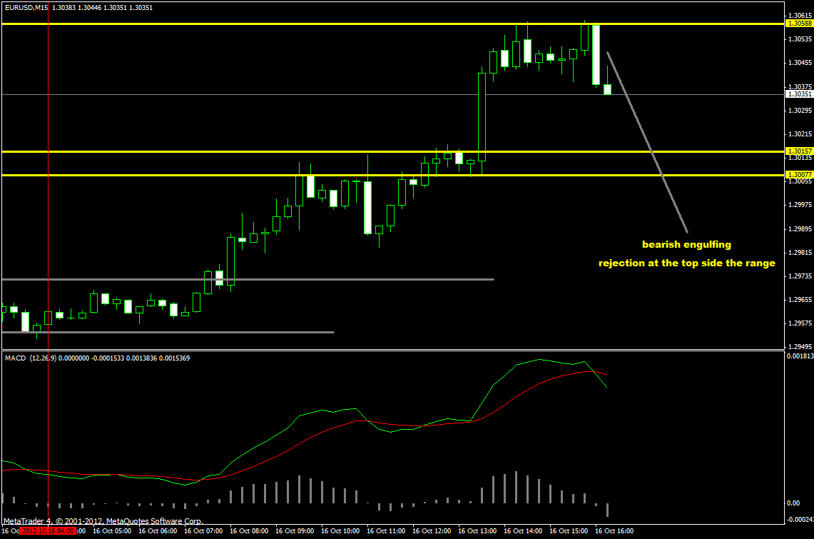
Orko555:«Hey Guys!
Check this out!
Any thoughts?«
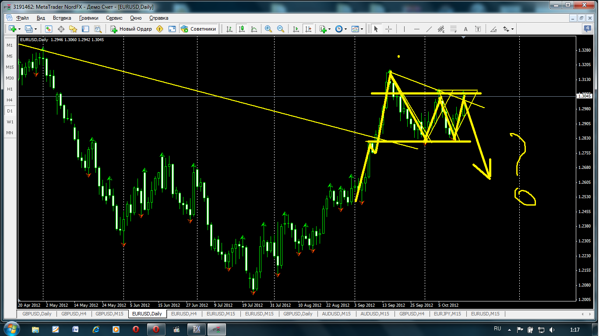
Weekly momentum is still to the upside. Dailys been pointing down for a month. Now its flatening out. While anything can happen, odds might be slim in this case.
Another thing to keep in mind is that the rallies had volume support, while sell offs had little.
/Orko555:« Try to find the pattern in the pictures that was marked in my previous post.
Patterns are usually well respected on big TF's!«
You got 50/50 shot going by the patterns. As of now, odds are stacked up against bears. (EUR/USD)
Orko555:« Yes of course my friend you are absolutely correct! One can also say that there is a W formation as well! So how shall we trade it???
See where in the market cycle you see w or m form. Understanding market cycle is much more cruicial than just looking for ms and ws. Even then, you need to be prepared to get stopped out several times. If you can't see that then wait for the initial rally or sell off. Market will either pull back or consolidat. Get in at the second entry point. (that's where the system can be applied.)
If you can read volume behind the moves, it helps. You can tell if the rallies or sell offs are intentional or manipulation.
/Not much can be read about this. You just need to see it on the chart. Look back in history. If you can see where the top or bottom has formed, see it from there.
/Trader330:« Euro usd short under 10 ema with pinbar
Any comments about this trade
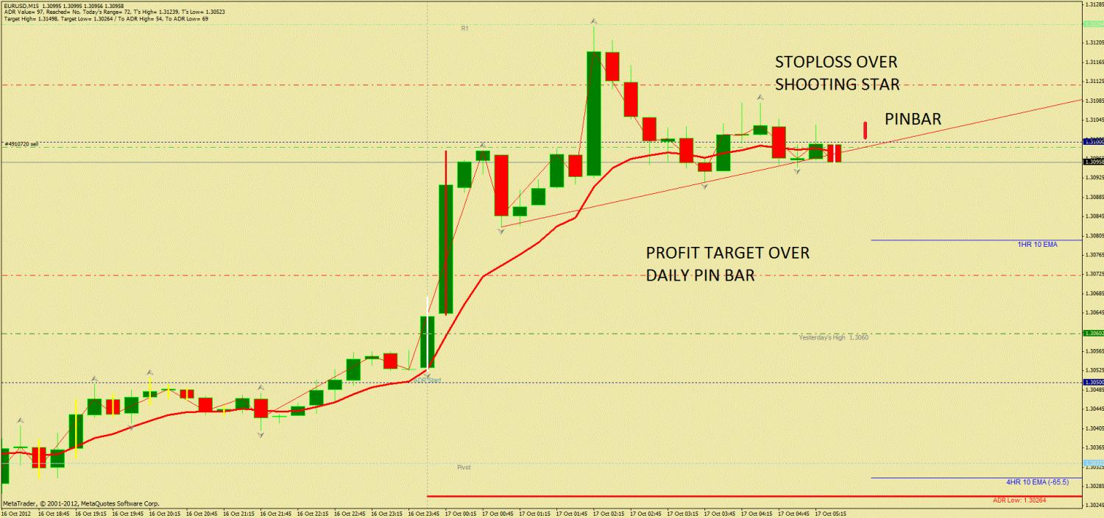
it could work out, but why reverse at this time? consolidate then should watch london action. though i'm not liking the rally after the session, no top is forming yet. bear divergence on 15 min, but the peeks are too far apart, plus price traveled too far from the previous peek. there are 2 different types of divergences, one that is happening right now is an early warning sign by the looks of it, but not an ideal signal for taking trades, imo.
Supply zone right at 3050 area.
Stopped out. reversed, now that's about to be stopped out too. 2 losses today in case anyone is wondering some of us always win, that is certainly not the case. everyone deal with losses. even the pros lose. i'm done for the day. see you all later.
losses recovered, plus weekly goal has been met. 250 pips total for the week with not much trading. it's been very frustrating week though...
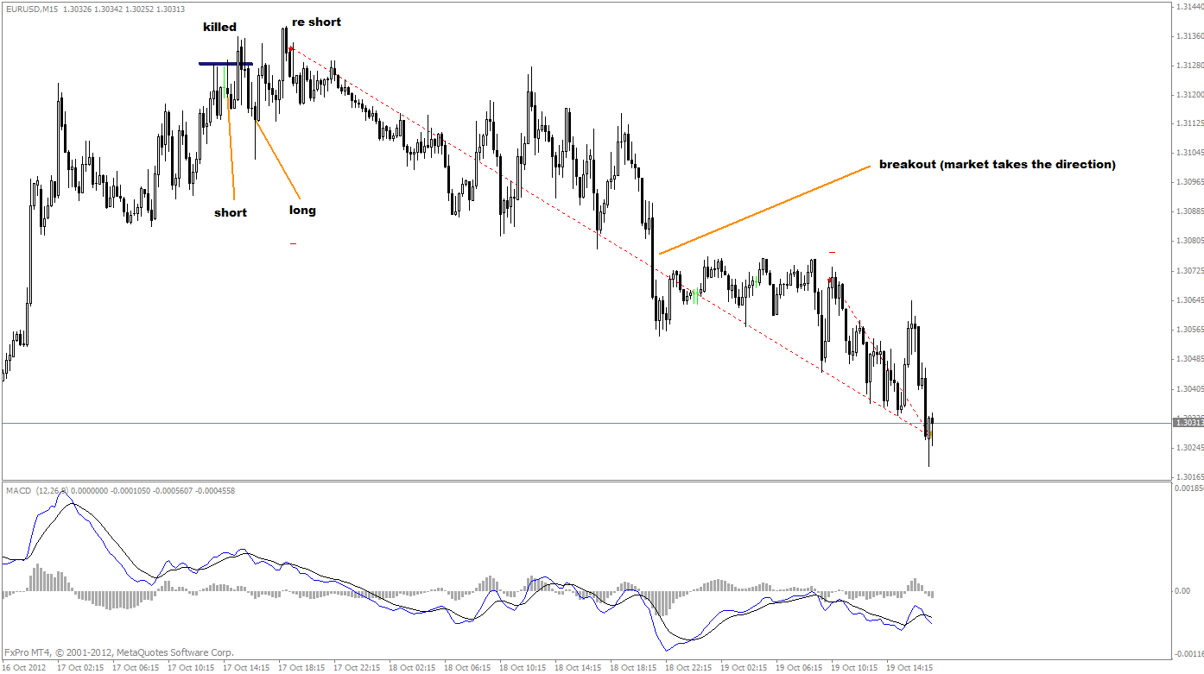
keep it simple. straight forward.
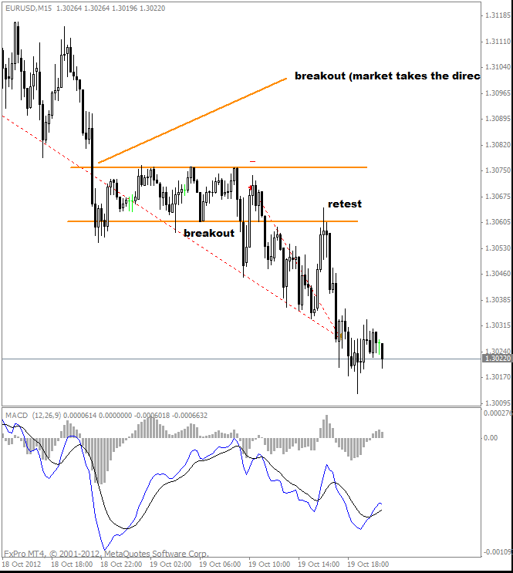
/that would have been a range breakout trade. price bouncing range top and bottom with momentum on higher tf down, downside break was much more favorable. when price is in range ma is pretty much useless.
/in regards to trendlines... i wouldn't be too crazy about it. there's always several different ways to draw trendlines and no one knows if that trendline will be respected. they give you unexpected results more often than not.
/there's no such thing as momentum trendline. and candles do not show you momentum behind the move. momentum can be measured only by the tools: macd, cci, rsi and so on. tdi: yellow line is equivalent to momentum measuring tool. tdi actually is a very good tool. it measures both momentum and cycle all in one.
it's a bit complicated process of identifying beginning/ending.
/i use macd as momentum measuring tool. 4hr typically is where i would want to see overall direction. topping and bottoming... end of the trend typically follow with a lot of bs, but parabolic moves.
example, last week's rally on tuesday right at the session end through asia was the first red flag (low volume time). from there on, i look at divergences. not all divergences provide entry signals. you need to look at it in terms of support and resistances.
p.s. in regards to top and bottom formations. they typically hunt stops.
/in any case, i wouldn't recommend picking the tops and bottoms unless you know what you're doing and prepared for couple of stop outs. stop hunts are very typical in major tops and bottoms. i never catch it in one shot and it can be very frustrating.
Cont.
one of the examples: this is the trade i've missed. but look at the drop during low volume time and how the divergence is being made. angle of the divergence is very important too.
here's 15 min chart and 1hr chart with nice angle of divergence.
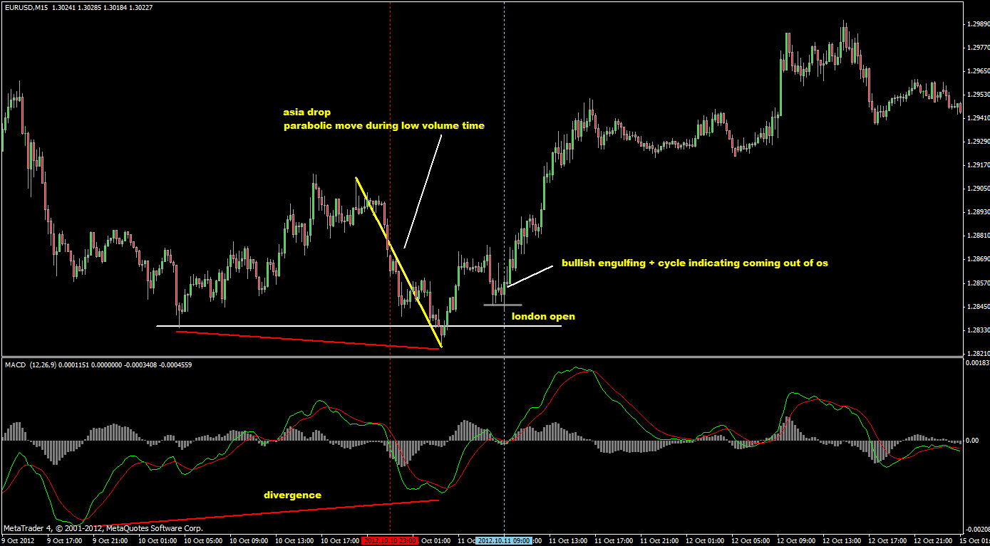

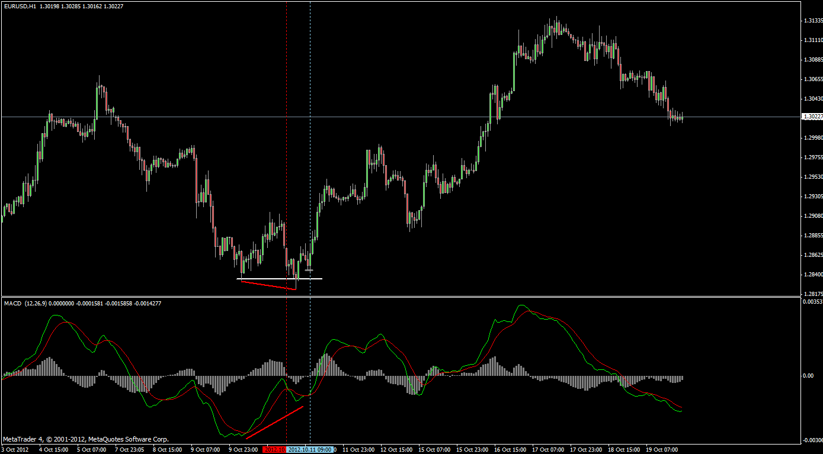
another example. last week. 15 min, 1hr, 4hr. you get the idea
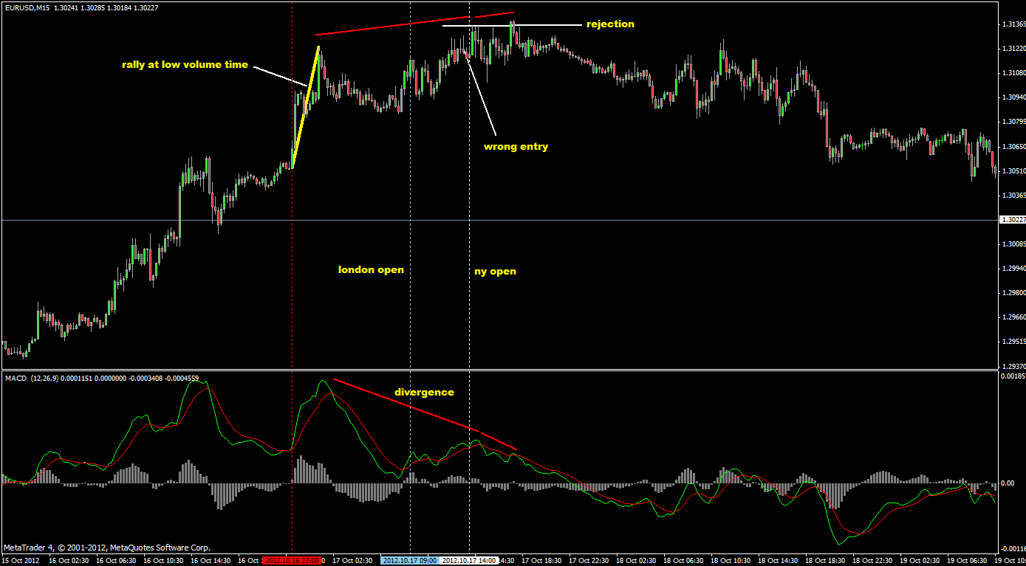
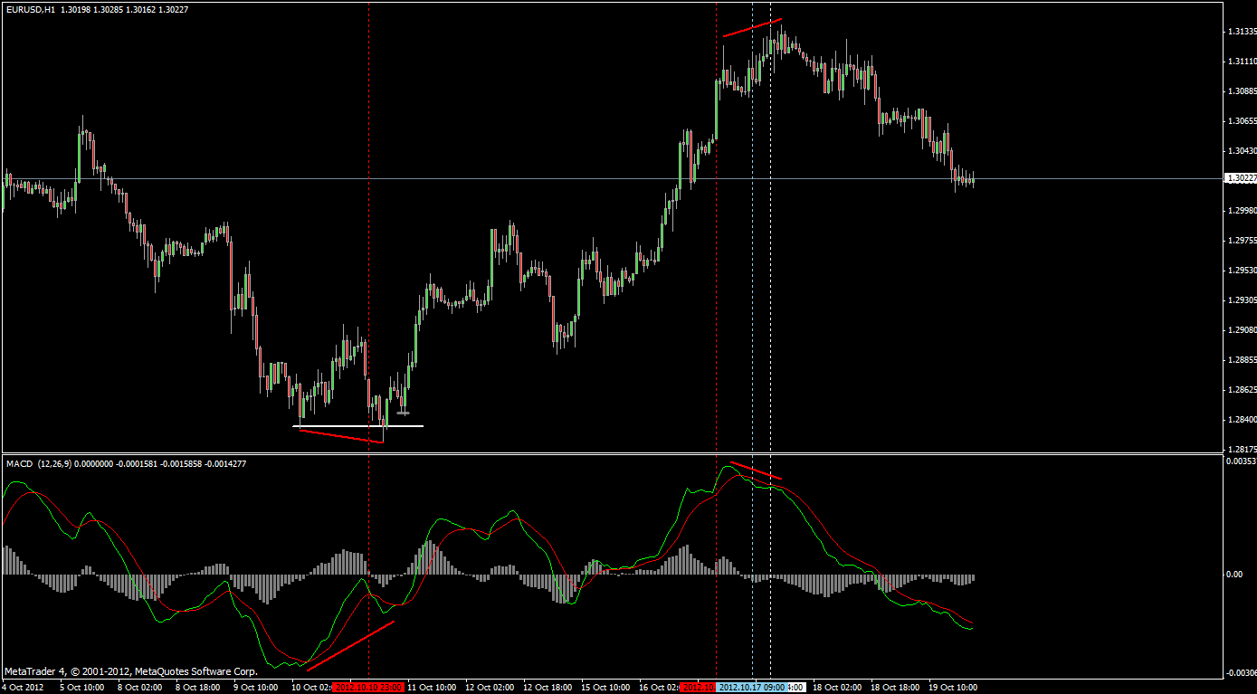
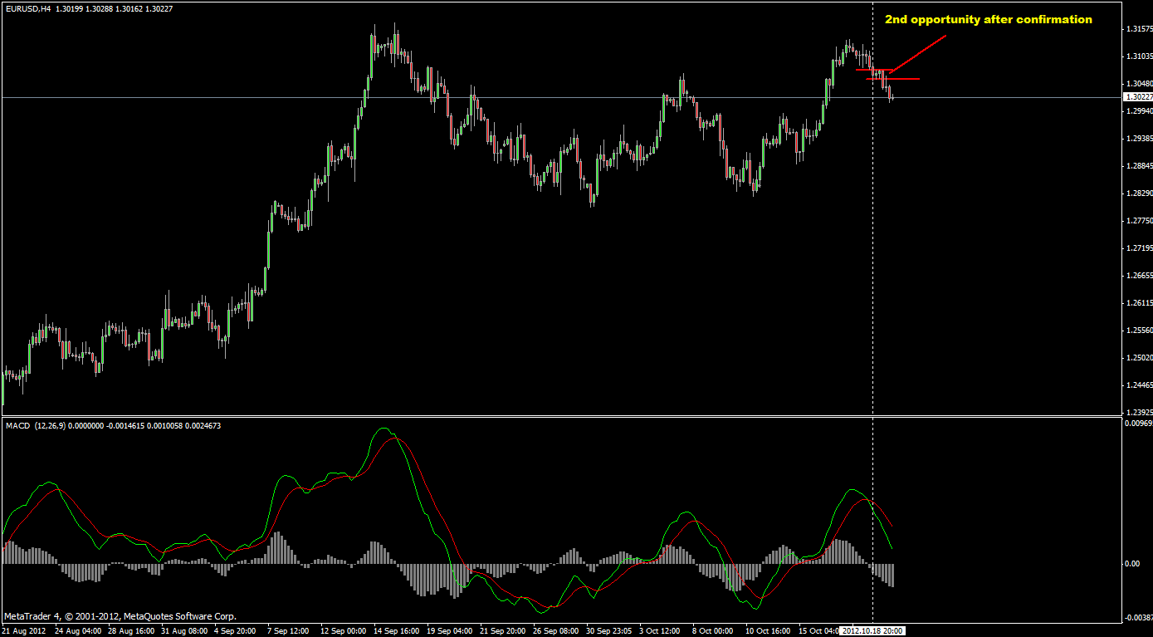
here's the problem with tl. example: obvious bounce at the tl on daily chart. according to tl, long trades were much more favorable... but the result?
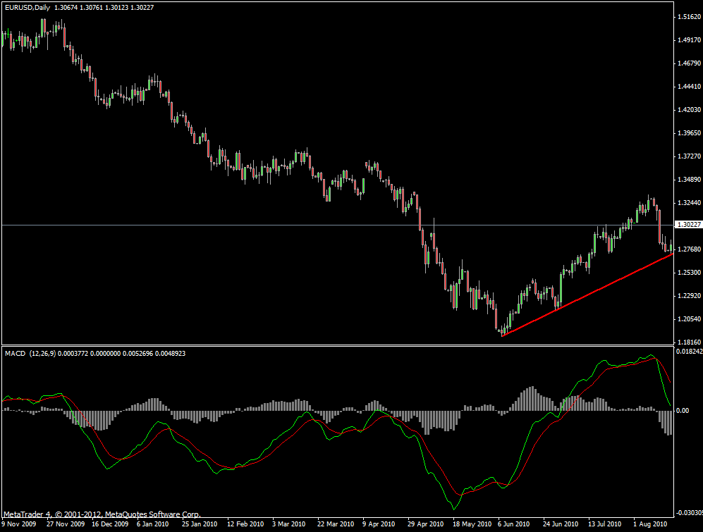
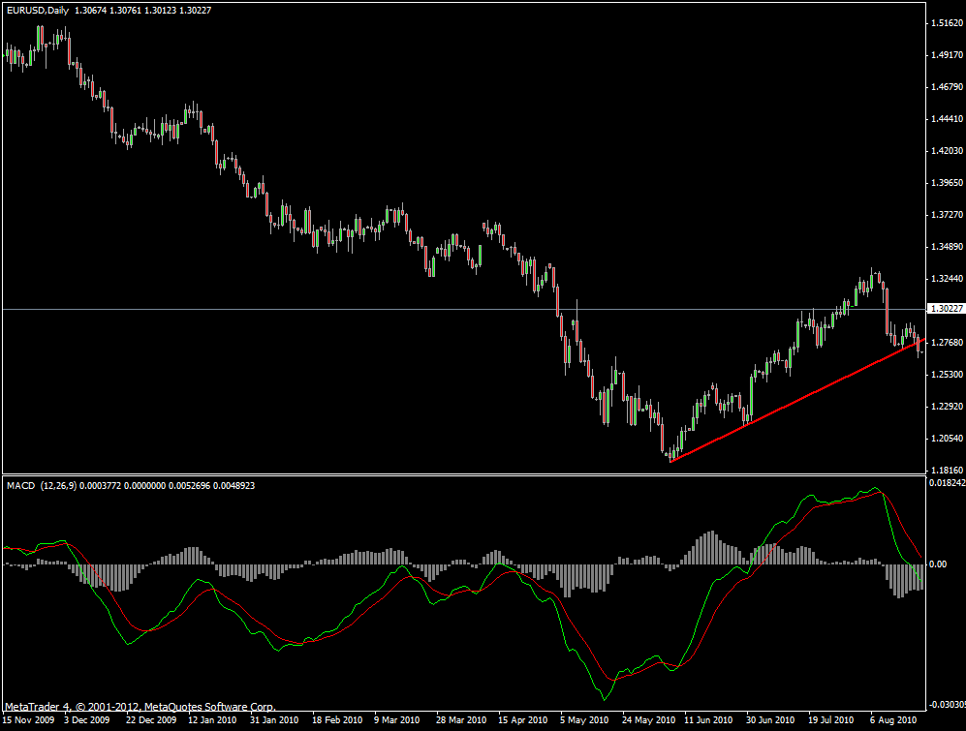
now what??? do we short? obviously short trades were failed too. so then what at this point? tl break and retest? short again?
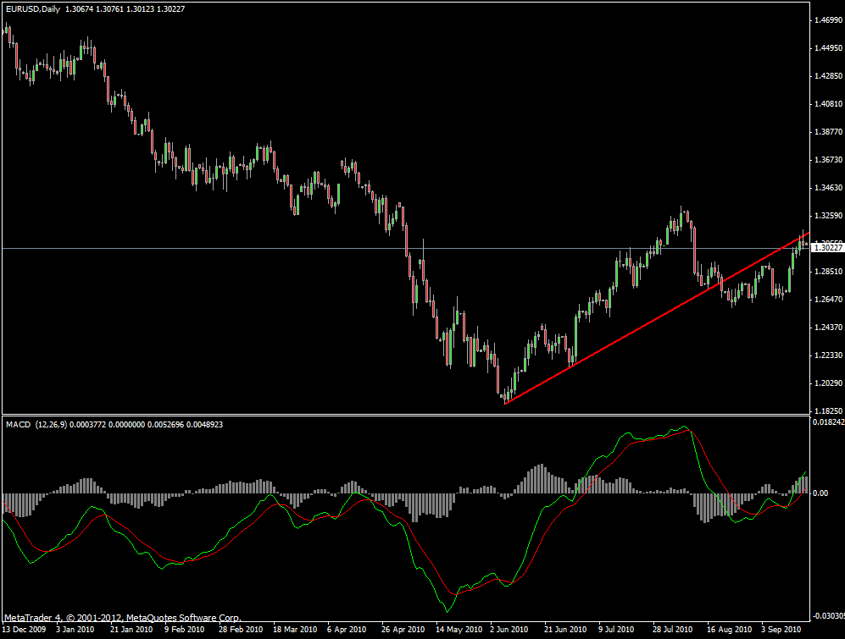
uh oh... guess at this point, we should re-draw the trendline as the chart at the bottom.
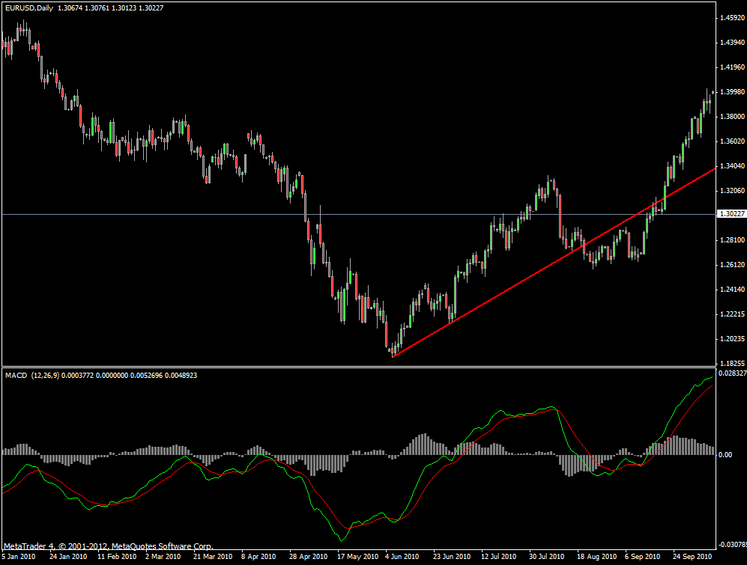
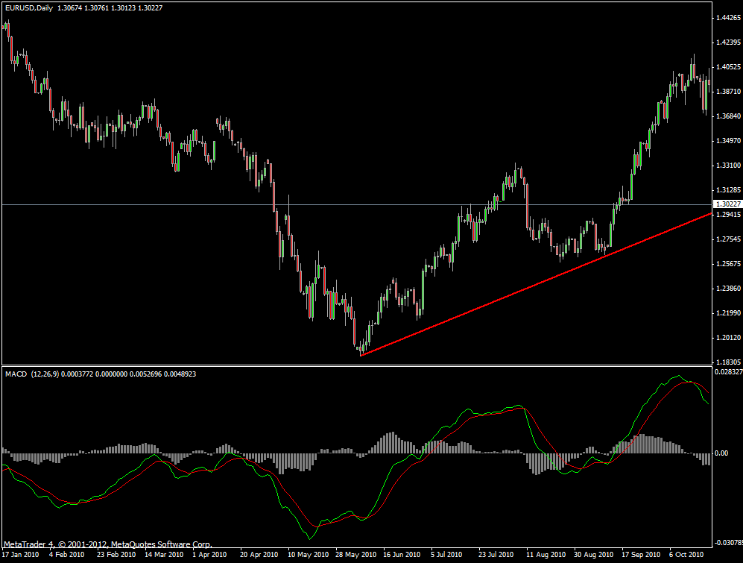
again, trendline breaks. do we short? or wait for the retest?
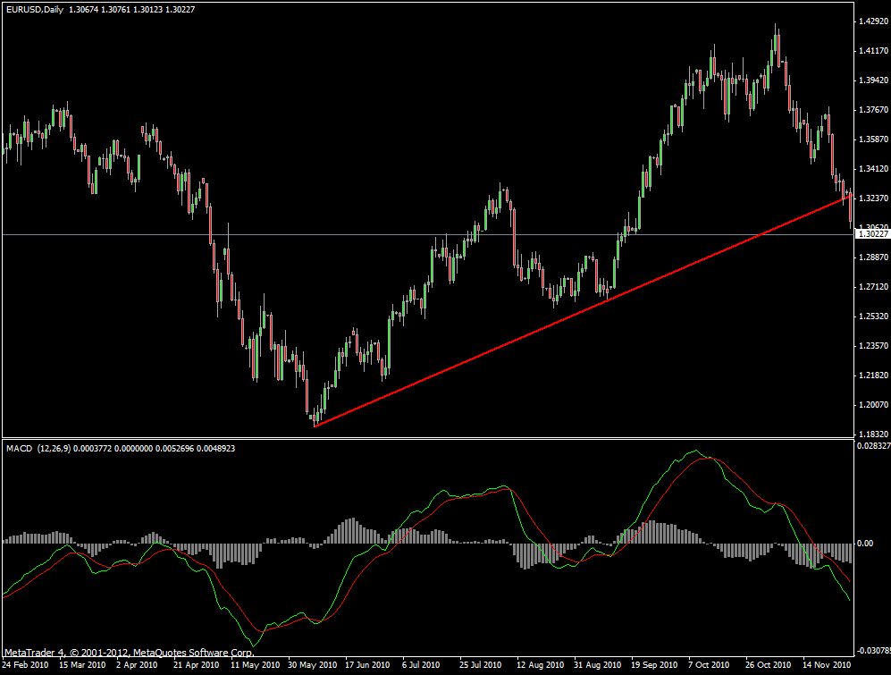
and here is the result...
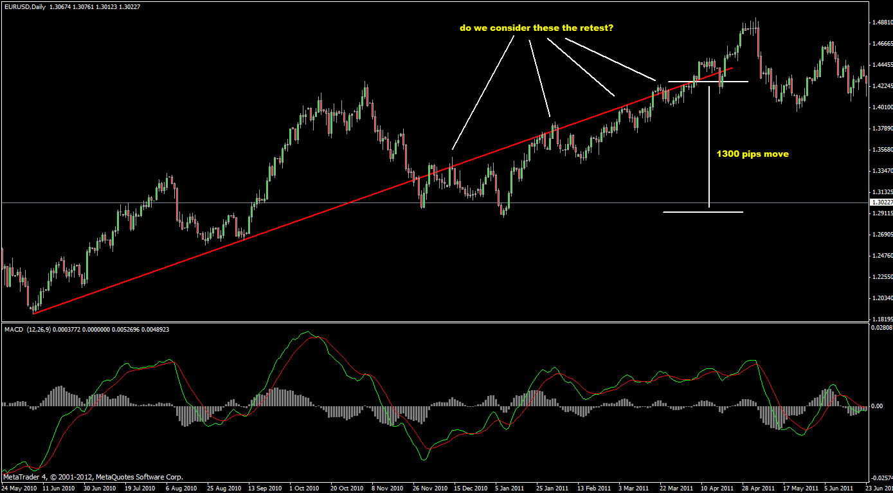
and this?
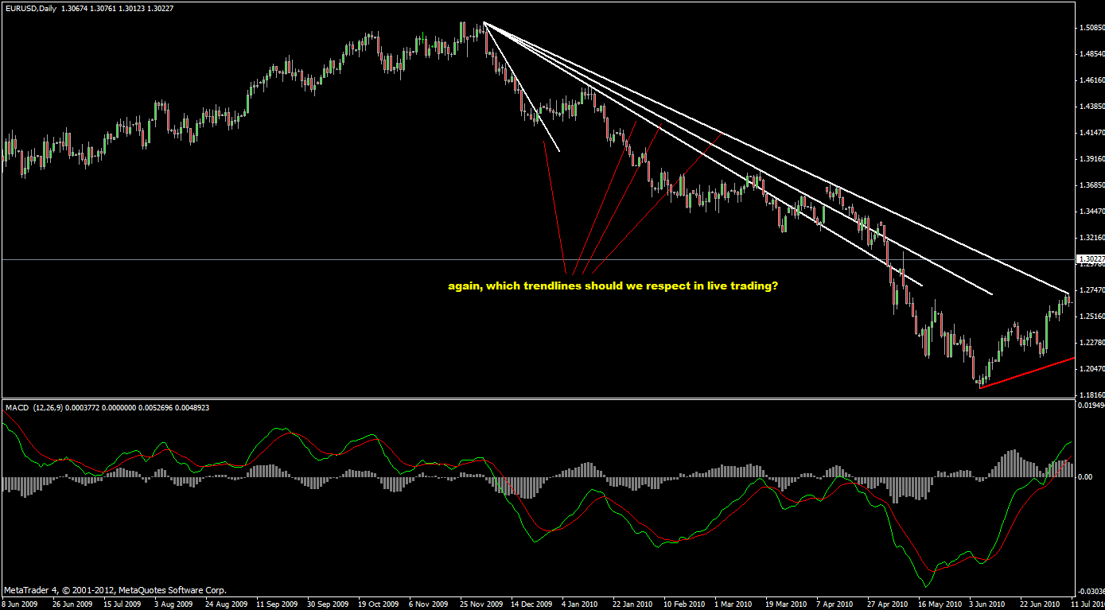
Turbobzik:« This is screen from yesterday, did not play yesterday and pointed my
possible entrys .Can you tell me if it's good and pointed yours entrys I will not get you more head turned back

here.
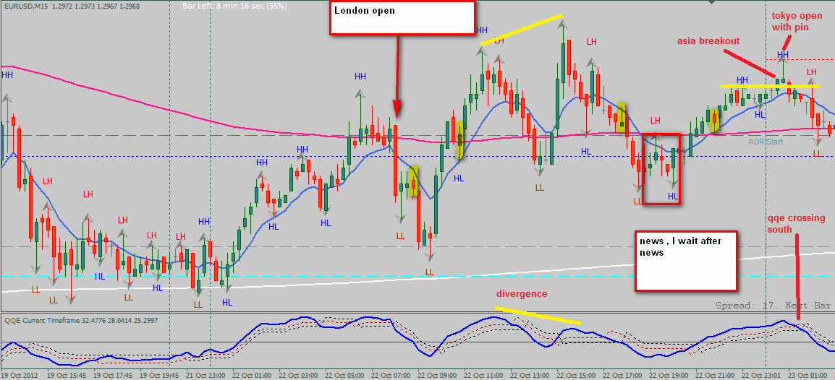
actually... there's been a noticeable bear divergence on both 1hr, 4hr.
with 15 min entry divergences with tripple top (pre ny range), rejection candle + news fade were the entry trigger. you are right about with this system, there were no trades. get in at the second opportunity. 4hr is in range with momentum just shifted to down side. break of the bottom should alert you to look for shorting opportunity.
/here's the last night's setup. entered at both spots. entry 1 = 60 pips, entry 2 = 50 pips.
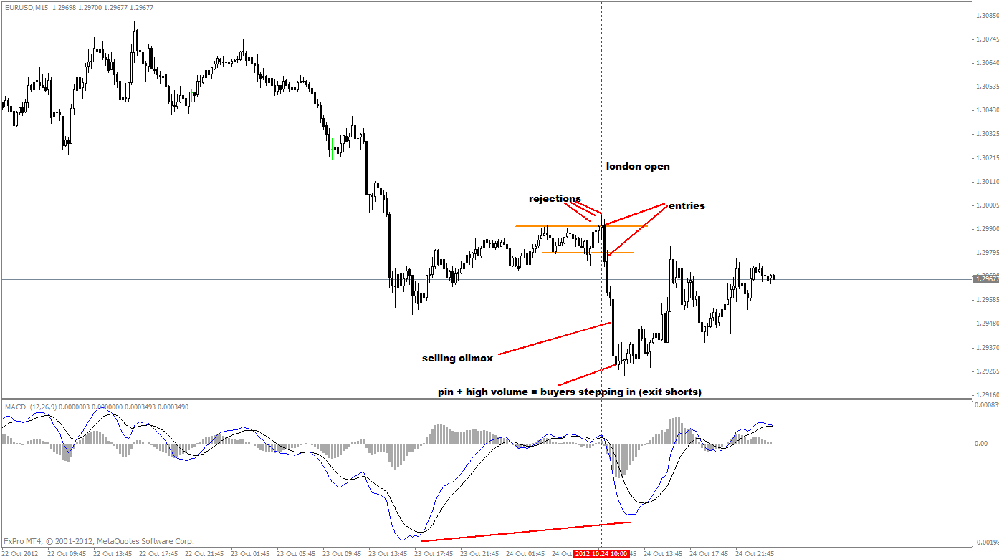
thanx roro. i can only see it in tech view from gu. 4hr momentum is to the upside. we've had a initial rally today. so i would expect another rally to be seen after a consolidation. interesting enough, euro had a bounce from daily gann, formed a pin (daily). i'm waiting for 4hr momentum to shift to north. might have a long opportunity soon.
need to pay attention to what HTF is up to. if they say down then i look for short setups, they say up then i look for longs. if it ranges before session open then it's free money to me. look where the rejections occur. other things i look at are divergences.
/WinwinFx:« Understood about the down and up setups, but don't understand "if it ranges before session open then it's free money to me." Is it trading the within the given range?????
Sorry, for the simple/silly question, but my knowledge is limited. Thanks for your reply, really appreciated.
pretty straight forward, they way i look at it. trading in given range is no fun. i wanna be in before the breakout.
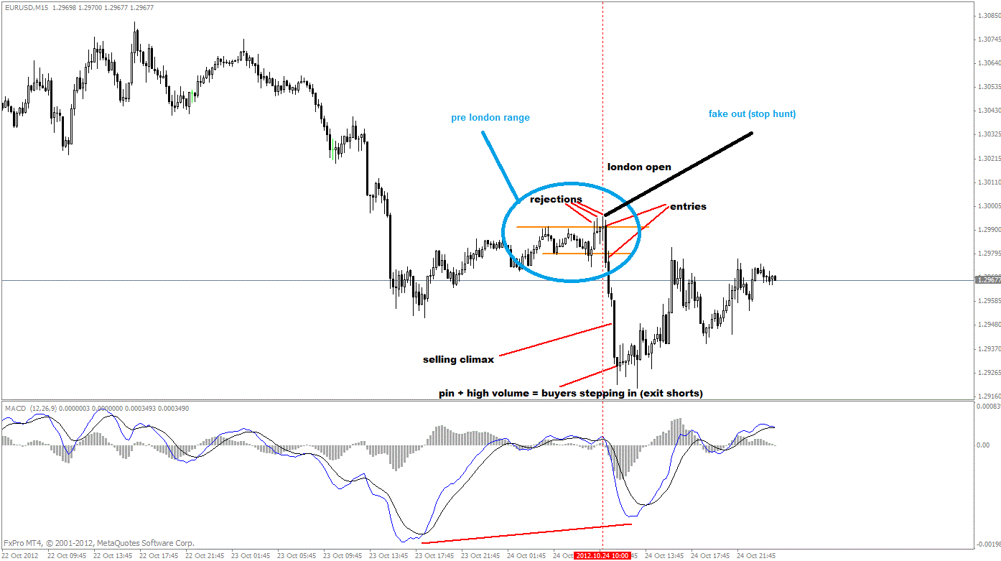
you might wanna spend some time over the weekend going over the chart and identify those setups, if you are taking this approach. it's a task, but it will help you a lot in the future. key things: 4hr, 1hr, 15 min (london open, and ny open), even some cases tokyo open). look for range, divergences, rejections.
you will need macd (or any type of momentum measuring tools) and stoch. tdi is fine if you already feel comfortable with this tool since it measures both momentum and cycle.

/first casualty of the week. was picking the bottom at london. stopped out nicely.

/Look 4hr. How many consolidation zones do you see? Normal trends consist of 2 pull backs, usually.

/yes, it was a bit risky. you've identified the range top and bottom and you've shorted at the bottom range. btw, that's not the type of range breakout i would have concentrated. pre session range needed to be formed either at the high or at the low.
99problems:« thanks for teaching a newbie like me. i guess by low and high you mean the previous day's high-low and then the subsequent day's range before the session (to see if we go higher or don't cross the last day's high)? for the trade i took within the range: i thought of the candle that went back into the range as a retracement candle. see attached pic
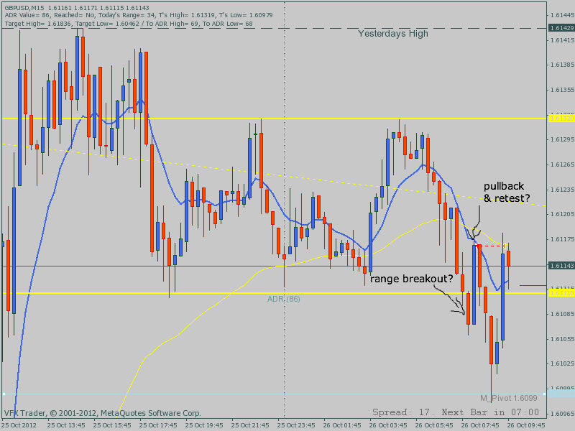
2 types of range:
1. initial sell off or rally, then consolidation. (continuation)
2. range at the session high or low, session changeover and price can't push through the session high or low. (reversal)
these are the typical setups, and amount of volume coming in the market is important factor along with candle formation.
p.s. 2nd pull back or consolidation are the last opportunity, to be safe.
/this is one of the topping formations. notice the volume of the rally before the consolidation.
as the price inching higher, volume decreases = first red flag (weakness).
rest is self explanatory, i think.
how many things are telling you to short at the top?
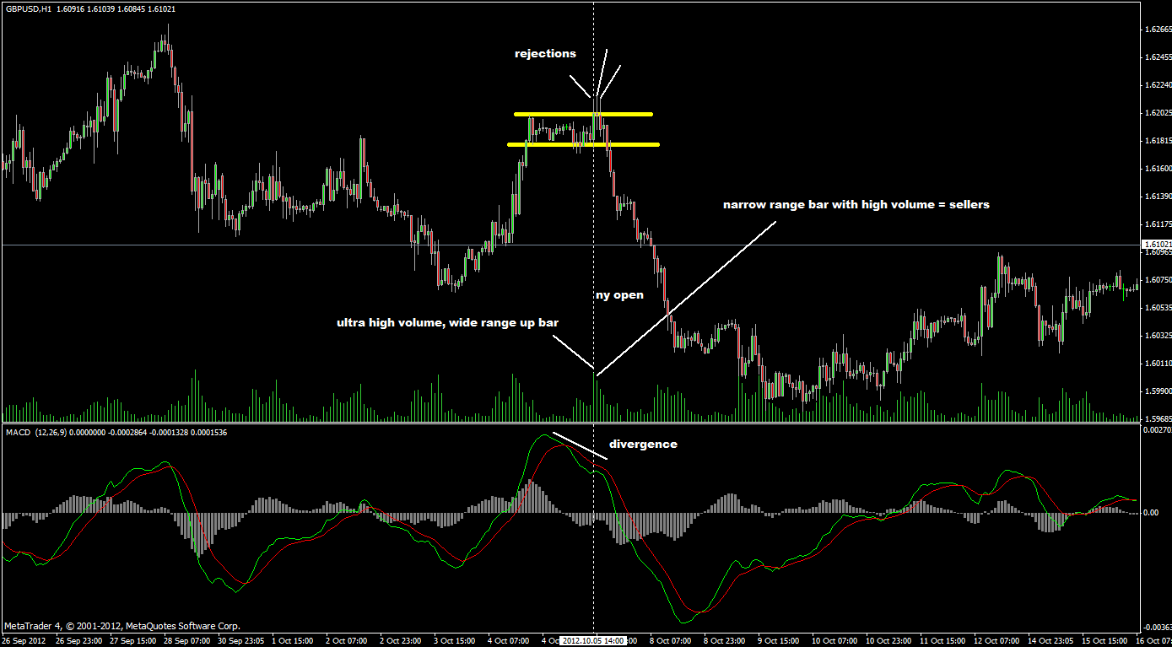
continuation pattern.
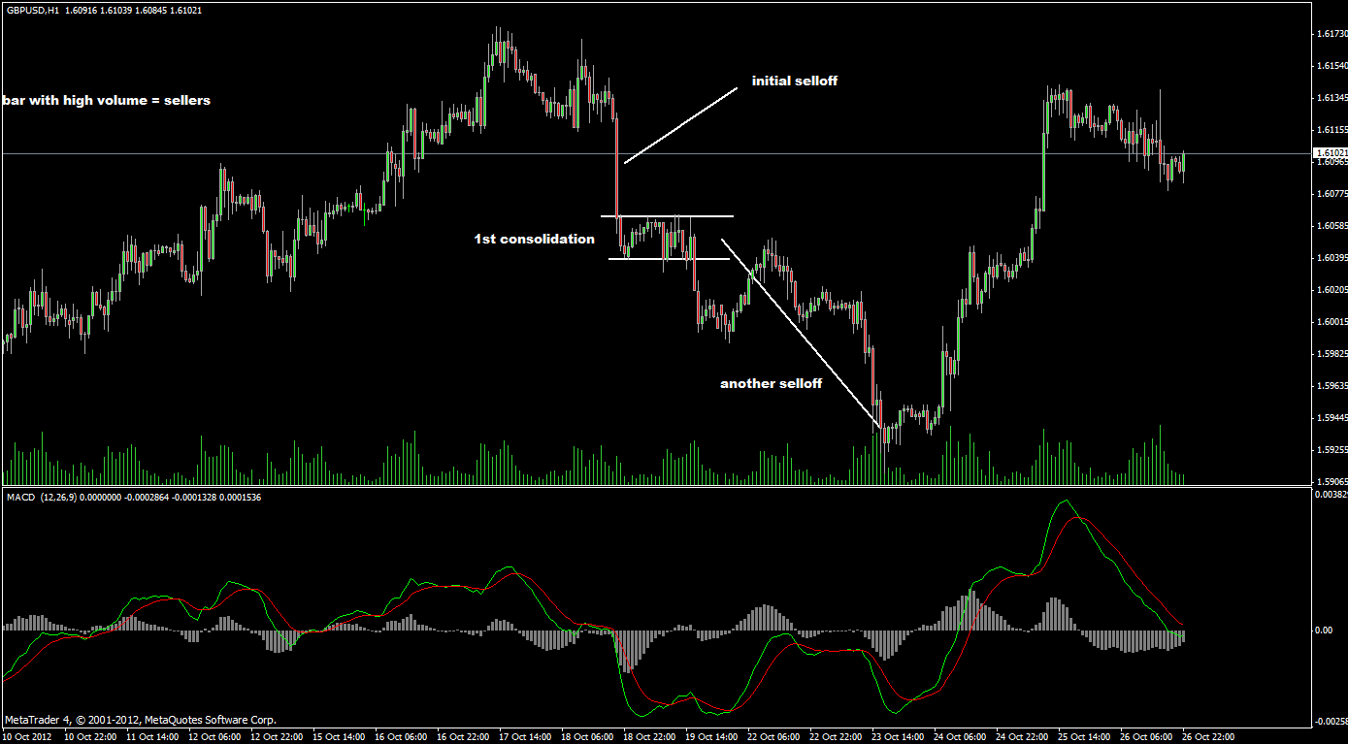

btw, another thing...
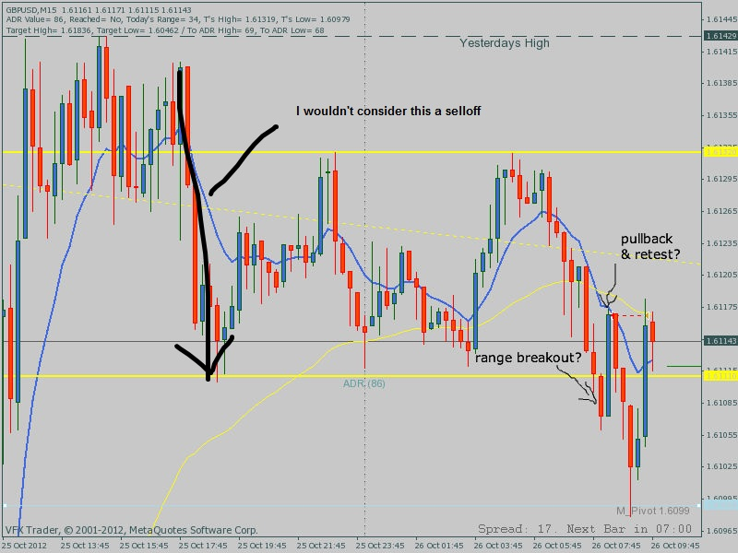
markets don't unusual like volume spikes. that ultra volume spike with wide range bar is a good example, failed close above the range high, failed to put the momentum back up to the north side. after that we get huge amount of volume flowing in, yet price not going anywhere tells me that the sellers are swarming in. bottom range wasn't going to hold at this point.
another thing to note: try to distinguish between consolidations and tops and bottom formations.
typical top and bottom formations: head and shoulder, M and W (also known as double tops and bottoms), and half batman.

/keeping the runner is doable in trending market. we are stuck in a range now. wait for the market to decide. either up or down. Moving sl should be at the next consolidation top or bottom.
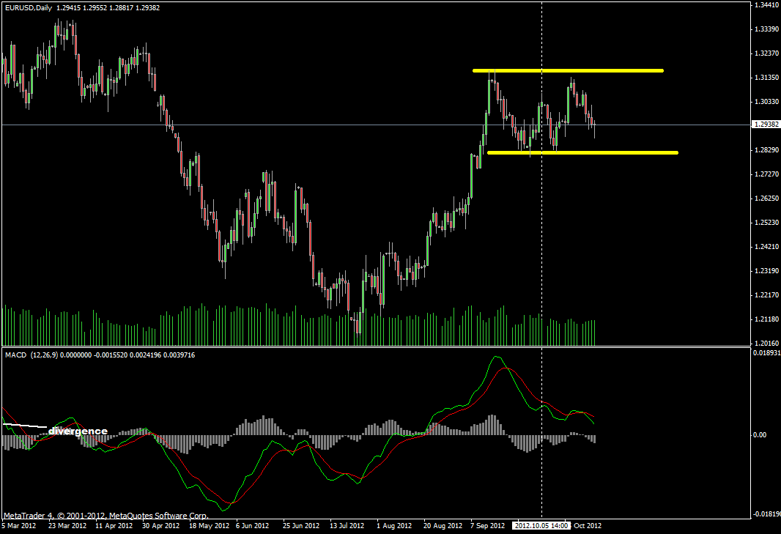
/Ramjet:« In general was there any other ways of getting the runners or you feel the markets don't stay in a trend as long to get the follow through moves?...or is it just a matter of trail the stop up under the HH and HL areas and see where the market takes us?«
You can if you can identify the short term trend and be done with that cycle, but i'd rather focus on higher tf to decide then keep the runners. daily, weekly. important thing is.... when stuck in a range like this, there's no clue when this thing is going to break out. if kept the runner from the bottom then you have no trade for over a month.

